Self-help Group of COPD Patients in Regional Center for Respiratory Disease of YU Hospital in Daegu, South Korea
Misook Lee, RN MPH¹⁾; Kwan Ho Lee, MD PhD¹⁾²⁾; Jin Hong Chung, MD PhD¹⁾²⁾; Kyeong-Cheol Shin, MD PhD¹⁾²⁾; Eun Young Choi, MD PhD¹⁾²⁾; Hyun Jung Jin, MD PhD¹⁾²⁾; Kyeong-Soo Lee, MD PhD¹⁾³⁾; Tae-Yoon Hwang, MD PhD¹⁾³⁾; Eunjung Kim, BPE¹⁾; Yeongju Kim, MS¹⁾; Hyejin Nam, RD MPH¹⁾; Dayoung Park, RN¹⁾
1) Regional Center for Respiratory Diseases, Yeungnam University Hospital, Daegu, Republic of Korea
2) Department of Internal Medicine, College of Medicine, Yeungnam University, Daegu, Republic of Korea
3) Department of Preventive Medicine & Public Health, College of Medicine, Yeungnam University, Daegu, Republic of Korea

Abstract
Statement of the Problem: Chronic Obstructive Pulmonary Disease (COPD) in Korea has a very low inhalation compliance rate of less than 20%. However, there are not many examples of patients' self-help groups in hospitals in Korea. In order to prevent the management and deterioration of COPD, it is very important to improve compliance, and self-help groups are a good way to improve compliance and self-management.
Methodology & Theoretical Orientation: Regional Respiratory Disease Center of Yeungnam University Hospital operated small group self-help group for patients who want to participate in the group. We conducted a preliminary questionnaire on patients enrolled in self-help groups and ate lunch together for icebreaking. Self-help groups held quarterly provided self-help groups, COPD education, introduction of personal experiences, and respiratory rehabilitation training. Each time a self-help group is held, we evaluate satisfaction rate and pt’s needs through surveys and reflects patients' opinions.
Findings: The COPD self-help group was held three times in 2016. Of the 11 registered COPD patients, seven were present at all three sessions without dropping out. Satisfaction with the self-help group was 3.3-3.6 out of 4 points. A handwritten presentation was held to share patient experiences. There was no significant change in satisfaction, self-efficacy, and depression scores.
Conclusion & Significance: In this study, there was no significant change in satisfaction, self-efficacy, and depression scores. The reason for this was that the patients who participated in the self-help group were well-compliant and self-managed. In the future, it may be necessary to involve patients who have low compliance or poor self-management in the program.

Image
Table 1. Satisfaction score of the subjects, 2016 (N=7)
Variable | Q1  April. 27 | Q2  Sep. 21 | Q3  Dec. 7 | p-value
Satisfaction score | 3.3±0.5 | 3.6±0.5 | 3.4±0.5 | 0.598
Mean±SD and measured by one-way ANOVA.
Maximum satisfaction score is 4 points.

Table 2. GSE and GDS scores of the subjects, 2016
Variables | Q1  April. 27  (N=8) | Q2  Sep. 21  (N=9) | Q3  Dec. 7  (N=11) | p-value
General self-efficacy score | 29.3±2.7 | 29.6±4.3 | 29.1±3.0 | 0.954
Geriatric depression scale score | 3.5±2.0 | 6.2±3.6 | 4.6±3.0 | 0.186
Mean±SD. and measured by one-way ANOVA.
Maximum general self-efficacy score is 40 points.
Maximum geriatric depression scale score is 15 points.

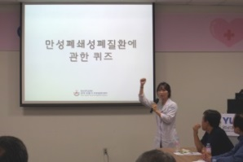  Figure 1. A quiz about COPD | 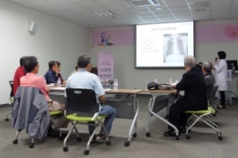Figure 2. COPD education
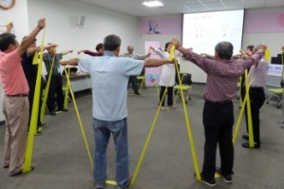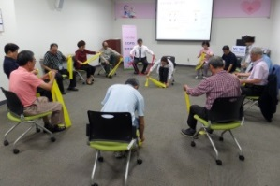
Figure 3. Respiratory rehabilitation training (Thera-Band)

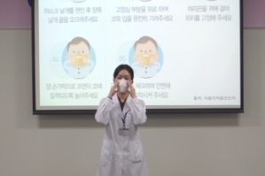Figure 4. How to use masks | 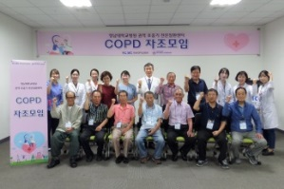Figure 5. Group photograph

Recent publications
- Johnson-Warrington V, Rees K, et al (2016). Can a supported self-management program for COPD upon hospital discharge reduce readmissions? A randomized controlled trial. Int J Chron Obstruct Pulmon Dis 2(11):1161-9.
- Zwerink M, Brusse-Keizer M, et al (2014). Self management for patients with chronic obstructive pulmonary disease. Cochrane Database Syst Rev. 19(3):CD002990.

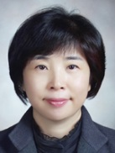
Biography
Misook Lee is the head of the patient education support team at the Regional Center for Respiratory Disease at Yeungnam Univ. Hospital. She is an RN and is a public health master. She has more than 30 years of clinical experiences and has experiences in patient education and counseling. Currently, she is the administrative officer of the Regional Center for Respiratory Disease and is responsible for educational counseling for patients.
Email: lms@ymc.yu.ac.kr

Notes/Comments:

