A Case Report on a 29 Year Old Male with Difficult to Treat Bronchial Asthma in Exacerbation: Rediscovering Asthma COPD Overlap Syndrome (ACOS)
Christoper John N. Tibayan, MD, Ospital ng Makati, Philippines
Jonathan Arquiza, MD, Ospital ng Makati, Philippines

Background. Asthma COPD Overlap Syndrome (ACOS) was formally described by the Joint Project of GINA and GOLD as persistent airflow limitation with several features usually associated with both Asthma and COPD. ACOS is identified by the features shared with both Asthma and COPD. The underlying cause though remains unknown, hence the project did not offer current formal definition. Objective. The objective of this article is to present a case of a 29 years old Male initially diagnosed of Asthma and on further diagnostic investigation is a likely case of Asthma COPD Overlap Syndrome (ACOS). Overview of the Case. XY is a 29 years old male, asthmatic and 8 pack years smoker who presented with chronic obstructive respiratory symptoms with non significant improvement on control of exacerbation despite standard maximal therapy. Diagnostic tests such as Pulmonary Function Tests, 2D Echo, Chest CT Scan and assay for alpha 1 anti trypsin were done to rule out for other disease entities and prognosticate the patient’s condition leading to the diagnosis of Asthma COPD Overlap Syndrome (ACOS). Conclusion. Asthma COPD Overlap Syndrome (ACOS) as a disease entity is still under debate and still has no current formal definition due to lack of specific biomarkers and lack of defining characteristics. Despite this, management should not be compromised since these patients often present with higher rates of exacerbations, hospitalization, associated co morbid illness and mortality. Treatment can be maximized to the so called Triple Therapy defined as combination Long Acting Beta Agonist + Inhaled Corticosteriod + Long Acting Muscarinic Antagonist, however management strategies must be always individualized depending on co morbid illness, patient’s functional capacity and response to initial treatment.

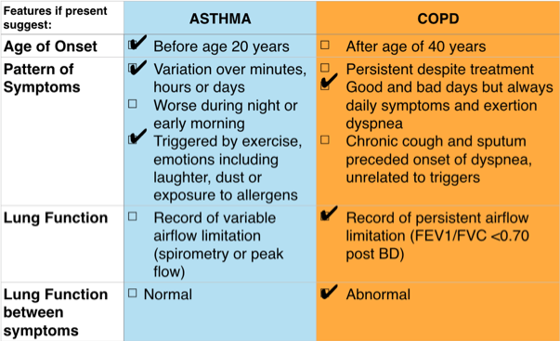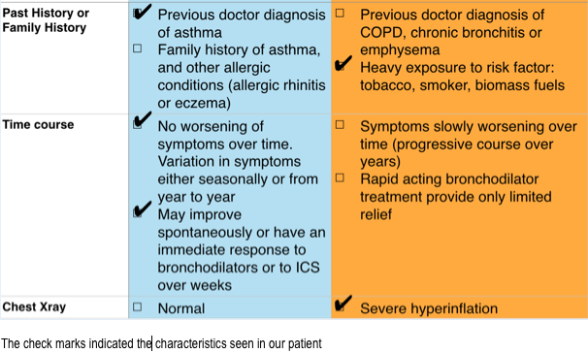
Figure1. The Syndromic Diagnosis of Asthma COPD Overlap Syndrome (ACOS)
References
- Benfante, et.al., The asthma-COPD overlap syndrome (ACOS): hype or reality? That is, a curiosity for the media or an opportunity for physicians?, 2014
- Brzostek, et.al., Asthma-chronic obstructive pulmonary disease overlap syndrome in Poland. Findings of an epidemiological study, 2014
- De Marco, et.al., The Coexistence of Asthma and Chronic Obstructive Pulmonary Disease (COPD): Prevalence and Risk Factors in Young, Middle-aged and Elderly People from the General Population, 2013
- FitzGerald, et.al., Global Strategy for Asthma Management and Prevention 2014 (Revision): Global Initiative for Asthma, 2014
- Harada, et.al., Causes of death in patients with asthma and asthma–chronic obstructive pulmonary disease overlap syndrome, 2015
- Kostikas, et.al., The asthma–COPD overlap syndrome: do we really need another syndrome in the already complex matrix of airway disease? , 2015
- Lee, et.al., A diagnostic approach and natural course of a patient with asthma–COPD overlap syndrome, 2015
- McLaughlin, et.al., ACCF/AHA 2009 Expert Consensus Document on Pulmonary Hypertension: A Report of the American College of Cardiology Foundation Task Force on Expert Consensus Documents and the American Heart Association, 2009
- Tho, et.al., Asthma-COPD Overlap Syndrome (ACOS): a diagnostic challenge. Respirology), 2015
- Yamauchi, et.al., Comparison of in-hospital mortality in patients with COPD, asthma and asthma–COPD overlap exacerbations, 2015

Biography

Christoper John N. Tibayan, RMT, MD is a Second Year Internal Medicine Resident at Ospital ng Makati, Makati City Philippines
Email: cjntibayanmd@gmail.com

