Nonlinear excitations of blood flow in large arteries under thermal radiations and magnetic field

Conrad Bertrand Tabi, Botswana International University of Science and Technology, Botswana

Abstract (300 word limit)
A nonlinear model of blood flow in large vessels is addressed. The influence of radiations, viscosity and uniform magnetic fields on velocity and temperature distribution waveforms is studied. Exact solutions for the studied model are investigated through the F−expansion method. Based on the choice of parameter values, single-, multi-soliton and Jacobi elliptic function solutions are obtained. Viscosity and permanent magnetic field bring about wave spreading and reduce the velocity of blood, while radiations have reversed effects with strong impact on the waveform frequency of both the velocity and temperature distribution.

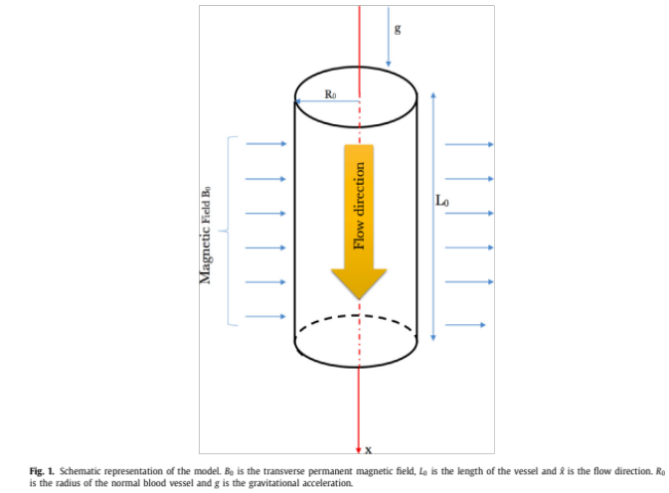

Recent Publications (minimum 5)

- Tabi CB, Motsumi GT, Bansi CDK, Mohamadou A (2017) Nonlinear Excitations of Blood Flow in Large Vessels under Thermal Radiations and Uniform Magnetic Field. Communications in Nonlinear Science & Numerical Simulation 49: 1-8.
- Shaw S, Murthy PVSN, Pradhan SC (2010) Effect of non-Newtonian characteristics of blood on magnetic targeting in the impermeable micro-vessel. Journal of Magnetism and Magnetic Materials 322: 1037–1043

- Majee S, Shit GC (2017) Numerical investigation of MHD flow of blood and heat transfer in a stenosed arterial segment. Journal of Magnetism and Magnetic Materials 424: 137–147
- Shit GC, Mondal A, Sinha A, Kundu PK (2016) Electro-osmotically driven MHD flow and heat transfer in micro-channel. Physica A 449: 437–454

- Kenjereš S (2008) Numerical analysis of blood flow in realistic arteries subjected to strong non-uniform magnetic fields. International Journal of Heat and Fluid Flow 29: 752–764

- Ogulu A, Abbey TM (2005) Simulation of heat transfer on an oscillatory blood flow in an indented porous artery. International Communications in Heat and Mass Transfer 32: 983–989

Prof. Dr. Tabi has a PhD in Theoretical and Computational Physics of Complex Systems. He graduated from the University of Yaoundé I in Cameroon and served as a staff member in the Department of Physics of the same University. His Research focuses on the study of nonlinear phenomena and chaos in complex dynamical systems, including biological settings, Nonlinear Optics (optical fibers, Metamaterials), Material Sciences (Carbon Nanotubes) and Bose-Einstein Condensations. Another strand of his research interests is oriented toward experimental Biophysics applied to Agriculture and Medicine. During the past eight years, he has contributed in building mathematical models and computer codes on a multidisciplinary basis, bringing together Biology, Nanotechnology, Optics Communication and Physics. His scholarly record includes authorship and co-authorship of over 50+ publications in reputed international journals and 10 conference proceedings. In 2014, He co-authored a book on “Solitons in DNA and Biological Implications” which gives strong tools to tackle various problems in nonlinear dynamical systems in technology and Biosciences. He has served as major thesis and research advisor of 25+ Master’s students and actually supervises 15+ PhD students from Botswana, Cameroon and Central African Republic.

Email: tabic@biust.ac.bw

