Title: Theoretical study on the electronic properties of nanocomposite semiconducting systems (PbS)_{n}(n=4,32,108)@(TiO₂)_{n}(n=23,33).

Tania Gabriela, Díaz Rodríguez
PhD student, BUAP, MÉXICO

Abstract (300 word limit)
A theoretical study was carried out for the first time in a series of six nanocomposite semiconducting systems (PbS)_{n}(n=4,32,108)@(TiO₂)_{n}(n=23,33). We stabilized two structures of TiO₂ using a simulated annealing procedure with Molecular Dynamics as a first approach, the anatase structures were found for this methology. We adopted the cubic structure of the (PbS)_{n} (n=4,32,108) quantum dot as suggested by experimental data [1,2]. The Density of States (DOS ) of the isolated systems and the composites (PbS)_{n}(n=4,32,108)@(TiO₂)_{n} (n=23,33) were assessed. Also, the adsorption energies on this systems were estimated.
The DOS were determined using Density Functional Theory (DFT) calculations, FHI-AIMS software package [3,4], and Molecular Dynamics using DL-POLY[5] and REAXFF software packages [6,7]. The DFT calculations were performed using a plane-wave basis set, and the generalized gradient approximation (GGA) of Perdew-Burke-Ernzerhof for the exchange-correlation energy [8]. The core electrons were described with Projector Augmented Wave (PWA) method, also it was included relativistic scalars effects (ZORA)[9] and Van Der Waals interactions using Tkatchenko-Scheffler methodology[10]. The (PbS)_{n}(n=4,32,108)@(TiO₂)_{n} (n=23,33) anatase composite systems results in a favorable electronic structure that may readily provide fundamental data to develop and design photocatalytic devices for hydrogen production[11,12], energy storage and photovoltaic applications[13,14].

Image

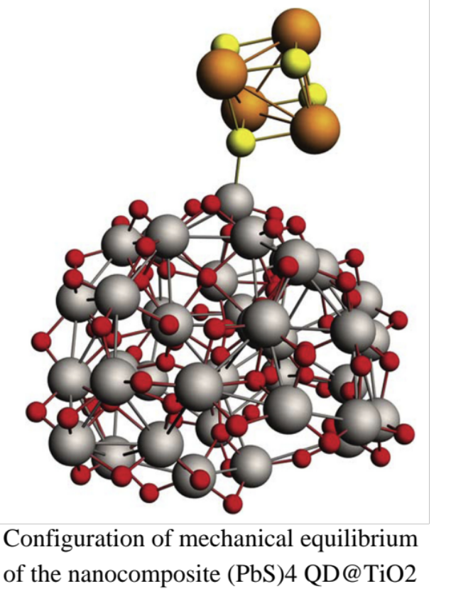

Recent Publications (minimum 5)
[1] K. Donghun, Impact of Stoichiometry on the Electronic Structure of PbS Quantum Dots,Phys. Rev. Lett., (2013).
[2] B. Kiran, (PbS)32:A baby crystal,J. Chem. Phys., (2012).
[3]. V. Blum, R. Gehrke, F. Hanke, P. Havu, V. Havu, X. Ren, K. Reuter, M. Scheffler. Comp. Phys. Comm. 180 (2009), 2175.
[4]G. Kresse and J. Hafner, Phys. Rev. B 47 , 558 (1993);ibid. 49 , 14 251 (1994).
[5].T. Todorov, DL POLY 3 new dimensions in molecular dynamics simulations via massive parallelism,J. Materials. Chem., (2006)
[6] van Duin, A. C. T.; Dasgupta, S.; Lorant, F.; Goddard, W. A. ReaxFF: A Reactive Force Field for Hydrocarbons. J. Phys. Chem. A 2001, 105, 9396?9409.
[7]Chenoweth, K.; van Duin, A. C. T.; Goddard, W. A. ReaxFF Reactive Force Field for Molecular Dynamics Simulations of Hydrocarbon Oxidation. J. Phys. Chem. A 2008, 112, 1040?1053.
[8] J.P Perdew,Generalized Gradient Approximation Made Simple, Phys. Rev. Lett., (1996).
[9]R. Ahuja, A. Blomqvist, P. Larsson, P. Pyykkö, and P. Zaleski-Ejgierd, Relativity and the Lead-Acid Battery. Physical Review Letters 106, 018301 (2011).
[10] A. Tkatchenko and M. Scheffler, PRL 102, 073005 (2009)
[11]F. Akira, H. Kenichi, Electrochemical photolysis of water at a semiconductor electrode, Nature 238 (1972) 37–38.
[12]A.V. Akimov, A.J. Neukirch, O.V. Prezhdo, Theoretical insights into photoinduced charge transfer and catalysis at oxide interfaces, Chem. Rev. 113 (2013) 4496–4565.
[13]J. Muñiz, M.E. Rincón, P. Acevedo-Peña, The role of the oxide shell on the stability and energy storage properties of MWCNT@TiO2, Theor. Chem. Acc. 135 (2016) 181–189.
[14]P.V. Kamat, J. Bisquert, Solar Fuels. Photocatalytic hydrogen generation, J. Phys. Chem. C 117 (2013) 14873–14875.

 Biography (150 word limit)
Tania Gabriela Díaz Rodrìguez is a PhD student in BUAP, México. at the age of 26 years. She has collaborated with Laboratorio Nacional de Supercómputo del Sureste de México. She has her expertise in Molecular Dynamics and Density Functional theory applied in study of optical and electronic properties of semiconductor nanoparticles.
Email: tgdiazr@gmail.com

Notes/Comments:

