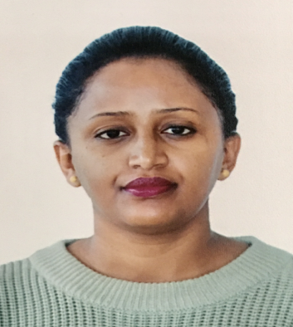
Title: Energy signal disaggregation and classification
Name: Alemawit Gebrehiwot Woldu
Yumna private enterprise, Addis Ababa, Ethiopia
Energy management is important for the economy of one country as well as for the today’s climate change concerns. The solution for the electrical consumption management is the use of Non-intrusive load monitoring. This system captures an aggregated energy signal, e.g. the total power consumption of a house, identify the features of the electrical appliances used within the house and dis-aggregate it into the different appliances. This paper describes a technique for feature extraction as the main stage for the implementation of an innovative NILM. Describes how to obtain unique characteristics of each appliance in order to make the disaggregation of each appliance from the aggregated energy easy. These studies clearly indicate that more detailed information on consumption of individual devices will lead to more virtuous energy saving.

Biography
My name is Alemawit Gebrehiwot I completed my Msc from Politecnico di Torino and Bsc degree from Mekelle Institute of Technology (MIT). I am working as a Technical support analyst. I have worked as a researcher in information network security agency for more than five years. I participated in many projects in the agency and leads the project team.
Presenting author details
Full name: Alemawit Gebrehiwot Woldu
Contact number:+251937013021
Twitter account:@ally14324
Linked In account: linkedin.com/in/alemawit-gebrehiwot-840a8078/
Category: (Oral presentation/ Poster presentation)

