FLICKBLOCKS
LINK
Download
PLATFORMS
HTC Vive and Oculus Rift
CATEGORY
Games, Research & Development, Virtual reality
iLLOGIKA fully developed FlickBlocks.
FlickBlocks mixes classic gameplay with VR to create an experimental game that’s high intensity action and strategy. This game prototype emerged from our research and development initiative and has been produced in 3 weeks. The prototype is now published on itch.io for all to enjoy.

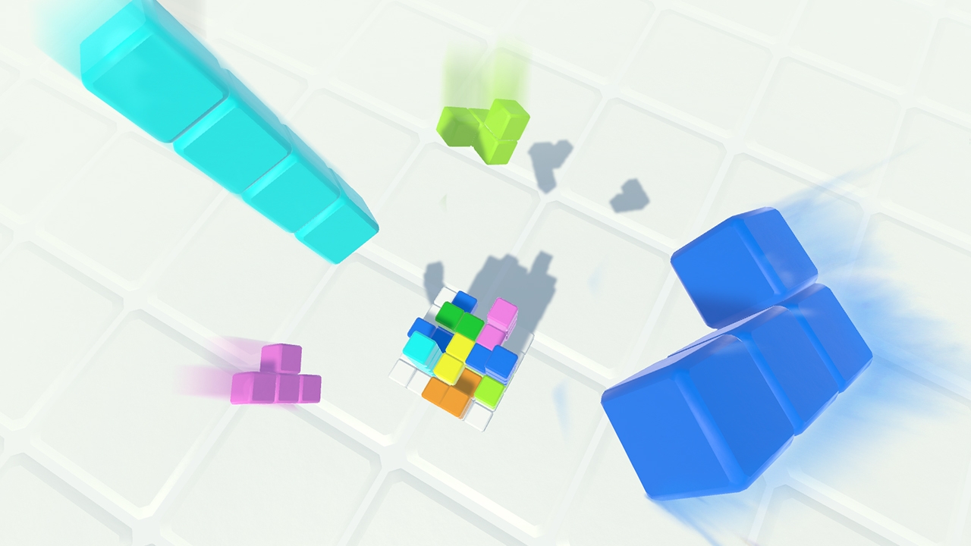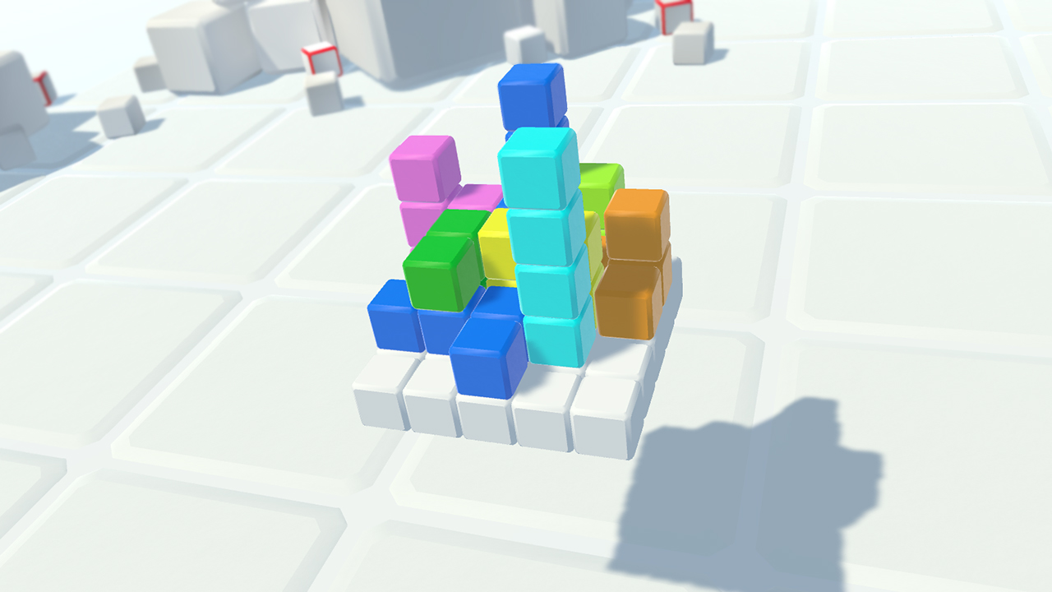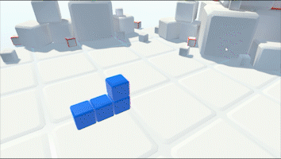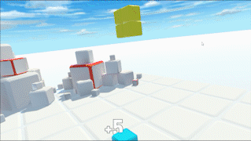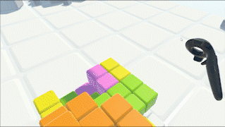

AIRPUNCH

LINK
Téléchargement
PLATFORMS
HTC Vive et Oculus Rift
CATEGORY
Games, Research & Development
While it is at an advanced stage of development and available for download, Air Punch is above all a prototype, created for R&D purposes.

Air Punch is an innovative VR demo exploring a new locomotion technique using punches we call Punch Dash ! Produced in between 4 to 5 weeks, the game is now published on itch.io for all to enjoy.

https://www.youtube.com/watch?v=G5kls_7Thsc
