C-reactive protein point-of-care testing and antibiotic prescribing for acute respiratory tract infections in rural primary health centers of Ethiopia
Henock Yebyo^{1*}, Araya Abrha Medhanyie¹, Mark Spigt², Rogier Hopstaken⁴
¹ School of Public Health, College of Health Sciences, Mekelle University, Mekelle, Ethiopia
² Department of Family Medicine, School for Public Health and Primary Care (CAPHRI), Maastricht University, Maastricht, the Netherlands
⁴ Saltro Diagnostic Centre, Utrecht, the Netherlands

Abstract:
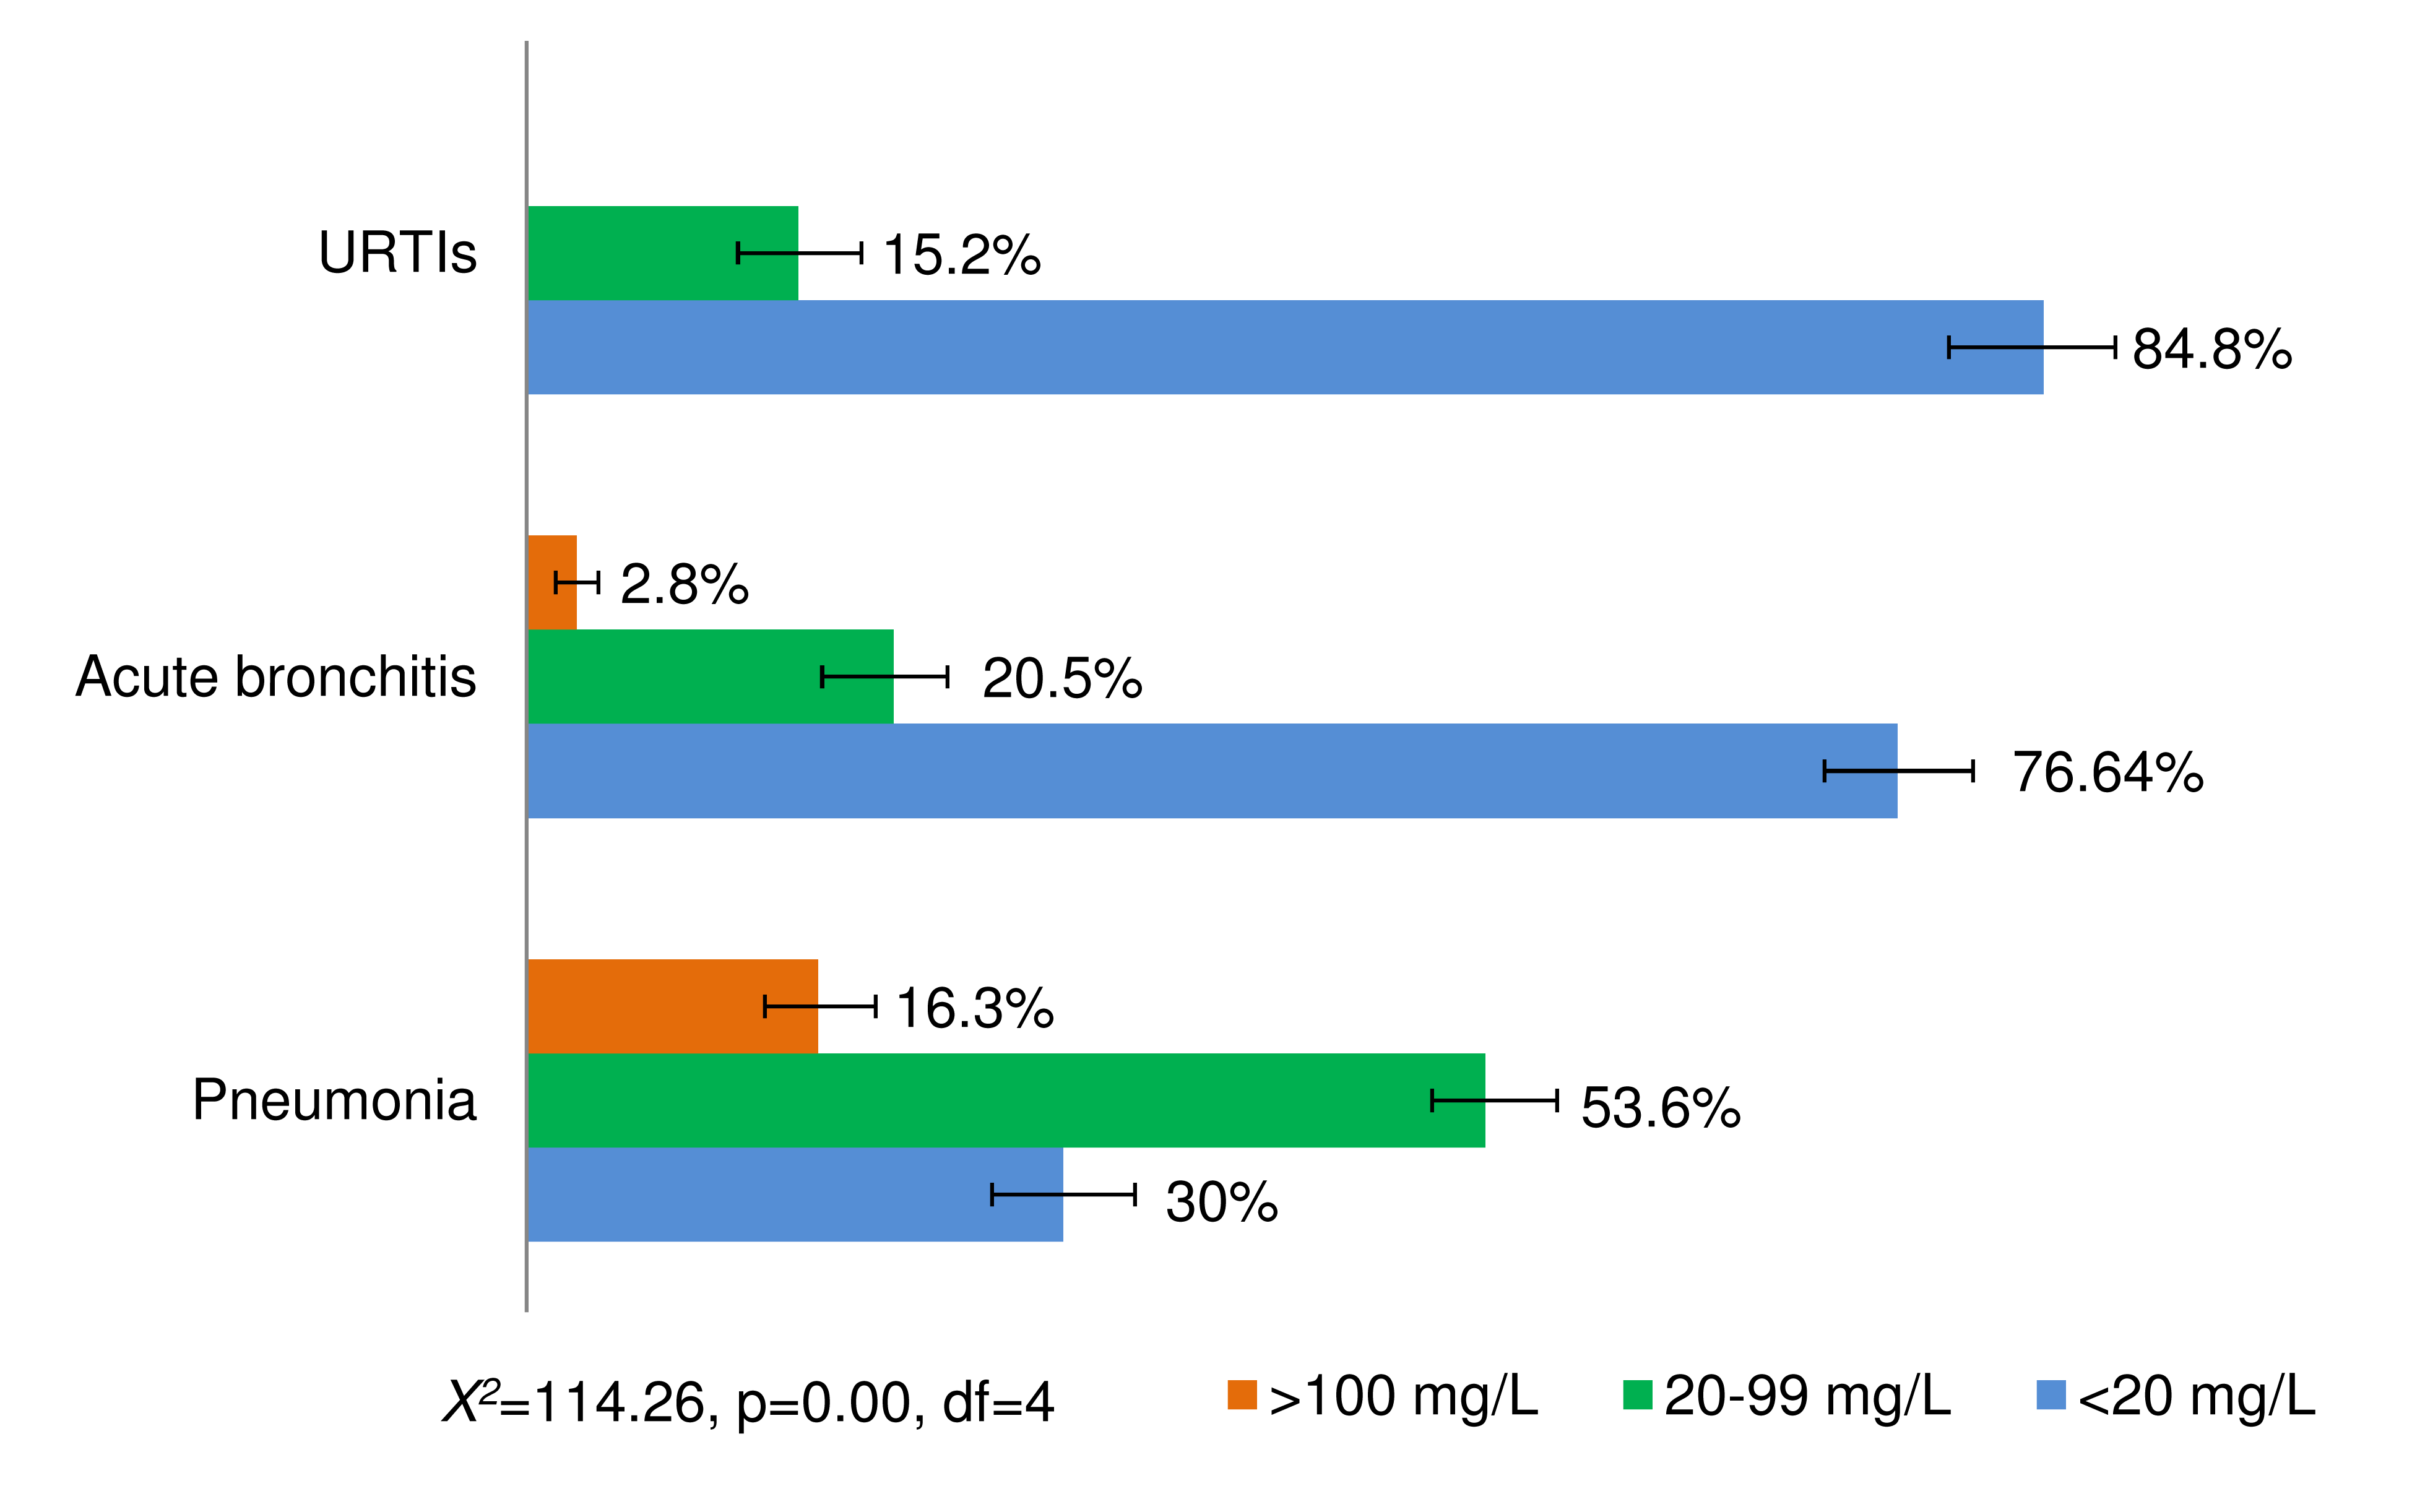
Unjustified antibiotic prescribing for acute upper respiratory infections (URTIs) is probably more common in poor-resource settings where physicians are scarce. Introducing easy tools to help identify infections requiring antibiotics is imperative. Use of C-reactive-protein (CRP) point-of-care testing– an inflammatory indicator, could be a competitive tool for this purpose. Clinical trials in developed countries show effectiveness of CRP, prepared as point-of-care testing, to identify patients requiring immediate antibiotics, pending or don’t need any. However, evidence about level of improper antibiotics prescribing and distribution of CRP in patients with URTIs in poor-resource settings is not yet studied, which will justify for introducing the CPR point-of-care testing. Our study pointed out the magnitude of antibiotics prescribing and distribution of CRP levels among the patients with URTIs in primary health care units in Ethiopia. We included 414 patients with acute URTIs from four health centers. Health professionals recorded the clinical features of the patients but laboratory technicians measured the CRP levels of the patients at the point of cares. The most prominent respiratory causes for consultation were acute URTIs combined (44.4%), and lower respiratory tract infections— pneumonia (29.71%) and acute bronchitis (25.84%). The CRP distribution was less than 20mg/l, 20-99mg/l and 100mg/l or more in 66.6%, 27.9% and 5.5% of the patients, respectively. These levels were significantly different among the clinical diagnoses (X²=114.3, p<0.001, df=4). A wide range of antibiotics was administered for 87.8% of the patients, regardless of the diagnosis or prognostic nature of their diseases. In sum, antibiotic prescribing for acute URTIs in the rural areas of Ethiopia is unduly high, with high proportions of mild, self-limiting illness, mostly URTIs. Implementation of CRP point-of-care testing in such resource-constrained settings could help low or middle health professionals identify patients who benefit from antibiotic treatment.


Fig. The respiratory diseases by CRP distributions and 95% confidence interval of the patients in four health centres
Publications
1. Yebyo HG, Kendall C, Nigusse D, Lemma W. Outpatient therapeutic feeding program outcomes and determinants in treatment of severe acute malnutrition in Tigray, northern Ethiopia: a retrospective cohort study. PLoS One 2013; 8: e65840.
2. Yebyo H, Medhanyie AA, Spigt M, Hopstaken R. C-reactive protein point-of-care testing and antibiotic prescribing for acute respiratory tract infections in rural primary health centres of North Ethiopia: a cross-sectional study. npj Prim Care Respir Med 2016; 26. DOI:10.1038/npjpcrm.2015.76.
3. Yebyo H, Alemayehu M, Kahsay A. Why do women deliver at home? Multilevel modeling of Ethiopian national demographic and health survey data. PLoS One 2015; 10: e0124718.
4. Ebuy H, Yebyo H, Alemayehu M. Adherence level to and predictors of Option B+ PMTCT program in Tigray, Northern Ethiopia. Int J Infect Dis 2014; 33: 1–7.
5. Alemayehu M, Tinsae F, Haileslassie K, Seid O, Gebregziabher G, Yebyo H. Undernutrition status and associated factors in under-5 children, in Tigray, Northern Ethiopia. Nutrition 2015; 31: 964–70.
6. Little A, Medhanyie A, Yebyo H, Spigt M, Dinant G-J, Blanco R. Meeting community health worker needs for maternal health care service delivery using appropriate mobile technologies in Ethiopia. PLoS One 2013; 8: e77563.
7. Medhanyie A, Little A, Yebyo H, et al. Health workers’ experiences, barriers, preferences and motivating factors in using mHealth forms in Ethiopia. Hum Resour Health 2015; 13: 2.

Biography Henock Yebyo is a PhD student at Epidemiology, Biostatistics and Preventive Medicine Institute, University of Zurich. He is doing his research on benefit-harm analysis of statins for primary prevention of cardiovascular diseases in Switzerland and Ethiopia and development of personalized clinical decisions tools. He has been working in Mekelle University, Ethiopia in different academic positions starting from graduate assistant to senior lecturer before he started his PhD study in Zurich. In addition to teaching, he undertook different public health researches as principal and co-investigator, and consultant. He authored over 20 papers on internationally reputed journals.
E-mail: henock.yebyo@uzh.ch

