Metacognition: An Hermeneutical phenomenology & Neurology approach
Rozita Aboutorabi, PhD. In educational philosophy, Ferdowsi university of Mashhad, Iran

Abstract

The current paper discloses the overlap of hermeneutical phenomenology and neurology. It is comparative analytical research. The human being(Dasein) in Heidegger’s viewpoint is temporal. As Dasein according to past possibilities, in the present he projects himself in the future. In fact, our life experiences open possibilities to us to understand what can I do and who I will be. Our understanding of the world is based on our life experiences and knowledge earned through it. Some evidence in neurology confirms this. One of the cases in neurology is H.M. who was cured by removing his hippocampus. But he lost the temporal link between one moment of the next. According to Heidegger in authentic understanding world disclosed; also on him every interpretation is essentially grounded in fore- structure which are fore-having, fore- sight, and fore- conception. In Heidegger’s view interpretation constituted on fore- having; and in interpretation, Dasein moves to the totality of for- conception involvement. Then we don’t have any conception without assumption. So he rises authentic understanding that Dasein becomes aware of its assumptions and discloses its world. A.J.Larner(2021) discussed procedural and declarative “metamemory”. Then he states episodic and semantic metamemory as branches of declarative metamemory. It seems to me questioning, thinking, and changing the content of these metamemory is what Heidegger considers to be authentic. Heidegger focused on anxiety and accounted for authentic attunement. He believes in this mood when all the world loses its meaning, Dasein discloses to the world by overcoming it. On the other hand, neurologists have found that Brodman’s area 10 is engaged in self-referential processing. This area has been activated when people reflect on their emotions, their past or future, and their personalities. Therefore, we can assume this area is an important part of metamemory and metacognition as well.
Image

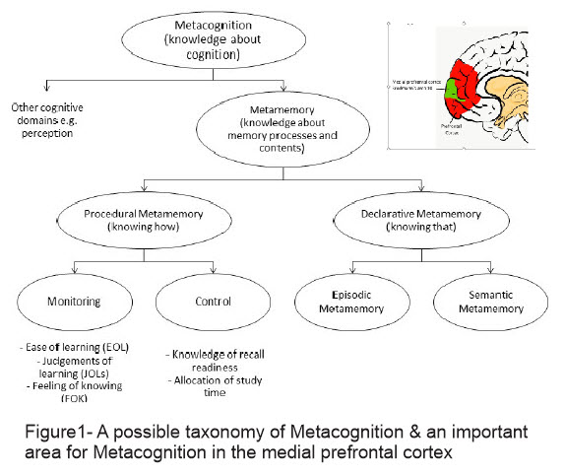

Recent Publications
- Heidegger, education, nation and race, Policy Futures in Education, 13(4), 2015
- Criticizing and Developing Being- in- the- world’s Implications in Education on Heidegger’s View, Foundations of education, ISSN: 2423-4273, Ferdowsi.
- Education & Heidegger’s Hermeneutical Phenomenology, Iran, Tehran: Raznahan, ISBN: 978-600-448-380-3, 2016.
- A Study of the Relationship between Principals' Philosophical Mindedness and their leadership style, Studies in Education and Psychology, No. 23, ISSN: 1608-2842, Ferdowsi university of Mashhad, Iran, 2010.
- A Study of the Relationship between Principals' Philosophical Mindedness and their Creativity, The International Journal of Learning, Vol 18, 2012, Illinois, USA by LLC, ISSN: 1447-9494.


Paste your Logo here
Biography
Rozita Aboutorabi has her expertise in educational philosophy and passion for hermeneutical phenomenology. Her open and contextual educational model based on Heidegger’s viewpoint about human beings and his understanding of the surrounded world in “Being & Time” creates new pathways for improving education. She has built this model after years of experience in research, teaching, and philosophizing in the educational implications on Heidegger’s view. She is enthusiastic about neuroscience and she is doing research on metacognition as well. She is a hard-working persistent researcher who has a very exact plan for every step of the way and is strict on sticking to them. She discloses the overlaps of these two fields. This approach is responsive to all stakeholders and has a different way of focusing. Hope that the results of this research can lead to changes in educational fields and give them new insights to bring up humanity.
Email: rozita_abootorabi@yahoo.com

Notes/Comments:

Presenting author details
Full name: Rozita_abootorabi@yahoo.com
Contact number:00989151022584
Twitter account: @rozita_abootora
Linked In account: https://www.linkedin.com/in/rozita-abootorabi-85340a36/
Session name/ number: Cognitive Neuroscience
Category: (Oral presentation/ Poster presentation) Poster presentation

