Managing Marine Ecosystems and Competing Uses: Global Perspective
An ecosystem is a community of living organisms and non-living components of their environment (things like air, water and minerals soil); interacting as a system. There are different types of ecosystems; terrestrial and aquatic ecosystems. Aquatic ecosystems are divided into marine (salt water) and fresh water ecosystems which have a distinct set of management issues such as to ownership issues, harvesting methods and allowable harvest quotas. There are different activities from the different types of ecosystems; this includes Diverse food webs, Nursery and feeding ground for many species, high biodiversity, Vulnerable benthic habitats, Tourism and recreation, trading and energy of goods and services, Fisheries and fish farming provides 90% of the world fish catch(see photos).

The United Nations estimates that 70% of the world’s marine fisheries are being overexploited as the number of fishers increases. Marine ecosystems are very important for the overall health of both marine and terrestrial environments (see Photos).
The management of marine fisheries resources is the difficulty in achieving agreement on limits to the harvest, across the oceans {with area closure on fishing activities, marine protected areas (MPA), and Benthis habitats}. For example, Canada, the USA over the management of Pacific salmon and the North Atlantic Cod in the 1990s, The management of coastal zones resources has difficulty in achieving agreement on urbanization with challenges such as water quality and pollution; and development in Shoreline stabilization, Land reclamation (see photos).
Thus, there is need for management tools in addressing the land-sea interface (coastal zone) is one of the most complex areas of management being the home to an increasing number of activities, rights and interests especially in mining and sand gravel activities. For example, there is a sea of chaos Superimposed projection of all activities and infrastructures in the Belgian waters (see photos).

Therefore, International agreements are required to manage the resource since the oceans do not belong to any country. Thus, international organization like the FAO, U.S.A,UNEP and Icelandic policies on the oceans and ecosystems management will maintain the marine ecosystem’s health, biodiversity and productive capacity of living resources to be utilized sustainably especially for my country Sierra Leone and the world.

References
- Environmental Science: A study of Interrelationships, Seventh Edition. Eldon D.Enger and Bradley F.Smith.
- Sigmar Arnar Steingrímsson: The Icelandic National Planning Agency, Coastal Zone Management (CZM).
- Marine Ecosystems | Biological Indicators of Watershed Health | US EPA
- Stachowicz, Fried, Osman, Whitlatch ESA Online Journals - Biodiversity, Invasion Resistance, and Marine Ecosystem Function: Reconciling Pattern and Process.
- Ecosystem-based management for the oceans: The role of zoning Principal Investigators: Gail Osherenko, Satie Airame, Larry B. Crowder, Elliott A. Norse, and Oran R. Young.

Figures and Photos

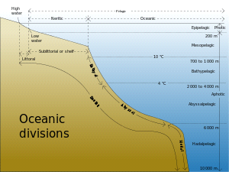
A classification of marine habitats.
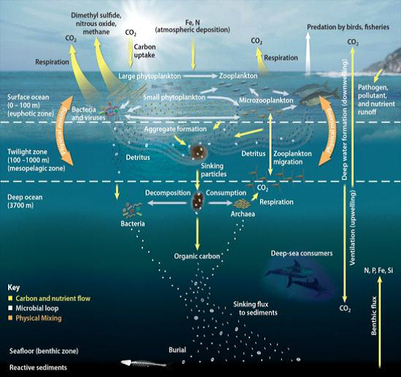

Diverse Food Web.
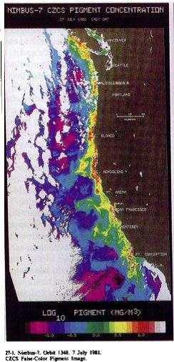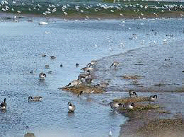
Primary Production. Nursery and feeding ground for many species.

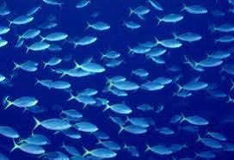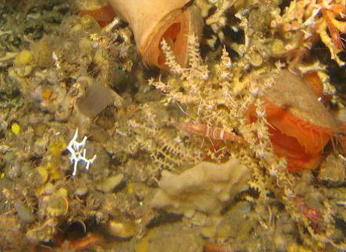
Majority of the World Fish Production. High Biodiversity.
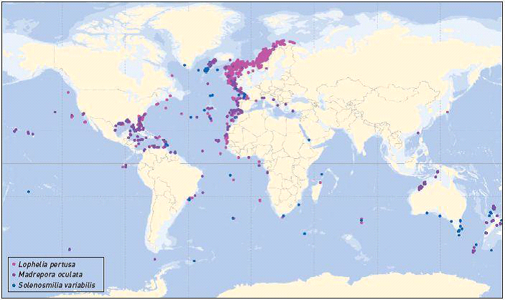
Vulnerable benthic habitats.

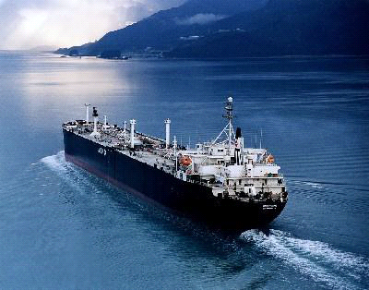. 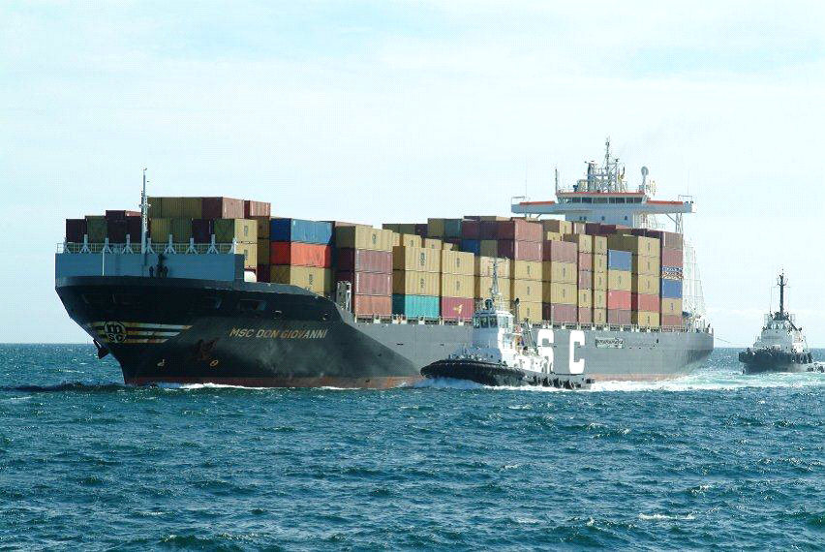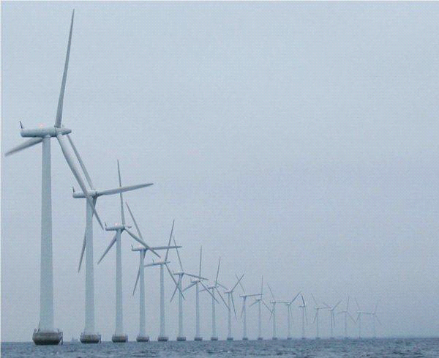
Trading and Energy.

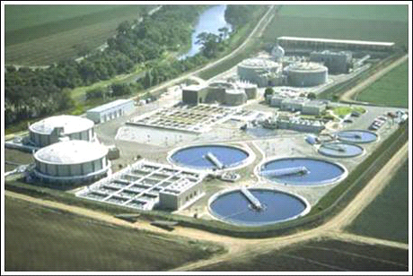
Water quality.
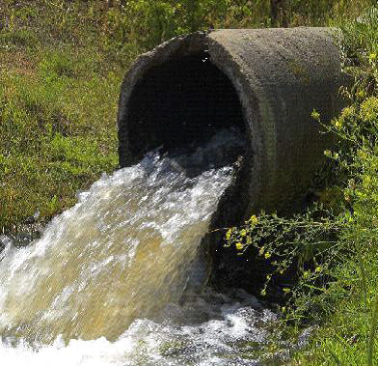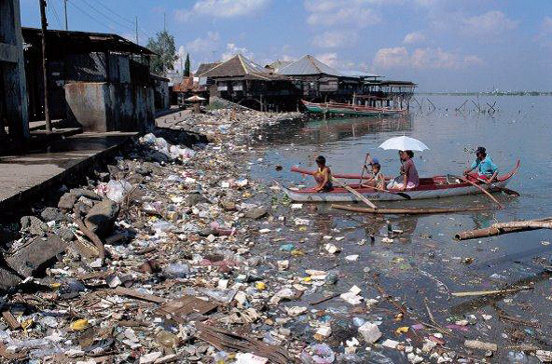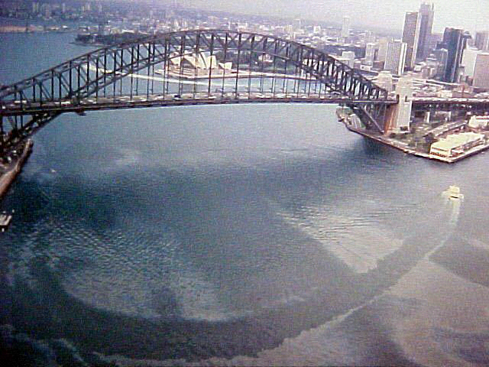Pollution.
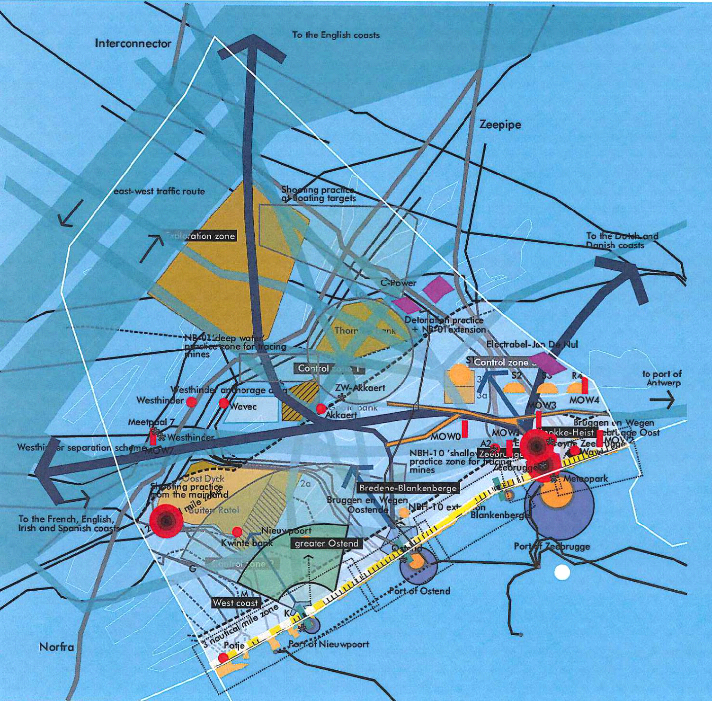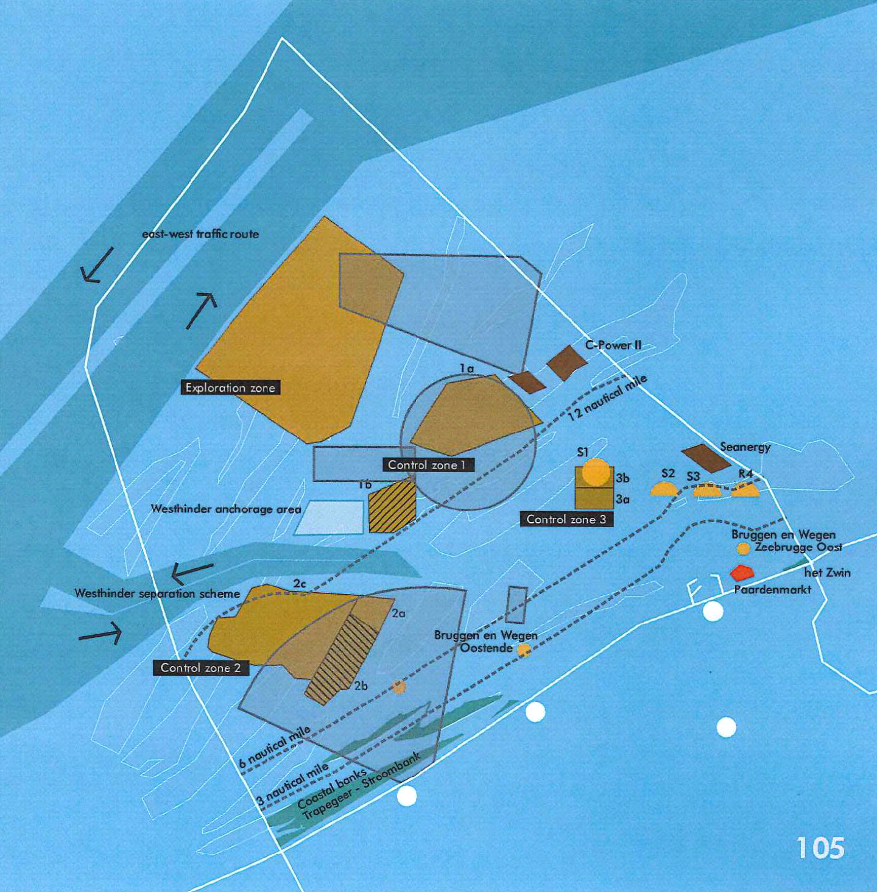

A Sea of Chaos. The Regulated Sea.


Coastal Zone area showing the Tombo Fishing Site, Freetown, Sierra Leone.

