Potential multi-function cylinder as wave attenuator
Norzana Mohd Anuar, Senior Research Officer, Research Centre for Coastal, National Hydraulic Research Institute of Malaysia, Malaysia
FaridahJaffarSidek, Honorary Associate Member, Coastal and Offshore Engineering Institute, UniversitiTeknologiKuala Lumpur, Malaysia
NorAslindaAwang, Senior Research Officer, National Hydraulic Research Institute of Malaysia, Malaysia

Abstract
An experimental investigation, conducted in unidirectional waves with different wave conditionsand model configurations were conducted to assess the wave energy loss on cylinder obstacles. Two sizes of cylinder were used, 100 mm and 200 mm with four different porosities ranging from 0.0625 to 0.48 respectively. The influences of water depth, incident wave steepness and porosities were studied. The test results shown that when the percentage of porosity decreased, more wave energy was dissipated, this resulted in the decrease in transmitted wave heights. Furthermore, it was also found that lower water depth has a significant influence on the loss coefficient at bigger modelsize with K_{l} being more than 0.60 at a water depth 0.27 m compared to K_{l} being less than 0.40 at water depth 0.35 m for similar porosity. Overall, the bigger model (single or double cylinder) with lower porosity (P=6.25% and 14%) showed promising performance in reducing wave heightat the lee of the model, having high percentage of wave energy loss, and smaller model has been found to be the least effective wave attenuator model to the same environments among all three models. In a way, cylindrical structurebeing porous could potentially be used together or alone as a wave dampening structure at mangrove sapling replanting coastal area and/or artificial reefs for fish breeding ground.

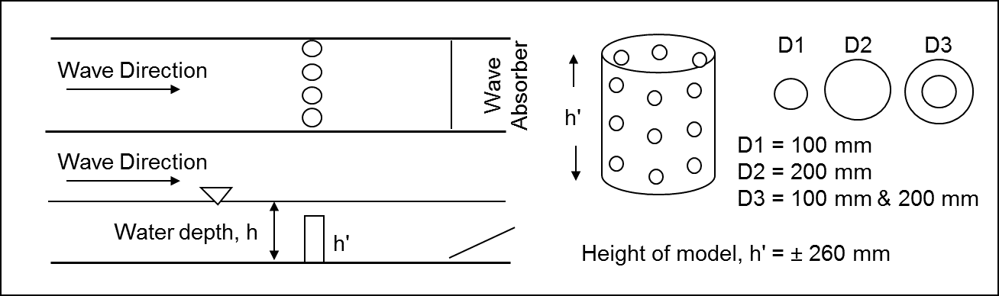
Figure 1: Model configurations and arrangements.
Recent Publications
- Armono, H. D. and Hall, K. R. (2000). Wave Transmission on Submerged Breakwaters Made of Hollow Hemispherical Shape Artificial Reefs. Canadian Coastal Conf. Victoria, Canada. 1-13.
- Black, K., and Mead, S. (2000) Submerged Structures for Coastal Protection: A short summary of what they were, why we need them and how they work. Summary Report, ASR Ltd., Hamilton, New Zealand, pp. 1-7.
- Thomson, G. G. (2000) Wave Transmission through Multi-layered Wave Screens. Master Dissertation, Dept. of Civil Eng., Queen’s University, Kingston, Ontario, Canada.
- Ting, C. H., Lin, M. C., and Cheng, C.Y. (2004) Porosity Effects on Non-breaking Surface Waves over Permeable Submerged Breakwaters. Coastal Engineering 50, pp. 213-224.
- Sidek, F. J., and Abdul Wahab, M.A. (2007) The Effect of Porosity of Submerged Breakwater Structures on Non-Breaking Wave Transformations. Malaysian Journal of Civil Engineering. 19(1), pp. 17-25.

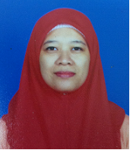Biography
Norzana Mohd Anuar has her experience in various aspects of coastal modelling to deliver better understanding of coastal conditions that feeds directly into engineering design – from option appraisal to detailed design.. Her master research in coastal protection structure has give an understanding on the alternative types of mitigation structures to attenuate wave energy in order to minimize coastal erosion. The findings are essential in order to further develop the possibility of producing a prototype model and site-tested for effective assessment.
Email: wajina04@gmail.com or norzana@nahrim.gov.my
Contact number: +603-89476400

Notes/Comments:

