The impacts of sea level rise to the planning and development of coastal zones at Manjung, Perak, Malaysia
Nor Aslinda Awang, National Hydraulic Research Institute of Malaysia (NAHRIM), Malaysia
Wan Ahmad Hafiz Wan Mohamed Azhary, National Hydraulic Research Institute of Malaysia (NAHRIM), Malaysia
Mohd Radzi Abd. Hamid, National Hydraulic Research Institute of Malaysia (NAHRIM), Malaysia

Abstract (300 word limit)
Climate change and global warming are global issues and inevitable. It is predicted to cause global sea level rise (SLR), which may impacting the development of coastal zones, especially in the low lying areas such as river estuary. Continuous intense pressure for development in Manjung coastal zones may lead to disruption to natural processes, thus greatly impacting the shape of the coastline, ultimately resulting in loss of land due to erosion, degradation of coastal resources, loss of development opportunities, decrease in land values, as well as increased exposure of human life and property to coastal hazards. Therefore, clear planning decisions with strong understanding and input on coastal processes are vital. The projected SLR along the coast of Manjung for the year 2020 and 2100 are 0.06m and 0.56m, respectively. A study was embarked to assess the extent of SLR impacts to the existing and future land use, and identify the type of land uses that will be impacted, including the area coverage. Findings: With the projected SLR of 0.56m in 2100, a total of 7,606ha of land will be inundated. Assessment of the impacted area indicates that lands zoned for residential uses are most affected, accounts to a total of 3,530.53ha (46.42%). The other major types of land use zone that will be impacted by the SLR are forest reserve (mangrove) and agriculture (including aquaculture) which account to 2,394.65ha (31.48%) and 644.49ha (9%), respectively. Conclusion & Significance: The study findings show that many critical urban areas are located within the high risk and future coastal hazards zone of coastal flooding. Therefore, the future local planner need to decide either to protect the coast and estuary line, accommodate the hazards or taking retreat options in planning. Recommendations of future land use, urban infrastructure and settlement shall be guided away from areas with high coastal hazards to reduce the impacts of sea level rise.

Image
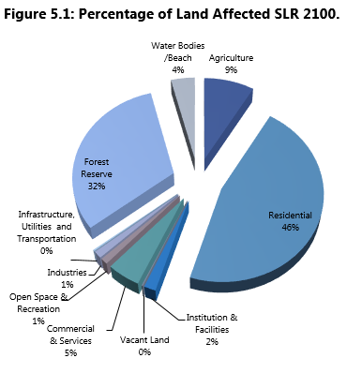
Recent Publications (minimum 5)
- Bates, BC, ZW Kundzewicz, S Wu and JP Palutikof, Eds., (2008) Climate change and water. Technical Paper of the International Panel on Climate Change, IPCC Secretariat, Geneva, 210p.
- IPCC (2012) Managing the risks of extreme events and disasters to advance climate change adaptation. A special report of Working Groups I and II of the Intergovernmental Panel on Climate Change [Field, CB, V Barros, TF Stocker, D Qin, DJ Dokken, KL Ebi, MD Mastrandrea, KJ Mach, G-K Platter, SK Allen, M Tignor, and PM Midgley (eds.)] Cambridge University Press, Cambridge, UK, and New York, NY, USA, 582p.
- NAHRIM (2010) The study of the impact of climate change on sea level rise in Malaysia. National Hydraulic Research Institute of Malaysia. 172p.
- Ercan A, Kavvas ML, Mohamad MF (2011) Sea level changes along the Peninsular Malaysia and Sabah and Sarawak coastlines for the 21st century. World Environmental and Water Resources Congress 2011: Bearing Knowledge for Sustainability ASCE 2011: 1292-1297.
- NAHRIM (2015) The study of impact of sea level rise to the planning and development of National Coastal Zones – case study: Part of Manjung District, Perak Darul Ridzuan). Draf Final Report. 78p.

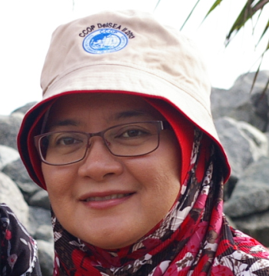Biography (150 word limit)
Nor Aslinda Awang is currently working as a Senior Researcher attached with the Research Centre for Coastal and Oceanography, National Hydraulic Research Institute of Malaysia (NAHRIM). Over the past 16 years, she has worked on hydrodynamic modeling for mangrove replanting, coastal erosion and impacts of sea level rise in Malaysia. She graduated in Civil Engineering from MARA University of Technology Malaysia, then pursued her studies in The University of Waikato, New Zealand where she earned her MSc. in Earth Sciences.
Email: aslinda@nahrim.gov.my
Contact number: +6 03 89476443

Notes/Comments:

