COMPARATIVE STUDY OF THE MANAGEMENT OF KIVUCIAN LACUSTRINE COAST, CASE OF THE CITY OF GOMA (DRC) AND GISENYI (RWANDA)

KAMBALE KAVYAVU. W
Department of Earth Sciences, Kasugho University of Nature Conservation and Development, DRC
wisdomkambale@gmail.com
KAMBALE SIMISI. B
Researcher Geologist, Order of Congolese Geologist, North Kivu section / DRC

Abstract
To achieve the objectives of this writing, the documentary reading related to the subject, accompanied of an analysis of Photographs and resorts to the map library. The field trips accompanied these foreplay as an illustration. Coastal sites are public areas whose management is worthwhile for the well being of the used population. Social development makes lead necessary to consider the development of cultural sites for leisure and other beautiful moments.
Thus, for Lake Kivu, in it’s Northern part, bays justify the existence of beaches in the suitable areas for games. The establishment and development of beaches for common gains; Gisenyi has the public beach and private ones whose management are due to hotels located at lake borders; in Goma, only the hotels dispose of beaches, situation which deprives the natives of these landscapes.
The installation of harbor agencies uses not only the geological conditions but the orientation of the trade winds and other currents too. Now days, for these two cities, only Goma’s is recognized and helped by artisanal sites.
In building of a city, urbanism must categorize spaces in order to classify and assign them to uses according to their geographical location and their bearing.
The management of garbage and wastewater is a parameter limiting the eutrophization of lake and marine areas.
The edges of Goma are lined with buildings invading the waters opposite Gisenyi. Thus, for these two cities the human activity against the lakesides is seen with more ambler, deteriorating the natural aesthetics of the landscape.
Key words: Lake, Berthing, Rock, bay
CO₂: carbon dioxide, Ca: Calcium; Fig: Figure; Km: Kilometer, Mg: Magnesium, m: Metter, N°: Number, Na: Sodium

Introduction
The Lake Kivu is, in natural beauty terms, one of the joyous sites of the great African lakes. It4s green banks with sharply jagged contours carry a volcanic Lithology which stakes the northern flank. Within this vast expanse of bluish water is a volcano-metamorphic mega-island, the island of Idjwi, the largest of the African lakes island. A transboundary lake found in an active volcanic zone whose area is estimated at about 2400 km²; with a maximum depth of 485m and a total water volume of about 500Km³ of water under the collapse pit as shown in Fig 1.
The Lake Kivu is located at 2° latitude and 29°East longitude Greenwich at 1465 m of elevation. It has an area of ​​2,300 km², not including some 300 km² of islands. From Bukavu town in the south to Sake Bay in the north, at the bottom of the Kabuno Gulf, the GPS recognizes a distance of 106 km longer; East-West, the largest width, across the Mushao, reaches 45 km. The area of ​​the lake's catchment area is about 7,300 km², including 2,600 km² for the lake and the archipels , 1.700 km² on the eastern slope of the Kivu Massif, and 3,000 km on the western side of the Rwanda plateau. For a long time, the Lake has been attributed considerable depths, of the order of 2,000 m and more. Systematic surveys, carried out from April 1935 to February 1936 by Damas, thanks to subsidies granted by the Institute of National Parks of the Belgian Congo and the National Fund for Scientific Research, have given, on 208 measures no postulate higher than 478 m that we can estimate 500 m. These soundings have shown that the bottom of the lake clearly shows the relief of an old valley whose slope decreases progressively from South to North, while at the same time the depths reach however to the present day, the lacustrine regression is seen by abandoning carbonates concentrations on banks, due to the amount of salts (Na, Ca, Mg) in this lake, which proves the activism of African rift. Photograph N ° 2.b
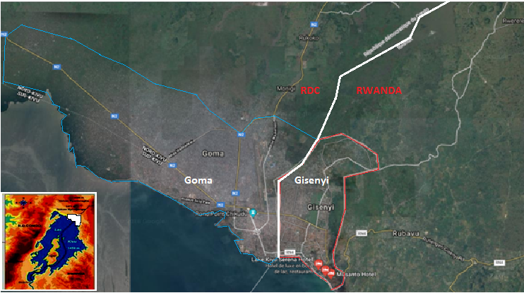
Fig N°1. Localization of study place

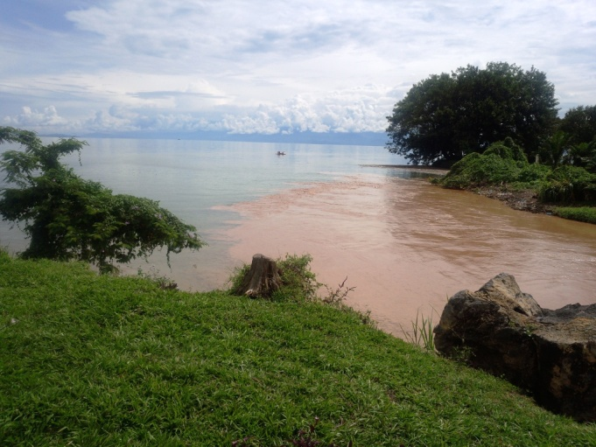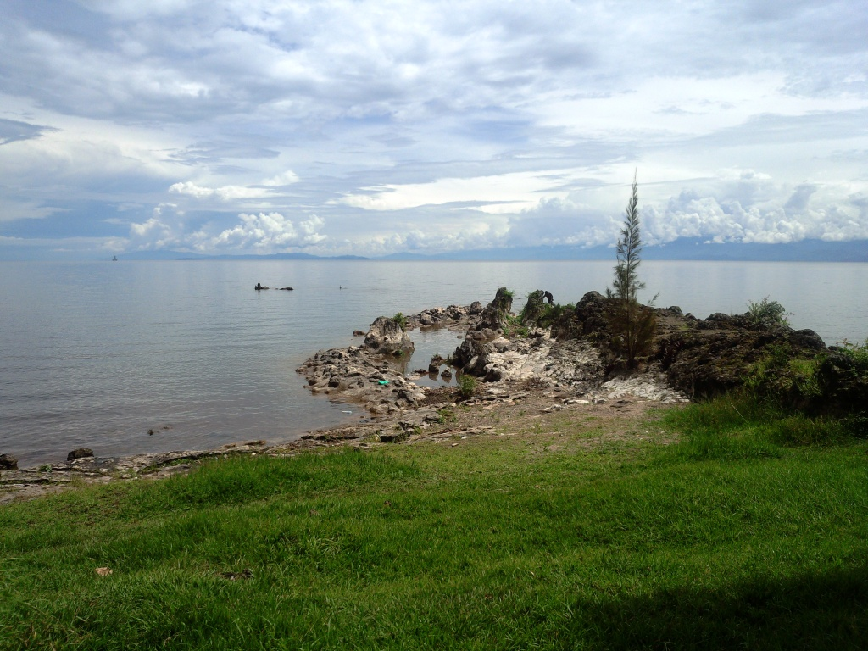
Photograph N ° 2: a, Estuary of the Sebeya River; b, effervescent encrustation and lake regression in Gisenyi
The topographical basin of this lake is demographically occupied on the Congolese side by the Hunde, Shi peoples, whereas the city of Goma, tourist has almost all the tribes of the country; the Hutu, Tutsi for the Rwandan side mixed with the other people the city of Gisenyi; we can see the presence of Bahavu, hybrids of Rwandans and Congolese abandoned on Idjwi island. The development of both lake and ocean and/or marine coastlines are generally areas likely to have a high biological and / or landscape interest; to be fragile and/or threatened and thus to be preserved; to be subject to protection and management measures; to be places of discovery of natural wealth. Does Africa as a whole and the cities of Goma and Gisenyi respect this claim?
It is true that Belgian urban planning had recognized a spatial occupation of the Congolese cities in past time; this is reflected in the recognition of geological topographical asperities in the assignment of sites to activities. For some cities, post, the galloping population mixed with the rural exodus resulting from the insecurity of the surrounding areas, the occupations of the zones at risk (unstable, marshy, floodable, beaches, gassed,...) is donable now days.
For some places, it also had the advantages of determining the thresholds of the spatial occupation of the city of Bukavu to 10,000 habitants, prohibiting subdivisions with plots of 1500m² (30m X 50m); to impose the land-use ratio and to control the rural exodus.
Geological appearance
East Africa was the scene of many of orogenic and tectonic phases during the Cenozoic. The tectonics had the effect of raising the horsts on one side and lowering the rifts on the other side. The African rift occurs from Mozambique to the Red Sea via Malawi and African Great Lakes and belongs to a network of two branches. Thus there is the eastern rift and the western one all of preferential direction NNE-SSW inside which are observed faults.
The cities of Goma and Gisenyi, major cities bordering the Northern tip of Lake Kivu are demographic units developing at the foot of the flanks of Virunga volcanic chain (Nyiragongo-Karisimbi).
This volcanic dam has a dozen of craters and cones of variable dirnenssion. Nowadays, the most majestic are Nyiragongo 4057m and Nyamulagira 3.056 m, all at the North of the lake. We also quote Mikeno, 4.437 m; Karisinibi 4.507m; Visoke 3.711m; Sabinio 3.634 m, Gahinga, 3.474 m and Muhavura. Bordered by a volcanic chain that surrounds it, the lake clearly evokes the idea of ​​a vast flood from which emerge a hundred or so summits turned into islands; the valleys of the ancient tributaries have formed bays, sometimes congested by desolations, being only an overlapping bench of lava. These cities are undoubtedly carriers of a basaltic lithology resting on a metamorphosed background except in Gisenyi where some pegmatitic points are seen in the city center and the hills overlooking the east.
The harbor and beaches of these cities are coasted with basaltic pebbles except in the Rwandan where the unique Quartzitic sand beach meets. Photograph 7b
Certainly, the lava of these cities are different according to their mineralogical composition, and size of origin. In Goma, Tholeïtic basalts while to more of these, Gisenyi carries proxemic and/or olivinic basalts in almonds, Photograph 3, cd. As on all the coasts of the lake, carbonated formations of chemical origin deprived of the traces of the life, resulting from the lacustrine transgression of which the Photograph 2b, 3, ab
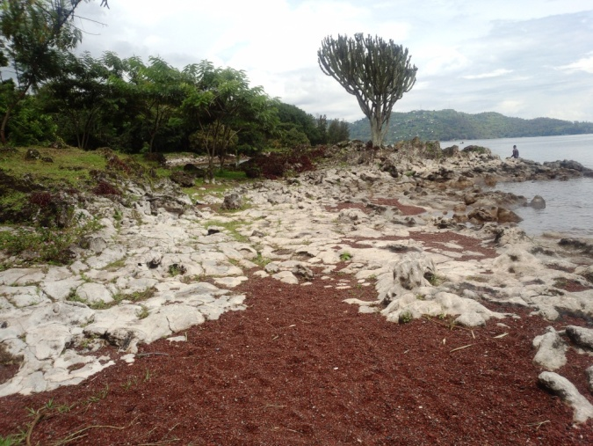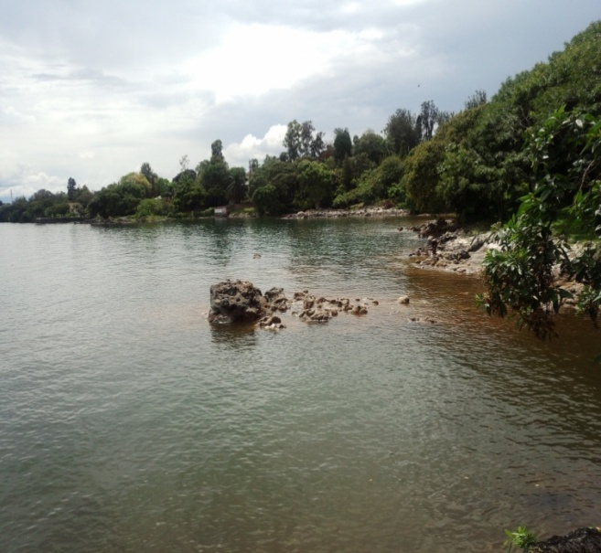
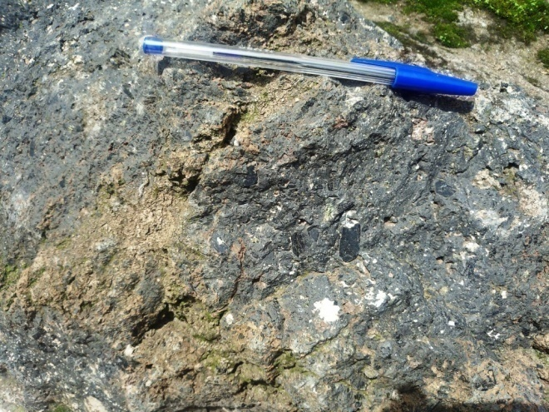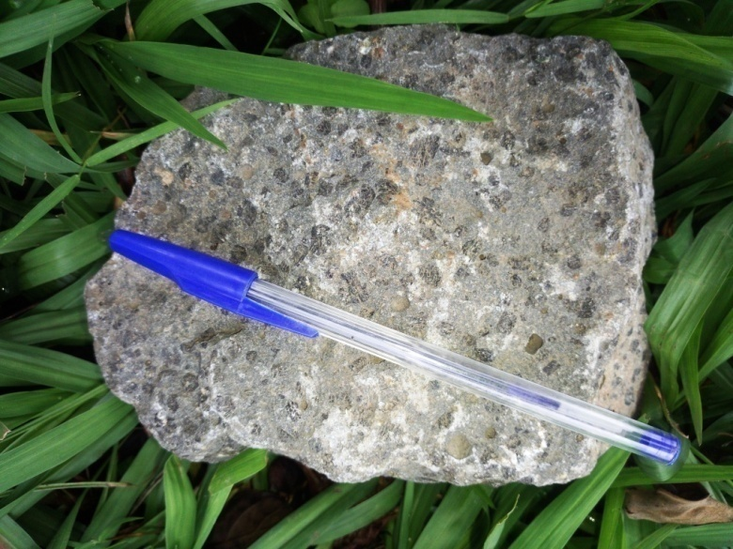
Photograph 3. Lithology of Kivucian coastlines, a, b, carbonate aggregation; c, outcrop of basalt ss STTIP Hotel; d, basanitic porphyry Basalt sample
THE MANAGEMENT OF KIVUCIAN LACUSTRINES COASTS
I have just traveled the shores of Kivu Lake from Don Bosco Lake to Bralirwa, passing through an asphalt road at 20m near the lake, I don’t see the lake at the Congolese side because the homes compounds go into the lake.
"When users allow themselves to throw rubbish on the beach or in the sea it’s not only a matter of not respecting the environment, but it also shows that this blameworthy behavior first takes root in their neighborhoods and ends with anchor then whatever the environment around usʺ. As mentioned in the text, the absence of the hydrographic network in the study environment leads to the population bending to the water bowl, Lake Kivu, yet so much soiled water, detritus on one side and the Gas from another! As elsewhere in the DRC, lake sides are bathing and laundry sites to leave dishes for some users.
On the initiative of the DATAR, the law of July 10, 1975 creates a public institution of the State to administrative nature: the Conservatory of Coastal Areas and Lake Shores, with the initial mission of carrying out, in the coastal cantons and the municipalities bordering lakes of more than 1,000 hectares, a land policy to safeguard the coastal area, respect for natural sites and the ecological balance, after consulting the municipal councils concerned.
Under certain conditions, during the occupation of the banks, three meters wide are taken as pedestrian way, so only obstacles such as military installations, harbors, naturally fragile areas ... can in principle be excluded. Some laws recommend preserving the rare and sensitive spaces, to manage the consumption of space, to open up the shoreline wider to the public and to prioritize activities whose development is linked to the sea.
Harbor
On Lake Kivu, the existence of such works began in the colonial period; the construction of a harbor around Kisenyi (Gisenyi) is motivated by the need to serve the north coast of the lake. The commander of the Navy Apel, consulted in January 1931 about the location of such a harbor, expressed the opinion that, from Gisenyi, in a westerly direction, the shores of the lake do not present until Keshero (current Kituku) no favorable place for the establishment of a natural harbor. That is why he advocated the maintenance of Keshero, where C.N.Ki. had already, since March 1930, studied and produced a provisional work. These facilities were joined to Goma post by a 7.8 km car track.
Goma Bay, located less than 2km from the post, was recognized as providing better natural shelter than Keshero. Located off the prevailing winds of the South and Southeast by the Cape of the Orteil (Mount Goma) Photograph 5. That’s why the shoreline of azimuth SW-NE of the bay will carry a naturally stable berthing work. Like us, already in 1931, the Commander Appel notes a disadvantage, not to lend to the extensions following the steep slopes and especially the geology of the site. At that time, the traffic was stable due to the demographics of the time, a more dignified thing nowadays where houses look like tunnels and burrows down cornice, Photograph, and pen plain facing, on the west side of the Harbar. See a nursery Chantiliers in the 10 m around, Photograph 12d.
The Lake serves as a mean of communication between the towns and villages bordering, the city of Bukavu being situated between the waters and the park of Kahi-Bièga, threatened by the natural disasters whose mass movement, recourse to Goma to refuel in live and construction materials. The state of unpaved Congolese roads pushes Lake Kivu to be the best way between its border entities. To the north, the lake has a single Harbar, Goma for multiple use whose management is statewide. In addition to this harbor of large boats on the waters of Kivu, we recognize the small installation Kituku whose rehabilitation is recognized at BRALIMA connecting the agglomerations of Idjwi Island and Kalehe territory whose bottom doesn’t allow the berthing of boats. On this site it’s known to see small boatsfor the repatriation of products of the host company, Photograph 4a, and artisanal boats (made of wood) being a walk of agricultural products from the feeder areas of Goma, the health attested by mounds of biological debris. In addition, serving slaughter goats, the appearance of pigsty doesn’t escape this place, imagine what junk would accompany this detail!
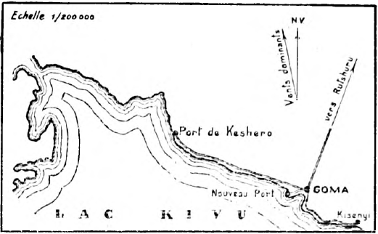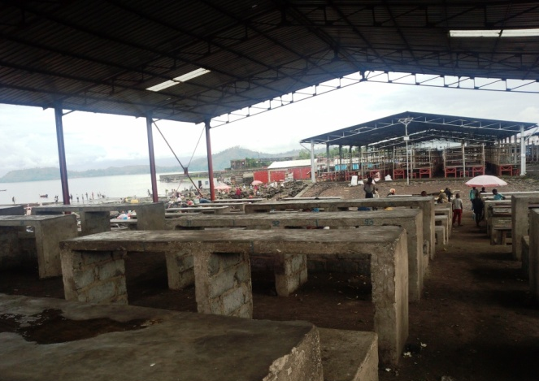
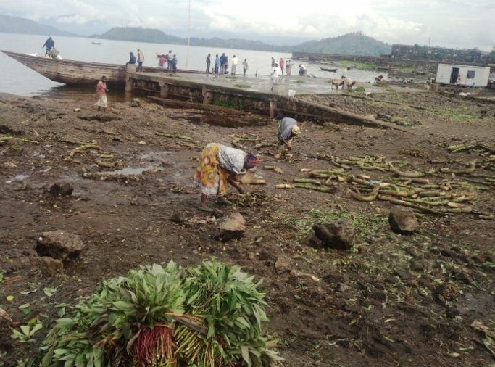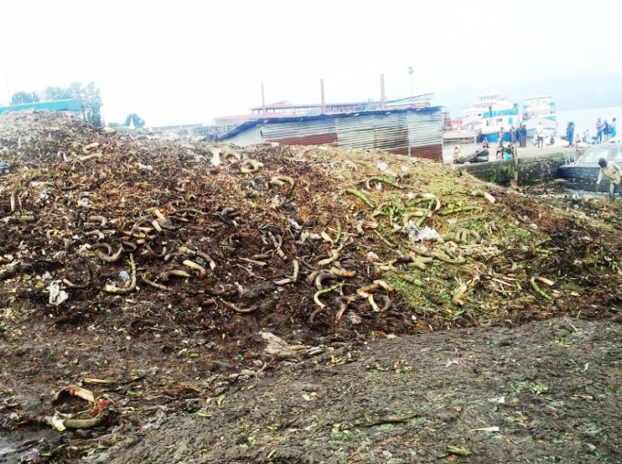
Photograph 4. Public site respectively. a, former harbor of Kyeshero; b, Market of Kituku; c,d, Kituku's healthiness
During the colonial period, before 1938, Sake (27k m from Goma) was a docking along with Goma, the propulsion of fluid volcanism offers nowadays this entity an impassable navigation.
The sanitary and hygienic states of these sites do not give hope of life, except at the harbar, where some agencies are thinking of building its premises as hangars. The most vulnerable case and the rain that pushes mixing and the passenger and his companion to shelter on the edge of big boats, the overweight caused a dive of the work which no sounding and the trace remains invisible, leaving the city under a funeral atmosphere. The local traffic resorts (Village to villages) to the Boats (artisanal ship) as say the natives, on all the lake, it is necessary to indicate therefore the necessity that sophistic harbor facilities are arranged by the government to the other interested.
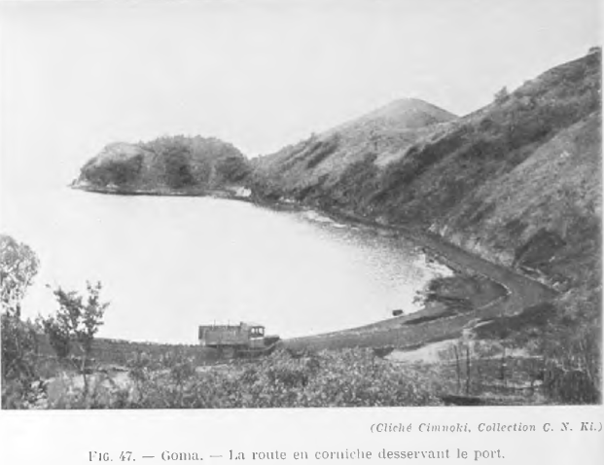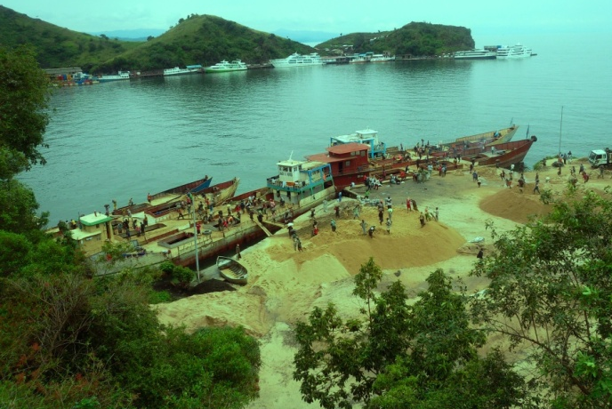
Photograph N °5. harbor of Goma, left shot of 1930, on the right the picture 88 years later

While demographics are galloping, the space remains motionless and is the target of pressure for urban works. The city of Goma placing it’s buildings by extracting phreatomagmatic lapilli on all the cones as at the feet of Mount Goma, something that disrupts the dimensions of the bays, Photograph 6. The car traffic being corollary of the popular one, the track harbar-city is seen enlarged accordingly because the use of heavy machinery roll this ledge while it’s pace is agricultural service on land unlaid. The absence of public buildings welcoming people during the fallout is a defect on these sites.
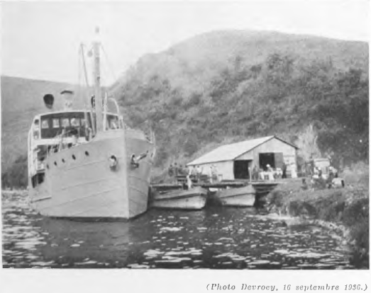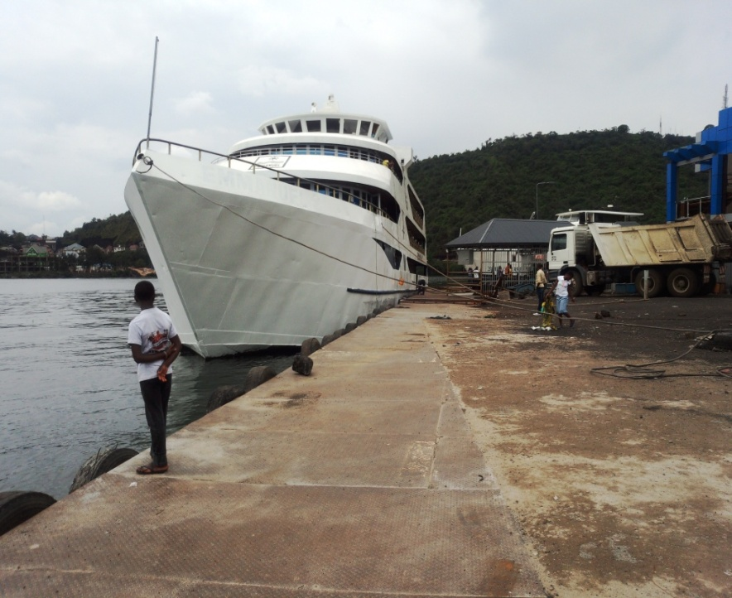
Photograph N°6. Boat at the harbor of Goma, auche in 1938 and right in 2018
Beaches
Lake Kivu, like any other marine, fluvial and/or lacustrine unit, consists of generally flat areas, whether discovered or not, whose lithological nature bears witness to the mineral debris and pebbles of the nourishing areas.
Management and development of lake areas is a necessity of the government. While the colonial history recognizes a beach in Gisenyi, nothing seen in Goma, it is only in 2017 that was inaugurated the beach o named plage du peuple by the urban authority, Photograph 8. This entity remains beaten on a basaltic bottom with a steep slope that does not allow rest and swimming, that's why the beach of Rwanda, pegmatic sand, Photograph 7b; Bonus for the users of these two cities.
For the Rwandan coast, the city of Gisenyi has "Kivu Beach", a tourist site in the region receiving urban ceremonies (local) and even the district of Rubavu. That being the case, the young Gomatracians don’t stop there for their birthdays.
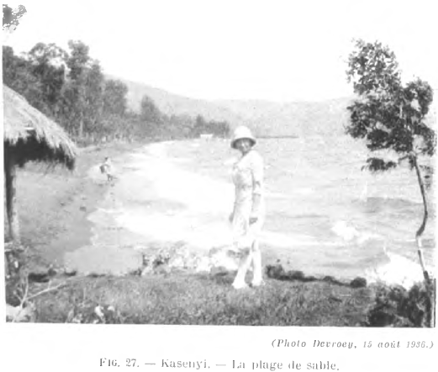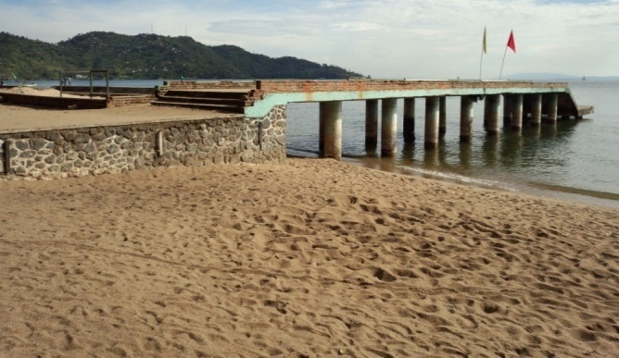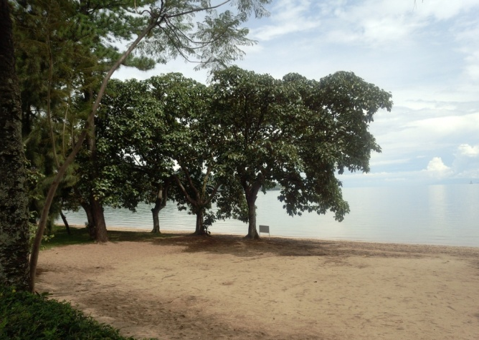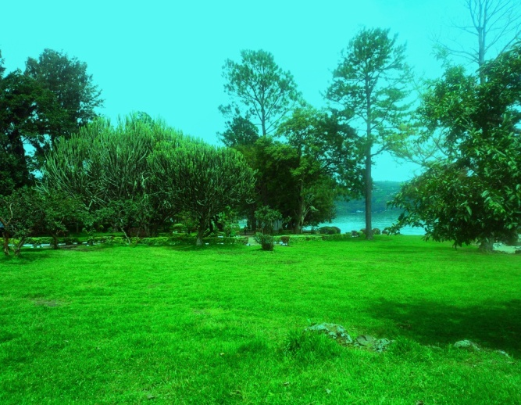
Photograph N°7. Comparative view of Kivu Beach in Gisenyi in 1938, colonial and contemporary, 2018

In terms of the environment, Gisenyi beach is a home to exotic plants dotted in a green lawn; whatever the flood of the Karisimbi flow over the city and even the lake coast, Gisenyi Bay enjoys a pegmatitic sand, the correction of which is made by adding in volcanic outcrops. Here and there, it is known to recognize in centripetal evolution effervescent lithological elevations. What characterizes the spacing of African rifting, Photograph 8.1.
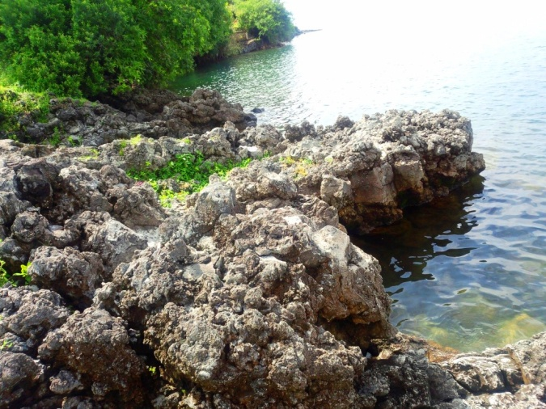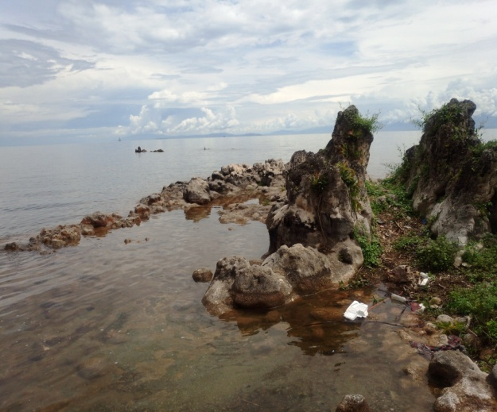
Photograph N ° 8.1 Lithology of Kivucian embankments, basaltic flow and bank cracking on a sloping slope attesting to rifting
Goma has a public site known as the beach of the people located on the Boulevard Eujeune SEREFULI, eyeing on the Photograph 8, we want to know, is it a car wash or a well site or a laundry! The presence of a pool at the beach, phytological ornamental rarity is a point that doubts this area.
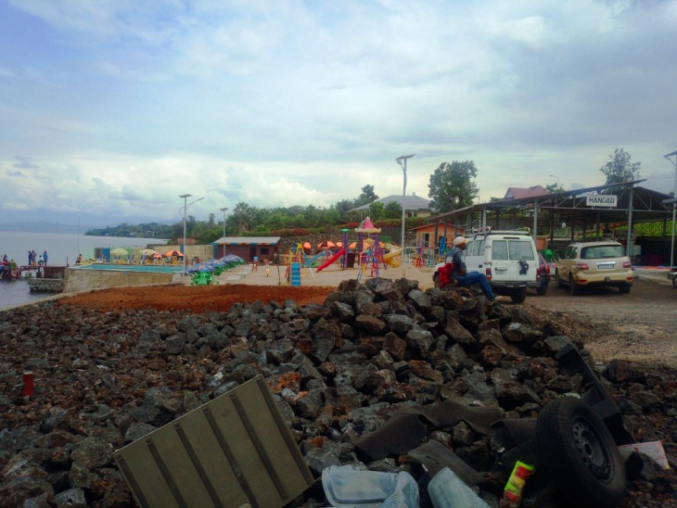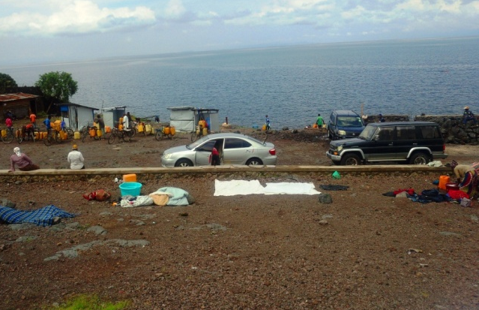
Photograph N°8. Beach of the people in the Himbi district
Public landfills
Belonging to the exoretic networks, a receptacle medium on the slopes, the Kivu Lake is a dumping ground for garbage, sewage and dripping water and hence for carrying materials. In some municipalities, lakes or fluviatil, the canals and/or drains of runoff and the beds of slopes are directly connected to the lakes either by a channel, an estuary; or by an offshoot, the Delta. In the case of Kivu Lake and especially for the cities of Goma and Gisenyi, being volcanic, the rivers remain invisible except in Gisenyi where the river sebeya,on pegmatitic bed pouring it’s water into the lake. The latter, starting from the deferential hydrochemistry of the lake, would be the source of Ruzizi taken as spillway of the lake towards the south in connection with Tanganyika. The edges of the lake is enriched with plastic waste, more on the Congolese side where non-biodegradable packaging is seen running, Photograph 9
In this part of the text, it should be pointed out that the septic tanks of the sanitary installations of these cities are in direct communication or not with the lake, this is justified by the geological carpet, volcanic of basalt whose permeability is too large led to a free circulation of substances even in the physical state. Thus, around 85% of these facilities reach the lake, yet a single source of more edible water in the Congolese city. In the city center, the commercial part of Goma, biodegradable and non-degradable packaging floating in the event of runoff to the downstream point (lake) is seen, while the collective or individual settling plants remain invisible throughout the city, Photograph 9.
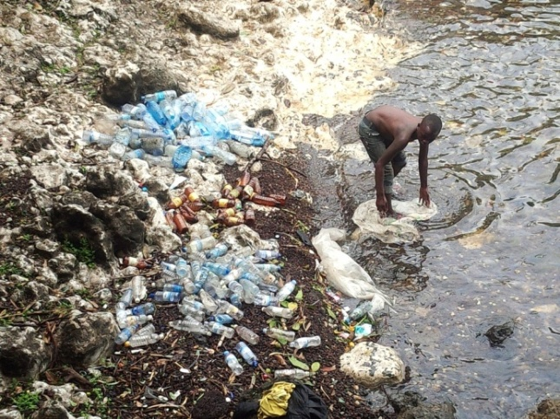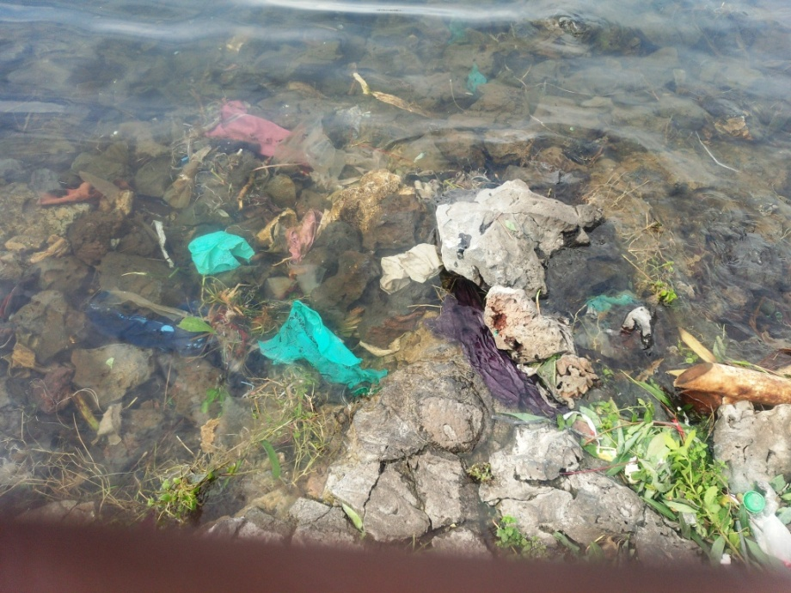
Photograph N°9. Plastic waste neglected by flood regressions respectively under STTIP Hotel and Kituku Market
Urbanism facing the Kivucian coast
The mind of the homo sapiens led them to lead a sedentary life which made a key development of certain techniques including the assembly of status, access track, clothing, logies, fire, it was a debit from a society.
On the planet there is an inequality in the demographic distribution in the countries, it is the same in Africa. This inequality may be due to the geomorphology of the entities, the plains being more inhabited to the detriment of the highlights, anhydrous. In the chain of Mitumba, of which Central Africa is a case in point, the existence of Virunga volcanic chains; as in Italy around Etna, Vessive concentrates an immense population. The establishment of the cities of Goma and Gisenyi at the foot of a series of volcanoes including Nyiragongo and Karisimbi in perpetual activity does not scare anyone.
The recognized fertility of soil profiles of volcanic environments is a basic element for density around volcanoes. As in a family, the increase of staff is accompanied by a variation of needs, the more the numbers of the cities of Goma-Gisenyi swell, the space is under threat from where deterioration of the recreational, cultural zones. Urbanism in African countries and cities is ceaselessly known as a developing country. Certainly, the vanity of the social classes within a population is seen in the occupation of the inhabitable areas. For the coastal cities, soles of lake edge, river, and sea belong to richs and build skyscrapers. Not with standing, regardless of standards, motivated pride that the financial body manages the company. The prefeasibility study and recognition of the territory is worth to develop a city. Thus the unoccupied areas are rigorously (slopes, shearing, flooding, subsidence, high voltage,...) taken into account. In the case of this study, Gisenyi evolves according to a cartography recognizing green spaces in a city. The lake is green because the lake banks are colonized by some man-made vegetation, Photograph 10a. For the policy of the management of the ratings succeeds in the city of Gisenyi, the Government considers to erect the road along the lake leaving 10 to 20 for public use, generally in this area no building is seen except a few hotels that take advantage of erecting mini so called private beaches. Except STTIP Hotel which fraud by erecting the foundation in the same waters, Photograph 10b.
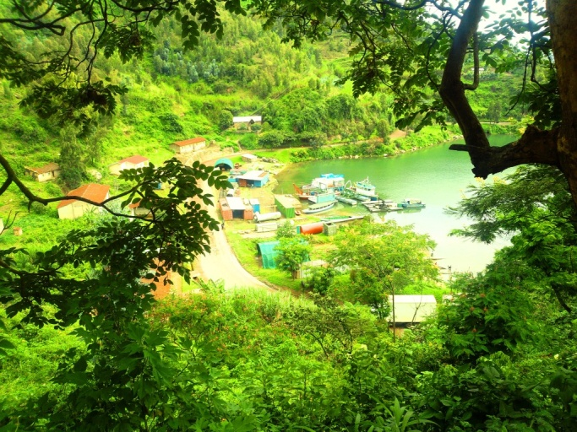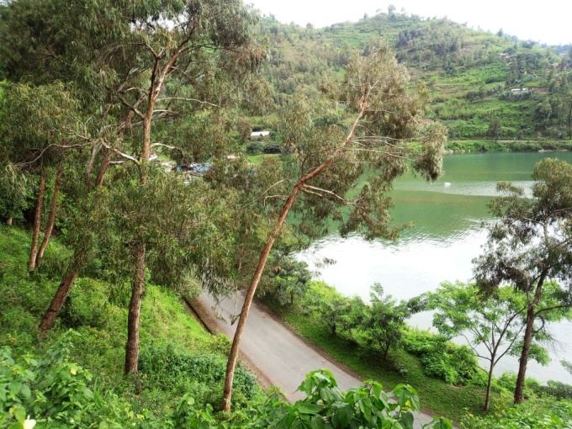
Photograph N°10. Green water. a, hydro electrical central at 1km from the beach; b, border road going to the ancient BRALIRWA.
The shameful case is that French-speaking city, Goma is characterized by the pride of which the judicial and executive system can’t control. Thus private logies have the tandem to push even the waters of the lake to enlarge their plots they don’t buy at the price of peanut. As are sites of luxury in a city, these parcels are allocated more by organizations of international renown. The shifting case is the location of machine rooms at the lake banks by some hotels, (Photograph 11b)
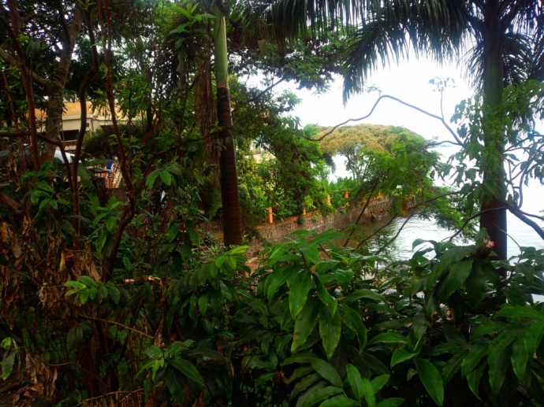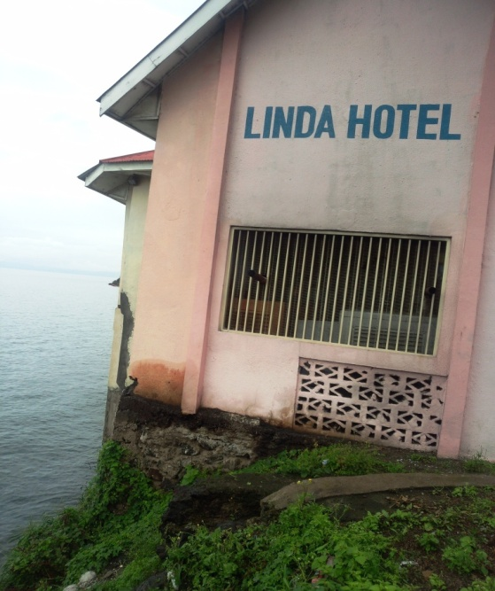
Photograph 11. Hotels erecting their premises in plain lake, a, STTIP in Gisenyi; b, Linda in Goma
Even today, we can see construction sites without a garden, not to mention parking along the lake. In some case we observe spaces like wooded savannas because the buildings escape gas zones and bottom rich in Mazuku (CO₂).
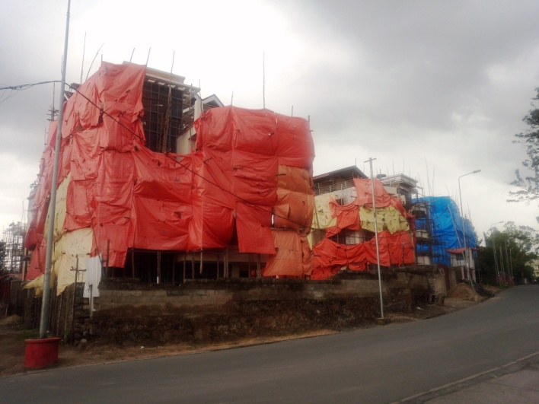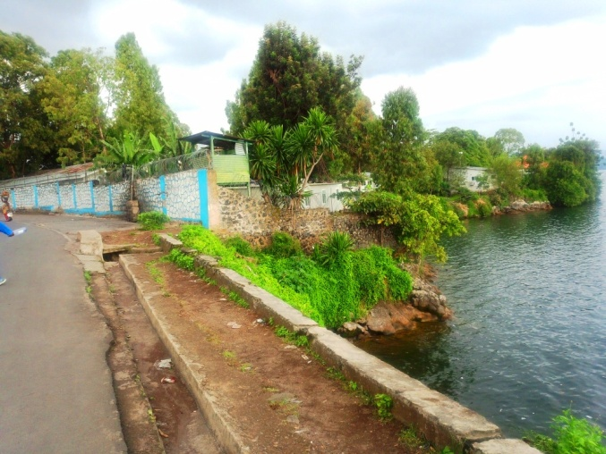
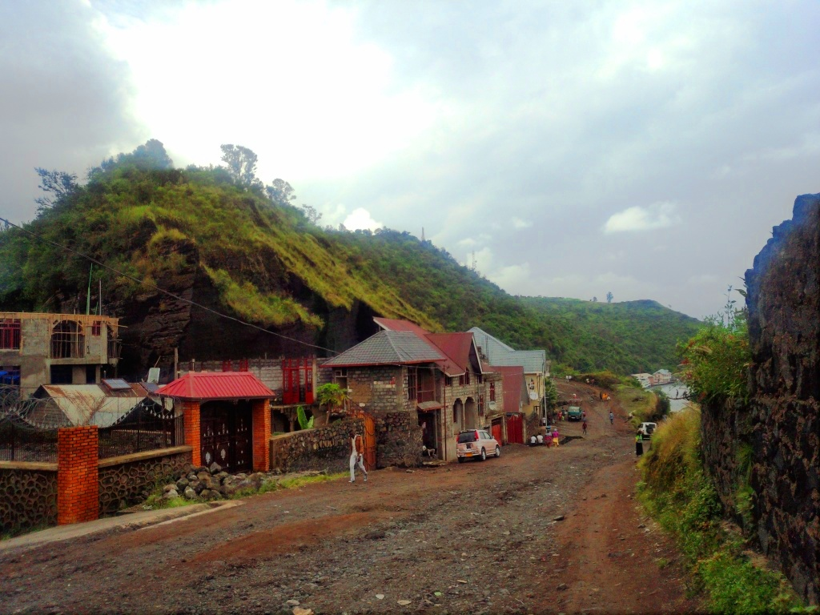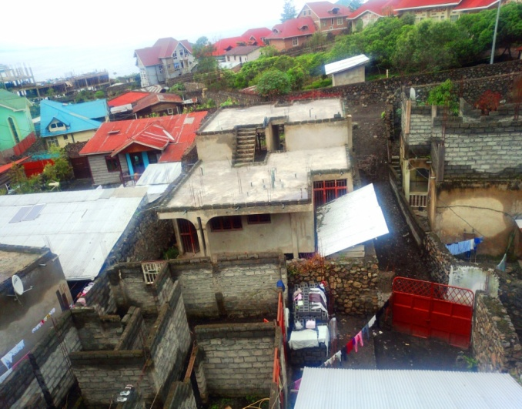
Photograph N°12. Implantation of buildings on Gomatracian sides. a, buildings facing the parcel separated by the road; b, UN base perched at the between VIP Palace and Linda Hotel
The worrying question is based on the notion of lift, is it calculated before building because even some pillars are under lacustrine to supharbar foundations of the douwlings, still others would rest on Pillow lava, Photograph 13a. Dykes are designed to save space on the banks for public or private use, Photograph 13b.c. In some cases where access to the lake is possible, the streets lined with fences go straight to the water, Photograph 13b.c. For other avenues, they’re finished in closing yet so much desired for the nap, childish drownings is a case that causes certain barriers, Photograph 13d.
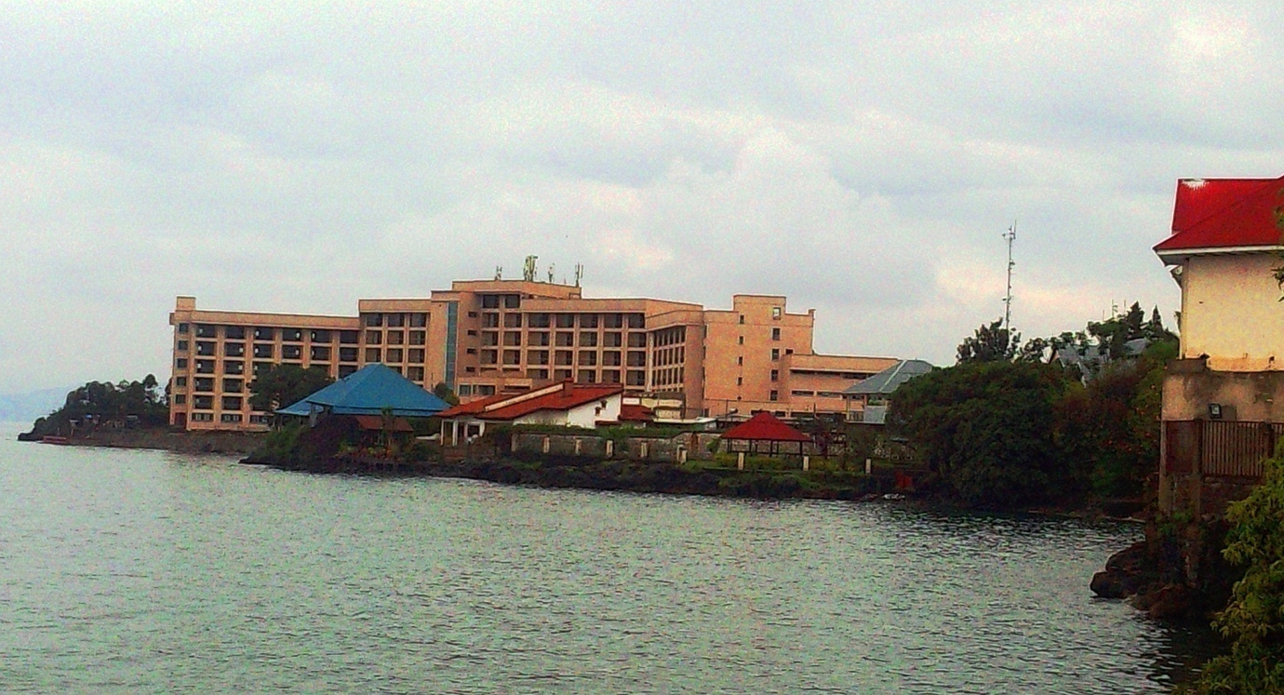
Lac kivu
Ihusi 2 Hotel
LINDA HOTEL
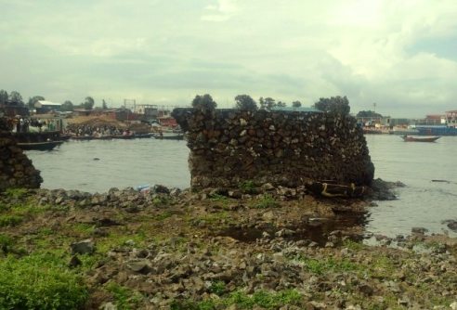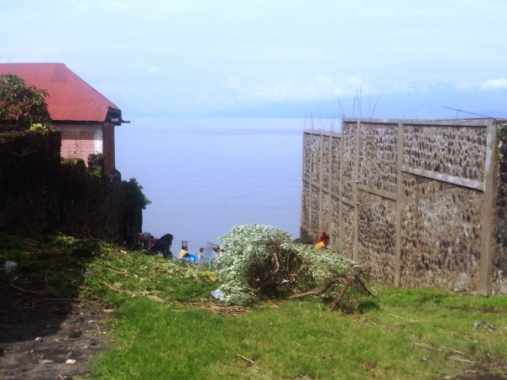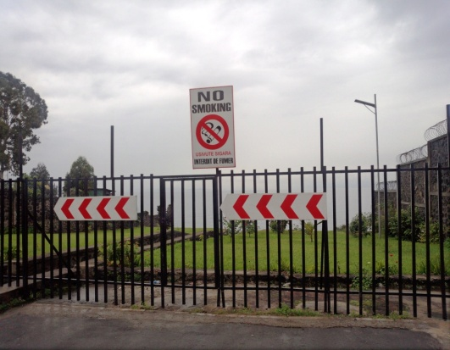
Photograph 13. Shipbuilding. a, Ihusi 2 Hotel and Linda Hotel; b, dike at Kituku's walk; c, d, streets ending at the lake with or without access behind UN base in Kituku and BDGL
Let's say a word on the ledge going to Goma Harbar, a track whose walls are vertical and even exceed the max, yet the Lithology of the slopes is plain decarbonation because exposed to the weather.
The structural case is comprehensive on the northern flanks of the Harbar, for the southern and southeastern termination of the penicillum breaking down the azilized, there are mega compartments of shredded pozzolana, Photograph 14. fracture networks is a dangerous on this facility as said far into the text, the enlargement is not possible but the assassin engineering exhibits the people under this slip.
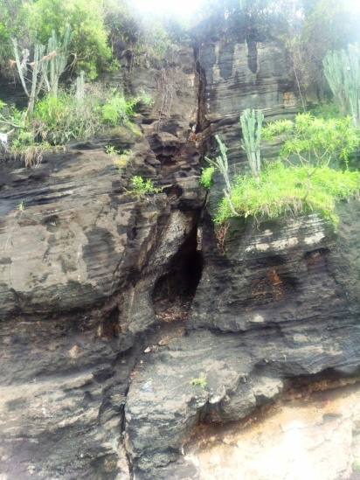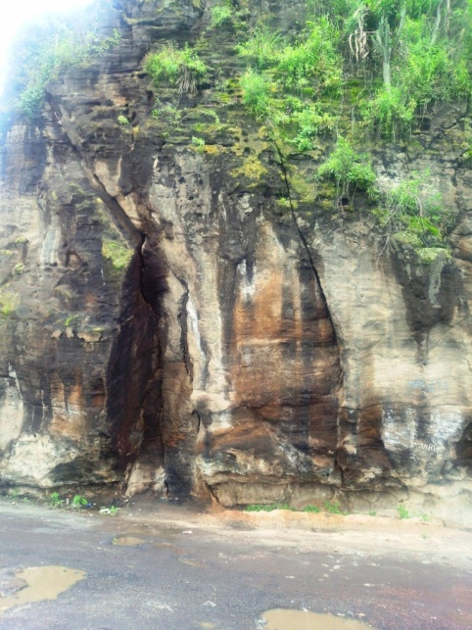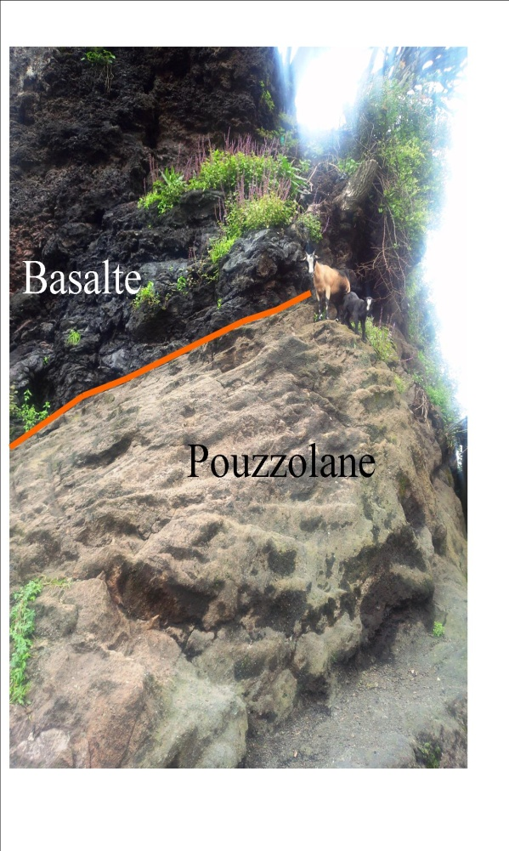
Photograph N°14. Lithology of the harbor of Goma, respectively the cracking of Pouzzolanes, cliff plane of weakness between basalt and pozzolana at the end of azimuth SW-NE of the harbar
Regarding to Photograph 15, the Kivu lakesides show a vegetarian in Rwanda and buildings in the DRC, everything starts even at the barrier, built on two sides by the same company under the same financing, the difference in the location of the premises.
Costama
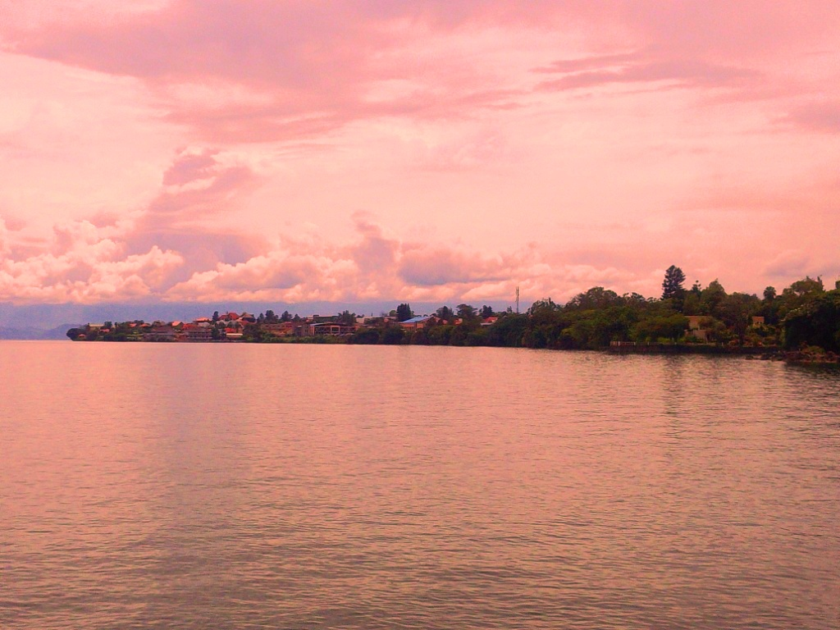
Photograph 15. Differential management of Kivucian banks, Goma NW and Gisenyi SE
Conclusion
The privation of public rights in the states is seen not only in judicial domain, defense and commercial sectors. It’s necessary from this study that even the urban cadastral system is a victim. Would like to accuse colonialism policy to linguistic belonging (Commonwealth-francophone) !! It has just been recognized in this text that the management of the Kivucian coast differs according to the country and here. We see that the waters of Lake Kivu are green in Rwanda (Gisenyi) compared to Congo (Goma). The occupation of the Rwandan banks respects the 10m uninhabitable. The project to make the country green is seen through anthropogenic plantations, the Congolese coast is disturbed by the usurpation and disruption of the public border area, buildings and some routes affect the water. While we say to sing to the managers of Gisenyi, the effort and conciliation of the population and executive apparatus of the DRC in general and the authorities of the city of Goma are to raise for the good management of the areas in the agglomerations. For entities under construction, the cadastre and land management department must proceed with a geotechnical analysis. He returns to the border plots in the city of Goma to think of the arbistes with the banks. Leaders might make a view about public place management.
Bibliographical references
DEVROEY E. et VANDER LINDEN R., 1939, le Lac Kivu, institut Rayal colonial Belge Mémoire présenté à la séance du 31 mars.
KAVYAVU.K.W, 2016 La caractérisation de la déformation des formations Géologiques de Bweshu et Kishumbu d’Idjwi (Kibarien) Sud -Kivu, R.D.Congo, in conservation et société N°008, pp 204-2014
NAMEGABE, J.K et al, 2015Les dix mètres de rive du Lac Kivu à Bukavu, une catastrophe environnementale dans l’avenir, in ISSN 2351-8014 Vol. 14 Nº2, pp. 244-251
Gabonews du 24 Avril 2008

List of Figure
Fig N°1. Localisation of study place
Photograph N ° 2: a, Estuary of the Sebeya River; b, effervescent encrustation and lake regression in Gisenyi
Photograph N°3. Lithology of Kivucian coastlines, a, b, carbonate aggregation; c, outcrop of basalt ss STTIP Hotel; d, basanitic porphyry Basalt sample
Photograph N°4. Public site respectively. a, former harbor of Kyeshero; b, Market of Kituku; c,d, Kituku's healthiness
Photograph N °5. harbor of Goma, left shot of 1930, on the right the picture 88 years later
Photograph N°6. Boat at the harbor of Goma, auche in 1938 and right in 2018
Photograph N°7. Comparative view of Kivu Beach in Gisenyi in 1938, colonial and contemporary, 2018
Photograph N ° 8.1 Lithology of Kivucian embankments, basaltic flow and bank cracking on a sloping slope attesting to rifting
Photograph N°9. Plastic waste neglected by flood regressions respectively under STTIP Hotel and Kituku Market
Photograph N°10. Green water. a, hydro electrical central at 1km from the beach; b, border road going to the ancient BRALIRWA
Photograph 11. Hotels erecting their premises in plain lake, a, STTIP in Gisenyi; b, Linda in Goma
Photograph N°12. Implantation of buildings on Gomatracian sides. a, buildings facing the parcel separated by the road; b, UN base perched at the between VIP Palace and Linda Hotel
Photograph 13. Shipbuilding. a, Ihusi 2 Hotel and Linda Hotel; b, dike at Kituku's walk; c, d, streets ending at the lake with or without access behind UN base in Kituku and BDGL
Photograph N°14. Lithology of the harbor of Goma, respectively the cracking of Pouzzolanes, cliff plane of weakness between basalt and pozzolana at the end of azimuth SW-NE of the harbar
Photograph N°15. Differential management of Kivucian banks, Goma NW and Gisenyi SE

DEVROEY E. et VANDER LINDEN R., 1939, le Lac Kivu, institut Rayal colonial Belge Mémoire présenté à la séance du 31 mars.
Joseph KIZA NAMEGABE et al, Les dix mètres de rive du Lac Kivu à Bukavu, une catastrophe environnementale dans l’avenir, in ISSN 2351-8014 Vol. 14 No. 2 Apr. 2015, pp. 244-251
KAVYAVU.K.W, La caractérisation de la déformation des formations Géologiques de Bweshu et Kishumbu d’Idjwi (Kibarien) Sud -Kivu, R.D.Congo, in conservation et société N°008, 2016 pp 204-2014
Gabonews du 24 Avril 2008

