PRESENTATION ON :

“In India, misconceptions about mental illness are pervasive, and a substantial number of patients suffering from severe mental disorders seek non-professional care . 80% of the population still depends on indigenous treatments consisting of religious treatments , prayers, fasting, as also various witchcrafts and magical rituals.”

NAME

RAMESH KUMAR THUKRAL, INDIA

ABSTRACT

In India, misconceptions about mental illness are pervasive, and the lack of understanding can have serious consequences for millions of people who have psychiatric illness (mental illness), according to the National Alliance for Research on Schizophrenia and Depression (NARSAD).
In our country, the main culprit that is influencing people’s attitudes toward mental illness is the stigma associated with mental disorders, which is rooted deep in the cultural beliefs and myths about mental disorders and that result in people avoiding association with individuals who suffer from
cure his/her sexual frustration or problem and thereby cure his/her mental illness. The stigmatization of individuals who are going through psychological distress creates hurdles for people from seeking mental health care; as a result, they may tend to seek help from traditional healers. Some people may
visit a general physician for help because it is not as stigmatizing as it is to see mental health professionals. These individuals and their families turn to mental health services as a last resort. There have been many cases where some families have even registered patients under false names at our hospital / clinic to remain anonymous.
In India, a substantial number of patients suffering from severe mental disorders seek non-professional care. In the present study, for psychiatric illness, most cases contacted faith healers as the primary helping agency. A study on the treatment of psychiatric disorders in India observed that in view of the paucity of facilities, 80% of the population had to depend on indigenous treatments consisting of religious treatments consisting of prayers, fasting, and so on, as also various witchcrafts and magical rituals. The situation is more or less the same even today, and not surprisingly 68.5% of the cases in our study contacted faith healers as the primary helping agency. Although, the ancient wisdom may have some role in the treatment of mental disorders, there is a need for generating awareness in the psychiatric patients in India to get professional help. Psychiatric patients used to go through different traditional and faith healers, including indigenous methods of exorcism, before arriving to proper care. This caused a delay in presentation, which was largely attributable to the stigma associated with such illnesses, which in turn, led to suffering, and affected the outcome. When after being tortured by the non-professional helping agencies , the patients avoid the illness and after few months, the symptoms relapse, the psychiatric treatment is then taken as a last resort when all other treatments had

failed.
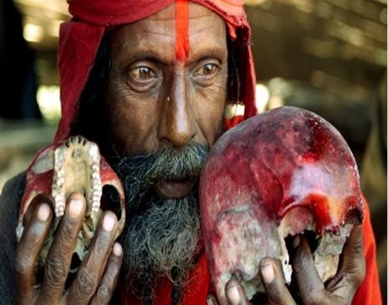
Witchcrafts and black rituals practiced in India to Snake charmers use their skills dupe people
treat mental illness to treat psychiatric disorders
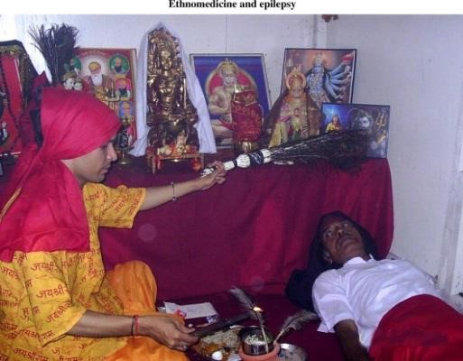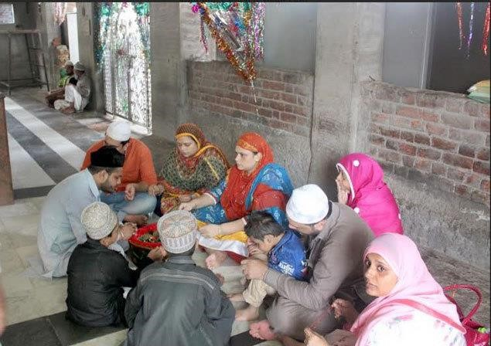
Faith healing practices in India in cases of major
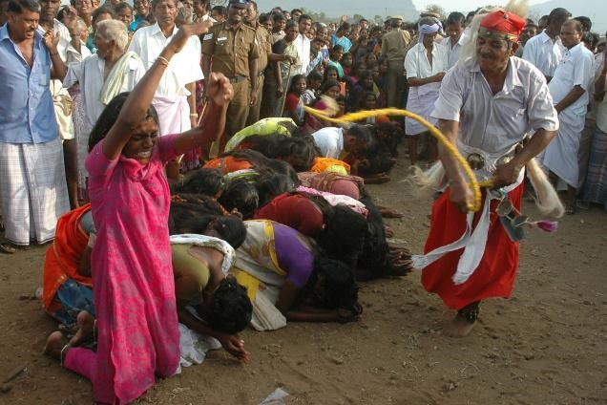
Women with mental illness are being beaten by sticks and brooms because they are thought to be possessed by evil or evil souls
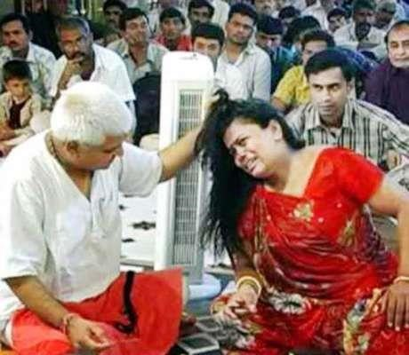

psychiatric disorders
Yoga is a group of physical, mental, and spiritual practices or disciplines which originated in ancient India. Yoga in Indian traditions, however, is more than physical exercise; it has meditative and spiritual core. One of the six major orthodox schools of Hinduism is also called Yoga, which has its own epistemology and metaphysics, and is closely related to Hindu Samkhya philosophy. It is a meditative means of discovering dysfunctional perception and cognition, as well as overcoming it for the release from suffering, inner peace and salvation. It is the raising expansion of consciousness from oneself to being coextensive with everyone and everything. Yoga is a workout for not only our body, but for our mind and emotions, as well.
With the modern world being as hectic as it is, the fact that most people live sedentary lives only increases the buildup of stress in the mind. Practicing yoga for just a few minutes can rid our body and mind of the stress that has accumulated throughout our day. Yoga is one of the best ways to calm a disturbed mind and bring ourselves to a place of peace.
When practicing yoga, because your attention is focused on the most present parts of yourself (your body and breath), you create a state of increased of awareness, which brings the mind to the present state moment, where it can stay happy and focused. When your mind is relaxed, happy and content, you are better able to be present for others and sensitive to your own behaviour and how it affects those around you. Yoga and meditation help to maintain a happy and positive state of mind and those effects extend out to your ability to listen, be attentive and have compassion.
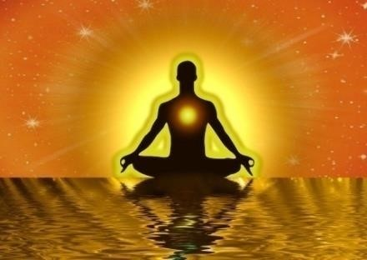
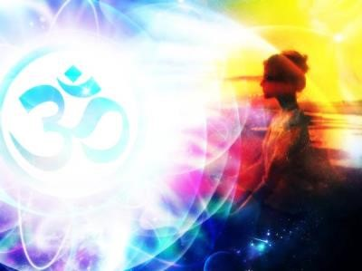
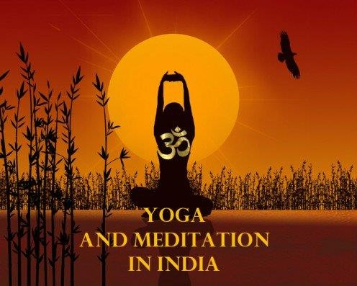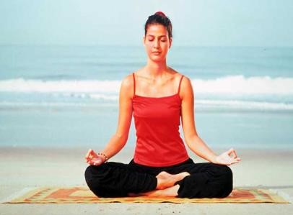Om is considered to be one of the most important sounds in all the universe and has been chanted for thousands of years. It’s believed thatcontinuous practice leads to profound enlightenment. Chanting of the Om Mantra purifies the environment around you and creates positive vibrations, your concentration increases and helps you focus, gives you better immunity and self-healing power, place you in a meditational state which gives you deep relaxation.
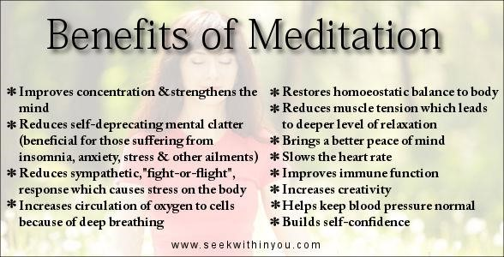
Meditation is a habitual process of training your mind to focus and redirect your thoughts. You can use it to increase awareness of yourself and your surroundings. Many people think ofit as a way to reduce stress and develop concentration.People also use the practice to develop other beneficial habits and feelings, such as a positive mood and outlook, self-discipline, healthy sleep patterns and even increased pain tolerance.
Sun Salutation or Surya Namaskar is a Yoga warm up routine based on a sequence of gracefully linked asanas.The nomenclature refers to the symbolism of Sun as the soul and the source of all life. One of the primary Surya Namaskar benefits is that it strengthens the entire body. Stimulates the nervous system including the brain, lower plexus, spinal cord, etc. Surya Namaskar Yoga strongly aids in preventing memory loss, builds focus and concentration, improves


70
%
10
%
15
%
5
%
Methods of treatment provided to the patients at Omnicare
House
Traditional medicines only
Counselling sessions and
CBT along with medication
Medicines and spiritualism
Hospitalization

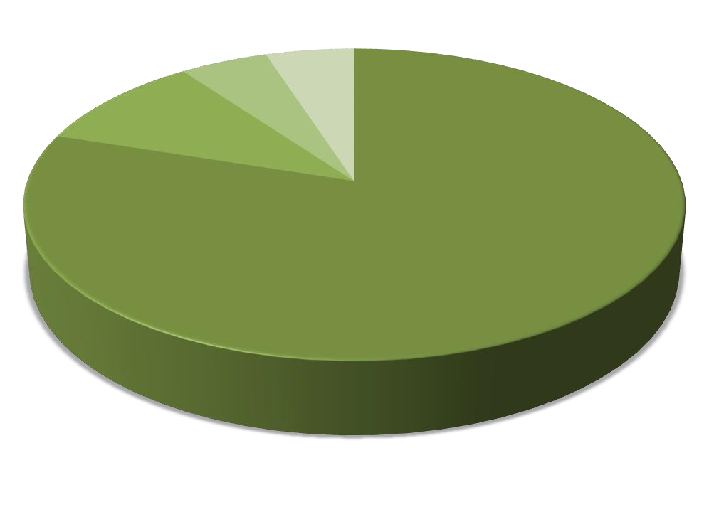
80
%
10
%
5
%
5
%
Effect of spiritual methods
Medicines have reduced
Symptoms reduced with
minimal medicines
No relapse with minimal
medicines
Only Spiritual methods
without medicines

BIOGRAPHY

Dr.Ramesh Kumar Thukral, has done MBBS and MD ( Psychiatry) from K.G.M.U., Lucknow, INDIA. Further, he has done D.C.M.N. from Delhi, INDIA.
He has been in the Practice of Neuropsychiatry in Omnicare House, B-20, Sec-A, Mahanagar, Lucknow since last 30 years and Consultant Neuropsychiatrist in ‘Sahara Hospital’.
He is the CEO in “Dakshi Diagnostic Services Pvt. Limited”: A centre for 3D Brain SPECT for Human Behaviour, Vital Bioenergy & Soul Imaging.
He owns 16 Neuropsychiatric satellite centers and sub-centers under the banner of Lucknow Neuropsychiatric Centre .
He has Approx 38 Participation in international conferences of Neuropsychiatry, and behavioral sciences, covering almost all the major countries of the world.

rpss2007@rediffmail.com
drrkthukralsoc@gmail.com

PRESENTING AUTHOR DETAILS
Full Name which you wish to be printed: RAMESH KUMAR THUKRAL
Contact Tel Number: + 91-9695517269 , +91-7897855555, +91-9839014550
Twitter account:
Linked In account: Pratibha thukral
Session of Interest: all sessions
Category: (Poster presentation)

