PERSISTENT DIFFUSE DEEP T WAVE INVERSION”:
AN ECG MANIFESTATION OF MYASTHENIA GRAVIS IN CRISIS: A CASE SERIES”

Jose Eduardo DL. Duya MD¹, Rodel Buitizon MD¹, Kristine Tumabiene MD¹, Jose Danilo Diestro MD²,
Michael Joseph Agbayani MD³, Richard Henry Tiongco MD³.
¹ Fellow in Training, Section of Cardiology, Department of Medicine
² Resident in Training, Section of Adult Neurology, Department of Neurosciences
³ Consultant, Section of Cardiology, Department of Medicine

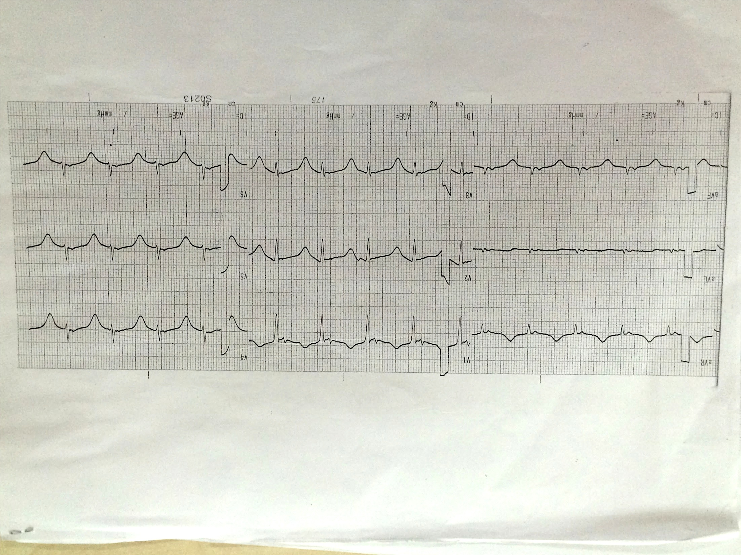
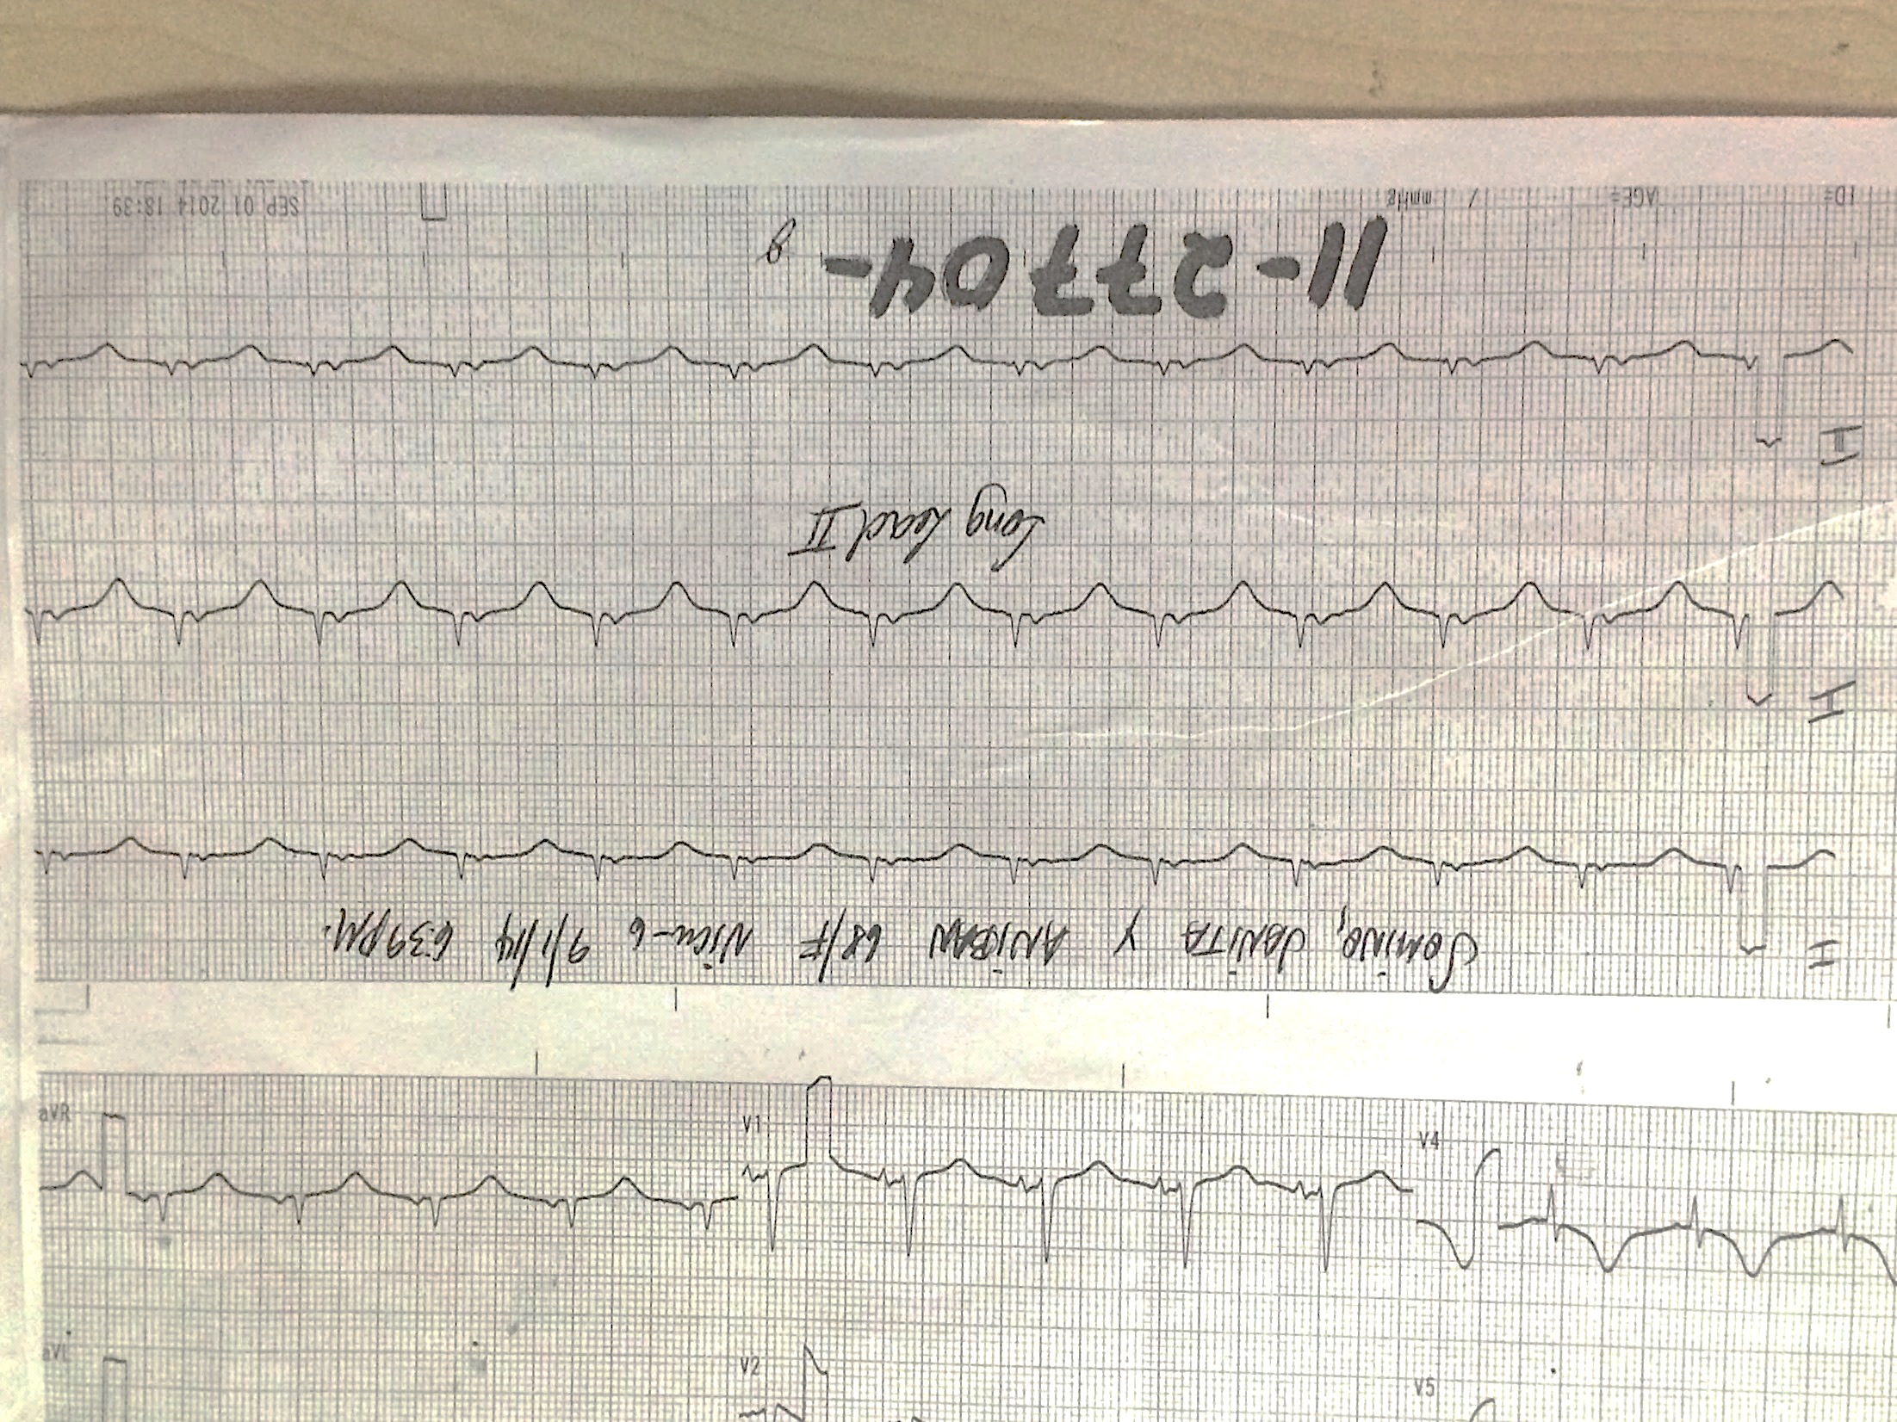
Myasthenia gravis (MG) is an autoimmune disorder directed against acetylcholine receptors. Despite the absence of these receptors in cardiomyocytes, asymptomatic ECG changes, tachyarrhythmias, myocarditis, and sudden death have been documented. We report 2 cases of MG presenting with deep diffuse persistent T wave inversions as a marker for possible MG related cardiac disease.

I
II
III
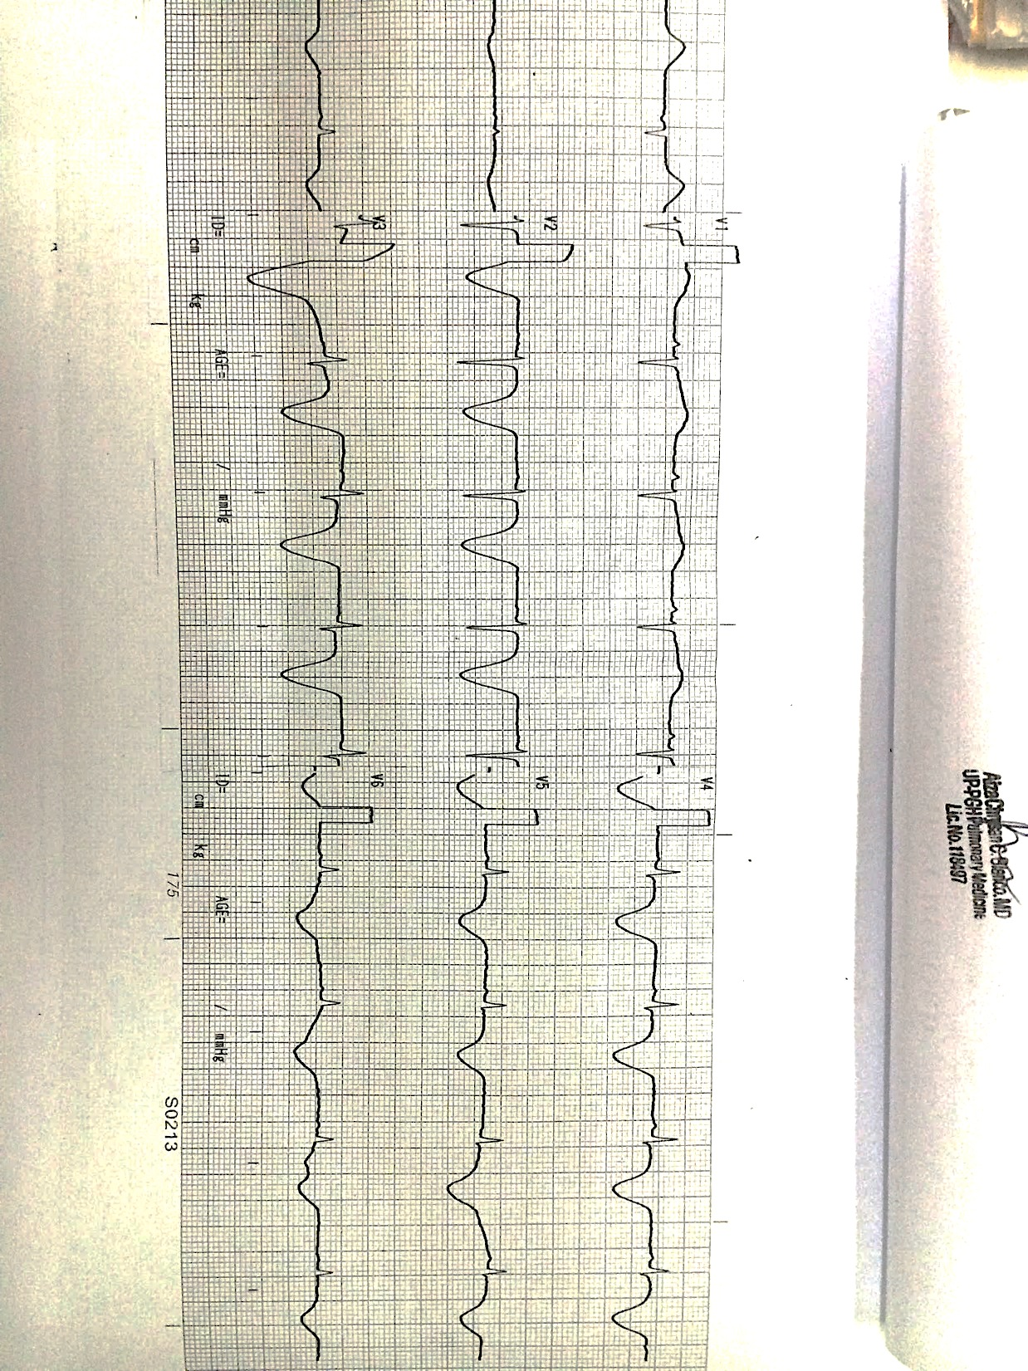
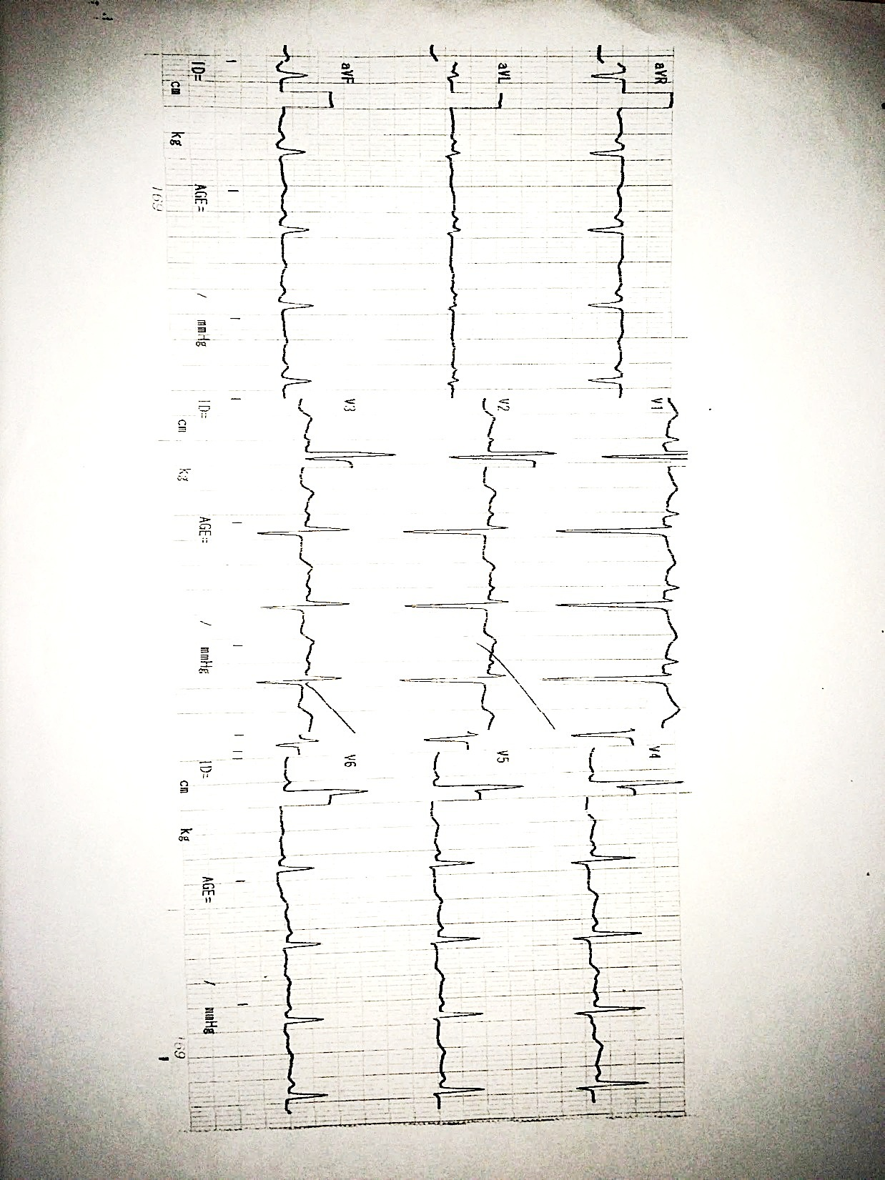
A 68 year-old female, diagnosed with MG, post thymectomy for malignant thymoma in 2013, was admitted for progressive weakness, pleuritic chest pain and cough. ECG showed regular sinus rhythm, normal axis, low voltage complexes on limb leads, poor R wave progression, prolonged QT interval, diffuse T wave inversion on all leads. Troponin I level was borderline elevated however, monitoring of troponin was negative. Echocardiography revealed concentric left ventricular hypertrophy with good contractility. ECG monitoring showed deepening diffuse symmetric T wave inversion. Due to the low CAD risk, this was interpreted as non-ischemic and was attributed to MG’s autoimmunity. Antibiotics, pyridostigmine, prednisone and plasmapheresis were given. She remained stable through out the course. Repeat ECG a month showed normalization of T wave inversion.
Repeat ECG showed worsening of the diffuse symmetric T wave inversion mimicking myocardial ischemia.
Case 1: Baseline ECG showing regular sinus rhythm, normal axis, low voltage QRS complexes on limb leads, poor R wave progression, prolonged QT interval, diffuse T wave inversion on all leads
A 29 year old female was admitted for MG crisis. ECG revealed sinus tachycardia, with upright T waves. On Day 8, patient developed sepsis induced hypotension and repeat ECG showed 2mm ST elevation on V2-V3 with 3 mm T wave inversion on lateral leads. Serial ECG showed deepening of T wave inversion on V2-V6 (deepest 7 mm). The cardiac enzymes, echocardiogram and electrolytes were normal. With medical management, the patient was discharged improved.

The dynamic ECG changes were attributed to possible immunologic myocarditis, which can present with deep T wave inversions. This case report highlights that clinicians should be aware that MG can present with this ECG feature, albeit seemingly alarming, usually follows a benign course and resolves with the resolution of MG crisis.
Repeat ECG taken 1 month post plasmapheresis showed normalization of the T wave inversion with persistence of non specific ST T wave changes

Recent Publications
- Myasthenia Gravis and the Heart. ACNR • VOLUME 8 NUMBER 5 • NOVEMBER/DECEMBER 2008 I 9
- Cardiac Involvement in Myasthenia Gravis – Is There a Specific Pattern? C. CĂLIN, OANA SAVU, DAFINA DUMITRU, IOANA GHIORGHIU et al. ROM. J. INTERN. MED., 2009, 47, 2, 179–189
- Mygland A, Aarli JA, Hofstad H, Gilhus NE. Heart muscle antibodies in myasthenia t gravis. Autoimmunity 1991;10(4):263-7.
- HooKim K et al. IgG anti-cardiomyocyte antibodies in giant cell myocarditis. Ann Clin Lab Sci 2008;38(1):83-7.
- C. Calin et.al. Cardiac Involvement in Myasthenia Gravis – Is There a Specific Pattern? ROM. J. INTERN. MED., 2009, 47, 2, 179–189
- GUGLIN M., CAMPELLONE J., HEINTZ K., PARILLO J., Cardiac disease in myasthenia gravis: a literature review. J. Clin. Neuromusc. Dis., 2003; 4:199–203.
- Ashok PP et.al.Cardiac involvement in myasthenia gravis. Acta Neurol Scand 1983;68 (2):113-20.

About the Author: Dr. Jose Eduardo Duya is the Chief Fellow of the Section of Cardiology, Department of Medicine, University of the Philippines Philippine General Hospital. His published works include IM PLATINUM, a textbook and guide in Internal Medicine for Filipinos which was awarded as Outstanding Book Award for 2016 by the National Academy of Science and Technology and several prospective researches on heart failure and diabetes. His passion for research is palpable with his numerous case reports and case series spanning topics like arrhythmia, congenital heart disease, cardiac manifestations of hematologic diseases and cardiac complications of neurologic disorders.
Email Address: joeyduya@gmail.com

