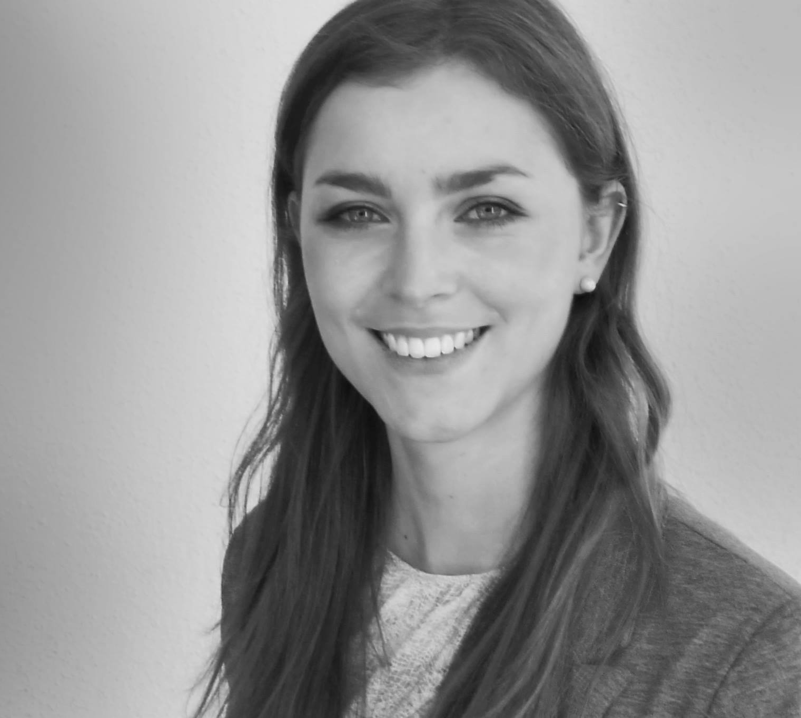

Title: The Role of Glia-specific NF-κB Activation in Traumatic Brain Injury

Name: Stephanie Nadine Reichel
Institute of Physiological Chemistry, Ulm University, 89081 Ulm

- The transcription factor NF-κB is a central regulator of various cellular processes, including cell survival and inflammation. Inflammation in the CNS is mediated by both astroglia and microglia, which become activated and crosstalk upon CNS damage, such as traumatic brain injury (TBI). There is increasing evidence that IKK/NF-κB activation in astrocytes and microglia is part of the secondary pathophysiology in TBI. However, neither the cell-type-specific activation kinetics after TBI nor the exact associated cellular functions induced by NF-κB in this context is properly understood so far.
- We used the closed head injury model in transgenic NF-κB reporter gene mice, which allow monitoring of NF-κB activation by GFP expression. Interestingly, we found increasing NF-κB activation in both astrocytes and microglia on the ipsilateral site after TBI, however with different kinetics. Notably, also on the contralateral site microglia showed NF-κB activation, suggesting that the TBI triggered inflammatory response can indeed spread from local site of damage to the uninjured hemisphere. Using conditional mouse models allowing conditional astrocyte-specific activation or inhibition of NF-κB, we found first evidence that NF-κB activation in astrocytes prior to TBI promotes development of neurological deficits post TBI. In contrast, animals with astrocyte-specific NF-κB inhibition show less neurological impairments suggesting beneficial effects of NF-κB suppression in astrocytes.
- Currently, we focus on the molecular mechanisms underlying this differential TBI outcome using immunohistochemical, biochemical and gene expression analyses as well as investigation of the blood-brain-barrier integrity and edema formation.

This research is supported by a grant of the Deutsche Forschungsgemeinschaft (DFG SFB 1194).

Biography

Stephanie Nadine Reichel studied Molecular Medicine at the Eberhard-Karls University in Tübingen. Since January 2014 she is doing her PhD at the Institute of Physiological Chemistry of the University of Ulm. Besides, she is a student representative in the International Graduate School in Molecular Medicine Ulm (IGradU) and a member of the biotechnological student initiative (bts e.V.) Ulm.

Presenting author details
Full name: Stephanie Nadine Reichel
Contact number: 0049 731 500 33842
Linked In account: https://www.linkedin.com/in/stephanie-nadine-reichel-2a5931107?trk=nav_responsive_tab_profile
Session name/number: Track 1-1 Brain dysfunction
Category: Poster presentation

