In vitro and In vivo Activities of LCB01-0648 and LCB01-0699
against Staphylococci

Jin-Hwan KWAK, Ph.D.
School of Life Science, Handong Global University, Korea

Abstract (300 word limit)

LCB01-0648 is a new oxazolidinone, which is under preclinical development. In this study, we tested in vitro and in vivo activity of LCB01-0648 against staphylococci. In vitro activity of LCB01-0648 against MSSA, MRSA and LRSA, was evaluated by the agar dilution method as described by the CLSI, and compared with those of linezolid, oxacillin, erythromycin, ciprofloxacin, sparfloxacin, moxifloxacin, gemifloxacin and vancomycin. The MIC₉₀ of LCB01-0648, at which 90% of bacterial strains are inhibited, was 0.5 μg/ml against MSSA, MRSA and was below 4 μg/ml against LRSA. In vitro activity of CB01-0648 was 4-fold more active than linezolid against MSSA and MRSA. Especially, the antibacterial activity of LCB01-0648 had good antibacterial activities against linezolid-resistant or -intermediate S. aureus. LCB01-0648, at the concentration of 8X MIC, showed a bactericidal activity against MSSA and MRSA. In vivo activity of LCB01-0699 which is the active prodrug of LCB01-0648 was also compared with that of linezolid against systemic infections caused by MSSA, MRSA and LRSA in mice. LCB01-0699 was more effective than linezolid against systemic infections. In conclusion, LCB01-0648 had potent in vitro and in vivo activity against drug resistant Gram-positive pathogen, including MRSA and LRSA. These results indicate that LCB01-0648 could be a good candidate for further pre-clinical studies.

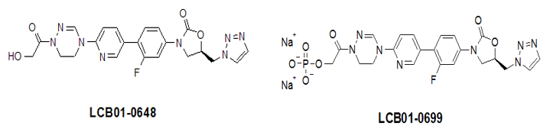

Image

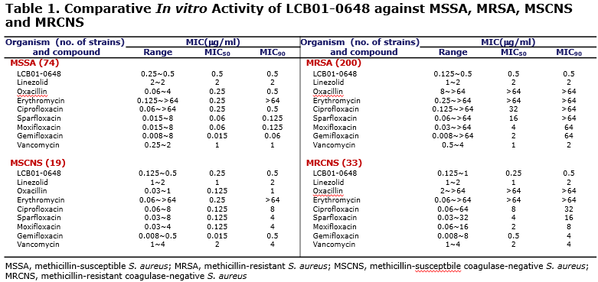
Recent Publications (minimum 5)
- Jin-Hwan Kwak (2017). In Vitro Activities of LCB 01-0648, a Novel Oxazolidinone, against Gram-Positive Bacteria. Molecules 22, 394-404.
- Jin-Hwan Kwak (2016). Antimicrobial Activity of Zabofloxacin against Clinically Isolated Streptococcus pneumoniae. Molecules 21, 1562-1570.
- Bo Ram Beck, Jin-Hwan Kwak (2016). Distinct immune tones are established by Lactococcus lactis BFE920 and Lactobacillus plantarum FGL0001 in the gut of olive flounder (Paralichthys olivaceus). Fish & Shellfish Immunology 55, 434-443.
- Yun Gyeong Kim, Jin Hwan Kwak (2015). Discovery of a potent enoyl-acyl carrier protein reductase (FabI) inhibitor suitable for antistaphylococcal agent. Bioorganic & medicinal chemistry letters 25(20), 4481-4486.
- Deepak Bhattarai, Jin-Hwan Kwak (2014). Synthesis and in vitro evaluation of the antitubercular and antibacterial activity of novel oxazolidinones bearing octahydrocyclopenta[c]pyrrol-2-yl moieties. Chem. Pharm. Bull.

Biography (150 word limit)
Jin-Hwan Kwak has his expertise in evaluation of new antibiotics. He was in charge of developing of new antibiotics including Factive® and Zabifloxacin. He has established various infection model in mice. He is also interested in mode of action of new antibiotics and resistance mechanism in bacteria.
Email: jhkwak@handong.edu

Notes/Comments:

