Clinical Trial: MUC Immunostaining Status of “Nuclear Inverse-Polarity Papillary Lesion Lacking Myoepithelial Cells”
Shinya Tajima, MD PhD, National Hospital Organization Shizuoka Medical Center, Japan
Keiko Kishimoto, MD PhD, Nihon-bashi Arayla Clinic, Japan
Masayuki Takagi, MD PhD, National Hospital Organization Shizuoka Medical Center, Japan

Abstract (300 word limit)
Breast cancer is world threatening disease now. And Clinical Trial may play a key role in breast tumor especially papillary lesions. Breast papillary lesions demonstrate wide range from benign to malignant. Furthermore, clinical trial may detect important new histological subtype. The previous study demonstrated two cases of female. They have abnormality in the breast. And they came to the hospital for further examination and treatment. Radiologically, malignancy could not completely excluded. Then, breast excision was performed. Histologically, both cases revealed papillary neoplastic lesions lined by fibrovascular core and nuclear inverse-polarity without atypia. Loss of myoepithelial cells was observed by p63, and calponin. Previous report indicate CK5/6, ER, p63 and MUC3 are important for distinguishing between papillary lesions according to the differential index. Based on this analysis, our 2 cases had benign lesions. Additionally, the Ki-67 index was <1% in both cases, and no evidence of disease was observed minimum 62 months of follow-up for both cases, despite lack of additional treatment. Here, we newly experimented MUC immunostainings in these cases because MUC immunostaining status is important in breast diseases. We did immunostaining of MUC1,2,4,5AC,5B and 6. The results are MUC2,4,5AC and 6 are negative. MUC1 revealed apical strong staining and also MUC5B was completely negative. MUC1 of apical staining is thought to be benign. MUC5B is thought that the staining positivity means early cancer lesion. Hence our staining status also turn out to be benign without myoepithelial cells. In conclusion, MUC immunostaining status also proved “Nuclear inverse-polarity papillary lesion lacking myoepithelial cells” are benign lesions. Someone think this lesion’s name is too long so “Tajima tumor” might be appropriate. Thus indicate the importance of clinical trial as well as reclaim the way to new histopathology.

Image
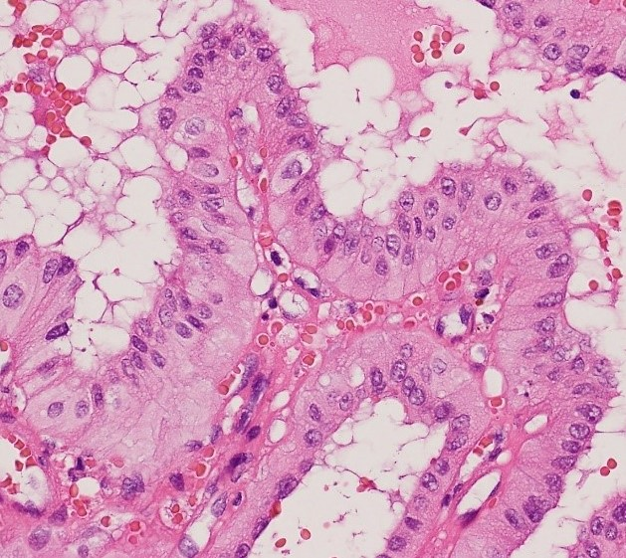
Recent Publications (minimum 5)
- Shinya T, Ichiro M, Motohiro C, Keiko K, Takafumi O, Koichiro T and Masayuki T. Breast Benign Papillary Lesions: Mini-Review. Clin Pathol & Res J 2018 2(1):1-2
- 2. Ichiro M, Shinya T, Akira N, Motohiro C, Mituru H, Yoshihide K, Takahiko U, Yasuyuki K, Koichiro T, Masayuki T. Availability of Computer-Assisted Image Analysis for Breast Pathology Using Immunohistochemistry for Myoepithelial Marker Antibody Cocktail Targeting CK14/p63 Differentiating Ductal Carcinoma In Situ from Invasive Ductal Cancer of the Breast. Clin Pathol & Res J 2019 3(1)
- 3. Ichiro M, Shinya T, Yoshihide K, Shinobu T, Koichiro T and Msayuki T. Use of immunohistochemical analysis of CK5/6, CK14 and CK34betaE12 in the differential diagnosis of solid papillary carcinoma in situ from intraductal papilloma with usual ductal hyperplasia of the breast. SAGE OPEN MEDICINE 2018(6);1-8
- 4. Shinya T, Ichiro M, Motohiro C, Masayuki T, Saeko N, Akira E, Yasushi A, Masatomo D, Keiko K and Koichiro T. Atypical Ductal lesion in the Breast: Review Biomed J Sci & Tech Res 2019 1(2):1-2
- 5. Shinya T, Ichiro M, Keiko K, Saeko N, Akira E, Masatomo D, Motohiro C, Koichiro T, Masayuki T, and Junki K. Malignant Intraductal Lesions in the Breast: Mini-Review. Biomed J Sci & Tech Res 2019 17(1)1-2
- 6. Takafumi O., Keiko K., Shinya T., Ichiro M., Masayuki T., Takahiko U., Nao S., Yasuo N., and Hidefumi M. Apparent diffusion coefficient (ADC) values of serous, endometrioid, and clear cell carcinoma of the ovary: pathological correlation"
- Acta Radiologica 2019 0(0)1-9
- 7. Shinya T., Ichiro M., Keiko K., Saeko N., Akira E., Masatomo Doi., Motohiro C., Koichiro T., Masayuki T., and Junki K. Intraductal Papilloma of the Breast: Short-Review Clinical Investigation Journal 2019 9(3)107-110

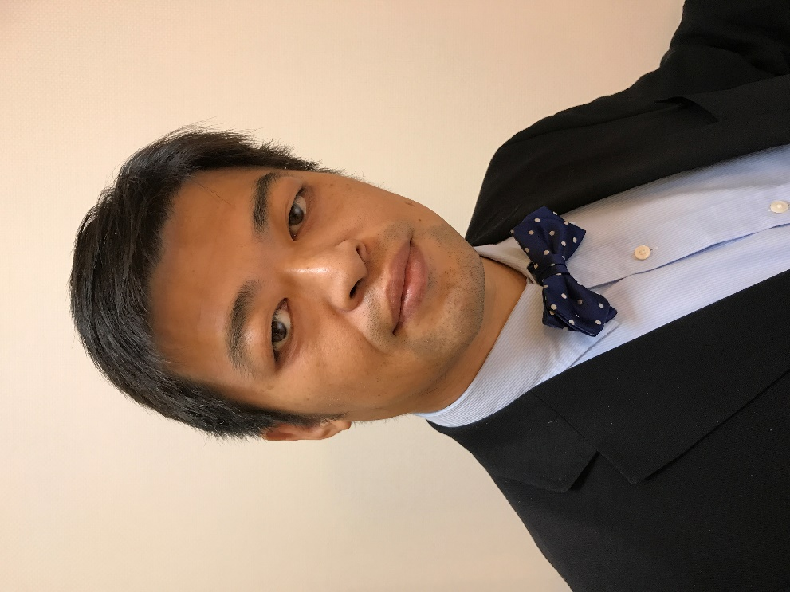 Biography (150 word limit)
I am Shinya Tajima MD, PhD from Japan. I was born in Saitama near Tokyo. I graduated from Keio University School of Medicine. After graduated the university, working in Department of Pathology at the same institution. Then I learned general pathology. And I would like to be a specialist of breast pathology. I affiliated St. Marianna University School of Medicine which is the most breast operation number in Japanese university. I received PhD in Radiologic-Pathology from the same Graduate School of Medicine, Kanagawa, Japan. I worked at the Department of Pathology and Radiology of this latter institution for 10 years. Now I am working at Department of Diagnostic Pathology of National Hospital Organization Shizuoka Medical Center.

Full Name Shinya Tajima
Tel: +81-90-3681-4114
Session Name/Track9: Research and Trials on Oncology and AIDS
Category: (Oral presentation (Keynote speaker) if could possible Video presentation because Japanese people are restricted by corona)
Email: stajima0829@gmail.com
D.O.B :……………………

Notes/Comments: I would like to be a keynote speaker and please send me the certificate of merit after the presentation. I will do my best and contribute to woman’s health.
- Abstract must be in 300 word limit
- Biography must be in 150 word limit
- Photograph is mandatory

