Colloid Cyst of the Third Ventricle: Long-term Results of Endoscopic Management in a Series of 112 Cases
Ehsan Nazari Maloumeh, MD, Skull Base Research Center, Loghman Hakim Hospital, Shahid Beheshti University of Medical Sciences, Tehran, Iran
Statement of the problem: Colloid cysts are benign intracranial lesions accounting for 0.5 to 2% of brain tumors. They are most often located at the roof of the third ventricle near the foramen of Monro. Although colloid cysts typically present with progressive headaches due to obstructive hydrocephalus, a few patients present with sudden death caused by severe obstructive hydrocephalus. Traditionally, the patients have been treated surgically by utilizing transcortical or transcallosal microsurgical approaches for colloid cyst resection. Nevertheless, less-invasive endoscopic approaches are used increasingly to minimize postoperative morbidity. The aim of this study was to report the results of endoscopic approach to resect third ventricular colloid cyst of 112 cases presenting between the years of 2003 to 2015. Material and Methods: We conducted a retrospective review of 112 cases with colloid cyst of third ventricle between 2003 and 2015, who underwent endoscopic surgeries at the Loghman Hospital. According to consistency of content, third ventricular colloid cysts were categorized as type 1 and type 2 colloid cysts (Samadian-Maloumeh-Ebrahimzadeh classification) assessed separately during the study. Findings: We found that the most common clinical presentations in patients with third ventricular colloid cyst were headache, vomiting, and impaired vision. Complete resection was obtained in majority of patients (92%). Meningitis, hemiparesis, and memory deficits occurred most commonly as postoperative complications. Conclusion: High rates of complete resection of third ventricular colloid cysts, with low morbidity and mortality, are possible with an endoscopic approach. The results of this study support the role of endoscopic resection in the treatment of patients with third ventricular colloid cysts as a safe and effective modality and show how endoscopic resection of third ventricular colloid cysts can produce favorable results.

Image

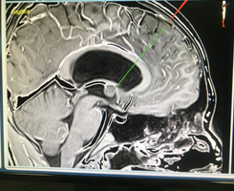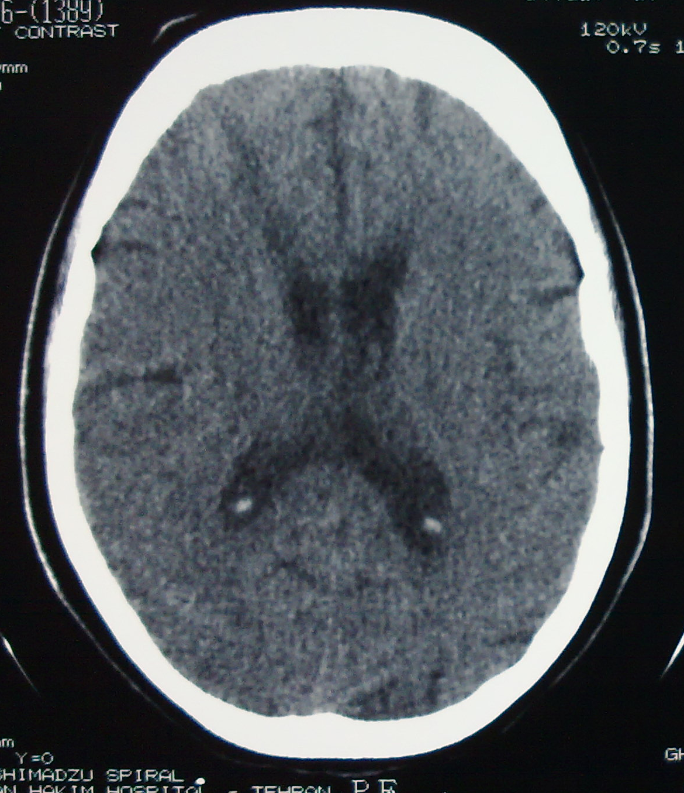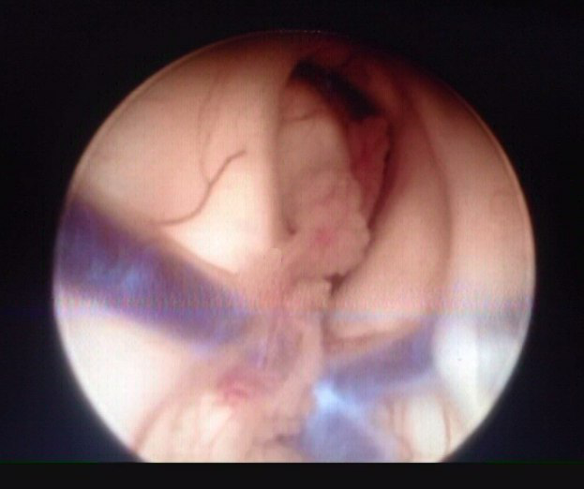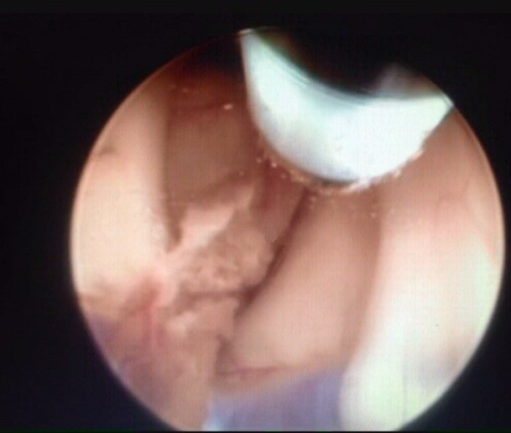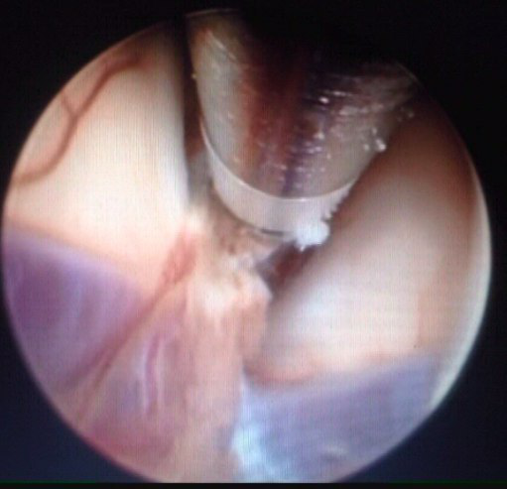
A B C D E
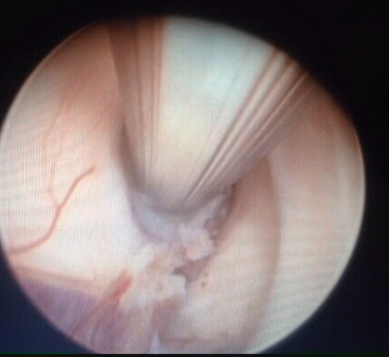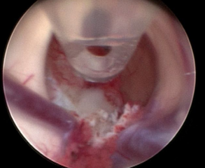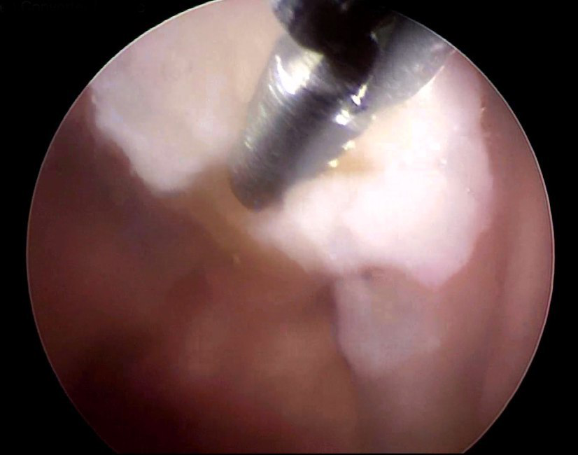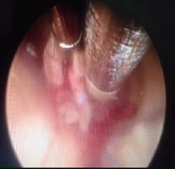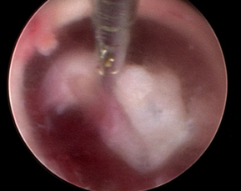
F G H I J
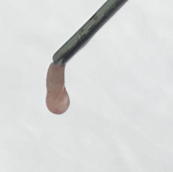
K
Colloid cyst of the third ventricle. (A&B) First of all Magnetic Resonance Navigation was applied in order to determine the most accurate trajectory to access the third ventricular colloid cyst. It is defined by determining a line from calvarium toward the target to provide the most appropriate access to prevent damage to the adjacent neuronal structures, particularly the head of caudate nucleus and fornices. The optimized trajectory to access third ventricular colloid cysts has 3 characteristics, including perpendicular to the roof of third ventricle, lateral enough to prevent damage to the fornix, and medial enough to avoid damage to the head of caudate nucleus. (C) View of a third ventricular colloid cyst and choroid plexus. (D&E) First, we coagulated both choroid plexus in proximity of colloid cyst and the cyst wall with bipolar electrocautery (F) Then, we opened the cyst wall, applying microscissors, and then aspirated the contents of the cyst using a suction aspirator. (G) To suction the invisible contents of the cyst, we applied also a specific side-cutting suction tube in such a way that at first an open-end suction aspirator was applied. Then, a side hole was created if necessary at the 3-mm end of suction aspirator with a 3-mm Kerrison Rongeur to aspirate the invisible contents of the cyst (side-cutting suction tube). By doing this, the contents could be aspirated by the created side hole even if the end hole of suction aspirator was blocked by the cyst wall. Also, by rotating the suction aspirator around inside the cyst, all invisible contents could be aspirated. (H) In our study, 19 of colloid cysts (17%; type 2 colloid cysts) had a great amount of viscid contents that could not be aspirated completely by suction aspirator. Thus, we had to use grasping forceps to evacuate completely the contents of these 19 colloid cysts. (I) After evacuation of the cyst content, we began to dissect the cyst wall from third ventricular roof, veins, and choroid plexus. A flexible forceps was applied along the side working channel to twist the cyst wall (twisting maneuver) to loosen the junction of cyst wall and third ventricle. Then, we gently pulled the cyst wall to either the right or left lateral ventricle depending on the location of Burr hole (right- or left-side Burr hole) and simultaneously the pedicle of the cyst comprising small vessels was coagulated with bipolar coagulator along the main working channel. (J) After dissecting the cyst wall and coagulating the cyst pedicle, we cut the pedicle with microscissors and removed the whole cyst wall en bloc. In some cases (8%), the cyst wall was removed partially because of firm adherence of the cyst wall to veins and vital structures. In these cases, the remaining part of the cyst wall was coagulated to decrease the rate of recurrence. (K) View of a colloid cyst of third ventricle resected completely during the endoscopic procedure.
Recent publications
1. Sharifi G, Bakhtevari MH, Samadian M, Alavi E, Rezaei O. Endoscopic surgery in nonhydrocephalous third ventricular colloid cysts: a feasibility study. World neurosurgery.2015;84:398-404.
2. Wilson DA, Fusco DJ, Wait SD, Nakaji P. Endoscopic resection of colloid cysts: use of a dual-instrument technique and an anterolateral approach. World neurosurgery.2013; 80:576-83.
3. Margetis K, Christos PJ, Souweidane M. Endoscopic resection of incidental colloid cysts. Journal of neurosurgery.2014;120:1259-67.
4. Sheikh AB, Mendelson ZS, Liu JK. Endoscopic versus microsurgical resection of colloid cysts: a systematic review and meta-analysis of 1278 patients. World Neurosurg.2014;82:1187–1197.
5. Ibanez-Botella G, Dominguez M, Ros B, De Miguel L, Marquez B, Arraez MA. Endoscopic transchoroidal and transforaminal approaches for resection of third ventricular colloid cysts. Neurosurgical review.2014;37:227-34.
6. Boogaarts HD, Decq P, Grotenhuis JA, Le GC, Nseir R, Jarraya B, et al: Longterm results of the neuroendoscopic management of colloid cysts of the third ventricle: a series of 90 cases. Neurosurgery.2011;68:179-187.
7. Brostigen, C. S., Meling, T. R., Marthinsen, P. B., Scheie, D., Aarhus, M. Helseth, E: Surgical management of colloid cyst of the third ventricle. Acta Neurologica Scandinavica .2016;1-4.
Biography
I began to study medicine seven years ago and graduated recently at Shahid Beheshti university of medical sciences. I have been researching in neurosurgery field for more than two years at skull base research center of Loghman Hakim hospital, as I am so much interested in neurosurgery.

