Telemedicine: its applications and the new era of clinical research
Janett Jalil, MD, BSc, School of Clinical Research USA, LLC
Lilia A. Curbelo, CCRC, School of Clinical Research USA, LLC

Abstract
Telemedicine has changed the face of medicine in the latest years. The number of physicians applying this technology to facilitate patient access to their services from anywhere around the globe, at any time of the day, is steadily increasing.
The potential applications of this technology in clinical trials are an exciting prospect. Although some major pharmaceutical companies and large research centers have spearheaded the implementation of telemedicine platforms as part of their common practices, its use has not spread to smaller settings.
The potential benefits derived from expanding the use of telemedicine in clinical trials cover critical areas such as safety reporting, data quality, data review and monitoring, among others. At the site level, this means an improved patient experience, and minimal-error, real time data reporting to Sponsors.

NCT Systems®
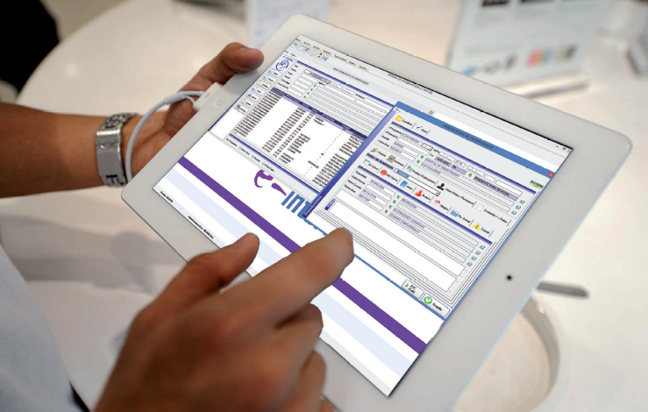

Biography
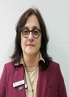
Janett Jalil obtained her Medical Doctor degree at the Medical Sciences Institute Carlos J. Finlay in Camaguey Cuba at the age of 27. Dr. Jalil completed her residency program in Internal Medicine at the same university three years later. She is the owner and director of School of Clinical Research USA, LLC, a clinical research site founded in 2010 to conduct industry sponsored clinical research trials and to promote community awareness about clinical research. Most recently, she was invited as an International Jury Member for the European division of the Videomed 2016 medical education media competition.
Janett Jalil Martinez
Tel: 305-961-1180
Category: (Oral presentation/Poster presentation)
Email: janett_jalil@scrusa.com

