A Brief Description about My Invention
“3d Printed Customize Drug Prescription System”
______________________________________________

As a Bangladeshi where technology is not seen, where people live under the poverty here I have made the revolutionary change in the traditional prescription system with my 3d printed customize drug prescription. I am a pharmacist with more than 9 years of experience in the field of pharmaceutical dosage form of drug design and formulation. This is the new type of drug formulation machine rather than conventional one. Traditional drug formulation consists of various steps including compression, drying, sieving, blending and others which need expensive machine, large space and huge man power. My new drug formulation machine is quite different, it just needs single click to the machine and the drug will produce. Even anyone can print drug remotely from his mobile device using the 3d drug printing app. Here we design the 3d drug printer machine and the polymer based ink for 3d printed customize drug.
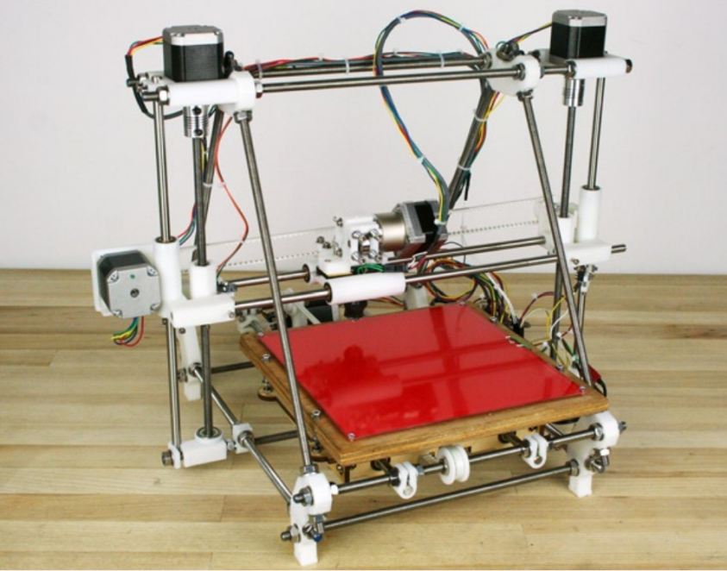
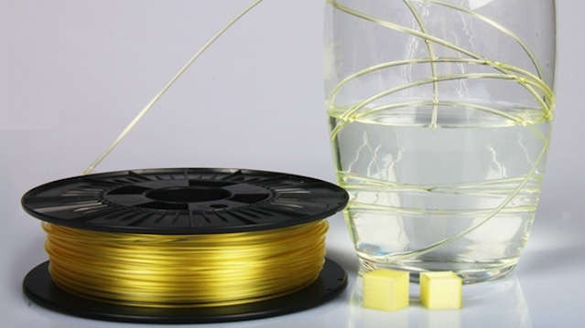
Fig: Water soluble polymer
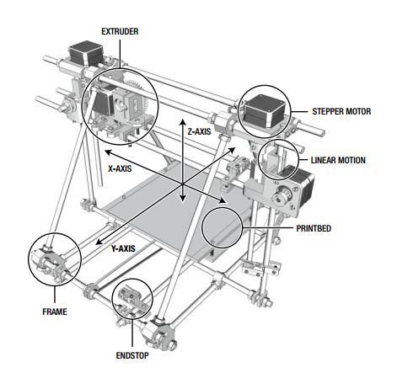
Fig: 3d drug printer
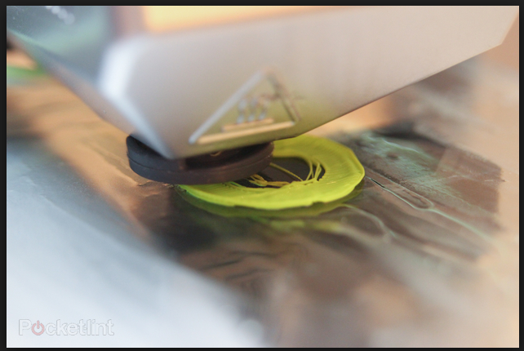

Fig: drug is printed
Fig: machine various parts
My interview with 3dprint.com magazine:
http://3dprint.com/87977/3d-printed-drugs-2/

About me in another prominent polymer newspaper:
http://www.plasticstoday.com/blogs/your-prescription-being-printed-150814

About me in a 3d printer newspaper:
https://all3dp.com/is-crowdfunding-3d-printed-medicine-a-good-idea/

Another newspaper of health science:
http://www.care2.com/greenliving/3d-printed-drugs-to-revolutionize-prescription-medicine.html

About my work in popular 3d print newspaper:
http://www.3dtectonix.com/Will-Drug-3DPrinters-and-3DPrinted-Drugs-Become-Available

In an Italian newspaper:
http://www.stamparein3d.it/3d-printer-drug-machine-di-mahmudur-rahman-la-stampante-tedesca-per-i-farmaci-personalizzati/

In popular gadget news:
http://www.notey.com/external/5444398/german-company-aims-to-sell-3d-printed-drugs-a-3d-drug-printer-3d-printing-health-3d-printing-3d-printed-medicine-3d-printed-drugs-drug-3d-printer-fda-approved-3d-drugs.html

In a 3d printer newspaper:
http://3dscannerclassifieds.com/gazan-medico-team-develops-3d-printed-30-cent-stethoscope-for-developing-world/

In a conference of 3d printer:
http://www.3dmpconference.com/pharmaceuticals/from-current-prescription-system-to-3d-printed-customized-drug-dose-video/

In linkedin:
https://www.linkedin.com/company/plasticstoday?trk=other_brands_name

My you tube video of polymer formulation:
https://youtu.be/FyUzZIIypiU

My youtube video of 3d printer:
https://youtu.be/p1YB-yLtw58

My website of drug formulation:
mahmudmitu.googlepages.com

