Serum Concentration and Dietary Zinc Intake in Children and Adolescent with Chronic Diseases

Marlene Fabiola Escobedo Monge, MD, Faculty of Medicine, Valladolid University, Spain
María Carmen Torres Hinojal, Faculty of Medicine, Valladolid University, Spain
Enrique Barrado, PhD, Department of Analytical Chemistry, Science Faculty, University of Valladolid, Spain
María Antonieta Escobedo Monge, PhD, Department of Chemistry, Science Faculty, University of Burgos, Spain
José Manuel Marugán de Miguelsanz, MD, Department of Pediatrics of the Faculty of Medicine, Valladolid University, Section of Gastroenterology and Pediatric Nutrition, University Clinical Hospital of Valladolid, Spain

Abstract

Statement of the problem: Zinc is an essential micronutrient and plays a significant role in human growth and development. Zinc deficiency is a public health problem and is now widely recognized as a one of the main risk factors for morbidity and mortality. There are few studies of zinc deficiency in children with chronic diseases. Therefore, the purpose of this study was to evaluate the nutritional status of zinc and its association with nutritional indicators in a series of children with chronic diseases. Methodology: A cross-sectional and comparative study was carried out by design. Anthropometric, biochemical, and dietary assessment were performed. The participants were classified according to their nutritional status by body mass index (BMI). The prevalence of patients with dietary zinc deficiency (<80% DRI: Dietary Reference Intake) was analyzed through prospective 72 h dietary surveys with a weekday, and hypozincemia (under 70 µg/dL in children under 10 years of age in both sexes and in females older than 10 years and below 74 µg/dL in males older than 10 years) was measured through atomic absorption spectrophotometry. Findings: Seventy-eight patients (43 females, 55%), 24 children with obesity, 30 with undernutrition, and 24 with normal BMI took part in this study. Mean serum zinc concentration in obese (87 µg/dL), undernourished (85 µg/dL), and eutrophic children (88 µg/dL) were normal, but in the undernutrition (60% DRI) and eutrophic (67% DRI) groups the mean dietary zinc intake was low compared to that in the obesity group (81% DRI). There were different associations between nutritional parameters, dietary zinc intake, and serum zinc. There were five cases with hypozincemia. All patients with hypozincemia had dietary zinc deficiency. Conclusions & Significance: In the whole series, 69% of participants showed a zinc intake lower than recommended and might be at high risk of zinc deficiency.

Image

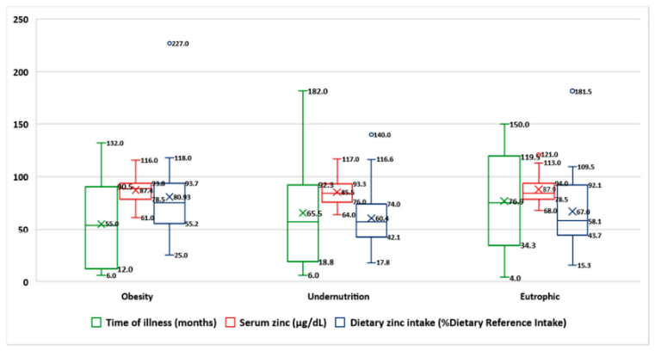
Figure1. Median, mean, and quartiles of the time of illness, serum zinc, and dietary zinc intake in the whole series by nutritional status via body mass index (N = 78).
Recent Publications
- Escobedo-Monge, M.F.; Torres-Hinojal, M.C.; Barrado, E.; Escobedo-Monge, M.A.; Marugán-Miguelsanz, J.M. Zinc Nutritional Status in a Series of Children with Chronic Diseases: A Cross-Sectional Study. Nutrients 2021, 13, 1121.
- Escobedo, M.F.; Barrado, E.; Alonso, C.; Marugán de Miguelsanz, J.M. Comparison study between colorimetric method and flame atomic absorption spectrophotometry in serum zinc status. Nutr. Clin. Diet. Hosp. 2018, 38, 128–133.
- Escobedo-Monge, M.F.; Ayala-Macedo, G.; Sakihara, G.; Peralta, S.; Almaraz-Gómez, A.; Barrado, E.; Marugán-Miguelsanz, J.M. Effects of Zinc Supplementation on Nutritional Status in Children with Chronic Kidney Disease: A Randomized Trial. Nutrients 2019, 11, 2671.
- Escobedo-Monge, M.A.; Aparicio, S.; Escobedo-Monge, M.F.; Marugán-Miguelsanz, J.M. Long-Term Effects of the Application of Urban Waste Compost and Other Organic Amendments on Solanum tuberosum L. Agronomy 2020, 10, 1575.
5. Escobedo-Monge, M.F.; Barrado, E.; Alonso Vicente, C.; Escobedo-Monge, M.A.; Torres-Hinojal, M.C.; Marugán-Miguelsanz, J.M.; Redondo del Río, M.P. Copper and Copper/Zinc Ratio in a Series of Cystic Fibrosis Patients. Nutrients 2020, 12, 3344.



Biography
Marlene is a pediatrician, Doctor of Medicine, and researcher at the Faculty of Medicine of the Valladolid University. She has a doctorate in "Health Sciences Research", two master's degrees, one in "Clinical Nutrition" and the other in "Biological Aspects of Nutrition." She is a peer reviewer for the MDPI editorial, International Journal of Environmental Research and Public Health and Medicine. She is very interested in food security and food biofortification and especially in the research that is being carried out on micronutrients in the nutritional status of patients with malnutrition and chronic diseases, especially in childhood and adolescence. She believes in the value of preventive medicine in reducing chronic diseases throughout the life of the human being.

Email: amescobedo@msn.com

Notes/Comments:

Presenting author details

Full name: MARLENE FABIOLA ESCOBEDO MONGE
Contact number: 0034639590467
Mail id: amescobedo@msn.com
Category: Oral presentation

