
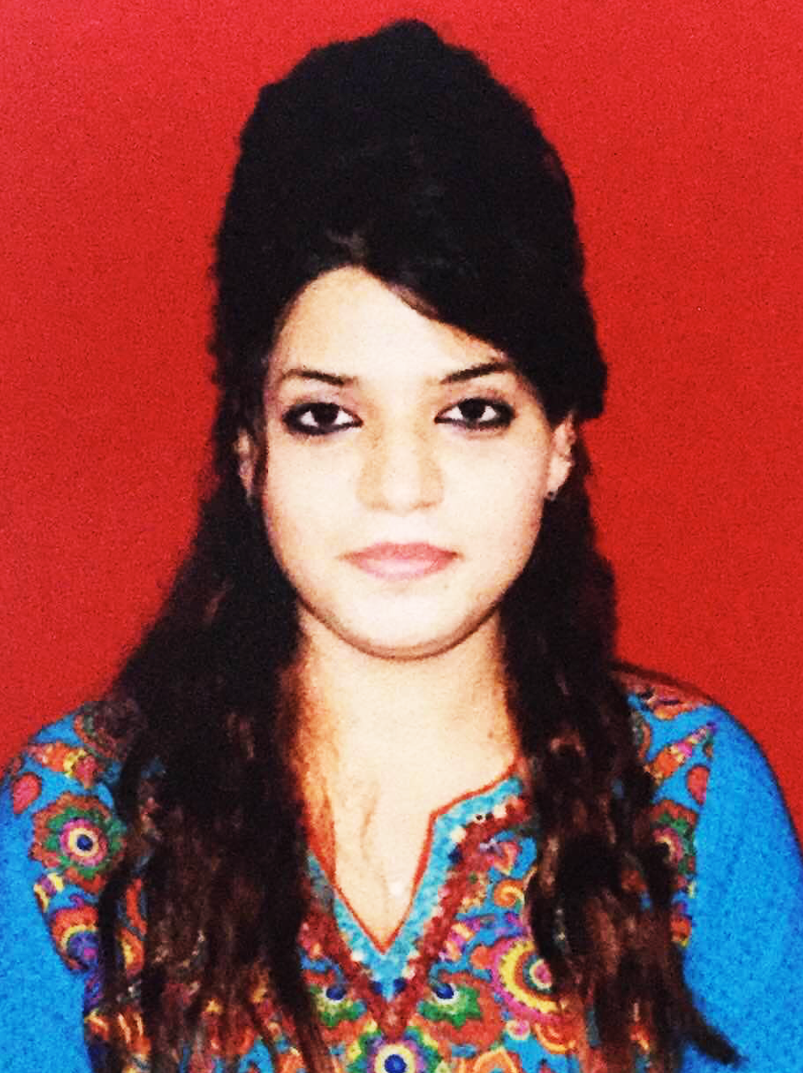

TITLE: Serous cystadenoma and FIBROTHECOMA: a rare combination in collision tumour of ovary with Pseudo- Meigs Syndrome.

Name: Dr Jehan Nizam Ansari, E-mail: jehan@nizamansari.com

Dr DY Patil Medical College and Research Centre, DPU, Pune, India

Collision tumors are defined as a coexistence of two adjacent but histologically distinct tumors without admixture in the same tissue or organ. They have been reported in various organs but collision tumors involving ovaries are extremely rare. The most common histological combination of collision tumor in the ovary is coexistence of teratoma with mucinous tumors.

Very few reports of benign collision tumors involving ovaries have been reported in world Literature. In 1937, Meigs described cases of pleural effusion, ascitis and ovarian fibromas and named it Meigs syndrome. In 1954, he limited the syndrome to cases where the removal of tumor cures the diseases. Pseudo-Meigs is a variant, not possessing the original tumor cell types described by Meigs. We report a very unusual combination of fibrothecoma and serous cystadenoma with Pseudo-Meigs syndrome.
A 63-year old menopausal woman presented with abdominal distention Ultrasonography and computed tomography scan revealed large cystic lesion with well-delineated solid area in it. Minimal ascitis was noted. Malignant neoplasm of ovary was suspected.
Cytology of ascitic fluid did not showed malignant cells. Carcinoma antigen [CA]-125 was mildly elevated. [0.42IU/ml]
Left ovary grossly showed a large uniloculated thin walled cyst with smooth surface and congested vessels. At one end of the cyst, well-demarcated solid homogenous yellowish white mass was seen.
Microscopy of multiple sections from solid area revealed benign fibrothecoma. Multiple sections from the cyst wall revealed serous cystadenoma.
Final diagnosis of benign ovarian collision tumor of fibrothecoma and serous cystadenoma with Pseudo-Meigs syndrome was made.

Biography:
Dr. Jehan Nizam Ansari is a licensed medical practitioner by the Medical Council India, after completing her graduation (MBBS), with top rank in the university.
Currently she is pursuing Post graduation in Pathology, She is passionate about her field and working on various Thesis project.

Presenting author Details:
Full name: Dr Jehan Nizam Ansari
Contact number: 0091-7744865894
Twitter account: @jehansari
Linked In account: https://in.linkedin.com/in/jehan-ansari-737341a3
Session name/ number: International Conference and Exhibition on cytology & Histology, Aug 11-12, 2016, Birmingham UK
Category: E-Poster

