Video Assisted Nutrition
Education for Cancer Patients
and Their Family Members
Randa Reda Mabrouk , ASU, Egypt

Abstract
Statement of the Problem: Cancer patients and their families are always in need to know the nutritional care process to complement the management of the morbidity. Unfortunately not all of them are aware of the different nutritional modalities at different stages. Most health materials are written at higher levels than most adults can understand. Limited literacy impacts health behaviors, decisions, and outcomes. Research suggests patient knowledge and comprehension can be increased by incorporating visual images and words using video technology. Development and implementation of appropriate videos can help the patients and their family members to reach an optimum knowledge of the different nutritional modalities. The implementation of a cost-effective and literacy-sensitive video-education program for this group delivers an easy access to the knowledge and information that is needed in this aspect. Methodology & Theoretical Orientation: The study was conducted at Clinical Oncology Department, Ain Shams University. The needs assessment was determined through conducting a focus group including clinical nutritionists who were responsible for the nutrition care process at the oncology department at Ain Shams University Hospitals, oncologists, and a clinical nutritionist nurse. Based on the focus group analysis, five video scripts were written in Arabic according to the decided needs with a timing of not more than four minutes each. One pilot video was displayed to the patients, their relatives, clinical nutritionists, and the nurse using both visual and audio effects. Check list for the quality and content of the pilot video was delivered to the whole group and results were satisfactory for all fields. Four additional videos were prepared. Conclusion & Significance: Cancer patients and their families lack the basic information about the importance of nutrition as a part of the treatment plan. Incorporating visual images and words using video technology is feasible and can enhance patient knowledge and comprehension

Image
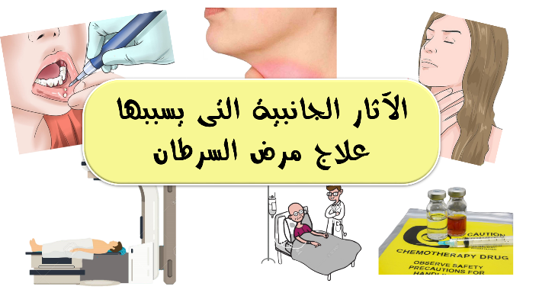
Recent Publications (minimum 5)
- Abu Abed, M., Himmel, W., Vormfelde, S., and Koschack, J., 2014. Video-assisted patient education to modify behavior: A systematic review. Patient Education and Counseling, 97 (1), 16–22.
- Blades, M., 2013. Nutrition for patients treated for cancer. Nutrition & Food Science, 43 (3), 236–242.
- Ferguson, L.A., 2012. Implementing a Video Education Program to Improve Health Literacy. The Journal for Nurse Practitioners, 8 (8), e17–e22.
- 4. Rauh, S., Antonuzzo, A., Bossi, P., Eckert, R., Fallon, M., Fröbe, A., Gonella, S., Giusti, R., Lakatos, G., Santini, D., and Villarini, A., 2018. Nutrition in patients with cancer: a new area for medical oncologists? A practising oncologist’s interdisciplinary position paper. ESMO Open, 3 (4), e000345.
- Wilson, E.A.H., Makoul, G., Bojarski, E.A., Bailey, S.C., Waite, K.R., Rapp, D.N., Baker, D.W., and Wolf, M.S., 2012. Comparative analysis of print and multimedia health materials: A review of the literature. Patient Education and Counseling, 89 (1), 7–14.

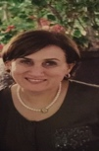 Biography
Professor Randa Reda Mabrouk is an Immunologist and Clinical Pathologist professor at Ain Shams University. She was assigned as a member of the National Committee for the Professors promotion in the whole country from the year 2013 till 2019. Currently she is the head of the Clinical Nutrition Master Board at the Faculty of Medicine and is the constructor of the first Clinical Nutrition Master for Physicians in Egypt and the Middle East at the Faculty of Medicine , Ain Shams University, Cairo, Egypt. She is also the head and constructed the Clinical Nutrition Diploma for the health Care Professionals and Physicians at the American University in Cairo. She is a passionate instructor in the field of nutrition in both programs and has many publications in the nutrition and immunology field. Her passion of medical education extends to the community awareness.
Email: randareda@gmail.com

Notes/Comments:
Video link: https://youtu.be/vTdHgwmg1IA
In case of being accepted , English subtitles will be delivered

