ANTIBACTERIAL EFFECT OF LANTANA CAMARA FRUIT AND STEM BARK EXTRACTION BY ETHANOL.

Mosisa Daba¹*,
1Department of Boilogy; Hawassa University. POBOX: 05, Hawassa, Ethiopia.

*principal author: e-mail:mosisadaba2007@gmail.com & Corresponding author

ABSTRACT
In view of the fact that ancient time, plants have been a tremendous source of medicine. Lantana camara has scientifically studied for various therapeutic activities like antioxidant, antipyretic, larvicidal, insecticidal, antimicrobial, wound healing and anti–hyperglycemic. The inhibitory effects of different extracts of leaves, immature and mature fruits of Lantana camara on the isolated bacterial strains in Mueller Hinton agar, using disc and well diffusion methods were studied. Inhibition zones were measured in mm 24 hours of incubation. All the dependent extracts have been found to inhibit the growth of tested bacterial strains. In general, regardless the method of study and type of extraction and parts of the plant, E.coli showed the most sensitivity, followed by Pseudomonas aeruginosa, Staphylococcus aureus, Proteus, Bacillus subtilis respectively and lastly Klebsiella. In disc method, E. coli and Pseudomonas aeruginosa were the most sensitive, followed by Proteus and finally the least sensitive were each of Bacillus subtilis, Staphylococcus aureus and Klebsiella. While in well method, E. coli and Staphylococcus aureus were the most sensitive, followed by each of Pseudomonas aeruginosa and Proteus, and lastly, the least sensitive was Klebsiella. Against mature fruit extract, the most sensitive strain was E. coli, followed by each of Pseudomonas, Staphylococcus aureus and Bacillus subtilis, and lastly the least sensitive was Proteus. Against immature fruit extract, S. aureus was the most sensitive, followed by each of Proteus, Pseudomonas, E. coli, Bacillus subtilis and lastly the least sensitive was Klebsiella. E.coli was the most sensitive followed by each of Pseudomonas and Proteus, and lastly Staphylococcus aureus and Klebsiella. Against aqueous extract, E. coli was the most sensitive, followed by each of Pseudomonas, Proteus and Staphylococcus and finally the least sensitive was Bacillus, while Klebsiella showed no sensitivity. While against alcohol extract, each of E. coli, Bacillus, Staphylococcus and Pseudomonas showed the same level of sensitivity, followed by Klebsiella and finally the least sensitive was Proteus. Key words: Lantana camara, Antibacterial, pathogenic bacteria

Keywords: Lantana camara, antibacterial effect, gram negative bacteria, gram positive bacteria. NDM1 strains, Antibacterial, pathogenic bacteria.

1. INTRODUCTION.
Antibiotics once hailed as the bedrock of modern medicine, may not work on infections in the present scenario where indiscriminate use of antibiotics resulted in drug resistant microorganisms (1). Whenever any problem goes out of our hand we used to pray to God nature to help us, similarly we believe that the nature has the answer for the antibiotic resistance also. If we do not develop new antibiotics to deal with the problems of resistance we will end up in serious trouble. Lantana Camara.L commonly known as weed or red sage is described as a notorious as well as an ornamental plant. The genus Lantana camara (Verbenaceae) as described by Linnaeus in 1753 contained seven species, six from South America and one from Ethiopia. Lantana camara from the Latin lento means to bend. Probably derives from the ancient Latin name of the genus Viburnum which it resembles a little foliage and inflorescence (2). Lantana camara.L commonly known as weed or red sage, unniceeti (Tamil), pulikampa (Telugu) and caturang (Hindi) is a significant weed commonly found throughout in India (3). It is ever green strong smelling shrub, with stout recurred prickles, leaves opposite, ovate or ovate –oblong, acute or sub acute, crenate -serrate, scab rid on both side (4). It is a woody straggling plant with various flower colors, red, pink, white, yellow and violet. The stems and branches are sometimes armed with prickles or spines. It was introduced in India as an ornamental plant but entirely naturalized and found throughout India3, it was listed one of the important medicinal plants of the world. The fruits are useful in fistula, pustules, tumors and rheumatism (5). In Asian countries, leaves were used to treat cuts, rheumatisms, ulcers and as a vermifuge. Decoctions were applied externally for leprosy and scabies. It has been claimed that a steroid, lancamarone, from the leaves exhibited cardiotonic properties (6). This study was undertaken to investigate the antimicrobial activity of Lantana camara. Linn leaves on gram negative organisms especially the NDM1 producing strains which were not explored previously.
The emergence of organisms resistant to nearly all classes of antimicrobial agents has become a serious public health concern in the past several years. The discovery of antimicrobial agents from plants based on the evaluation of traditional plant extracts is very important research topic (7). In last few decades, many of traditionally known plants have been extensively studies by advanced scientific techniques and reported for various medicinal properties , anticancer, antiinflammatory, antidiabetic, anthelmintic, antibacterial, antifungal, hepatoprotective, antioxidant and larvicidal activities(8). Extracts from the leaves have been reported to have antimicrobial, fungicidal, insecticidal and nematicidal activity (9).Leaves extract exhibit antiproliferative, antimicrobial, fungicidal, insecticidal and nematicidal activity (10).Lantana camara flower extract possess strong antibacterial activity. Yellow, lavender, red, and white Lantana camara, flowers displayed almost similar antibacterial activities (11).The chloroform extract of lantana camara showed activity against all three strains of Mycobacterium tuberculosis (12).Recently (13). Reported that the leaves extracts of Lantana camara are active against various Gram positive and Gram negative bacteria. The extract of flower, leaf, stem and root of Lantana camara showed antibacterial activity against E. coli, P. aeruginosa, S. aureus and S. saprophiticus (14).Different varieties of L. camara plants (leaves and flowers) were reported for antibacterial activity. Three different solvent extract of leaves and flowers of four different varieties of L. camara exhibited significant antibacterial activity against E. coli, Bacillus subtilis and P. aeruginosa while poor antibacterial activity against Staphylococcus aureus(15). Ethanolic extracts of L. camara leaves and roots were reported for antibacterial activity by micro dilution method. The extracts exhibited antimicrobial activity against Staphylococcus aureus, Proteus vulgaris, Pseudomonas aeruginosa, Vibrio cholareae, Escherichia coli and two multiresistant strains E. coli and S. aureus (16).Methanolic extracts of different parts of L. camara were screened for antimicrobial activity against 10 bacteria and 5 fungi by disc diffusion method and both showed highest activity against Gram positive Bacillus cereus and Gram negative Salmonella typhi (17).The plants that exhibit great activity could be considered as a source of potential antimicrobial compounds. Crude plant extract that were used in traditional folk medicine are still widely used to treat infections for their antimicrobial properties. Therefore it is

3. METHODOLOGY

3.1 Description of Study Area
The study was conducted at Hawassa University Biology Department. Hawassa is found 278.31km from Addis Ababa the capital city of Ethiopia, Hawassa University was found in the capital city of southern nation nationality and peoples region of Ethiopia. It is situated at elevation of 1697 meters above sea level. The average temperature of Hawassa city is between 20.8 and 33.5 ºC. The city is found at latitude of 7º03’43.38’’N and longitude 38º28’.46’’E. The compound of Hawassa University has a tropical savanna climate though it borders on a subtropical highland climate. There are two seasons: a lengthy wet season from March to October and a short dry season from November to February. The extra cloudness of the wet season is sufficient to make it substantially cooler than the dry season despite a higher sun angle; however, the coolest morning temperatures is often closer to freezing, during the dry season.
The sample (stem bark and fruit of Lantana camara were collected from Hawassa University around the stadium and the female student dorm at the back of Fm 97.7 Radio station respectively.
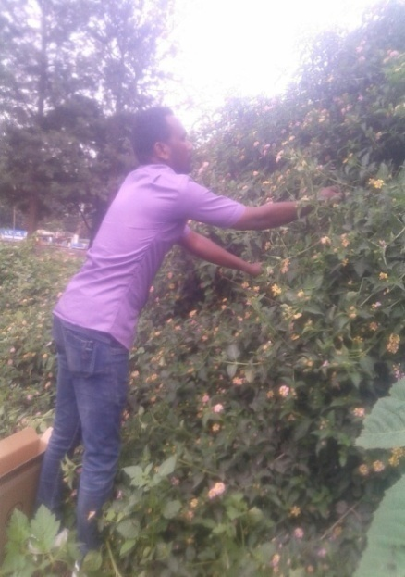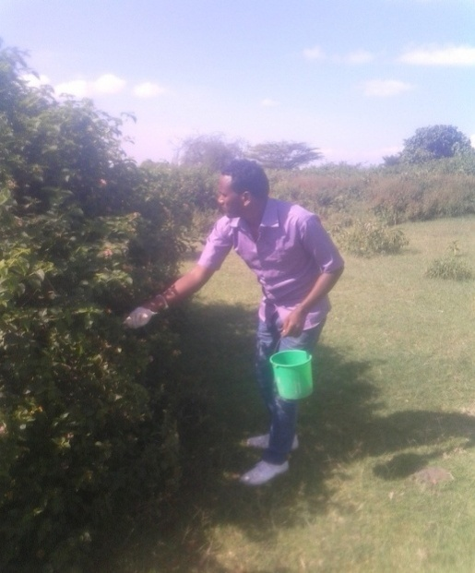
Figure 1.Collection of mature fruit lantana camara and stem bark.
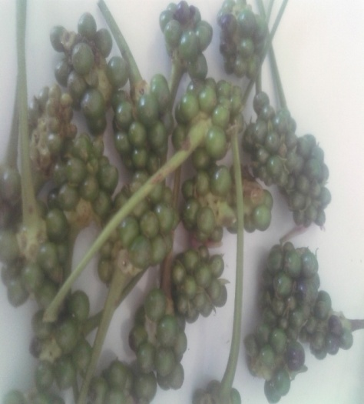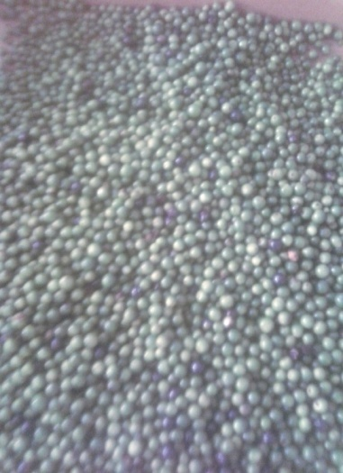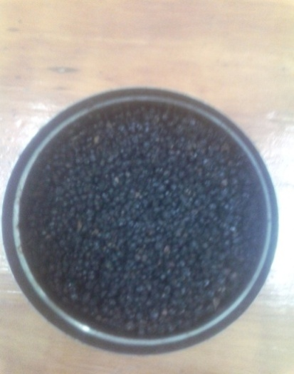
Figure 2.Mature of fruit Lantana camara after dried atroom temperature
SAMPLE PREPARATION
. Plant material fruit and stem bark of Lantana camara were collected in October 2017 from the Hawassa University around the female student dorm. The plant was indentified and certified by the botanical science teacher. Plant materials Fresh mature fruits of Lantana camara. Preparation of extracts Fresh fruit mature and stem bark of the plants were air dried at room temperature before grinding them to powder form with the help of mechanical grinder. 100 g of the air dried powder of each of fruit, mature and stem bark powder were filled in the thimble and extracted successively with 400 ml of ethanol solvent using a shaker extractor for 72 hours.
Measuring of Lantana camara fruit and stem bark and dissolving of Lantana camara fruit and stem bark powder by Ethanol.
Each extract was first filtered using Whatman No. 1 filter paper. Shaking of Lantana camara fruit and stem bark.B) FiltrationofLantana camara fruit and stem bark.
Shows during the removal of organic solvent (Ethanol) from the extraction by rotary evaporator.
The filtrate was evaporated under reduced pressure in vacuum evaporator. The dried crude extracts were sterilized overnight by UV radiation and stored at room temperature in amber color glass vials until used for antibacterial testing (39; 40; 41).
.

Preparation of the concentrations One gram of solvent residue was dissolved and used in the study for the antibacterial activity (20; 21; 22). The concentrations of 10%, 11.7%,,30% and 43% were used in this study. Test bacterial strains The following bacterial strains were used as test organisms: Staphylococcus aureus, Bacillus subtilis, E. coli, Pseudomonas aeruginosa, Klebsiella pneumonia Shigella boydi and Proteus vulgaris All the bacterial strains were obtained from Department of biology in micro Biology Laboratory.
Screening of extracts for antibacterial activity The antibacterial effects were tested by diffusion method (23). diffusion method was used to determine minimal inhibitory concentration. The bacteria to be tested were inoculated into nutrient agar, and incubated for 3-6 hours at 35oC. Petri dishes containing nutrient Agar were impregnated with these bacterial suspensions by streaking over the surface of the agar media using a sterile cotton swab to ensure uniform inoculation. Different concentrations of extracts (10%, 16.7%, 30%,43%) were prepared in with Distilled water Cork borer of 5 mm diameter were impregnated with different concentrations of each extract. The discs were then aseptically applied to the surface of the agar plates at well spaced intervals. Blank disc impregnated with DMSO was used as negative control and disc of standard antibiotics as positive control. The plates were incubated at 37oC for 24 hours. The zones of inhibition as well as the minimum inhibitory concentration were measured in mm (24; 25, 21).
Preparation of extracts Sample of fresh fruit and stem bark of Lantana camara were prepared using cold extraction method. A total of 400grams of fresh fruit and stem were placed in a flask containing cold ethanol separately and left for 72 hours at an ambient temperature. A rotary vacuum pump extractor were used to remove the ethanol from the extracts (under reduced pressure 80o C).The extract was weighed and stored under refrigeration at < 4o C until further testing Investigation of antibacterial activity Fully characterized, stocked strains of Gram negative bacteria Escherichia coli, staphylococcus aureus and fully characterized known NDM1 strains of Klebsiella pneumonia were used for the study.
The antibiotics used for the study were fruit and stem bark lantana camara cruidoil. Disc diffusion method 6 mm filter paper discs (Whatman, no. 1) were impregnated with 20 ml of each of the effective concentration of Lantana camara fruit extract 10%,16.7%,30% and 43% where used all the seven bacteraia. The diffusion were allowed to remain at room temperature until complete diluents evaporation and kept under refrigeration until ready to be used
The bacterial inoculum is adjusted to certain concentration, and inoculated on to the entire surface of a nutrient agar plate with a sterile cotton-tipped swab to form an even lawn. The loaded discs were placed onto the surface of the agar. Paper discs impregnated with 20 ml of diluents used to dilute natural products were used as control. Tests were performed in duplicate A Paper disc impregnated with distilled water was placed in all the culture plates separately to rule out any activity. Then the plates were incubated aerobically and the diameter of zone inhibition was measured by a ruler .Based on the diameter of the inhibiton zone The results are then assigned in two categories such as susceptible or resistant. The bigger the diameter of the inhibition zone, the more susceptible is the microorganism to the antimicrobial. Agar dilution method. Minimum inhibitory concentration (MIC) MIC by Agar dilution Technique It is a quantitative method for determining the minimum inhibitory concentration of the antibacterial agent against a given organism. It is mainly useful in testing isolates from serious bacterial infections or to verify equivocal results (e.g. intermediate susceptibility). The required dilutions of the antibiotics are made as follows: The stock solution was prepared using antibiotic/plant extract to be tested viz., extract 10%, 16.7%, 30% and 43% of distilled water. 0.2ml of above solution(200 µg/ml).. The minimum inhibitory concentration (MIC) was defined as the lowest extract concentration of fruit and stem bark extract of Lantana camara required to inhibit the bacterial growth by agar dilution test method. Preparation of agar plate with different concentration of the antibiotic/extracted.The plate must be dry before performing the test.A grid is marked on the bottom of the plates containing antibiotics 20-25 strains can be test in plate control. The organisms to be tested are inoculated into peptone water and Incubated at 37 ̊C for 3-4 hours. Inoculation is done starting with the plates containing highest dilution of the antibiotic. A control plate without lantana camara is simultaneously inoculated Allow the drops to dry and incubate the plates without inverting at 37 C for 16-18 hours. Antibacterial potentiating effect of Lantana camara fruit and stem bark extract by using diffusion method In order to evaluate the antibiotic potentiating effect of fruit and stem bark extract of the different concentration the MIC of fully characterized stocked strains of gram negative and gram positive bacteria those bacteria are Staphylococcus aureus, Escherichia coli, Pseudomonas aeruginosa, Proteus vulgaris, , Bacillus subtilis, , and. . Klebsiella pneumonia Shigella boydi.

3.2 Phytochemical analysis of plant extracts
The Phytochemical analysis of Lantana camara crude extracts were carried out to determine the presence of the following biomolecules using standard procedures. The Lantana camara fruit extract was analysis by different reagent and chemical determine the presence and absence of the following test.
3.2.1Test for tannins
About 0.01g of the crude extract was boiled in 20 ml of water in a boiling tube. Few drops of 0.1 % of FeCl₃ were added. Formation of brownish green or a blue black coloration indicated the presence of tannins.

3.2.2 Test for saponins
About 0.01 g of the crude extract was boiled in 20 ml of distilled water in a water bath. Then it was mixed with 5 mlof distilled water and it was shaken well. Stable persistent froth indicated the presence of saponins.

3.2.3 Test for phlobatanins
About 0.01 g of the crude extract was boiled with 1 % aqueous hydrochloric acid. A deposition of a red precipitate indicated the presence of phlobatanins.

3.2.4 Test for flavonoids
About 0.01 g of the crude extract was dissolved in 2 ml of ethanol solvent. Con. HCl and Mg turnings were added. Formation of yellow color indicated the presence of flavonoids

3.2.5 Test for steroids
About 0.01 g of the crude extract was dissolved in 2 ml of ethanol solvent. 2 ml of acetic anhydride and 2 ml of con H₂SO₄ were added. A color change from violet to blue or green indicated the presence of steroid

3.2.6 Test for cardiac glycosides
0.01g of the crude extract was dissolved in 2 ml of ethanol and then 2 ml of glacial acetic acid containing one drop of ferric chloride solution was added. This was underplayed with 1 ml of con. H₂SO₄. Appearance of brown ring indicated the presence of the cardiac glycosides.

3.2.7 Test for alkaloids
About 0.01 g of crude extract was dissolved in ethanol and it was divided into two parts. Few drops of Mayer’s reagent were added to one part. A creamy white precipitate indicated the presence of alkaloids. Few drops of Wagner’s reagent were added to other part. A red-brown color precipitate indicated the presence of alkaloid

3. Experimental Design
Four treatments with different concentration of lantana camara fruit and stem bark extract and one control group are used in this experiment. It was conducted in Completely Randomized Design (CRD) with four replications. The four treatments prepared by adding the concentration of 10%, 16.7%, 30% and 43% extract and without any addition considered as control group for comparing the effect, 0.2ml four concentrations were used for each and allowed for inhibition.
4. Statistical analysis All values are expressed as the mean ± the standard error of the mean (SEM). The data were analyzed by using one way analysis of variance ANOVA, and then the test of the least significant differences between the means of inhibitory zones (26). The significant level of test was P <0.05.

5. RESULTS AND DISCUSSION
Different extract of lantana camara were tested against bacteria strain from Hawassa University micro biology laboratory using well diffusion method. All the extract prepared from the fruit and stem bark o lantana camara have been found inhibit the growth of bacteria strains. The result revealed that aqueous extract lantana camara stem bark showed significant inhibitory activity Staphylococcus aurous, Escherichia coli, Pseudomonas aeruginosa, Proteus vulgaris, , Bacillus subtilis, , and. . Klebsiella pneumonia Shigella boydi compared to fruit extract lantana camara. Increases the concentration the inhibition of bacteria are increase and the concentration decreases the inhibition of bacteria decrease. The inhibitor of all bacteria where not equal the more inhibited by lantan camara fruit extraction are Klebsiella pneumonia, Proteus vulgaris and Shigella boydi but Staphylococcus aureu sand Bacillus subtilis less inhibited by extraction .the other are medium indicated by table one blow.
Fruit lantana camara extract inhibition of bacteria table
Table 1
 | Lantana camara concentration percent
Strain of Bacteria | 10% | 16.7% | 30% | 43%
Staphylococcus aureus | 0.25cm | 0.85cm | 1.9cm | 2.625cm
Escherichia coli | 1.2cm | 1.67cm | 2.75cm | 3.4cm
Pseudomonas aeruginosa | 1.3cm | 1.5cm | 2.375cm | 3.25cm
Proteus vulgaris | 1.5cm | 2cm | 2.15cm | 2.25cm
Bacillus subtilis | 0.875cm | 1.4cm | 2.25cm | 3.4cm
Klebsiella pneumonia | 1.5cm | 1.75cm | 2.15cm | 3.75cm
Shigella boydi | 1.65cm | 1.85cm | 2.5cm | 3.5cm

The resistance and sustainable of different strain of bacteria were different because one more resistance and the other more sustainable. The resistance and sustainability of bacteria are depend on the concentration and strain type.
Graph 1.Lantana camara minimum concentration( 10%) of fruit lantana camara extraction by ethanol illustrate by the graph all the bacterian strain
Graph 1.

Lantana camara fruit extraction by ethanol were inhibit bacteria the inhibition was depend on the concentration and type of bacteria strain. The 10% and 43% are not equal inhibit the more concentration was more inhibited than the less concentration and the Klebsiella pneumonia was more inhibited by the concentration than the other bacteria strain and Proteus vulgaris was less inhibited than the other bacterian strain.The concentration percent increase the inhibition of bacteria were increase 10% and43% were different.The graph was illustrated the growth of bacteria inhibited by fruit lantana camara 43% by different bacteria strain.

Graph.2

Incease the concentration the inhibition of bacteria are increase and the concentration decrease the inhibition of bacteria decrease.The inhibion of all bacteria where not equal theone more inhibited by lantan camara fruit extraction are Klebsiella pneumonia, Staphylococcus aureus and Shigella boydi but Bacillus subtilis less inhibited by extraction .the other are medium indicate by table two blow
Stem barklantana camara extract inhibition of bacteria table
Table 2
 | Lantana camara concentration percent
Strain of Bacteria | 10% | 16.7% | 30% | 43%
Staphylococcus aureus | 2.375cm | 2.875cm | 3.375cm | 4cm
Escherichia coli | 1.75cm | 2.5cm | 3.375cm | 4.25cm
Pseudomonas aeruginosa | 1.75cm | 2.15cm | 2.375cm | 3.25cm
Proteus vulgaris | 2cm | 2.35cm | 3.15cm | 4.15cm
Bacillus subtilis | 1.375cm | 2.56cm | 3.5cm | 3.85cm
Klebsiella pneumonia | 2cm | 2.75cm | 3cm | 3.85cm
Shigella boydi | 2.15cm | 3cm | 3.5cm | 3.89cm

Lantana camara stem bark extracted by ethanol was more inhibited growth of bacteria than the fruit exctracted .the graph below was illustrated stem bark lanatana camara extract low percent(10%)inhibition of different bacterian strain.
Graph.3.lantana camara stem bark extraction10% concentration bacteria inhibition.

The graph below was illustrated stem bark lanatana camara extract hight percent(43%)inhibition of different bacterian strain.
Graph.4.lantana camara stem bark extraction43% concentration bacteria inhibition.

6. CONCLUSIONS
Under laboratory conditions the presence of fruit and stem bark extract Lantana camarawere one of the major factors responsible for bacteria inhibition. However, findings have shown that antibiotic interactions between bacteria and lantana camara were also partly responsible for such losses in bacteria growth.Lantana camarais one of the antibacteria which have bacteria growth.The researcher could observed laboratorically by taking the fruit and stem bark extracts of lantana camara which have effects o bacteria growth( inhibition bacteria). Laboratory bioassay on growth of bacteria.The test bacteria strain was investigated under Ethanol fruit extracts of different concentrations 10, 16.7, 30 and 43%).
The results showed that the solvents extracts of Lantana camarahave antibiotic effect ofbacterian strain. Growth parameters and performance of the test bacteria were inhibited in concentration dependent manner. Comparison between different concentration ethanol extracts showed that the high concentration extracts had higher effect(inhibited) on the measured parameter than low Ethanol extract. However, fruit and stem bark lantana camara extract concentration was toxicity test made in the laboratory and affection growth of bacteria .The comparison between fruit and stem bark lantana camara were the stem bark was more effect on bacteria growth than the fruit because on the fruit extraction control, 10 %& 16.7% the inhibition was decreased when the concentration was increased On the 30% & 43%the inhibition also increase.
The stem bark extraction of Lantana camara was more inhibited tha fruit lanatana camara extraction Depend on those result I concluded that the stem bark was more antibiotic than fruit extraction ..

Acknowledgments
I would like to express my deepest gratitude to my brother Lami Daba forhis helped critical sample collection and encouragement throughout the entire period of senior projects work. I would also like to thank my friends for his relentless guidance and valuable comments on the senior projects, and encouragement during the course of my research work.

Appendex
Figure 1.fruit lantana camara etraction inhibition of bacteria.
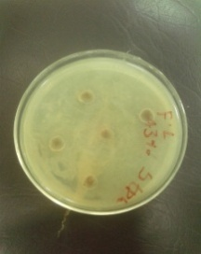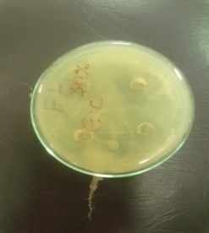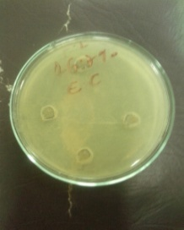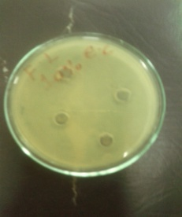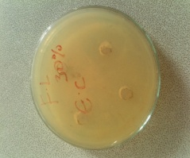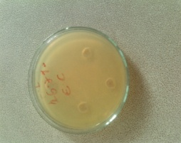
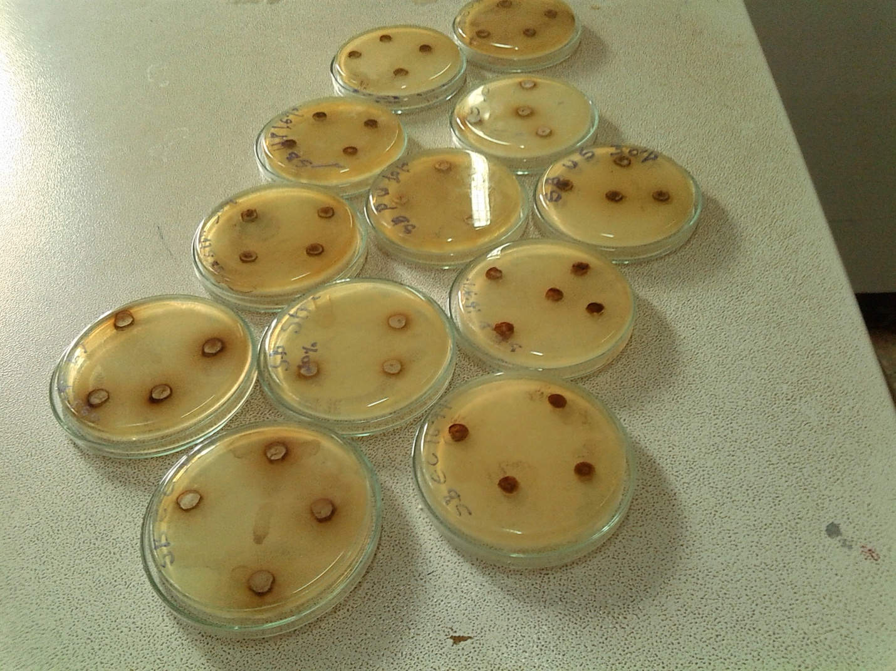

Figure 2.stem bark lantana camara extraction inhibition of bacteria

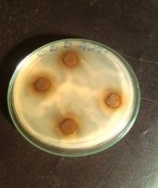 | 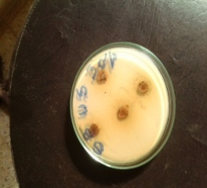 | 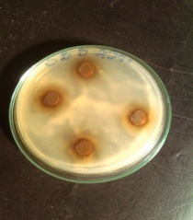 | 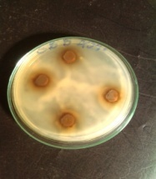 | 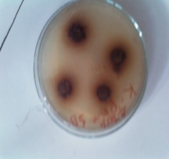 | 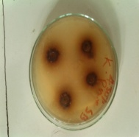
 |  | 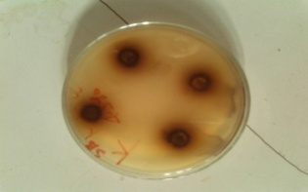 | 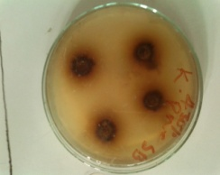

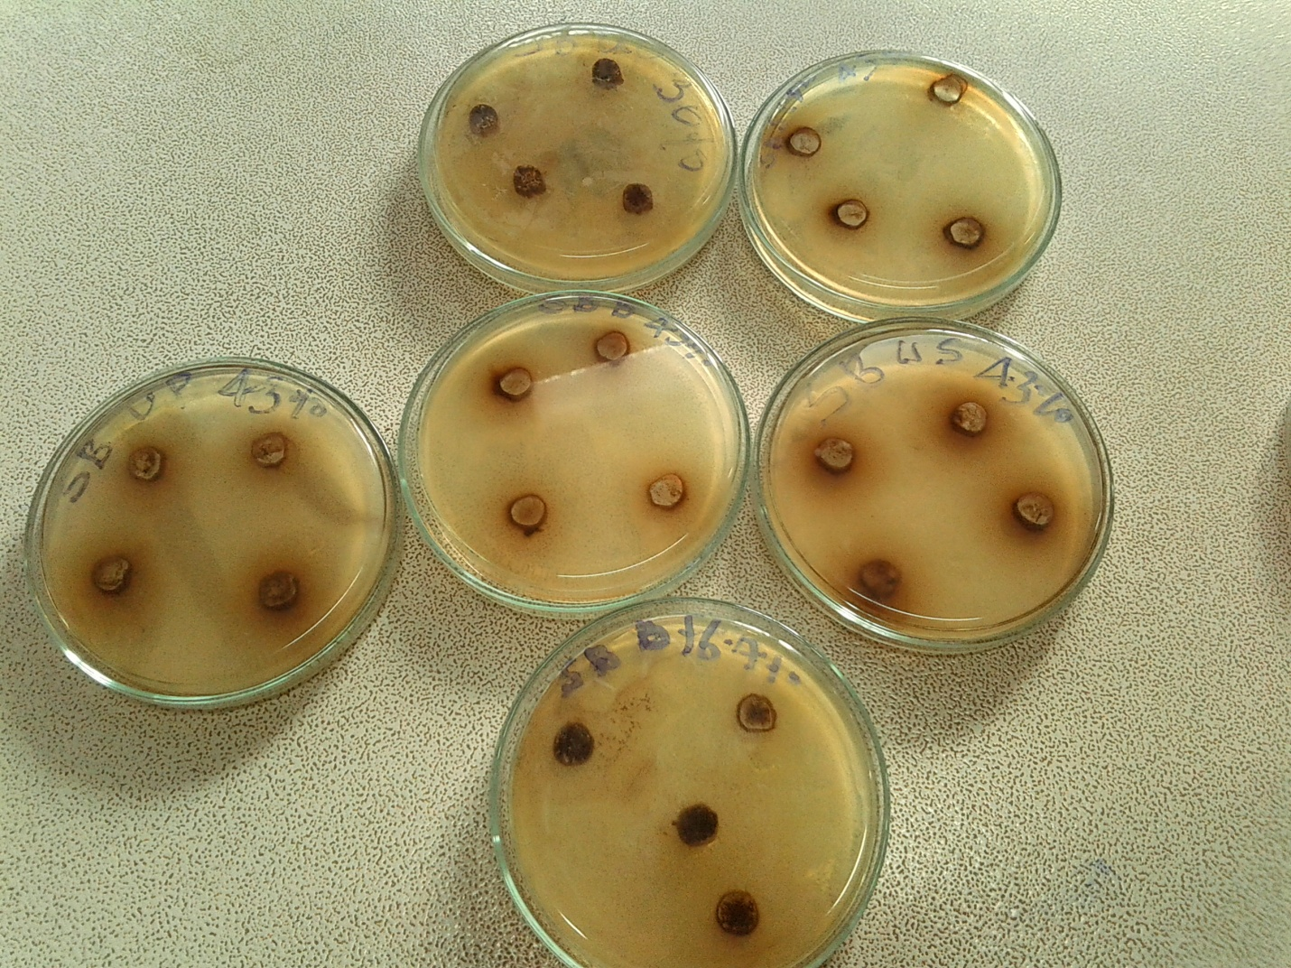

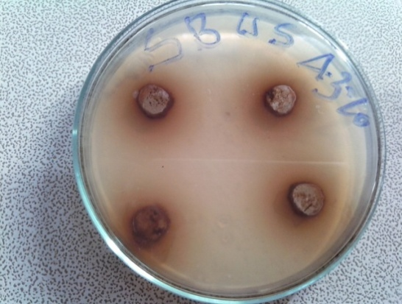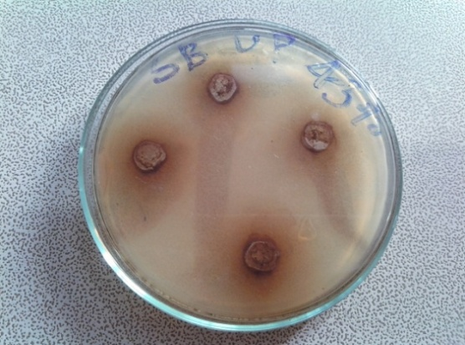

REFERENCES
(1). Céire Costelloe : Effect of antibiotic prescribing in primary care on antimicrobial resistance in individual patients: systematic review and meta-analysis. BMJ (2010;) 340 doi : http://dx.doi.org/10.1136/bmj.c2096.
(2). E.L. Ghisalberti. Lantana camara L._(Verbenaceae) Fitoterapia 71(2000).467-486
(3). N.A. Aravind1 etal. Impact of the invasive plant, Lantana camara, on bird assemblages at
( 4). )Malé Mahadeshwara Reserve Forest, South India. Tropical Ecology 51(2S): 325-338, 2010
( 5). Ganesh T,Saikat sen, Thilagam G, Loganathan, TRaja Chakaraborty, Pharmacognostic and anti hyperglycemic evaluation of lantana camara (L)var. aculeate leaves in alloxan – induced hyperglycemic rats.Int.j.Res.Pharm. Sci. vol – 1,Issue - 3, 2010, 247- 252.
( 6) CSIR. The useful plants of India. Publication and Information Directorate, CSIR, New Delhi, 1992:316.
[7] DidemD, Berrin, O., Sanem, H., Mecit, V. Assessment of antioxidant, antibacterial, anti mycobacterial and antifungal activities of some plants used as folk remedies in turkey against
dermatophytes and yeast – like fungi. Turk. L. Biol. (2012). Vol. 36,pp 672-686
[8] Kumar, G., Karthik, L., Rao, K.V.B. In vitro antimicrobial activity of latex of Calotropisgigan tea against pathogenic microorganisms. (2010). Vol. 3,pp 155-163.
[9] Saksena, N., Tripathi, H.H, Plant volatiles in relation to fungistasis. Fitoterapia. . (1985),Vol. 56,pp 243- 244
(10) Saxena, R.C., Dixit, O.P., Harsttan V. Insecticidal action of Lantana camara against Callosobruchuschinrensis (Coleoptera Bruchidae). Jou. Stored Pro. Res. (1992),Vol. 5,pp230-235
(11) Deepak, G., Silviya, S., Kishwar, H.K.H. Biochemical compositions and antibacterial activities of Lantana camara plants with yellow lavender, red and white flowers. Eurasia. Jour.
Bio.Sci (2009), Vol.3, pp 69-77.
(12) Claude, K., Paul, W., Moses, J., Olwa, O.The anti-mycobacterial activityof Lantana camara a plant traditionally used to treat symptoms of tuberculosis in Southy–Western.(2009).
(13) Ashish, S.S., Quereshi, K., Sharma, K.H. Antimicrobial activity ofLantana camara. Jour. Experi. Sci. .(2011),Vol. 2,pp50- 54.
(14).Mary, K. V. Studies on phytochemicalscreening and antibacterial activities of
Lantana camara. Plant Sci. Feed.( 2011),Vol .1,pp74-79.
(15).Ganjewalla, D., Sam, S., Khan, K.H.. Biochemical compositions and antibacterial activities of Lantana camara plants with yellow, Lavender,red and white flowers. EurAsian
Journal of BioSciences. (2009),Vol. 3,pp 69- 77
(16) Barreto, FS., Sousa, EO., Campos, AR., Costa, JGM., Rodrigues, FFG.. Antibacterial activity of Lantana camara Linn and Lantana montevidensis Brig extracts from Cariri –ceara, Brazil. Journal of young Pharmacists (2010).Vol. 2,pp 42-44
(17) Badakhshan, M.P., Sasidharan, S.,Rameshwar, N.J., Ramanathan, S.. Comparative study. (2009).
(18) Kan, A., Ozcelik, B., Kartal, M.. Invitro antivirus activities under cytotoxic diseases against herpessimple type- 1 and para influenza – 3 viruses of Cicerarietinum L . Afr. J. Pharm. Pharmaco (2009 ).Vol.3,pp 627–631.
(19) Harborne, J. B. (1984). Phytochemical methods. A Guide to modern technique of plant analysis. II edition, Chapman and Hall, London, New York . 2nd ed.: 1 – 228
(20) Okeke, M.I., Iroegbu, G.U., Eze, E.N. (2001). Evaluation of extracts of the root of Landolphia Overrience for antibacterial activity. Journal of Ethanopharmacology. 78: 27-119.
(21) Karaman, I., Sahin, F., Gullile, M. (2003). Antimicrobial activity of aqueous and methanol extracts of Juniperus Oxycedrus L. Journal of Ethanopharmacology. 85: 5- 231
(22) Mingarro, D.M., Acero, N., Linares, F., Pozuelo, J.M., Mera, AC., Peres C. (2003). Biological activities from Catalenbignonoideswalt.(Bignonoiecea e). J. Ethnopharmacol. 87:163-167
(23) Bauer, R.W., Kirby, W. D. K., Sherris, J.C., Turk, M. (1966). Antibiotic susceptibility testing by a standardized single disc method. Am. J. Cl. Pathol. 45: 493- 496.
(24) Srinivasa, D., Nathan, S., Suresh, T., Permuasamy, O. (2001). Antimicrobial activity of certain Indian Medicinal Plants used in folk loric Medicine, J. Ethanopharmacol.74: 217- 220
(25) Masika, P.J., Afolayan, A.J. (2002). Antimicrobial activity of some plants use for the treatment of livestock disease in the Eastern Cape. South Africa Journal of Ethanopharmacology. 83: 34 -129.
(26) Steel, R. G., Torrie, J. H. (1985). Principles and procedures of statistics, a Biometrical Approach, 2nd ed., McGraw – Ho; Inc, Singapore. 183.

