Guided Bone Regeneration (GBR) with non-resorbable titanium-reinforced membranes versus titanium-meshes and resorbable membranes

ALESSANDRO CUCCHI DDS, MSClin, PhD
Alma Mater Studiorum – University of Bologna – Bologna - Italy

Abstract

Guided Bone Regeneration (GBR) has proven to be a successful and predictable technique for vertical and horizontal ridge augmentation in short- and long-term studies. However, the newly-formed bone could have a significant resorption and the implant survival and success rate could be minor than implant placed in native bone. The aim of this randomized clinical trial is to compare 2 different approaches for Guided Bone Regeneneration (GBR) in posterior region of atrophic mandibles, in order to find differences regarding the reconstructed bone volume. Forty partially edentulous patients, who require a three-dimensional bone regeneration and an implant-prosthetic rehabilitation, were randomly divided into two groups and consecutively treated by means of d-PTFE titanium-reinforced membranes (group A) or titanium meshes covered by cross-linked collagen membranes (group-B). Bone augmentation and implant surgery were performed simultaneously according a GBR technique (t0). A mixture 50:50 of autogenous bone and bone allograft was used. After 9 months of submerged healing, reopening surgery was performed (t1). After 3 months, the definitive restoration of implants was accomplished (t2). All surgical and healing complications, peri-implant bone defect, vertical bone gain, and other variables were recorded and analyzed. The patient was regarded as the statistical unit of analysis and the collected data were subjected to statistical analysis to observe any statistically significant differences (P=0.05). The result of this study showed that d-PTFE membranes and titanium meshes plus collagen membranes have similar results regarding healing complications rates, peri-implant bone defects, and vertical bone gain. Since an adequate bone augmentation was achieved if no complications occurred, GBR can be considered a sustainable solution for restoration of atrophic posterior mandible.

Images

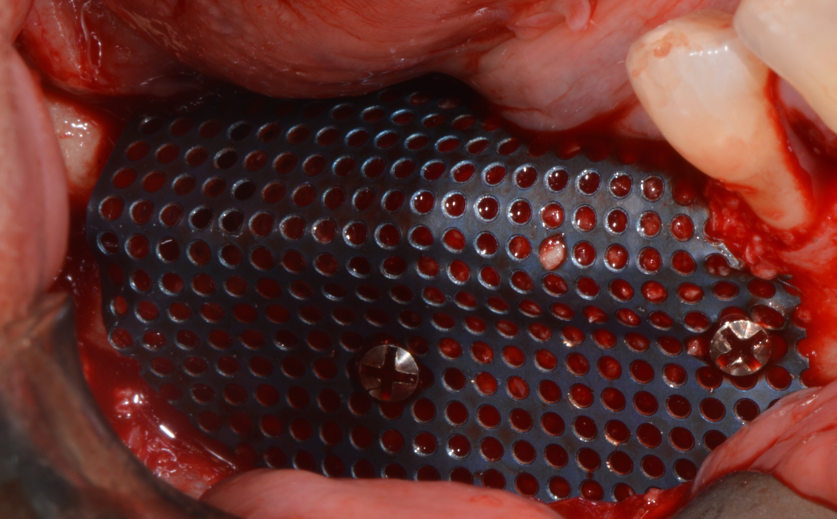 Fig. A

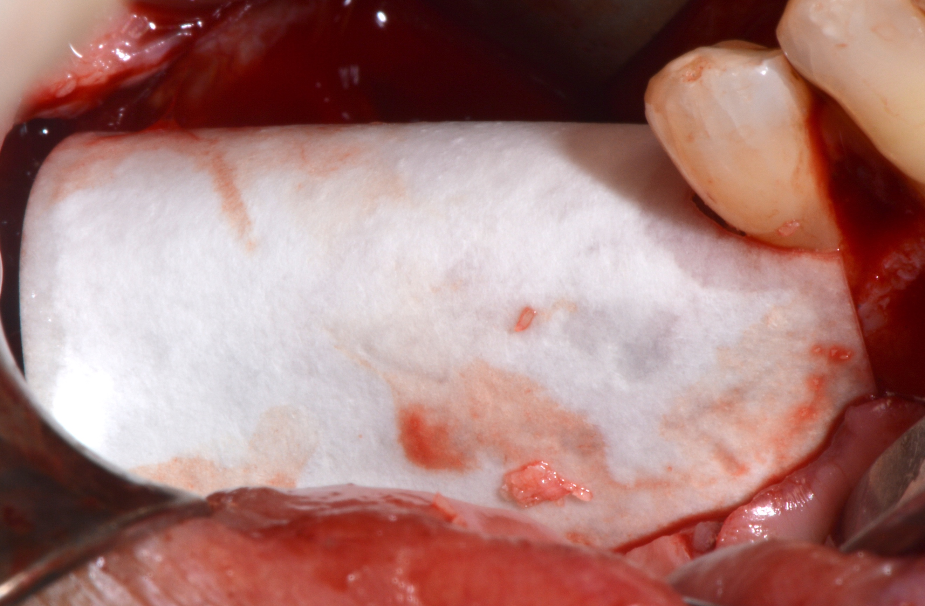 Fig. B

Recent Publications

Cucchi A, Vignudelli E, Napolitano A, Marchetti C, Corinaldesi G. Evaluation of complication rates and vertical bone gain after guided bone regeneration with non-resorbable membranes versus titanium meshes and resorbable membranes. A randomized clinical trial. Clin Implant Dent Relat Res. 2017 Oct;19(5):821-832.

Cucchi A, Ghensi P. Vertical Guided Bone Regeneration using Titanium-reinforced d-PTFE Membrane and Prehydrated Corticocancellous Bone Graft. Open Dent J. 2014 Nov 14;8:194-200.

Garcia J, Dodge A, Luepke P, Wang HL, Kapila Y, Lin GH. Effect of membrane exposure on guided bone regeneration: A systematic review and meta-analysis.
Clin Oral Implants Res. 2018 Jan 24. 10.1111/clr.13121.

Ronda M, Rebaudi A, Torelli L, Stacchi C. Expanded vs. dense polytetrafluoroethylene membranes in vertical ridge augmentation around dental implants: a prospective randomized controlled clinical trial. Clin Oral Implants Res. 2014 Jul;25(7):859-66.

Rocchietta I, Simion M, Hoffmann M, Trisciuoglio D, Benigni M, Dahlin C. Vertical Bone Augmentation with an Autogenous Block or Particles in Combination with Guided Bone Regeneration: A Clinical and Histological Preliminary Study in Humans. Clin Implant Dent Relat Res. 2016 Feb;18(1):19-29.

Biography

Dr. Alessandro Cucchi earned his DDS degree from the University of Verona in Italy and completed his post graduate degree in oral surgery at the University of Milan in Italy. He then received his PhD in surgical science from the University of Bologna in Italy, and finally he completed a continuing education course in Periodontal Plastic and Regenerative Surgical Techniques at the University of Milan. Dr. Cucchi is a visiting professor at the master’s program in oral surgery and implantology at the University of Bologna. He has published several scientific articles in implantology and oral surgery in international peer-review journals, and he is speaker at training courses and scientific meetings focused on implantology and reconstructive surgery. Dr. Cucchi dedicates his private practice to periodontology, implantology, and reconstructive surgery of the hard and soft tissues of the oral cavity.

Presenting author details

Full name: Alessandro Cucchi
Contact number: +393477479741
Linked In account: Alessandro Cucchi
Instagram account: Alexandercookies
Session name/ number: Oral Surgery
Category: Oral presentation

