Effects of colchicine on major adverse cardiac events in next 6‑month period after acute coronary syndrome occurrence; a randomized placebo‑control trial
Hamed Bazrafshan M.D.
Department of Cardiology Medicine, Al‑Zahra Charity Hospital, Shiraz University of Medical Sciences

Abstract

Myocardial infarction (MI), myocarditis, stroke, tachyarrhyth- mias, and pulmonary embolism have been reported as compli- cations of coronavirus disease-2019 (COVID-19). However, clinical characteristics and outcomes of bradyarrhythmias in this pandemic is less investigated. Here, we describe a complete heart block secondary to fulminant myocarditis in a patient who has recovered from COVID-2019.

We describe the first case report of fulminant myocarditis and complete heart block which was initially presented by severe systolic dysfunction and tachyarrhythmia, in a patient who recently recovered from covid-19. Continuous close follow-up should be considered for patients infected with COVID-19 after dis- charge, especially for those with any metabolic and pharmacologic risk factors for the conductive block to recognize these rare complications and reverse CHB early by administering a high dose of corticosteroid or other anti-inflammatory medications.

Learning objective: To illustrate the presentation of COVID-19 fulminant myocarditis by severe sys- tolic dysfunction, tachyarrhythmia, and different degrees of atrioventricular block. To introduce the proper management of fulminant myocarditis in a patient who recently recovered from covid-19.
Image
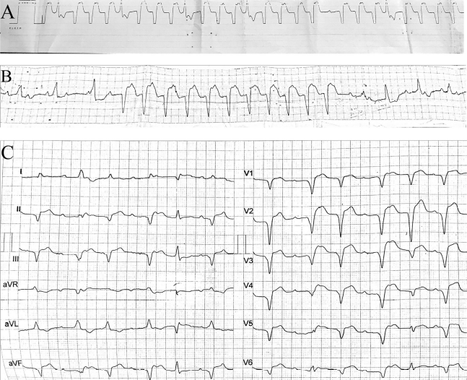
Fig. 1 Rhythm series of the patient (A) Repetitive sustained ventricular tachycardia (B) Complete heart block accompanied by non-sustained ventricular tachycardia (C) Complete heart block with two different escape rhythm and one of the escape focus could be explained as parasystole mechanism (D) The first degree AVB with LBBB (E) The first normal sinus rhythm after CHB.
Recent Publications (minimum 5)
- Nikoo, M. H., Mozaffari, R., Hatamnejad, M. R., Bazrafshan, M., Kasaei, M., & Bazrafshan, H. (2021). Systolic dysfunction and complete heart block as complications of fulminant myocarditis in a recovered COVID-19 patient. Journal of cardiology cases.
- Jahangiri, S., Mousavi, S. H., Hatamnejad, M. R., Salimi, M., & Bazrafshan, H. (2022). Prevalence of non‐steroidal anti‐inflammatory drugs (NSAIDs) use in patients with hypertensive crisis. Health Science Reports, 5(1), e483.
- Hatamnejad, M.R., Heydari, A.A., Salimi, M., Jahangiri, S., Bazrafshan, M. and Bazrafshan, H., 2022. The utility of SYNTAX score predictability by electrocardiogram parameters in patients with unstable angina. BMC Cardiovascular Disorders, 22(1), pp.1-11.
- Hatamnejad, M. R., Tafti, F. F., Abdi, A., Boogar, S. S., & Bazrafshan, H. (2021). Coronary Thrombosis in a Patient with COVID-19 Who Was on Anticoagulant Therapy. International Cardiovascular Research Journal, 15(3).
5. Zibaeenezhad, M. J., Sayadi, M., Bazrafshan, H., Daneshvar, Z., Parsa, N., Farshadi, N., ... & Razeghian-Jahromi, I. (2021). The Prevalence of Cardiovascular Risk Factors in Fatal Cases of COVID-19 in Fars Province, Iran. International Cardiovascular Research Journal, 15(1).

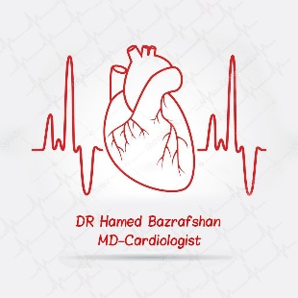

 Biography
I am a dedicated and caring cardiologist with more than four years of experience in clinical practice, helping over 70 patients with their cardiac ailments daily, conducting research on cardiovascular disease, and treating patients accordingly. I have been working at the Shiraz University of Medical Science, teaching medical students and residents of cardiology. Proficiency in teaching clinical cardiology and serving as problem-based learning (PBL) tutor at various stages in the medical program (The best attending of shiraz medical university at education). I have worked as a senior researcher at the cardiovascular research Centre of shiraz university.
Email: Hamedbazrafshan@yahoo.com

Notes/Comments:

Presenting author details
Full name: Hamed Bazrafshan
Contact number: +989177120900
Category: Oral presentation

