ABSTRACT

Isolated Capitate Fracture-Dislocation : A Rare and Frequently Missed Diagnosis
M. Souissi, S. Kallel
Tunis, Tunisia

Isolated fractures of the capitate bone are rare as it is surrounded and reinforced by other carpal bones. They usually occur in association with other carpal injuries. These fractures often go unnoticed on initial radiographs, resulting in complications related to the disruption of blood supply. We present a case of an isolated fracture dislocation of the capitate, with a 180° rotation of the proximal fragment.
A 32-year-old right-handed plumber, presented to our emergency department following a MVA resulting in a direct trauma to the dorsal aspect of the left wrist. Physical examination revealed a swelled and a functionally impotent wrist and hand. Plain radiographs showed a fracture of the proximal phalanx 3rd finger and a gap of the capitate head. The patient had a cast, and a CT-scan was performed at 1 month of follow-up, since the pain was persistent. It confirmed a fracture of the capitate head with a dislocated and rotated proximal fragment of 180°, with foci of avascular necrosis. The patient underwent an arthroscopic removal of the proximal fragment and a wrist denervation, by transecting the posterior interosseous nerve.
Isolated fractures of the capitate bone are rare and account for only 1.3% of carpal fractures, as it’s the largest and most protected of the carpal bones[1]. It usually occurs in concordance with other carpal fractures, mainly a peri-lunate fracture dislocation or the scapho-lunate syndrome of Fenton : a fracture of the scaphoid and capitate with a rotation of the proximal fragment of 90° to 180°. [2]

Adler et al. proposed three mechanisms for capitate fractures, based on their experience. Most commonly a fall onto the palm with forced extension of the wrist, a direct trauma to the dorsal surface of the carpus, and least commonly, a fall onto a forcefully flexed wrist[3].

Displaced fractures of the Capitate necessitate anatomic repositioning and internal fixation with either headless compression screws (allowing compression and early motion) or K-wires to avoid avascular necrosis.[4]

Increased displacement of capitate fractures is responsible for disruption of the blood supply, and the devascularization of the proximal pole. Similar to the scaphoid, the Capitate is perfused in a retrograde scheme[2]. The delay of diagnosis and the lack of initial treatment, especially in highly displaced fractures, as was our case, can lead to non-union or eventually avascular necrosis.

-1- Kadar A, Morsy M, Sur YJ, Akdag O, Moran SL. Capitate Fractures: A Review of 53 Patients. J Hand Surg Am. 2016 Oct;41(10):e359-e366. doi: 10.1016/j.jhsa.2016.07.099. Epub 2016 Aug 11. PMID: 27524693.
-2- Ting M, et al. Pancarpal dissociation with palmar Capitate fracture-dislocation: Case report. Orthop Traumatol Surg Res (2017), http://dx.doi.org/10.1016/j.otsr.2016.12.023
-3- Adler JB, Shaftan GW. Fractures of the Capitate. J Bone Joint Surg 1962;44-A:1537–47.
-4- Sabat, Dhananjaya et al. “Isolated capitate fracture with dorsal dislocation of proximal pole: a case report.” Hand (New York, N.Y.) vol. 6,3 (2011): 333-6. doi:10.1007/s11552-011-9337-5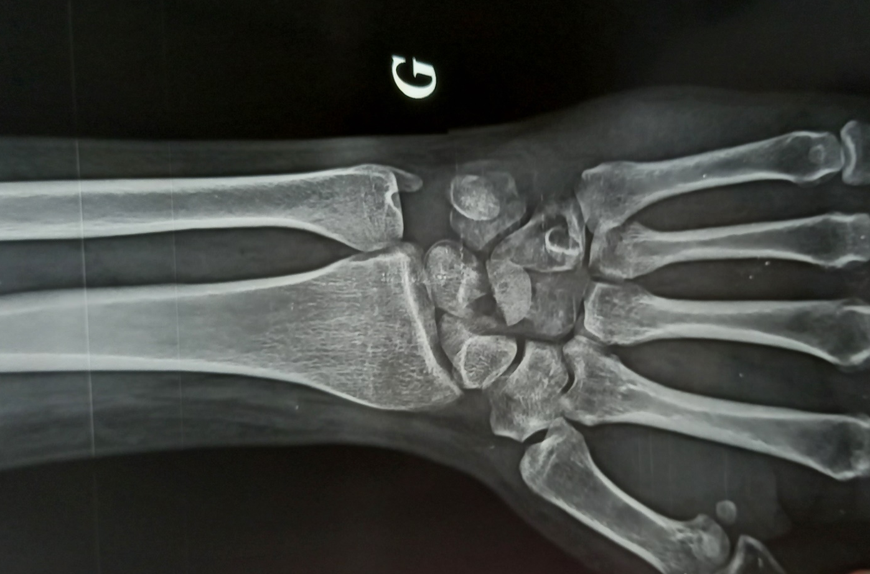

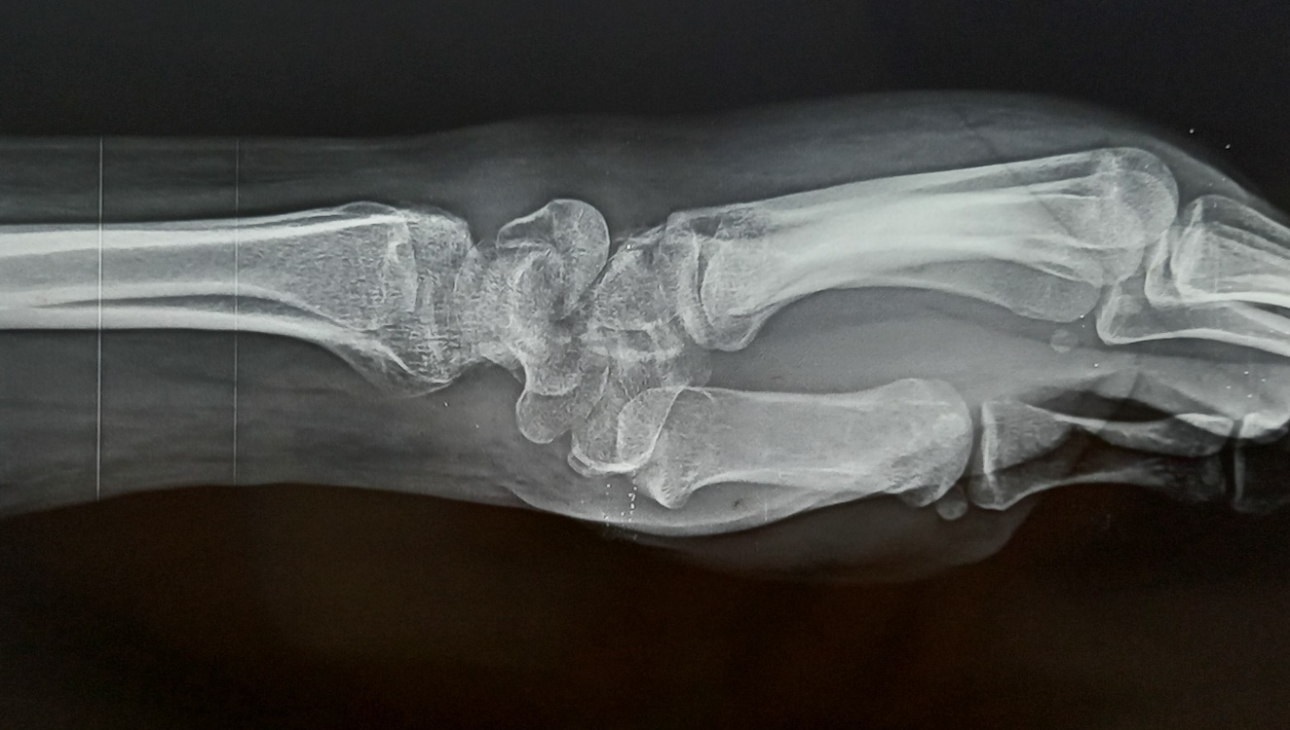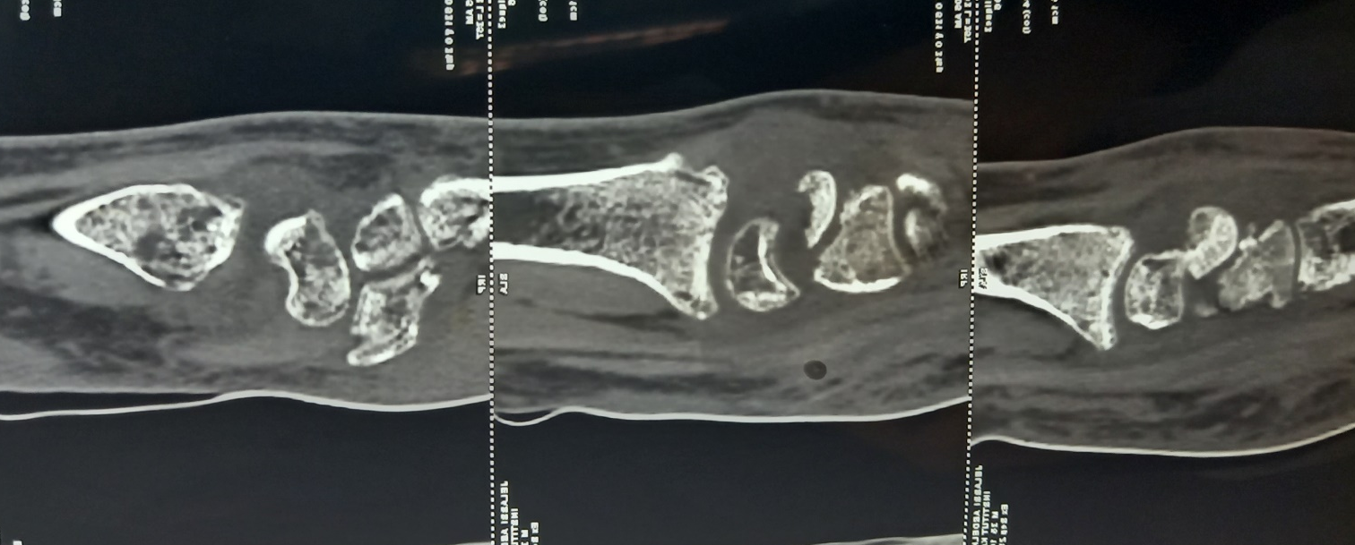

Souissi.meriem2@gmail.com
Sofiene.kallel@gmail.com

