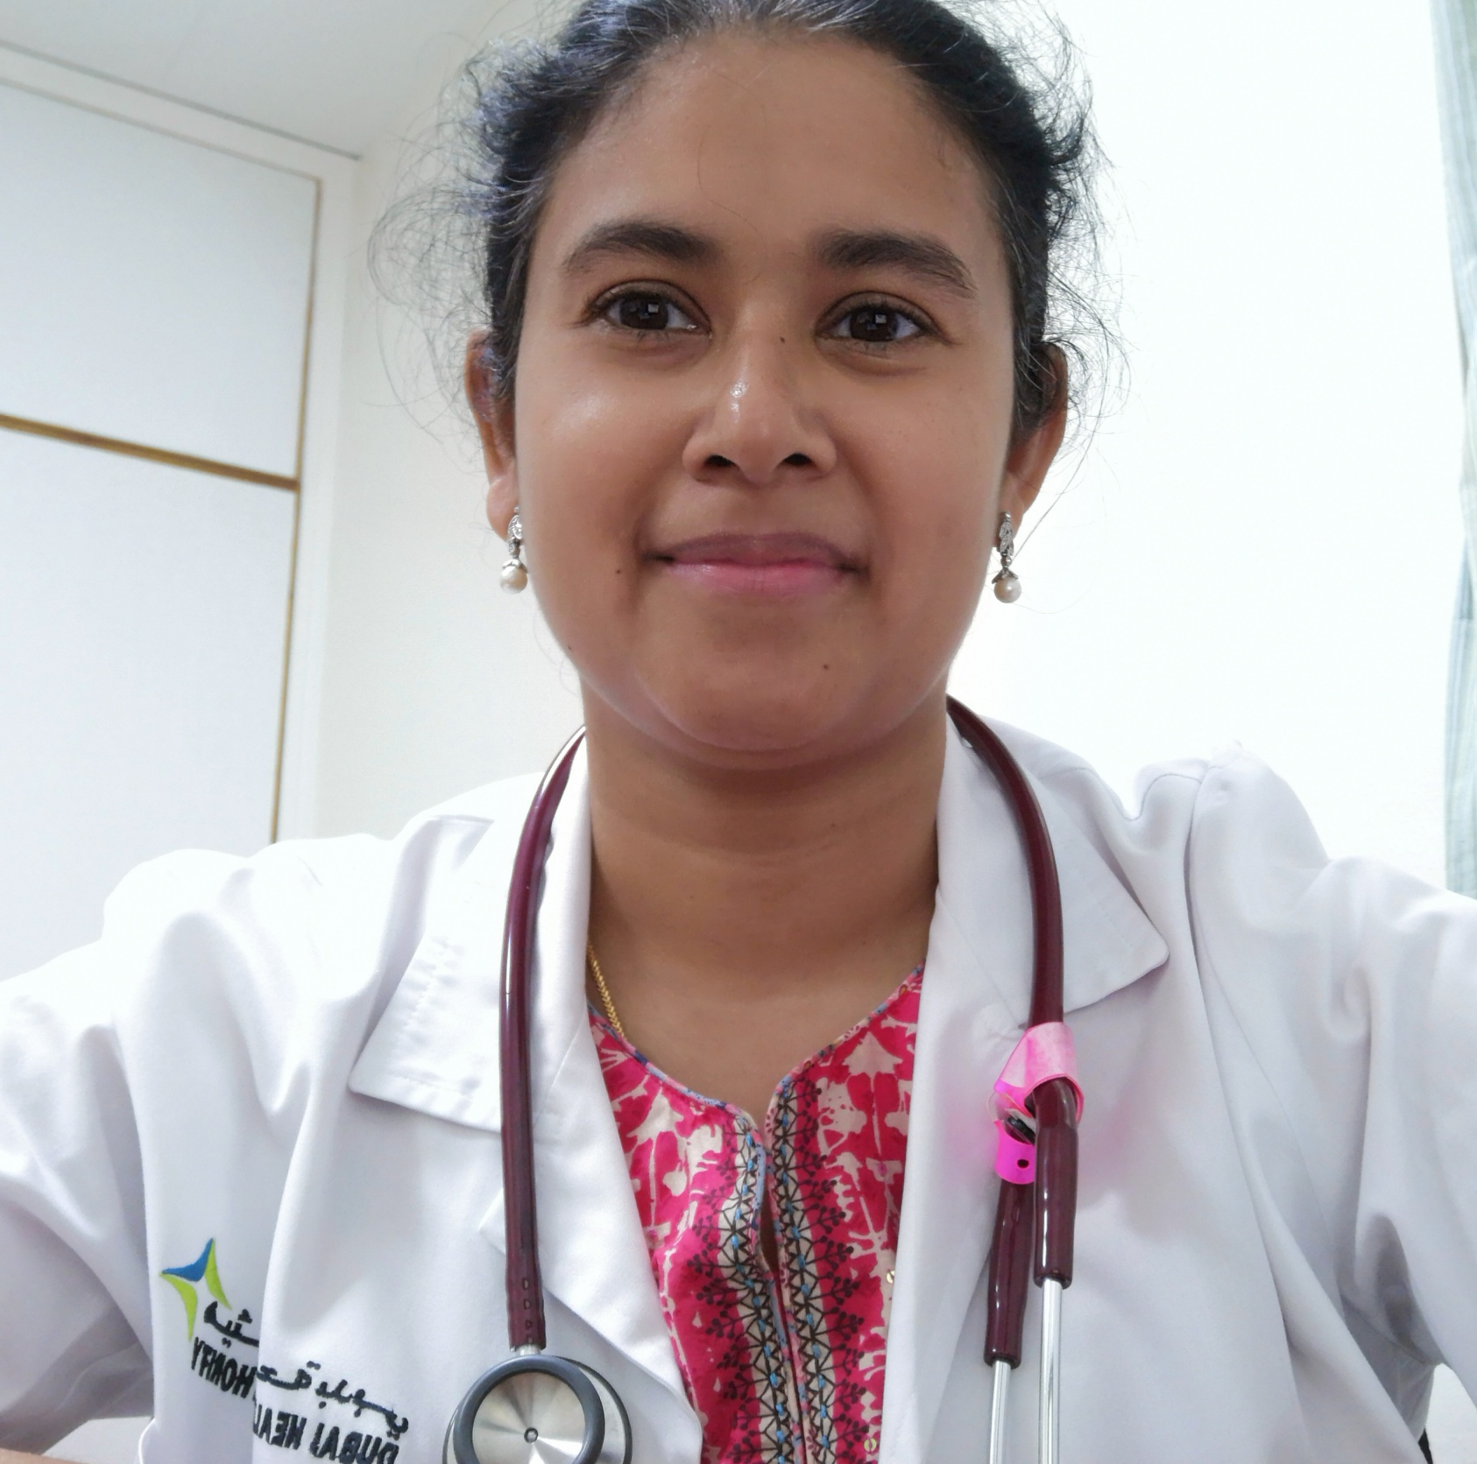

Title: An Unusual case of Stupor in a Febrile Patient.

Dr. Liza Mariam Thomas
Senior Specialist
Rashid Hospital
Dubai, DHA

A 45yr old Fillipino lady, presented to the hospital with history of fever with chills, myalgia, and generalised rash for 5 days. Observation in hospital and further workup was suggestive of Adult Onset Still's Disease (AOSD). She was started on oral steroids, but within 24 to 48 hrs of starting steroids, she had a febrile spike and her GCS dropped from 15/15 to 9/15. Urgent workup was sent for a possible undiagnosed infection, which could have flared up on steroids. Though she had a systemic inflammatory response syndrome (SIRS), the lab parameters were not suggestive of infection, and the possibility of Macrophage activation syndrome (MAS) was suspected and work up was sent. Clinical and laboratory features were suggestive of MAS. She was started on pulse steroids, and IVIG. Her clinical condition improved over the next five days, with sensorium returning to normal, resolution of the SIRS and laboratory parameters showing a trend towards normalisation. At discharge, she was well, afebrile, and the rash had resolved. She stayed a total 10 days in the hospital, was discharged on oral prednisolone 1mg/kg and advised rheumatology follow up.

This case is remarkable, for highlighting, the not commonly known fact that Macrophage activation syndrome, can present with a decreased level of consciousness and prompt diagnosis and management can avert a potentially calamitous outcome. It is also significant to note that, the course of AOSD can become complicated despite steroids being initiated when the patient is clinically stable and early in the course of the disease

Biography

Dr. Liza has been practicing in various hospital settings in India and is currently working in Rashid Hospital a tertiary government hospital in Dubai, UAE. She completed her M.D. in Internal Medicine from JIPMER, Pondicherry University, India.
During her more than a decade of professional practice, she has had the opportunity of being involved in the care and treatment of an extraordinary variety of patients. The patients and their stories- rare and not so rare, heartwarming and heartbreaking, challenging but ultimately fulfilling, puzzling and sometimes even unsolved - they have all left their imprint and taught valuable lessons in medicine and life. She has published some of these case reports in leading international journals and presented many of them in various medical conferences.
The case reported here is one of those rare cases which presented a huge diagnostic challenge and has invaluable learning points for the medical community.

Presenting author details
Full name: Dr. Liza Mariam Thomas
Contact number: 971 0551031718
Email id:drlizathomas@gmail.com
Category: Oral presentation
Session name: case reports in rheumatology
Research interest: Rheumatology, Stroke, Alcohol withdrawal syndrome

