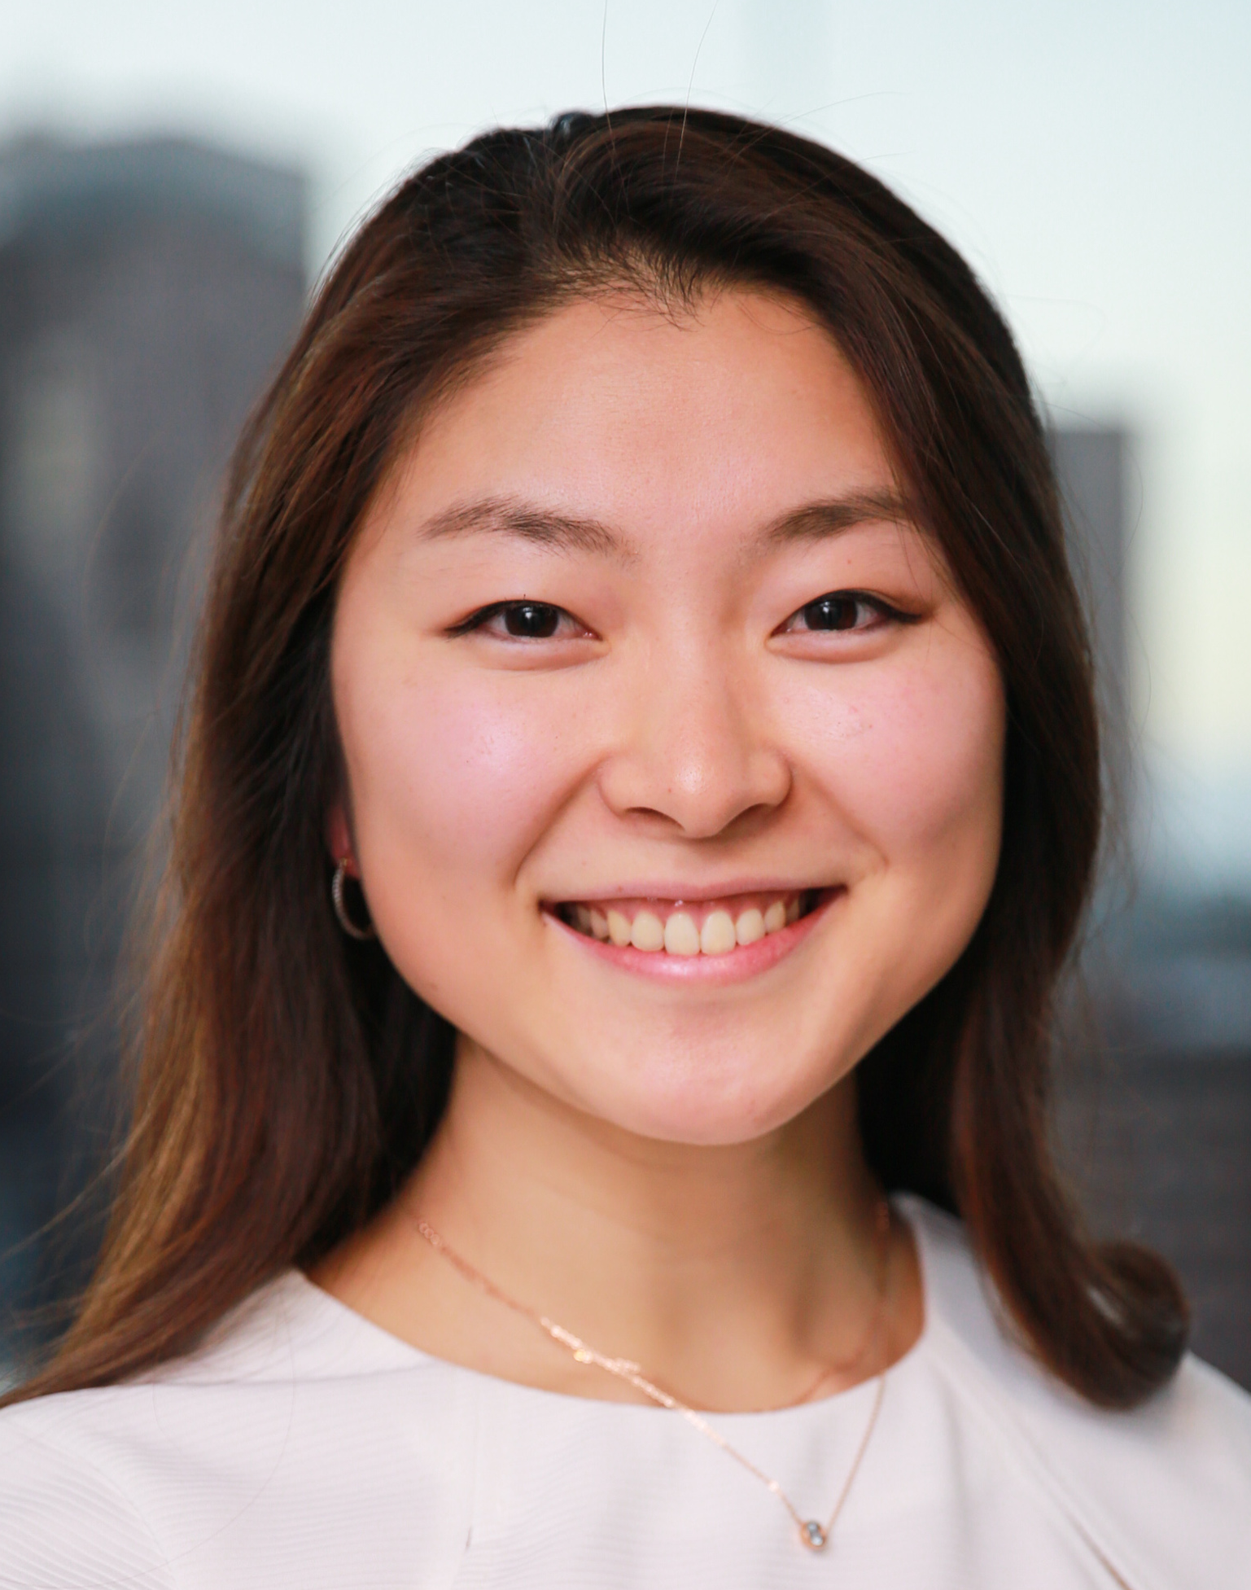
Title: Renal recovery in a dialysis-dependent patient with end-stage kidney disease secondary to analgesic nephropathy
Name: Yeung-Ae Park¹, Greg Harris², Dov A. Degen³

- University of Melbourne Department of Medicine, Royal Melbourne Hospital, Parkville, Australia
- Department of Renal Medicine, Bendigo Health, Bendigo, Australia
- Department of Renal Medicine, Alfred Health, Melbourne, Australia

A 31-year-old male presented to the hospital with renal failure thought to be secondary to chronic analgesic abuse of ibuprofen/codeine combination tablets for three years, which peaked at approximately 100 tablets per day, equivalent to 20g ibuprofen and 1.3g codeine. Following admission, he was noted to be oligo-anuric requiring haemofiltration and required ongoing dialysis for end-stage kidney disease (ESKD) with an estimated glomerular filtration rate (eGFR) under 10mL/min/1.73m². A renal biopsy was performed demonstrating global sclerosis in 100% of the 21 glomeruli sampled and severe diffuse cortical interstitial fibrosis with widespread tubular atrophy.

2 years and 7 months later, his renal function improved enabling cessation of dialysis. The mechanism for this recovery is not clearly understood. The patient has remained dialysis-free for two years and is clinically well with stable chronic kidney disease with a serum creatinine of 276μmol/l corresponding to an eGFR of 25mL/min/1.73m².

Renal recovery has been reported in specific aetiologies of kidney failure such as autoimmune disease, haemolytic uraemic syndrome and renovascular nephrosclerosis, but is less likely in analgesic nephropathy. To the best of our knowledge, there is limited literature regarding reversible dialysis-dependent ESKD secondary to analgesic nephropathy. Given this rarity, this case report of renal recovery in a 31-year-old with dialysis-dependent ESKD secondary to analgesic nephropathy is remarkable despite poor prognostic features on biopsy and a relatively long period of regular dialysis. (Words: 226)

Biography

Yeung-Ae has completed her Doctor of Medicine with Honours at the age of 24 years from the University of Melbourne, Australia following her completion of Bachelor of Biomedicine with Honours at the same institution. Yeung-Ae is currently working as an intern at the Royal Melbounre Hospital, Victoria, Australia.

Presenting author details
Full name: Dr Yeung-Ae Park
Contact number: 0433016290
Linked In account: https://www.linkedin.com/in/yeung-ae-park-3a421325/
Session name/ number: Unknown.
Category: Poster presentation

