Does an early implantation of Extra-corporeal Membrane Oxygenator in high risk emergency Open Heart Surgery patients improve the outcome in comparison to elective patients? A prospective cohort comparative study

Yasser Mubarak

Abstract

Background: - Extracorporeal Membrane Oxygenator (ECMO) has been implemented in refractory post-cardiotomy cardiogenic shock (PCCS) patients to maintain an excellent oxygenation and hemodynamic support. Aim of this study is to compare the results of early ECMO implantation to treat refractory PCCS in emergency versus elective patients who developed univentricular or biventricular pump failure. Patients and Methods: - Between January 2019 and June 2021 thirty five patients received ECMO after refractory PCCS. Patients have been categorized into two groups which are group A that contains 18 patients who have been operated upon urgently and group B which includes 17 patients who have been operated upon electively. ECMO was implanted through central cannulation (right atrium and ascending aorta), or through peripheral cannulation (femoral vessels or through axillary artery). Results: - There was no statistically significant difference between the two ECMO groups in the preoperative patient’s characteristics, the complication rate, duration of mechanical ventilation, posts ECMO weaning hospital stay, duration of ICU stay, in-hospital mortality, the number of patients who have been discharged from the hospital or in 1-year survival on follow-up. Conclusion: - Early use of ECMO in high risk emergency cardiac surgery should be taken in consideration when possible without hesitance. Emergency and elective patients benefit equally from ECMO implantation and show comparable complication rates.

Image

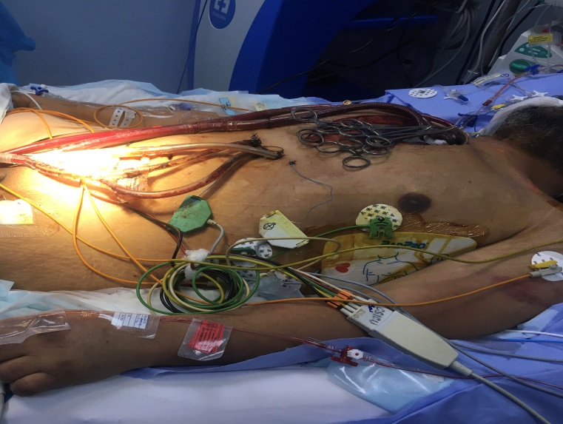
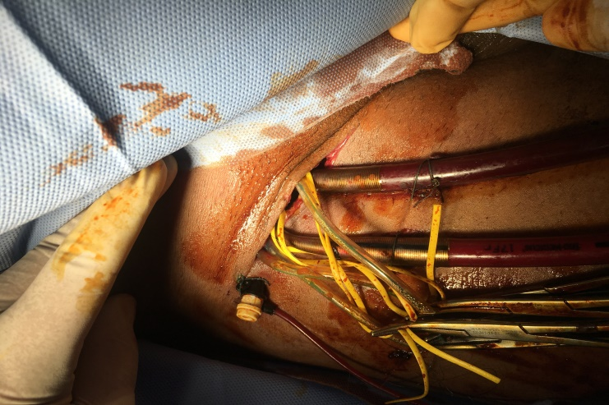
Figure (2):- Patient was on ECMO with peripheral cannulation (Femoral access)

Recent Publications
- Rastan AJ, Dege A, Mohr M, Doll N, Falk V, Walther T, et al. Early and late outcomes of 517 consecutive adult patients treated with extracorporeal membrane oxygenation for refractory postcardiotomy cardiogenic shock. J Thorac Cardiovasc Surg. 2010;139:302-11.
- Rastan AL, Lachmann N, Walther T, Doll N, Gradistance T, Gummert JF, et al. Autopsy findings in patients on postcardiotomy extracorporeal membrane oxygenation (ECMO). Int J Artif Organs. 2006;29: 1121-31.
- Wagner J, Tiller C, Dietl M, Ulmer H, Brenner C, Stastny L, et al. Extracorporeal life support in myocardial infarction-induced cardiogenic shock: weaning success. Ann Thorac Surg 2019;108:1383-90.
- Morris AH. Extracorporeal support and patient outcome: credible causality remains elusive. Critical Care Med. 2006; 34:1551-52.
- Bakhtiary F, Keller H, Dogan S, Dzemali O, Oezaslan F, Meininger D, et al. Veno-arterial extracorporeal membrane oxygenation for treatment of cardiogenic shock : clinical experiences in 45 adult patients. J Thorac Cardiovasc Surg. 2008; 135:382-88.

Figure (1):- Patient was open chest on ECMO with central cannulation, and drains were connected on cell-saver

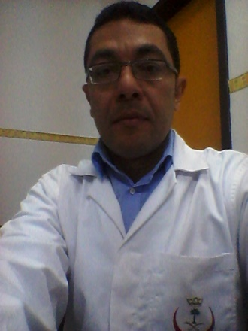

26th World Cardiology

Conference

March 23-24, 2022 Bangkok, Thailan

Biography
Yasser Shaban Mubarak , MD
Assistant Professor of cardiothoracic surgery
Department of Cardiothoracic Surgery. Minia University, El Minya, Egypt.
Associate Consultant of adult cardiac surgery
Madinah Cardiac Center, King Fahd Hospital, Madinah, Saudi Arabia.
Tel: +996560708223; +201002554078. E-mail: yassermubarak73@gmail.com

Notes/Comments:

Presenting author details
Full name: Yasser Shaban Mohamed Mubarak
Contact number : +201002554078
Twitter account:
Linked In account:
Session name/ number:
Category: Poster presentation

