Case study: Unibanco Institute for Sustainability Commitment
Liliane Rocha, Gestão Kairós, Brazil

Abstract (300 word limit)
Due to the global efforts on sustainability, the Unibanco Institute, in partnership with Gestão Kairós, developed the Unibanco Institute for Sustainability Commitment. With this initiative, the Institute makes public the commitment to become a reference in sustainability in third sector organizations, adopting practices of mitigation of direct and indirect impact from four axes of action: emission of greenhouse gases, conscious consumption of water, energy efficiency and solid waste management. In 3 years of work, the program was responsible for ending the use of plastic cups in the office (an estimated 90,000 plastic cups a year in the year prior to the program); a waste recycling plan was developed; equipment was adapted in the office for energy efficiency and reduction of water consumption; and an inventory of greenhouse gas emissions was made, resulting in actions to offset emissions and to carry out a campaign to reduce the use of air travel by employees. In addition, the practice was extended to suppliers of the Institute, and a manual of good sustainability practices was developed and distributed to encourage adaptations of suppliers and to reinforce the importance of the theme for the Unibanco Institute. In 2018, the Institute acquired the Silver Seal in the Brazilian GHG Protocol Program, attesting to the completion of the Institute's complete emissions inventory. In the same year, 3 eco-efficient events and complete compensation of emissions of 2017 were carried out. This program gave a unique learning to the Gestão Kairós and Unibanco Institute, being important therefore its dissemination as practices to be adopted by other organizations.

Image
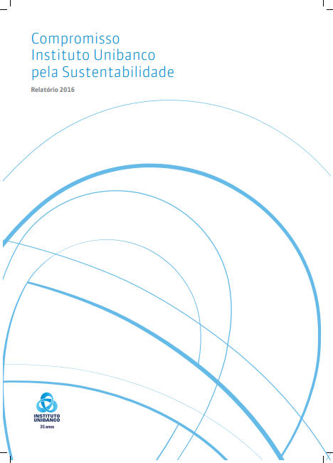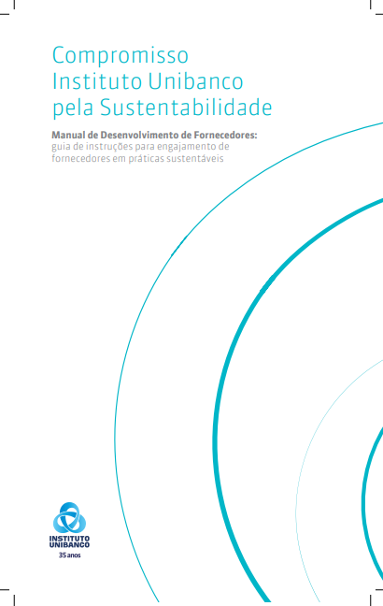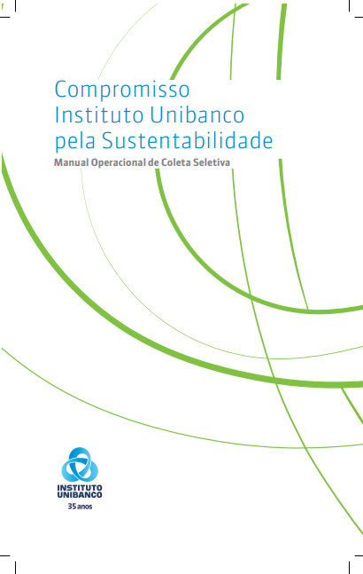
Figure 1: Documents made during the Unibanco Institute Commitment for Sustainability program.
Recent Publications (minimum 5)
- Rocha L (2018) O que você precisa saber para aprimorar as práticas de diversidade e inclusão na sua empresa?. E-book.
- Rocha L (2017) Como ser um líder inclusivo. Liliane Rocha. São Paulo : Scortecci.
- Rocha L (2017). Poluição – O que o Brasil deve aprender com a China?. Envolverde Jornalism website.
- Rocha L (2017). A era das transformações sustentáveis exponenciais. Envolverde Jornalism website.
- Rocha L (2016). Pessoas novas para um mundo novo. Envolverde Jornalism website.

 Biography (150 word limit)
Liliane Rocha is the CEO of Gestão Kairós (Sustainability and Diversity consultancy) founded in 2015. She is a professional with 14 years of experience in the sustainability and diversity area, working to multinationals in the position of Latin America Executive in Brazil, Peru and Colombia. She holds a Master degree in Public Policy Management by FGV, Executive MBA in Sustainability Management by FGV, Master in Coaching by SBC and Bachelor degree in Public Relations by Cásper Líbero.She is also a teacher in the Post Graduation Sustainability program at SENAC and at FIA/USP (most recognized university in Brazil). She is also the designer and teacher of the Diversity class to the Marketing course in ESPM.
.
Full name: Liliane Cássia Rocha dos Santos
Contact number: +55 11 98339 5775
LinkedIn account: https://www.linkedin.com/in/liliane-rocha-796388a/
Email: liliane.rocha@gestaokairos.com.br
Track Name: Green Initiatives, Products and Climate Change

Notes/Comments:

