Fostering Sustainable Development by Empowering Indigenous Abilities: The border zone case of rural South Lebanon

G. Gharios*, A. Allan**,
* UNESCO Centre for Water Law, Policy and Science, School of Social Sciences, School of Law, University of Dundee, g.gharios@dundee.ac.uk
** UNESCO Centre for Water Law, Policy and Science, School of Social Sciences, School of Law, University of Dundee, a.a.allan@dundee.ac.uk

Abstract
Statement of the Problem: Lebanon has built its water sector on foundations laid down by Mesopotamian, Roman, Ottoman, and French water laws that were superimposed on Muslim customs and practices and traditional Arab social water arrangements in Lebanon. Experts agrees that Lebanon will be the first country in the Middle East to be affected by climate change. Rural communities in the region have historically adapted to the characteristic water scarcity by harvesting and storing rainwater. The focus of this study is on the role of indigenous water arrangements, customary law and inherited practices in developing the water sector in Lebanon.
Methodology & Theoretical Orientation: How can we effectively prepare rural communities for the impacts of future water management problems, and what can be done to strengthen traditional social water arrangements? Indigenous water practices are the result of the complex interactions of changing practices imposed over time, combined with lessons learned regarding successful techniques, forming a palimpsest of legislative and administrative water competence that are potentially better able to address climate change because of their tested adaptive capacities. This work researches the influences and effects that strengthening customary, locally developed water arrangements could have on community resilience and adaptation to climate change.
Findings: We were able to identify several ancestral social water arrangements that were developed in the region for the conservation of property and for the periodic distribution of water between interested parties, that allowed for the mediation of disagreements between users and assured each of the equitable allocation of water to match needs. These include: Urf, Hima, Mushaa, Sabil. Birket, Jall, Aouna, Sulha, Mudaraba, and Chaoui. Following the application of a series of criteria relevant to resilience and climate change adaptation (e.g.: democracy, equity, equality, fairness, spontaneity, transparency, participatory, replicability, adaptability, flexibility, efficiency, effectiveness) particular focus was made on communal pools (Birket). Rainwater harvesting and storing has long been a traditional approach to water management in South Lebanon. Here, precipitation occurs ordinarily only during winter (e.g. in Jebel Amel, Bilad Beshara, Northern Galilee), so it is important for the inhabitants to conserve this water into the dry season. During the research, ninety-nine birket-s were identified using very old maps, and their status assessed using comparison with modern aerial images, across eighty-five villages and cities in three administrative regions and nine sub-regions. Only one third of these pools are still functioning and the remaining are either abandoned or transformed.
Conclusion & Significance: The case of the pool in the village of Marwaheen is of special interest: it was abandoned thirty years ago and transformed into a dump site, but was then restored by the municipality and currently functions as a communal water reservoir to which all farmers have access to irrigate their fields. This fact has contributed to a remarkable increase in vegetable farming which has risen from 12 to 25 ha in one year. Based on this experience, reclaiming these traditional rainwater harvesting pools are important in facing future challenges of water management at the local level
Image
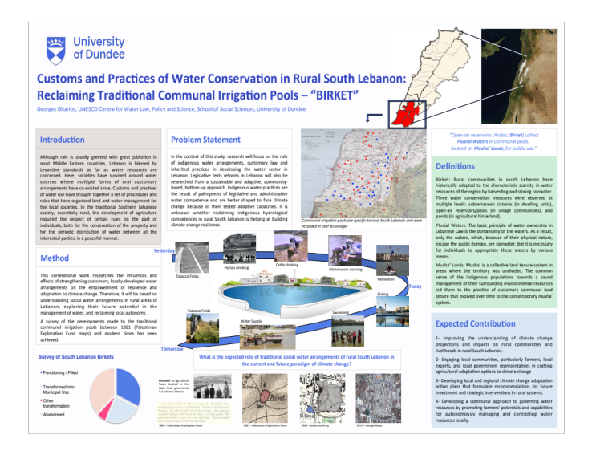

Keywords

Custom and Practices, Rainwater Harvesting, Communal Pools, Migration and forced displacement, climate change adaptation

Notes/Comments:

Biography
Georges Gharios is a PhD Candidate in Water Law at the university of Dundee in Scotland, UK since December 2015. Gharios’ work focuses on Islamic and Ottoman water laws, customs and practices, legal pluralism, and social water arrangements. He is particularly interested on customs and practices of water conservation in rural South Lebanon. Gharios has also expertise in International land and water management, Integrated Water Resources Management, and Water Users’ Associations. Gharios has edited and reviewed multiple chapters of the ‘Arab Water Report 2013’, co-authored the five-year plan ‘Blue Gold of Lebanon’, and has several other journal articles and attested presented conferences related to the topic of water laws and governance. Gharios help teaching posts during five years at the American university of Technology in Halat where he taught several courses on water law, water policy, water politics and soils. He was recipient of the Edgecombe Memorial Prize in 2007 in recognition of outstanding scores at the American University of Beirut from where he holds a Bachelor of Science in Agriculture (2007) and a Diploma of ingenieur agricole (2007). He also holds a Master of Science in International Land and Water Management from Wageningen University and Research Center (2009). He is currently pursuing his PhD in Water Law at the university of Dundee (2020). He is an active member of the Mediterranean Water Youth Network (MedYWat)
Email: ggharios@dundee.ac.uk

