The Black Sea SST fluctuations in Association with Temperature and Precipitation of West and Northwest of Iran
1. Iman Rousta*, Department of Geography, Yazd University, Yazd 8915818411, Iran, Email: irousta@yazd.ac.ir
2. Haraldur Ólafsson, Department of Physics, University of Iceland and Icelandic Meteorological Office, Bustadavegur 9, IS-150 Reykjavik, Iceland, Email: haraldur@vedur.is

Abstract

In recent years, global warming has come to the fore as one of the world’s most serious environmental problems. The interaction of the ocean and atmosphere plays an important role in shaping the climate and its variations. Meanwhile, SST fluctuations have diverse effects on climate variability. The purpose of this study was to investigate and analyze the effects of Black Sea SST anomalies on the temperature and precipitation of west and northwest of Iran. For this purpose, the SST of Black Sea has been obtained from the NCEP/NCAR database. After extraction of Black Sea SST, daily temperature and precipitation data of 80 stations were retrieved for the west and northwest of the Iran from IRIMO during the period of 1960 to 2010. Then, by using Pearson correlation coefficient, the relationship between temperature and precipitation in the West and northwest of Iran with the positive and negative anomalies of the SST of Black Sea were calculated. The results of this study showed that the positive anomalies of the SST of Black Sea more affected the temperature of the west part of study region, so that the spatial variation of the temperature during the negative anomalies of Black Sea SST in this region was higher. However, the temperature in the northwest of the study region is more associated with negative anomalies. In the case of precipitation, the situation is different, so that precipitation in the study area is more associated with negative anomalies of SST of Black Sea, which is more affected the western provinces. At the time of positive anomalies, only the provinces of Ardabil, East and West Azarbaijan are weakly influenced.

Keywords: Black Sea Surface Temperature (SST), Iran's temperature and precipitation, positive and negative anomalies, West and Northwest of Iran

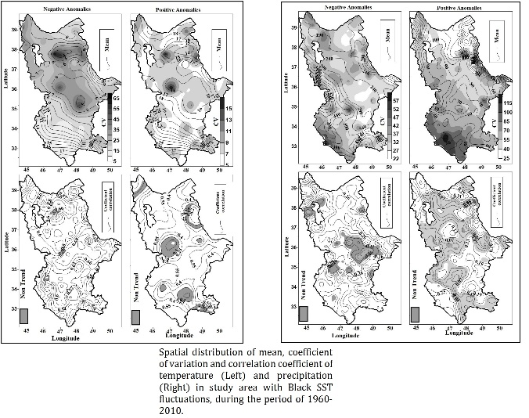
Recent Publications
- Soltani, M., Laux, P., Kunstmann, H., Stan, K., Sohrabi, M.508 M., Molanejad, M., Sabziparvar, A.A., Ranjbar SaadatAbadi, A., Ranjbar, F., Rousta, I., Zawar-Reza, P., Khoshakhlagh, F., Soltanzadeh, I., Babu, C.A., Azizi, G.H., Martin, M.V. (2016) Assessment of climate variations in temperature and precipitation extreme events over Iran. Theoretical and Applied Climatology 126, 775-795.
- Rousta, I., Akhlagh, F.K., Soltani, M., Sh, S.M.T., (2014) Assessment of blocking effects on rainfall in northwestern Iran, in: Kanakidou, M., Mihalopoulos, N., Nastos, P. (Eds.), C O M E C A P 2 0 1 4, 1 ed. CRETE UNIVERSITY PRESS, Grecce, p. 291, 127-132.
- Nazemosadat, M. J., & Cordery, I. (2000). On the relationships between ENSO and autumn rainfall in Iran. International Journal of Climatology, 20(1), 47-61.
- Rousta, I., M. Doostkamian, E. Haghighi, H. R. Ghafarian Malamiri, and P. Yarahmadi, )2017(: Analysis of spatial autocorrelation patterns of heavy and super-heavy rainfall in Iran. Adv. Atmos. Sci., 34(9), 1069–1081, doi: 10.1007/s00376-017-6227-y.
- 5. Rousta Iman, Nasserzadeh, Mohammad Hossain, Jalali, Masoud, Haghighi, Esmaeil, Ólafsson, Haraldur, Ashrafi, Saeide, Doostkamian, Mehdi, Ghasemi, Ali (2017), Decadal Spatial-Temporal Variations in the Spatial Pattern of Anomalies of Extreme Precipitation Thresholds (Case Study: Northwest Iran), Atmosphere, 8, 135, 1-15; doi:10.3390/atmos8080135


Biography: Iman Rousta has completed his PhD from Tehran University, Tehran-Iran. His PhD thesis has been performed in Climate Change and Atmospheric Blocking, He is currently assistant Professor of Climatology at the Dept. of Geography, Yazd University. He has published more than 20 papers in reputed journals. The details of his research interests and activities are available in google scholar (https://scholar.google.com/citations?user=p2ctLzkAAAAJ&hl=en).
Full name:Iman Rousta
Contact number: 00989171902098
Twitter account:
LinkedIn account: https://www.linkedin.com/feed/?trk=
Email: irousta@yazd.ac.ir
Track Name:
Notes/Comments:

