Smart Spatial Analyses in Land Levelling
Short title:
Predict the environmental indicators for land leveling.
Authors:
Isham Alzoubi1, Farhad Mirzaei²
Affiliation:
Department of Surveying and Geometric Eng., Engineering Faculty, University of Tehran, Iran
alzoubi@ut.ac.ir
iazzabi@yahoo.com
2 College of Agriculture and Natural resources, University of Tehran, Iran
fmirzaei@ut.ac.ir
*Corresponding author: Alzoubi@@@1976
Isham Alzoubi@@@1976 https://ar.ilovetranslation.com/
Abstract
Land leveling is one of the most important steps in soil preparation for agricultural and other purposes. . New techniques based on artificial intelligence, such as Artificial Neural Network, integrating Artificial Neural Network and Imperialist Competitive Algorithm (ICA-ANN), or Genetic Algorithms (GA-ANN), or Particle Swarm Optimization (PSO-ANN) have been employed for developing predictive models to estimate the energy related parameters and the results were compared to SPSS and Sensitivity Analysis results. In this study, several soil properties such as cut/fill volume, compressibility factor, specific gravity, moisture content, slope of the area, sand percent, and swelling index were measured and their effects on energy consumption were investigated. Totally 90 samples were collected from 3 land areas by grid size of 20m×20m. The aim of this work was to develop predictive models based on artificial intelligence techniques to predict the environmental indicators of land leveling . Results of sensitivity analysis illustrated that only three parameters consist of soil density, soil compressibility, and soil cut/fill volume had meaningful effects on energy consumption. Among the proposed methods, the GA-ANN had the most capability in prediction of the environmental energy parameters. However, for prediction of LE and FE the ANN and ICA-ANN algorithms had better performance
. On the other hand, SPSS software had higher R 2 value than Minitab software and sensitivity analysis and in fact close to the ANN values. Keywords: Energy; Imperialist competitive algorithm; Sensitivity analysis; ANN; Land levelling; Environmental indicators.
Keywords:Artificial Neural Network; energy; environmental research; Imperialist Competitive Algorithm; Sensitivity Analysis

Introduction
Nowadays, energy production and consumption is one of the biggest challenges related to environment in the world. Some special policies are required to consider energy issues from various viewpoints such as financial and eco-friendly aspects to reconciliate between them. In agricultural sector, like other fields, energy is regarded as one of the most important parameters. However, inherent disadvantage of using fossil fuels (particularly gasoline) as energy source is pollution. After a sharp increase in energy consumption in agriculture during last decades, environmental protection and techniques of reducing fossil fuel usage attracted attention of researchers in the world. Therefore, land leveling which is one of the heaviest and costly operations among agricultural practices that needs substantial amounts of energy, got into limelight. Consequently, finding the relationship between energy consumption and land leveling parameters is necessary for prediction and optimization of the amount of energy needed in a particular land and achieving sustainable agriculture and also for reducing the ensuing pollutions. The best choice is finding an ideal and optimum way through which all pros and cons can be considered so, it will be easier to compromise. In the following some of the highlighted results reported by researchers will be presented. It is anticipated that environmental conservation and market globalization will be dependent on food security in the future (Jat et al. 2006). Even if developing and improving strategies continue and led to some worthwhile effects, there would be some undesirable effects remaining (Rezaia–Moghaddamet al. 2005). Furthermore, Environmental Impact Assessment (EIA) involves the investigation and estimation of scheduled events with a view to ensuring environmentally sound and sustainable agriculture (Toro et al. 2010). Considering individual, social, financial, and agronomic aspects of environmental conservation will improve farmers’ awareness of benefits ant their willingness of using laser land levelling for water and soil management (McFarlane et al. 2006). Today, a new technique using evolutionary artificial neural network (ANN) model based on artificial intelligence is widely used in various fields for solving multiple variable problems (Amiri et al. 2013). . Artificial intelligence methods have been widely used for solving complicated problems as the discussed problems. ANNs are calculating methods made up of a number of simple, extremely interrelated processing essentials, also termed neurons. In general, an ANN is made of an input layer, one or more hidden layers (HLs), and an output layer of neurons (Tracey et al. 2011). Through fuzzy language instructions, when ANNs is created in form of trained connections and weights, an Adaptive Network-based Fuzzy Inference System (ANFIS) will be developed and it will connect the input and output data. It is broadly believed that an ANFIS model is livelier than an ANN model (Azamathulla et al. 2009). Reviewing the literature shows that there are several studies in profitability of application of ANN and ANFIS models in agricultural activities. In order to forecast the oven-dried bulk density from soil samples, a stepwise multiple regression process was established (Sonja et al. 2005). F. Ramezani et al. used a social based optimized ANN for prediction of sediment volume in river beds. They reported that this approach was more accurate and flexible than conventional methods (Ramezani et al. 2015). In a research, Iounousse et al. proposed a probabilistic neural network approach to classify lands usage by remote sensing (satellite images). Their approach resulted in very accurate classification with lower than 3.5% error in comparison with actual results (Iounousse et al. 2015). AI has also been used to realize the connection between toxic environment and living species. Sroczyńska et al. used verteberate species as indicator of toxicity of rivers by means of Kohonen ANN and they reported a successful approach (Sroczyńska et al. 2017). Moumenis et al used ANNs and ANFIS for calculation of subsurface water level in paddy fields of plain areas (Moumenis et al. 2013). ICA is obtainable through Atashpaz-Gargari and Lucas in 2007 and is based on socio-political evolution process (Abdechiri et al. 2010). The algorithm has several advantages in resolving engineering optimization complications such as data clustering (Ebrahimzadeh et al. 2012), Nash balance point attainment (Rajabioun, Atashpaz-Gargari and Lucas 2008), ANN training (Zhang 2012), composite constructions (Abdi et al. 2011), production administration complications (Nazari-Shirkouhi et al. 2010), optimization complications (Ahmadi et al. 2013). Since, land leveling with machines requires considerable amount of energy, optimizing energy consumption in land leveling operation is of a great importance. As a result, here, five approaches comprising: ANN, integration of ANN and ICA (ICA-ANN), sensitivity analysis, GA-ANN, and PSO-ANN have been tested and surveyed to predict the environmental indicators for land leveling and to determine the best method. Hitherto, only a limited number of studies associated with energy consumption in land leveling have been done. In these studies energy was a function of the volume of excavation (cut/fill volume). Therefore, in this research, energy and cost of land leveling are function of all the properties of the land including the slope, coefficient of swelling, density of the soil, soil moisture, special weight and swelling index.
2 Materials and methods
Case study region
In order to verify the accuracy and feasibility of the proposed models, a case study region was specified in district of Karaj, Iran regarding the proposed land levelling project. The study farm was a 70 ha area located in the west of Iran, between 31° 28' 42'' north latitude and 48° 53' 29'' east longitude. Topography of the farm was carried out at scale of 1:500. Outputs of plan were length, width and height of the points (coordinates of x, y and z). The grid size in the region was selected about 20 m* 20 m and samples were collected from two different sites at two different depths including: surface soil (0−10 cm) and subsurface soil (10−30 cm). Total of 90 samples (30 from each plantation site and 15 from each soil depth) were collected from 3 land areas. Then every five samples were mixed together to prepare one sample. In this way total of 90 samples were reduced to 18 composite soil samples for convenient laboratory analyses. In the laboratory, collected moist soil samples were firstly sieved through 10 mm mesh sieve to remove gravel, small stones and coarse roots and then passed through 2 mm sieve. Then the sieved samples were dried under room temperature and moisture content of soil samples were determined. At this time, soil texture, soil bulk density and soil optimum density were determined. ANNs are massively parallel-distributed information processors that have certain performance characteristics resembling biological neural networks of human brain (Movagharnejad and Nikzad, 2007). They have been developed as a generalization of mathematical models of human biological neural system (Mohammadi et al., 2009). There are a lot of structure types of ANN models. In this study, a typical feed forward back propagation (BP) MLP structure was used. The main advantage of MLP structures over other types is that they have the ability to learn complex relationships between input and output patterns, which would be difficult to model with conventional algorithmic methods (Azadeh et al., 2008). An ANN structure usually consists of an input layer, followed by one or more hidden layers and an output layer. The input nodes are the previous lagged observations, while the output provides the forecast for the future value. Hidden nodes with appropriate nonlinear transfer functions are used to process the information received by the input nodes. The model can be written as follows (Azadeh et al.,2008):
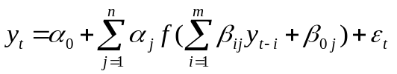 , j= 0, 1,…,n and i= 0, 1, …,m (1)
Where m is the number of input nodes, n is the number of hidden nodes, α_{j}denotes the vector of weights from the hidden to output nodes and β_{ij} denote the weights from the input to hidden nodes. α₀and β_{0j}represent weights of arcs leading from the bias terms which have values always equal to 1 and f is a sigmoid transfer function (Shakibai and Koochekzadeh, 2009). Multiple layers of neurons with nonlinear transfer functions allow the network to learn nonlinear and linear relationships between input and output parameters (Tiryaki, 2008). The linear output layer lets the network to take any values even outside the range of −1 to +1; while if the last layer of a multilayer network has sigmoid neurons, then the outputs of the network will be only in a limited range (Tiryaki, 2008). Input variables were specific gravity, density, moisture content, slope, inflation rate and type of the cut soil. Relevantly, output variables were fuel energy, machinery energy, labor power, total cost and energy consumption. In this study, all available data sets were used for regression modelling, but for ANN model development, data were randomly divided into two groups of training 70% of the dataset for training, (II) 15% for model cross validation and (III) 15% for testing. (Diamantopoulou, 2005). Several architectures of MLP type have been investigated to find the one that could result in the best overall performance. The learning rules of Momentum and LevenbergMarquart were considered and also no transfer function for the first layer was used. For the hidden layers, the sigmoid and hyperbolic tangent transfer functions were applied, and for the last one a linear transfer function was set. Also, a number of different network sizes and learning parameters have been tried. The ANN system applied for the predictor models had Seven inputs and a single output. These inputs were ( soil cut/fill volume, soil compressibility factor, specific gravity, moisture content, slope, % sand, and soil swelling index) . The outputs of each model were were Labor Energy ,Fuel energy ,Total Machinery Cost ,Total Machinery Energy The schematic architecture of the used ANN is shown in Fig.1 As mentioned earlier, the main elements of ANNs are constituted by artificial neurons. The input model consists of dendritic nodes similar to a biological cell that could be represented as a vector with N items X= (X₁, X₂,… ,X_{n}); the summation of inputs multiplied by their corresponding weights could be represented by scalar quantity S.
$S=\sum_{n=1}^{n}{W_{n}X_{n}}$(2)
whereW=(W₁ ,W₂ ,… ,W_{N}) is the weight vector of associations among neurons. The S quantity is then passed to a non-linear activation function f, yielding the following output:
$y=f(s)$(3)
Non-linear transfer function is usually represented as sigmoid functions and is defined via:
$f\left(s\right)=\frac{1}{1+e^{-s}}$ (4)
The output of y can be as a result of the model or that of the next layer (in multilayer networks). In the design of an ANN, certain elements should be taken into account including type of input parameters. In this research, the three-layer perceptron network was used which is composed of an input layer, one hidden layer of computational modes, and an output layer. In each layer, a number of neurons were considered which were connected to the neurons of neighboring neurons via some associations. In these networks, the effective input of each neuron was as a result of the multiplication of the outputs of the previous neurons by the weights of those neurons. Neurons in the first layer receive the input information and transfer it to hidden neurons through related connections. The input signal in such networks is only expanded in a forward direction. The main advantage of such a network is the simplicity in implementing the model and estimating input/output data. Some of the major shortcomings of this model are the low training rate and need for a huge set of data.
Imperialist competitive algorithm (ICA)
ICA is a novel swarm-intelligence method that has been developed by mimicking the human being’s socio-political evolution strategies. ICA optimization process starts with initialization of random populations and some incipient empires. In each stage of ICA, a union of sub groups, colonies, and imperialists assemble the empires. ICA breaks the early population into the subpopulations, and then it searches the solution space for the best point by using two main operators: competition and assimilation. During algorithm proceedings empires can interact with the members of the swarm. Throughout the assimilation procedure, colonies move towards the relevant imperialist progressively. Imperialistic competition among the empires is the momentous procedure of the ICA (kaveh andTalatahari, 2010;Talatahari et al., 2012). In competition stage powerless empires collapse, whereas the dominant ones gain further control over their colonies. This operation is stopped whenever one empire controls the entire countries. In termination condition, empire has equal cost with its colonies, which can be regarded as a satisfactory solution for the problem. To explain the algorithm more practically, the required steps are as follows:Step 1: Initializing phase. Scattering the early population randomly over the search space and composing the basic solutions in the format of a 1×N_{var} array via Eq. (5):
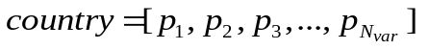 | (5)
Where p_{i}represents variables that are fundamentally related to socio-political characteristics of the countries such as culture, language, religion, and economic policy. N_{var}shows the total variables of the target problem. Step 2: computing the cost of every country using Eq. (6):
(6)
Step 3: Initializing the empires. The normalized cost of an imperialist is obtained via Eq. (7)
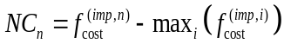 (7)
Where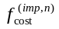stands for the cost of nth imperialist, and NC_{n}indicates its normalized cost.
p 4: Dividing the colonies among imperialists. This process is based on the power of imperialist and relationships between the countries and their interdependent empires (i.e., the countries should be possessed by their imperialist based on the power). This step is completed using Eqs. (8)-(10), respectively:
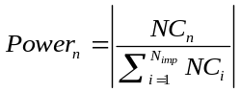 (8)
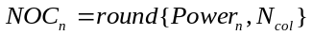 (9)
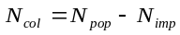 (10)
Where Power_{n}is the normalized power of each imperialist, N_{col} and N_{imp} are the given number of colonies and imperialists, respectively, and NOC_{n} represents the total number of colonies that are possessed by nth empire. Step 5: Assimilation strategy. The purpose of the assimilation procedure can be expressed as the movement of the colonies towards their interdependent imperialist. Based on this stage, each movement is performed according to Eq. (11):
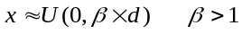 (11)
Where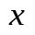is a random number with uniform (or any proper) distribution, β is a number greater than 1, and d is the distance between a colony and related imperialist.Step 6: Revolution strategy. In this strategy, a random amount of deviation is added to direct the colonies movement via Eq. (12):
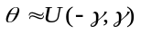 (12)
Where θ is a random variable with uniform distribution, and γ shows a parameter for adjusting the deviation from the initial movement direction.Step 7: Exchanging phase. During assimilation, whenever a colony reaches to a position with lower (better) cost compared with the imperialist, the imperialist and the colony exchange their positions, and the colony becomes new imperialist and vice versa.Step 8: Imperialistic competition phase. Calculating the overall power of an empire that is mainly affected by the power of empire and its colonies as Eq. (13):
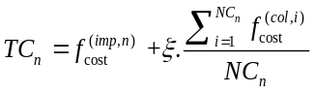 (13)
Where TC_{n} represents the total cost of the n^{th} empire, and ζ is a coefficient between 0 and 1 for decreasing the effect of colonies cost. Step 9: Imperialistic competition strategy. Based on this process, each empire tries to extend its power to possess more colonies compared with other empires. Throughout the competition, weakest colony from the weakest empire is selected to be governed by the strongest empire. Imperialistic competition conducts a searching procedure towards a peak solutions. The competition operator is designed to dedicate the colonies of the weakest empires to other empires. Based on TC_{n}, the normalized total cost is evaluated using Eq. (14):
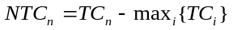 (14)
Where NTC_{n} is the total normalized cost of nth empire. According to NTC_{n}, the possession probability of each empire is computed with Eq. (15):
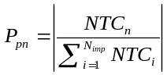 (15)
To find out the winner of competition with less computational effort, the vectors P, R, and D are formed via Eqs. (16)- (17)-(18):
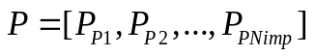 (16)
(17)
(18)
Where P is the vector of possession probability of the imperialists and R represents a vector with uniformly distributed random values. Maximum index of Ddetermines the winner empire of the competition.Step 10: Eliminating phase. When a powerless empire loses all of its controlled colonies, it should be removed from the competition. Step 11: Convergence phase. Finally, the most powerful imperialist controls all the remained colonies. In such a condition, the algorithm is stopped. Training of ANNs can be done using the ICA. For this purpose, the algorithm should be able to adjust the weights and bias, so that the difference between the output of ICA and real output be minimized. Mean squared error (MSE) was considered to determine the error.
ICA-ANN
In this study, after writing commands of ANNs in MATLAB software, the number of neurons in the input layer considered the same as the number of effective parameters; Cut-Fill Volume (V) (embankment volume), soil compressibility factor, specific gravity, moisture content, slope, sand percent, and soil swelling index.Similarly, the number of neurons in the output layer should be equal to the number of desired parameters for modeling. Instead of the default commands for network training, ICA was used. For running ANNs 70% of the data were used for training, 15% for evaluation, and the remained 15% were used for test.
Genetic algorithm
The concept of genetic algorithm (GA) was first introduced by (Holland 1962). These algorithms are a particular group of evolutionary algorithms, which their working principle is the same as Darwinian selection and evolution (Massone and et al. 2017). The principle of GA is to create new generations using strong individuals and eliminating weak individuals to obtain better offsprings. Individuals are modified by crossover and mutation operations in the same way as biological evolution (Hakli 2017). The GA algorithm gets rid of minima by using a waste range of population. In this research input parameters for GA were soil cut/fill volume, soil compressibility factor, specific gravity, moisture content, slope, sand percent and soil swelling index while the output parameters were Labor Energy, Fuel energy, Total Machinery Cost and Total Machinery Energy (TME).
PSO algorithm
The Particle Swarm Optimization (PSO) technique was introduced by (Kennedy and Eberhart 1995). Scientists have found that the synchrony of flocking behavior was through maintaining optimal distances between individual members and their neighbors. Thus, velocity plays the important role of adjusting each other for the optimal distance. Furthermore, scientists simulated the scenario in which birds search for food and observed their social behavior. They perceived that in order to find food, the individual members determined their velocities by two factors; their own best previous experience and the best experience of all other members (Kennedy and Eberhart 1995). Application of PSO for determining artificial neural network weights and also comparing it with GAs demonstrated the good performance and superiority of this method. In their paper, birds are called particles, each representing a potential solution (Shi and Eberhart 1998).
ICA-ANN
ICA-ANN method was one of the applied methods to predict the prospective environmental indicators. The algorithm required for this model was compiled in MATLAB software in a way that in the first layer 7 neurons were considered which are correspond of effective parameters (Cut-Fill Volume, soil compressibility factor, specific gravity, moisture, slope, sand percent, and soil swelling index) and in the output layer 4 neurons were responsible for desired parameters of the problem, LE, FE, TMC, and TME. In training section, 70% of the data were used by applying ICA approach. From remaining data 15% were used for validation and the remaining 15% were used for test.
Results
Results of Sensitivity Analysis
The results of the model are shown in Table 1, which are derived from 500 thousand run of the model. All F-values shown in Table 1, were indicated a great significance (α<0.0001) for all developed sensitivity analysis which refutes the null hypothesis. All models have significant pvalues too. Fig. 1 shows the sensitivity analysis for Labour Energy (LE), Fuel energy (FE), Total Machinery Cost (TMC) and Total Machinery Energy (TME). In this figure diverse Factors are defined as follows: F1: land slope, F2: moisture content, F3: density, F4: soil compressibility factor, F5: cut/fill volume, F6: Soil Swelling Index (SSI), F7: sand percent. The results revealed that F3: density, F4: soil compressibility factor, and F5: cut/fill volume were the most sensitive factors affecting Labour Energy. Furthermore, sensitivity analysis illustrated that three soil parameters: soil volume, specific gravity and soil compaction had the greatest impact on amount of energy used in land-levelling. The more the soil density and compaction, the greater required energy for constant volume of the soil. This is because of more weight and difficulty in handling which is direct result of higher volumes. Another point is the working time. It is obvious that harder handling demands more work hour which in turn needs more energy. Direct relationship between the volume of excavation and energy consumption is evident. By increasing the soil volume, the time required for working will raise, and then fuel consumption will also get higher Among seven studied parameters on LE, FE, TMC and TME only three of them had significant effect. After multi variable regression analyse, soil cut/fill volume was recognized as the most significant parameter that is shown in Table 1. Increasing the cut/fill volume of a soil will lead to an increase in the number of required machinery, work hour, number of labours, and also total cost of operation. It is obvious that these in turn will intensify the energy consumption in all four evaluated parameters. Embankment and excavation are the most demanding and heavy part of the land levelling operation such as preparing lands for irrigation, building infrastructures and airports and road constructions so, it is sensible to minimize the energy consumption of this operation. A proper solution for reducing the amount of required energy for soil cut/fill volume during land levelling operations will diminish the cost of such operations. Avoiding excessive cut/fill volume and lessening the displaced volume of soil will directly reduce the amount of

Results of Regression
F-values of all models in (Table 1) indicated great significance (α<0.0001) for all developed regression models in rejecting the null hypothesis. All models have significant p-value as well. The fitted nonlinear equations for all of the responses of interest including: LE, FE, TMC, and TME are represented in Eqs. 16-19, respectively, in which the coefficients are provided in coded units. The coefficients in the actual equation compensate for the differences in the ranges of the factors as well as differences in the effects. For final LE, TMC, and TME models only one
variable (Cut-Fill Volume (V)) had significant effect.

Sqrt(LE)=+651.47+477.91 * V | (19)
Sqrt(FE)=+3112.34+2275.41 * V | (20)
Sqrt(TMC) =+2.024E+005+1.479E+005* V | (21)
Sqrt(TME) =+40138.00+29455.50 * V | (22)

Among the seven parameters of soil and land characteristics (moisture, density, soil
compressibility factor, land slope, soil type, embankment volume), Cut-Fill Volume (V) had the most significant effect on labor energy (LE), Fuel energy (FE), Total Machinery Cost (TMC), Total Machinery Energy (TME) in land leveling (Table 2).

Results of ANN model prediction
The results of regression models and training various networks with different structures are presented in this section. The ANN models were developed by training the networks with various combinations of Network Training Functions (NTF), number of hidden layers, and number of neurons inside each hidden layer. For selecting the best Network topology totally 20678 different network models were evaluated and the RMSE and coefficient of determination R2 values were calculated. For a full comparison between performances of the trainingalgorithms in trained structures, results are represented in Table 3 and Table 4. These results were obtained from an ANN of feed forward back-propagation type with 7 different network training algorithms that are available in the Neural Network Toolbox software. This type of network uses (Levenberg 1944) and (Montgomery 2007) Bayesian regularization which has been proven to have appropriate generalization properties when used in the training of an ANN (Mahersia and et al. 2015). Scaled conjugate gradient (trainscg) is one of the most popular second-order gradient supervised procedure (Moller 1993), which is a network training function that updates related values of weight and bias based on conjugate gradient back propagation with Fletcher-Reeves updates (Pandey 2012). Resilient back-propagation (trainrp) in which the ordinary gradient descent back-propagation modification is applied in order to omit the magnitudes related harmful effects of the partial derivatives (Shiblee and et al. 2010). Gradient descent with momentum and adaptive learning rate back propagation (traingdx) is a network
training function to update bias and weight values according to gradient descent momentum and learning rate (Pandey 2012). Gradient descent with adaptive learning rate back propagation (traingda) is a batch gradient descent that runs with variable learning rate (Hagan et al. 1996) and finally Gradient descent with momentum back propagation (traingdm) is a network training function which is used to update weight and bias values according to gradient descent with momentum (Pandey 2012). These networks have 10 input parameters in the input layer to predict the outputs. The network utilizes a linear function in its output layer to transfer the data to a proper value in the output. All ANN models have RMSE values below 0.03 and the lowest RMSE value among regression models was 0.138. Results obtained from the best models and their characteristics are illustrated in Table 3 and Table 4. The outputs of the models presented in Table 3 were resulted from 500 thousand runs of these models. The selected network training functions for labour energy (LE) in land leveling, as shown in the first row of the Table 3, is the best according to its correlation coefficient and RMSE. The first row of Table 3, shows that the network had 8 neurons in the first layer, and three neurons in the second layer. Totally, the first row of Tables 3, shows characteristics of a network which had the best training functions. Superior trained networks for prediction of LE are demonstrated in Table 3. Based on results, the NTF of trainlm resulted in higher RMSE and lower R2 for 2 (8-3) and 3 (2-7-6) hidden layers but NTF of trainbr for 1 hidden layer had best statistical outcome. The NTF of trainlm with 2 neurons in one hidden layer was the simplest ANN for forecasting the LE and it had RMSE of lower than 0.021 and R2 value of higher than 0.996. Details of the selected networks for prediction of FE are presented in Table 3. The NTF of trainlm had higher RMSE and lower R2 for 2 (4-2) and 3 (8-2-5) hidden layers but NTF of trainscg for 1 hidden layer led to the best outcome. The NTF of trainlm including 2 neurons in one hidden layer was the simplest ANN for forecasting the FE and it had RMSE of lower than 0.033 and R2 of higher than 0.995. As can be seen from Table 4, the first model consisting of three hidden layers (5-8-10 topology) had the highest coefficient of determination (0.997) and the lowest values of RMSE (0.029) indicating that this ANN can accurately predict the TMC. As a result, this model was introduced as the best solution for estimating the TMC. Table 4 contains detail of the selected networks for prediction of TME. The NTF of trainlm had higher values for RMSE and lower values for R2 in networks with 2 (6-4) and 3 (4-5-3) hidden layers, but NTF of trainscg for 1 hidden layer was the most statistically sensible. The NTF of traingdx including 2 neurons in one hidden layer was the most elementary ANN for forecasting the FE. The RMSE for this model was found to be 0.225 which was significantly low. Fig. 2 depicts the plots of ANN models for actual responses versus that of predicted ones. As the predicted values approach to the actual values, the points on the scatterplot fall closer around the regression diagonal line. Due to closeness of the points to the regression line, it is evident that the models can predict targets accurately. For a perfect fit, all of the data should fall along a 45 degree line, where the network outputs are equal to the targets. The training record was used to plot the training, validation, and test performance progress of the training record (error vs.
number of training epochs).

3.4 Results of (ICA-ANN), (GA-ANN), and (PSO-ANN) model
The results of training various networks with different structures are presented in this section. By training the networks with different number of neurons (3-11) in the hidden layer and using ICA with parameters which are presented in Table 6, the ANN models were developed. For each response totally 18000 networks were trained and evaluated. Finally, the RMSE and coefficient of determination R2 values were calculated. The networks utilize a tensing function in their
output layer to transfer the data to a sensible value in the output. The results obtained from the best trained models and their characteristics are illustrated in Table 6. R2 values for prediction of LE, FE, TMC and TME were found to be 0.9989, 0.9971, 0.9968 and 0.9989, respectively. As it is shown in Table 4, by applying different numbers of Initial Imperialists, the least RMSE for TME and LE were achieved when the Initial Imperialists were set to be 10. This was achieved for FE and TME in 20 and 25 numbers of Initial Imperialists respectively. It must be mentioned that in this table the countries were set to be 250. In some researches the slope of the straight line of the indicator is used as a benchmark for comparison.
DISCUSSION
Statistical results of artificial intelligence techniques (ICA-ANN, ANN, PSO, GA and Sensitivity analysis) are shown in Table 7. As it can be seen from the Table 7, among ICA-ANN, ANN, GA-ANN, PSO-ANN and Sensitivity analysis, GA-ANN models had significantly better performance according to their R2 and RMSE values. Soil cut/fill volume had effects on time of working and leveling of machines. Thus, due to an increase in working hours of machines, the fuel and energy consumption also increased. In a same manner, the more slope of the land results in longer work time and as a result higher fuel and energy consumption. Bulk density of soil had a similar impact on fuel consumption. Higher bulk density reduces the working capacity of machinery which in turn increases the working time and finally increases the fuel consumption. Moisture, soil compressibility factor and specific gravity in fine-textured soils like clays and with high organic materials cause a resistance against machine movement. Slower movement of machine increases working hours of machines and laborers which again results in an increase in fuel and total energy consumption. In coarse-texture soils, like sand, because of low organic materials, there was not any meaningful difference in energy consumption. Soil moisture and soil swelling index had a little effect on the work hours of machine so fuel and energy increases a little. Results of this study are in harmony with that of other studies. (Taghavifar et al. 2013) implemented a meta-heuristic optimization algorithm to foretell soil compaction indices. In their study, they developed ANN in combination with ICA. They compared the results on the basis of a modified performance function and R2 and they concluded that hybrid ICA–ANN had lower modeling error. In another study by (Marto et al. 2014), an approach based on the mixture of ICA and ANN was applied to predict fly rock occurrence. The authors concluded the superiority of the proposed ICA-ANN model in comparison with the conventional BP-ANN models and approaches in accurately prediction of distances in which fly rocks fall. In a recent study, (Nikoo et al. 2016) employed a hybrid approach with combining Evolutionary Algorithm (EA) and ICA. The author evaluated the model performance for a river flooding problem and their results approved the applicability of this approach. They reported that hybridizing EA with ICA is a potential way to build a quick, reliable and accurate algorithm for solving hard problems. They concluded that this method had better results in performance and efficiency.Altogether, in the literature, there are numerous reports of utilizing and establishing accurate models based on ICA and ANN. Results of this study is fully supported by other researches.
Conclusion
Hitherto, a limited number of researches related to energy consumption in land leveling have been done that study the function of the volume of excavation and embankment on energy consumption. However, in this research, a holistic approach was proposed to find the correlation between energy and cost of land leveling that are dependent on other properties of the land including the slope, coefficient of swelling, soil density, soil moisture. The paper's argument was built on different theories, concepts, and other ideas and methods were employed appropriately. In this study, the ability of Integrating artificial intelligence techniques (ICA-ANN), ANN, GAANN,
PSO-ANN and Sensitivity analysis) for prediction of LE, FE, TMC, and TME values were used. These methods were compared based on the statistical criteria, RMSE, MEA and R2. According to the results, networks with 10-8-3-1, 10-8-2-5-1, 10-5-8-10-1, and 10-6-4-1 layer structures were chosen as the best MLP networks. Levenberg-Marquet were used as network training function for prediction of all LE, TE, TMC, and TME. Sensitivity analysis revealed that only three parameters of soil density, compressibility, and cut/fill volume had significant effects on environmental indicators. Using GA-ANN, PSO-ANN, ICA-ANN, ANN and Sensitivity analysis for prediction of LE, FE, TMC, and TME can be promisingly applied to solve various problems. The results show the RMSE and R2 of five applied methods beside regression analysis conducted with SPSS and Minitab softwares. The regression analysis with Minitab software had higher RMSE value and less R2 value which results in a less-precise equation for determination of LE, FE, TMC and TMC. Although SPSS had higher R2 value in comparison with Minitab software and sensitivity analysis ( in fact near the ANN values), its RMSE value was greater compared to ANN-based prediction algorithms which cannot be set as the best prediction equation. As discussed in results, sensitivity analysis had the least ability in prediction of energy consumption compared to the other four ANN based methods because of the highest RMSE and lowest R2. The other methods have greater ability to predict the environmental energy parameters in which GA-ANN has the most capability in prediction according to least RMSE and highest R2 for TMC and TME. On the other hand, for LE and FE the appropriate algorithms which are almost better compared to others, are ANN and ICA-ANN algorithms respectively. In fact ccomparison of ANN, ICA-ANN, PSO-ANN, GA-ANN and Sensitivity Analysis (ASA) methods in estimating the amount of LE, FE, TMC and TME based on statistical indicators shows that GA-ANN and ICA-ANN methods are more accurate despite very slight difference between their results noticing that the sensitivity analysis method is the least accurate one. Ability of GA-ANN and ICA-ANN models in prediction of sophisticated problems with high accuracy makes it a powerful tool for engineers and researchers to use it not only in agricultural operations, but also in other fields such as finance, mining, infrastructures, etc. Using this tool will lead to an economical land levelling operations in farm lands. Furthermore, implementing this techniques on heavy operations such as land leveling will help in protecting the environment which in turn increases the life quality. These implications are consistent with the findings and conclusions of this study.
Symbols
ANN=Artificial Neural Network
FE =Fuel energy
GA-ANN = Integrating Artificial Neural Network and Genetic Algorithms
ICA-ANN =Integrating Artificial Neural Network and Imperialist competitive algorithm (ICAANN)
LE= Labour Energy
MAE =Mean absolute error
ME: mean Error
MSE: mean square error
PSO-ANN= Integrating Artificial Neural Network and Particle Swarm Optimization
R2= correlation coefficient
RMSE: Root mean square error
RMSE= Root mean square error
SA= Sensitivity Analysis

References
Abdechiri M, Faez K, Bahrami H (2010) Adaptive Imperialist Competitive Algorithm (AICA), Cognitive
Informatics (ICCI). 9th IEEE International conference 940-945
Abdi B, Mozafari H, Ayob A, Kohandel R (2011) Imperialist Competitive Algorithm and Its Application
in Optimization of Laminated Composite Structures. Eur J ScI R 55 (2):174-187
Ahmadi MA, Ahmadi MR, Shadizadeh SR (2013) Evolving Artificial Neural Network and Imperialist
Competitive Algorithm for Prediction Permeability of the Reservoir. Appl Soft comput 13 (2):
1085-1098. Doi: 10.1007/s00521-012-0983-5
Amiri A, Nikoo M, Nikoo M (2013) Flood Routing in Maroon River Using Time Series in Modular
Neural Network. Geographic Space 13 (42): 229 - 251.
Azadeh A, Ghaderi SF, Sohrabkhani S (2008) Annual electricity consumption forecasting by neural
network in high energy consuming industrial sectors. Energy Convers manage 49:2272-2278.
Doi:10.1016/j.enconman.2008.01.035
Azamathulla HM, Chang CK, Ghani AA (2009) An ANFIS-based approach for predicting the bed load
for moderately sized rivers. J Hydro-Environ R; 3: 35– 44. doi.org/10.1016/j.jher.2008.10.003
Diamantopoulou MJ (2005) artificial neural networks as an alternative tool in pine bark volume
estimation. Comput Electron Agr 8 (3): 235-244. Doi:10.1016/j.compag.2005.04.002
Ebrahimzadeh A, Addeh J, Rahmani Z (2012) Control Chart Pattern Recognition Using K-MICA
Clustering and Neural Networks. ISA Transac 51(1):111-119. Doi:10.1016/j.isatra.2011.08.005
Hagan MT, Demuth HB, Beale M H (1996) neural network design, PWS Pub. Co., Boston, 3632
Hakli H, Harun UZ (2017) A new approach for automated land partitioning using genetic algorithm. Expert Sys Apple 82:10–18. Doi:10.1016/j.eswa.2017.03.067 Page 21 of 35 URL:
Holland J H (1962) Outline for a logical theory of adaptive systems. J ACM (JACM) 9(3): 297-314.doi>10.1145/321127.321128
Iounousse J, Er-Raki S, El Motassadeq A, Chehouani H (2015) Using an unsupervised approach of Probabilistic Neural Network (PNN) for land use classification from multitemporal satellite images. Appl Soft Compu 30: 1-13. Doi:10.1016/j.asoc.2015.01.037
Jat ML, Gupta RK, Rodomiro RS (2006) Diversifying the intensive cereal cropping systems of the Indo- Ganges through Horticulture. Chronical Horticulture 46 (3): 27-31. doi:10.1016/j.still.2009.06.003
Kaveh A, Talatahari S (2010) Optimum design of skeletal structures using imperialist competitive algorithm. Comput Struct 88 (21): 1220-1229. Doi:10.1016/j.compstruc.2010.06.011
Kennedy J, Eberhart R (1995) Particle swarm optimization. In: IEEE International Conference on Neural Networks (ICNN’95), vol. 4, IEEE, Perth, Western Australia.
Levenberg K (1944) A method for the solution of certain non-linear problems in least squares. Q J Mech Appl Math 2: 164–168.
Mahersia H, Hamrouni K (2015) Using multiple steerable filters and Bayesian regularization for facial expression recognition. Eng Appl Artif Intel 38: 190-202. Doi:10.1016/j.engappai 2014.11.002
Marto A, Hajihassan M, Armaghani D (2014) A novel approach for blast-induced fly rock prediction based on imperialist competitive algorithm and artificial neural network. Sci World J. Doi:10.1155/2014/643715
Massone M, Gabrielli F, Rineiski A (2017) A genetic algorithm for multigrain energy structure search. Ann Nucl Energy 105:369-387. DOI: 10.1016/j.anucene.2017.03.022
McFarlane BL, Stump-Allen RCG, Watson DO (2006) Public perceptions of natural disturbance in Canada’s national parks: the case of the mountain pine beetle (Dendroctonus ponderosae Hopkins). Biolo Con 130 (3): 340-348. Doi:10.1016/j.biocon.2005.12.029
Mohammadi A, Rafiee S, Keyhani A (2009) Modeling of kiwifruit (cv.Hayward) slices drying using Artificial neural network. 4th International Conference on Energy Efficiency and Agricultural Engineering. Rousse. Bulgaria 1-3:397-404. DOI: 10.3923/pjn.2009.78.82
Moller MF (1993) A scaled conjugate gradient algorithm for fast supervised learning. Neural networks 6(4): 525-533. Doi:10.1016/S0893-6080 (05)80056-5
Montgomery D, Runge,r G (2007) Applied Statistics and Probability for Engineers. Fourth ed. Wiley J,Sons, Inc, United States of America.
Moumenis B, Golmai H, Abbas Palangi J (2013) Comparison of Using Different Systems of Artificial Intelligence in Subsurface Water Level Prediction (Case Study: Paddy Fields of Plain Areas between Tajin and Nectarous Rivers, Mazandaran, Iran). J Novel Appl Scie 2-9:375-381
Movagharnejad K, Nikzad M (2007) Modeling of tomato drying using artificial neural network. Comput
Electron Agr 59 (1): 78-85. Doi:10.1016/j.compag.2007.05.003
Nazari-Shirkouhi S, Eivazy H, Ghodsi R (2010) Solving the integrated product mix-outsourcing problem
using the imperialist competitive algorithm. Expert Syst Appl 37 (12): 7615-7626.
Doi:10.1016/j.eswa.2010.04.081
Nikoo M, Ramezani F, Nyarko MH (2016) Flood-routing modeling with neural network optimized by social-based algorithm. Nat Hazards 82 (1): 1-24. DOI: 10.1007/s11069-016-2176-5
Pandey S, Hindoliya DA, Mod R (2012) artificial neural networks for predicting indoor temperature using roof passive cooling techniques in buildings in different climatic conditions. Appl Soft Comput 12(3):1214-1226. doi:10.1016/j.asoc.2011.10.011
Rajabioun R, Atashpaz-Gargari E, Lucas C (2008) Colonial competitive algorithm as a tool for Nash equilibrium point achievement. In International Conference on Computational Science and Its Applications, pp. 680-695. Springer Berlin Heidelberg.

Ramezani F, Nikoo M, Nikoo M (2015) Artificial neural network weights optimization based on socialbased
algorithm to realize sediment over the river. Soft Comput 19:375-387. DOI:
10.1007/s00500-014-1258-0
Rezaia–Moghaddam K, Karami E, Gibson J (2005) Conceptualizing Sustainable Agriculture Iran as an
Illustrative Case. J Sust Agr 27(3): 25-56. DOI: 10.1300/J064v27n03_04
Safa M, Samarasinghe S (2011) Determination and modeling of energy consumption in wheat production using neural networks: A case study in Canterbury province. New Zealand. Energy 36: 5140- 5147. doi:10.1016/j.energy.2011.06.016
Seuntjens P, Mallants D, Simunek J (2002) Sensitivity analysis of physical and chemical properties affecting field-scale cadmium transport in a heterogeneous soil profile. J Hydrol 264 (1): 185- 200. Doi: 10.1016/S0022-1694 (02)00071-9
Shakibai AR, Koochekzadeh S (2009) Modeling and predicting agricultural energy consumption in Iran. Am-Eurasian J Agr Environ Science 5 (3): 308-312
Shi Y, Eberhart RC (1998) A modified particle swarm optimizer. In: Proceedings of the IEEE Congress on Evolutionary Computation, NJ, and Piscataway 69–173
Shiblee M, Chandra B, Kalra PK (2010) Learning of geometric mean neuron model using resilient propagation algorithm. Expert Syst Appl 37(12): 7449-7455. doi:10.1016/j.eswa.2010.04.018
Sonja A, Craig C, Philip M (2005) Using Soil Physical and Chemical Properties to Estimate Bulk Density. Soil Sci Soc Am J 69: 1-7
Sroczynska K, Clar M, Kruk A, Wojtal-Frankiewicz A, Range P, Chicharo L (2017) Indicator macroinvertebrate species in a temporary Mediterranean river: Recognition of patterns in binary assemblage data with a Kohonen artificial neural network. Ecol Indic 73:319-330. Doi:10.1016/j.ecolind.2016.09.010
Taghavifar H, Mardani A, Taghavifar L (2013) A hybridized artificial neural network and imperialist competitive algorithm optimization approach for prediction of soil compaction in soil bin facility.Measurement 46 (8):2288-2299. DOI: 10.1016/j.measurement.2013.04.077
Talatahari S, Kavehand A, Sheikholeslami R (2012) chaotic imperialist competitive algorithm for optimum design of truss structures. Str Multidisc O incl 46 (3): 355-367. Doi: 10.1007/s00158- 011-0754-4
Tiryaki B (2008) Predicting intact rock strength for mechanical excavation using multivariate statistics,
artificial neural networks, and regression trees. Eng Geol 99 (1): 51-60.
Doi:10.1016/j.enggeo.2008.02.003
Toro J, Requena I, Zamorano M (2010) Environmental impact assessment in Colombia: critical analysis
and proposals for improvement. Environ Impact Asses 30 (4): 247-261.
Doi:10.1016/j.eiar.2009.09.001
Tracey JA, Zhu J, Crooks K (2011) Modeling and inference of animal movement using artificial neural networks. Environ Ecol Stat 18(3): 393-410. Doi: 10.1007/s10651-010-0138-8
Trejo-perea M, Herrera-Ruiz G, Rios-Moreno J, Rivasaraiza RCM (2009) Greenhouse Energy Consumption Prediction using Neural Networks Models. INT J AGRIC BIOL 11:1:6
Zhang X (2012) The Application of Imperialist Competitive Algorithm based on Chaos Theory in Perceptron Neural Network. Phis Pros 25: 536-542. Doi:10.1016/j.phpro.2012.03.123

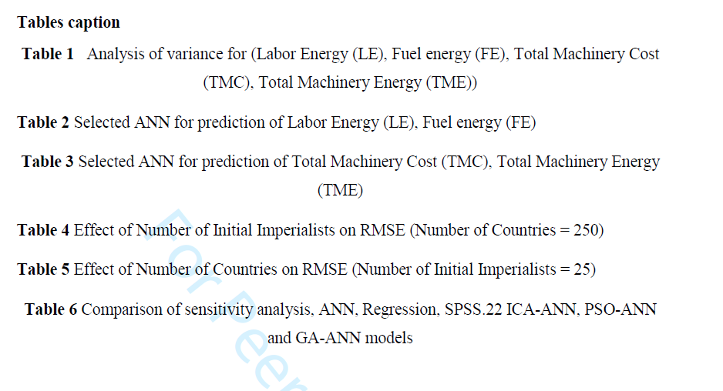

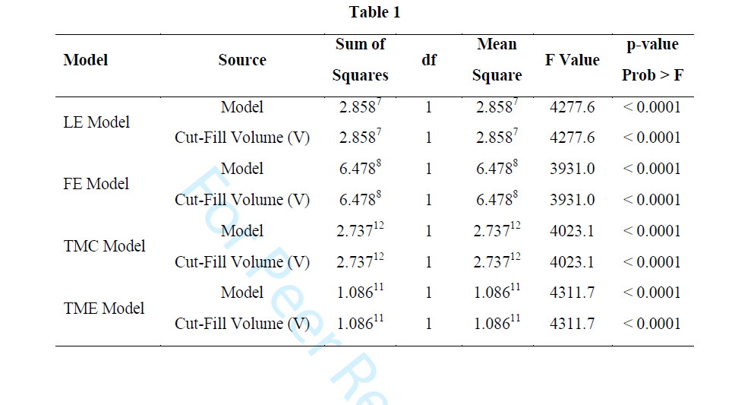

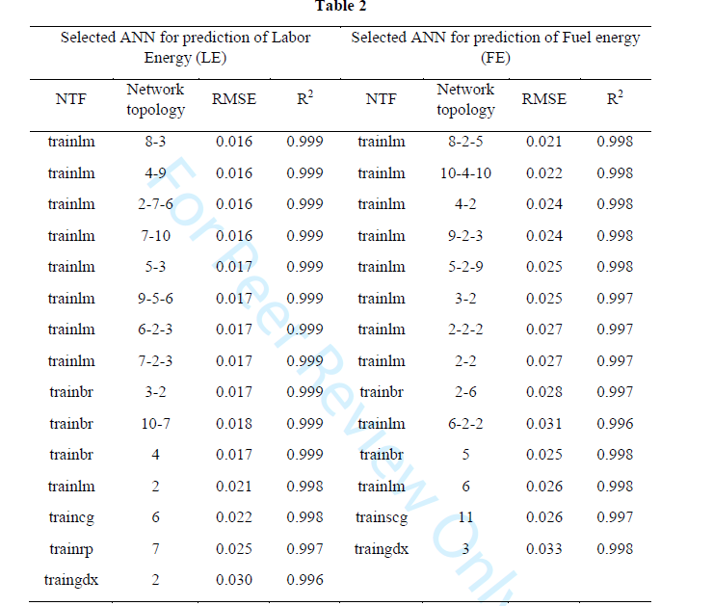

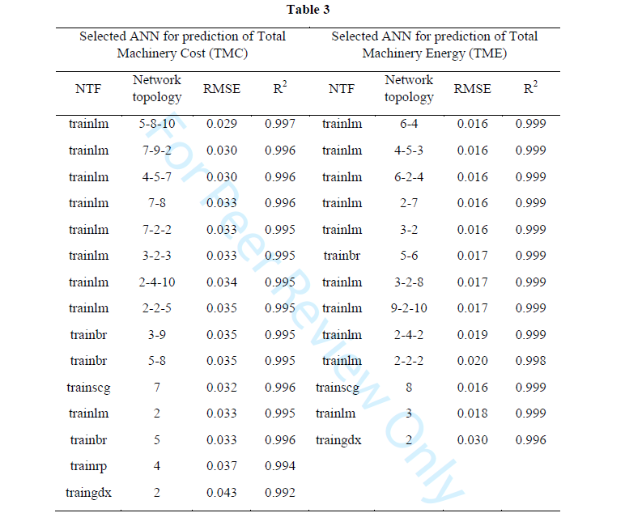

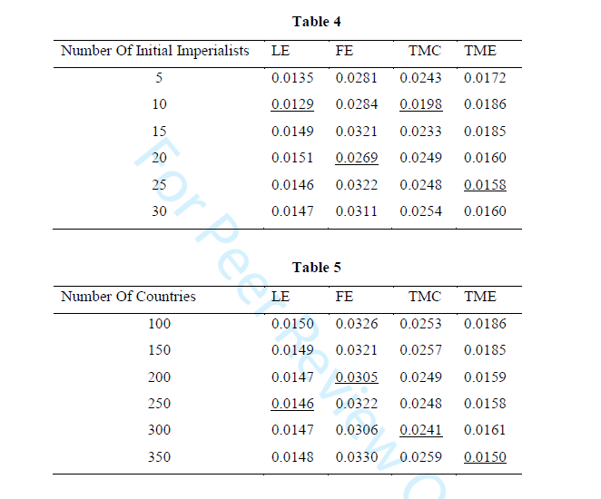

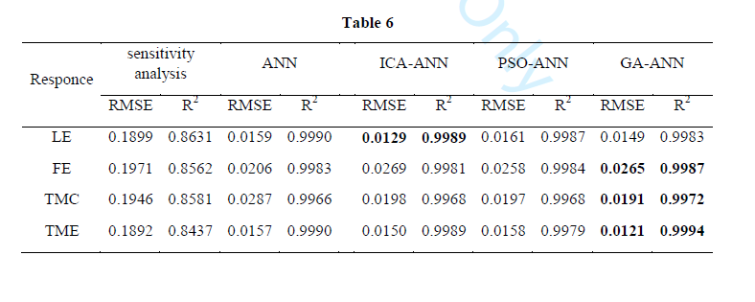
gg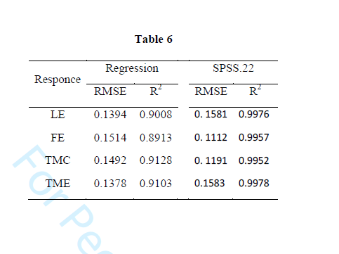
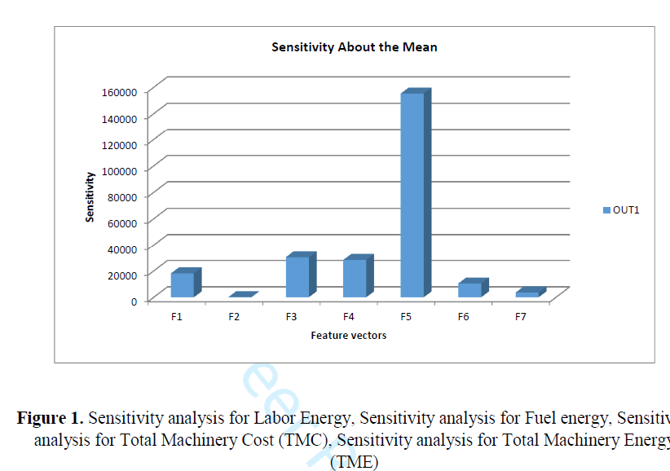

a) | b)
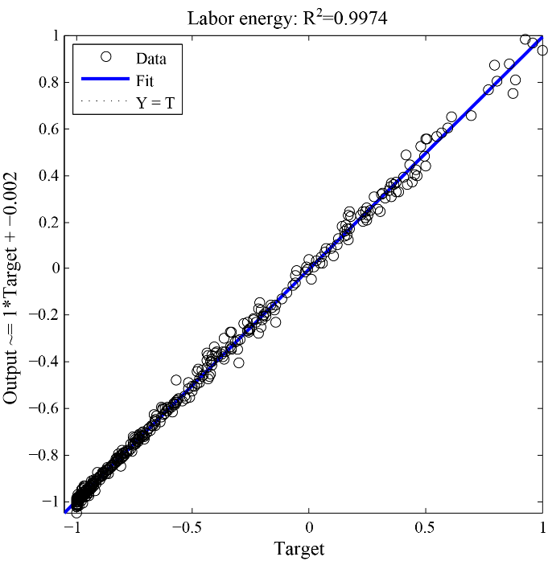 | 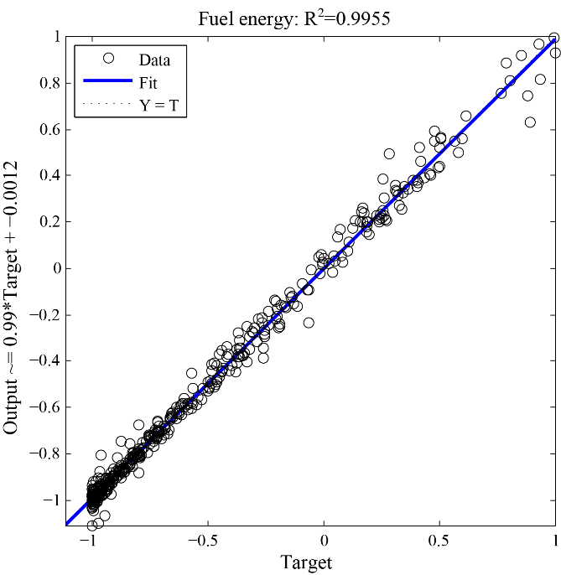
c) | d)
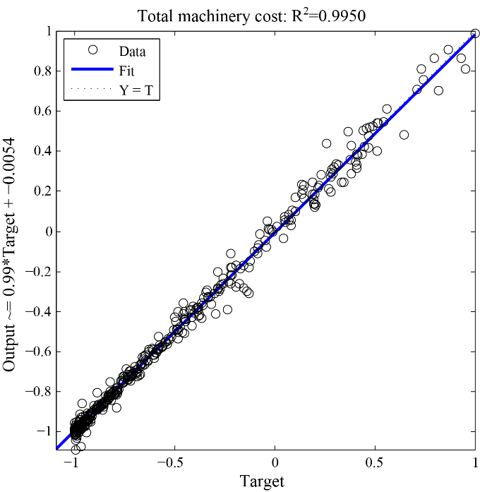 | 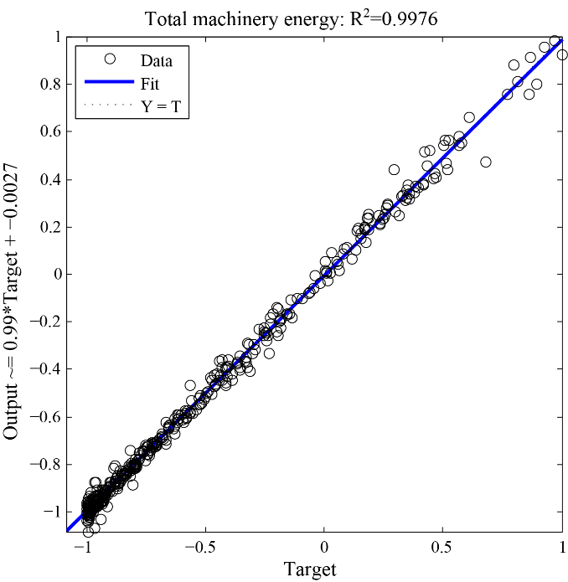
Figure 2. Scatter plots of output VS. target using ANN models for prediction
of (LE)

