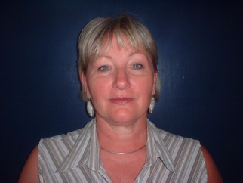
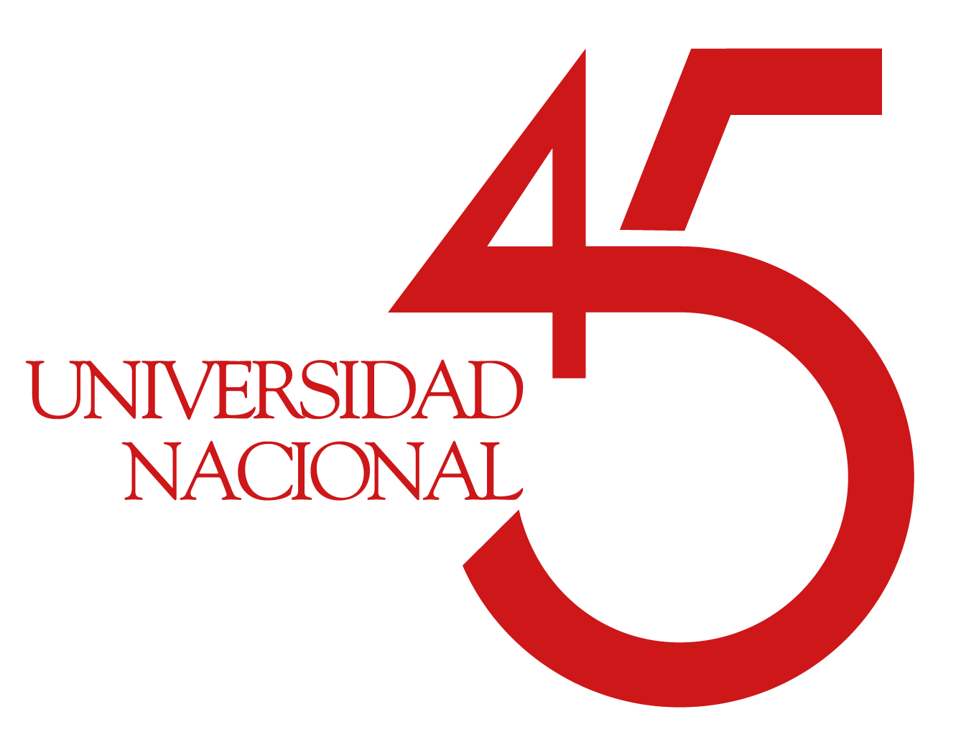

Paste your Lo go here

Title: Sustainable development indicators on water resource management in the Liberian district of Costa Rica.
Name: S.Nikolaeva*,G.Moraga*
*National University of Costa Rica/Physics Department, Heredia, Costa Rica.
svetlana.nikolaev.nikolaeva@una.cr

The Liberia District is located in Guanacaste in Costa Rica. The purpose of the study was to determine the current situation of Liberia in terms of its water resource and climatic situation in order to elaborate a proposal of the sustainable development plan for the Liberia District. Analyzing existing information from climatic measurements, a given course of actions on the environment, human population, level of consumption per person and the quality and quantity of water in the study area, a diagnosis was made of the water and climate situation of the District. Taking into account that in the last 15 years the city of Liberia has undergone an increasing transformation of socioeconomic activities, as well as being an important center of transport, agricultural trade and the core of services related to tourism. It is necessary to guarantee a quality and quantity access to the water resource, so it is very important to know its climatic situation and the water resource. So during this project was realized interviews, field visits, compilation and generation of climatic information and quality of the different water sources in the study area. The systematization of this information in order to prepare a proposal for a sustainable development plan to climate change in the Liberian zone, to serve as an input to incorporate these results into the different action plans. In order to analyze the climatic change of the zone, three indicators used: Average monthly hourly temperature, Average monthly precipitation per hour and cumulative monthly precipitation per hour. The collection of existing information, quality and quantity of water, and the generation of climate measurements in the district of Liberia allows a diagnosis of the climatic conditions and water situation of the study area. The study indicates that the rate of urban growth is uncontrolled and relationship between consumption needs and there effects on water disponibility is not consider. The District are at high risk of being harmed by the impact of drought and is necessary take action to prevent environmental and economic damages.

Biography

Svetlana Nikolaeva born in Moscow, Russia. Her first Master Degree in Mechanical engineering obtained in Gubkin Russian State Oil and Gas University. Second master degree in Climate change and sustainable development in the INIECO Institute, Spain. Since 1980she works at the National University of Costa Rica and is currently a member of the Commission of Academic Career and researcher in the field of water treatment, materials and climate change.

Present Position: Catedratica, Industrial materials Laboratory (LAMI), Physics Department, Faculty of Exact Science, National University of Costa Rica (UNA),Heredia, Costa Rica.

