Hydrogen Deep Ocean Link: An energy storage solution for deep
Julian David Hunt, International Institute for Applied Systems Analysis (IIASA)

Abstract (300 word limit)

The world is undergoing a substantial energy transition with an increasing share of intermittent sources of energy on the grid such as wind and solar, which is increasing the challenges to operate a grid. An option that has been receiving much focus after the COVID pandemic is the development of a hydrogen economy. The main challenges for a hydrogen economy are the high investment costs involved in compression, storage, and long-distance transportation. This paper analyses an innovative proposal for the creation of hydrogen ocean links, which increased the flexibility for hydrogen production, consumption, compression, storage, and transportation. Hydrogen Deep Ocean Link has the potential of increasing the interconnectivity of different regional energy grids into a global sustainable interconnected energy sector.

These proposed arrangements benefit from the high pressures at the deep sea, which allows HDPE pipes to perform the these services cheaply. The paper estimate that the investment costs for H2 isothermal compression from 100 bar to 500 bar is 14,730 USD/(m3/d), for long-term energy storage at 500 bar of 0.018 USD/kWh, for deep ocean H2 pipeline of 60,917,453 USD/GW at 400 bar and 5,000 km, and for deep ocean H2 submarine of 37,597,147 USD/GW at 400 bar and 500 km. The global potential for the shows that deep sea pipeline can be built surrounding the continents facilitating the transport of hydrogen within the continents, and connecting continents, resulting in a global sustainable energy grid.

Image
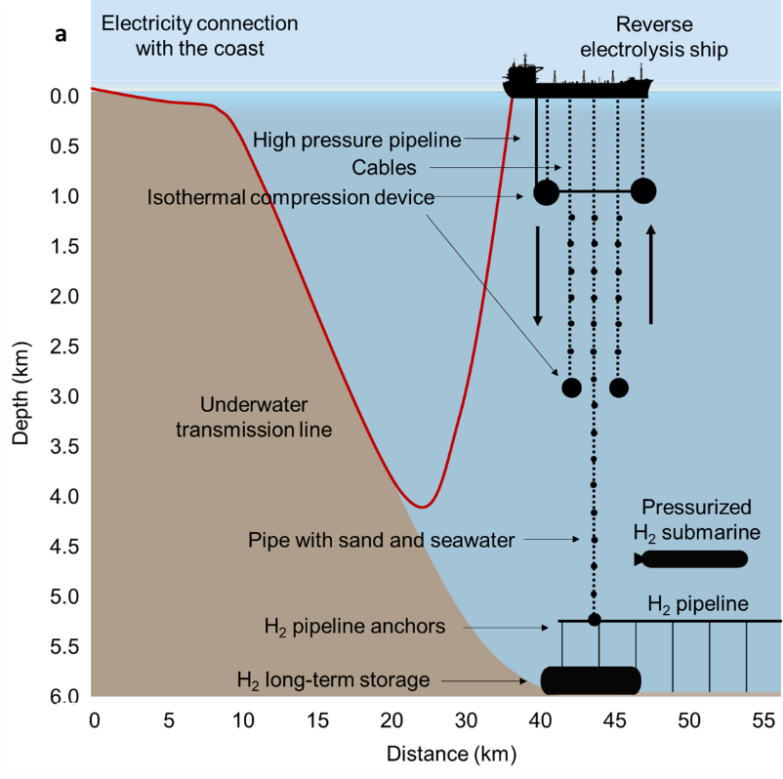
Recent Publications (minimum 5)
- Deep seawater cooling and desalination: Combining seawater air conditioning and desalination. Sustainable Cities and Society 74, 103257. 2021
- Buoyancy Energy Storage Technology: An energy storage solution for islands, coastal regions, offshore wind power and hydrogen compression. The Journal of Energy Storage 40, 102746. 2021
- Deep Seabed Mining: A Note on Some Potentials and Risks to the Sustainable Mineral Extraction from the Oceans. Journal of Marine Science and Engineering 9(5). 2021
- Global resource potential of seasonal pumped hydropower storage for energy and water storage. Nature Communications 11(947). 2020.
- Electric Truck Hydropower, a flexible solution to hydropower in mountainous regions. Energy (pre-print). 2022.


Biography (150 word limit)
Julian Hunt is a research scholar in the Sustainable Service Systems (S3) Research Group of the IIASA Energy, Climate, and Environment Program where he focuses on implementing daily and seasonal storage energy technologies in MESSAGE models and analyzing the impact of these technologies on long-term energy planning. His research interests include analysis of energy systems, water-energy-land interfaces, climate change risks, energy security, and energy storage.
Email:hunt@iiasa.ac.at

