Centering Microbes in the Emerging Role of Integrative Biology in Understanding Environmental Change

Ebony I. Weems, Alabama A&M University

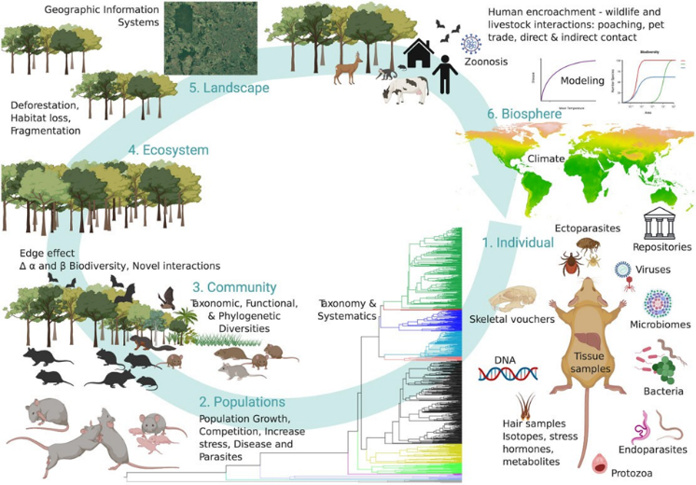
Abstract
The current environmental changes stressing the Earth’s biological systems urgently require study from an integrated perspective to reveal unexpected, cross-scale interactions, particularly between microbes and macroscale phenomena. Such interactions are the basis of a mechanistic understanding of the important connections between deforestation and emerging infectious disease, feedback between ecosystem disturbance and the gut microbiome, and the cross-scale effects of environmental pollutants. These kinds of questions can be answered with existing techniques and data, but a concerted effort is necessary to better coordinate studies and data sets from different disciplines to fully leverage their potential.
Fig. 1. Conceptual framework identifying key components of the ecological hierarchy linking: (1) Individuals of a particular taxa and the various attributes with additional datasets associated [e.g., voucher specimens, their associated tissue samples, DNA samples, skeletal material, associated parasites (i.e., endoparasite, ectoparasites, blood parasites, and viruses), microbiomes (e.g., gut, skin, and fecal), and dataset from hair samples (i.e., stress hormone, isotope profiles, metabolites, disease prevalence, and parasite loads)]. (2) Population’s dynamics and (3) community structure, quantifying various dimensions of biodiversity (e.g., TD, FD, and PD), and potential changes along gradients. Population and community structure should be coupled with (4) ecosystem and (5) landscape-level datasets to understand the impact that human-driven environmental change impacts their structure. Finally, landscape-level modeling can be valuable for inference and modeling of even bigger picture analyses at the (6) biosphere level as we assess the interplay between local, regional, and landscape-level processes and biodiversity patterns react to global changes (e.g., climate change). Phylogeny was con- structed using Steppan and Schenk (2017) beast concatenated dataset. Figure was created on BioRender.com.

Recent Publication:
Ebony I Weems, Noé U de la Sancha, Laurel J Anderson, Carlos Zambrana-Torrelio, Ronaldo P Ferraris, Centering Microbes in the Emerging Role of Integrative Biology in Understanding Environmental Change, Integrative and Comparative Biology, 2021;, icab047, https://doi.org/10.1093/icb/icab047

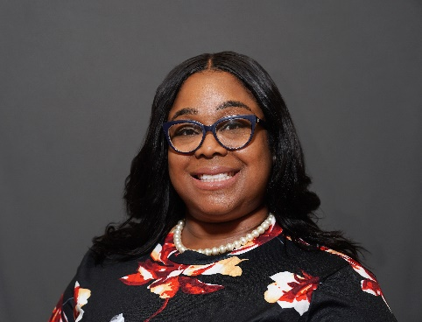
Dr. Ebony Weems is an Assistant Professor at Alabama Agricultural and Mechanical University in Huntsville, Alabama. Her research focuses on investigating the molecular mechanisms associated with metabolic diseases and addressing health disparities that are prevalent in minority communities. Recently, her research interest also includes the adverse impacts of climate change on health outcomes in minority communities.
Email: Ebony.Weems@aamu.edu
Presenting author details
Full name: Ebony Weems
Contact number: 404-644-2193
Mail id: Ebony.Weems@aamu.edu
Category: Oral Presentation

