The unattended role of co-benefits on health and equity in climate change policies
Sonia Quiroga, Professor, Department of Economics, Universidad de Alcalá, Spain

Abstract

The interconnection among climate, policies for environmental promotion and human health and wellbeing will gain importance in the following decades. Global change will bring new challenges to human health due to the spread of new diseases, pollution and the increased habitational density accompanying the spread of megacities. Policies that tackle impacts of climate change may suppose a financial and economic burden that could be reduced if adequate strategies are overtaken. This paper analyses the co-benefits in health that nature promotion policies destined to adapt to climate change, such as those encompassed in the Ecosystem-based Adaptation (EbA) category. Green environments have been associated not only with stress reduction, but also with lower prevalence rates in different illnesses and health problems (Martinez-Juarez,2015; Maas et al. 2009). Forgetting that ecosystems are valuable also because of the subjective inclination of societies towards greener environments is a cause of the excess of attention that has been paid to policies such as grey infrastructures. While their positive impact as adaptive measures is undeniable, their cost efficiency may not be as clear as it should. Soft adaptation measures have been showing encouraging results, even taking just into account their ability to fulfill their direct role (New York City Department of Environmental Protection 2008). It has also been suggested that green neighborhoods reduce health inequalities, providing better health to both high and low income areas, but improving health conditions more strongly in economically deprived areas (Mitchell and Popham 2008). This subject will be of growing importance as climate change affects the income structure both within countries and among them. There is still much to be analysed on the issue of the potential reduction of socioeconomic inequalities through environmental policies (Quiroga and Suárez 2016).
Image
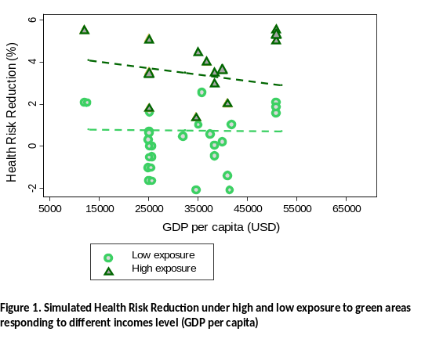
Recent Publications (minimum 5)
- Chiabai, A., Quiroga S., Martínez-Juarez P., Higgins S., Taylor T. (2018). The nexus between climate change, ecosystem services and human health: Towards a conceptual framework. Science of the Total Environment, 635, 1191-1204.
- Weiss G, Lawrence A, Hujala T, Lidestav G, Nichiforel L, Nybakk E, Quiroga S, Sarvasova Z, Suarez C, Zivojinovic I (2018). Forest Ownership Changes in Europe: State of Knowledge and Conceptual Foundations. Journal of Forest Policy and Economics, (In Press).
- Sarvasova Z, Ali T, Djordjevic I, Lukmine D, Quiroga S, Suarez C, Hrib M, Rondeux J, Mantzanas KT, Franz K. (2018). Natura 2000 payments for private forest owners in Rural Development Programmes 2007–2013 - a comparative view. Journal of Forest Policy and Economics, (In Press).
- Quiroga S, Suárez C, Fernández-Haddad Z, Philippidis G. (2017) Levelling the playing field for European Union agriculture: Does the Common Agricultural Policy impact homogeneously on farm productivity and efficiency? Land Use Policy, 68, 179-188.
- Feliciano D., Bouriaud L, Brahic E, Deuffic P, Dobsinska Z, Jarsky V, Lawrence A, Nybakk E, Quiroga S, Suarez C, Ficko A. (2017). Understanding private forest owners’ conceptualisation of forest management: Evidence from a survey in seven European countries, Journal of Rural Studies, 54, 162-176.

Biography (150 word limit)
Dr. Sonia Quiroga is a Professor of Economics at the University of Alcala in Spain. Her research focuses on the quantitative relations of climate, water, weather and the economy, specially focusing climate change impacts and adaptation. Methodological approaches include the econometric estimation of empirical relationships, CGE modelling, Cost-Benefit analysis, Contingent Evaluation and risk management tools. She has contributed to a range of EU projects (H2020, FP7, FP6, CostAction), and a number of technical assistances for World Bank, World Meteorological Organization, United Nations Framework for Climate Change, UNECE FAO, among others. She has disseminated her research findings in a number of prestigious international research journals and international congresses and seminars.
Email: sonia.quiroga@uah.es

