Potential of African Indigenous Vegetable Farmers to Adapt to Climate Change in Kenya
Chepkoech W., MSc, Center for Rural Development (SLE), Humboldt – Universität zu Berlin, Germany
Mungai W. Nancy., PhD, Horticulture and Soils, Egerton University, Kenya
Stöber S., PhD, Center for Rural Development (SLE), Humboldt – Universität zu Berlin, Germany
Bett K. Hillary. PhD, Agricultural Economics and Agribusiness Management, Egerton University, Kenya
Lotze-Campen H., PhD, Potsdam Institute for Climate Impact Research (PIK), Humboldt-Universität zu Berlin, Germany

Abstract (300 word limit)
Statement of the problem: Understanding the adaptive capacity (AC) of farmers is crucial in planning effective adaptation. This is because Climate Change (CC) brings unpredictable changes in weather patterns that call for actions that promote the AC of farmers. Based on the Sustainable Livelihoods Framework (SLF) we explore how access to natural, physical, financial, social and human capitals enhances AC. Methodology and theoretical orientation: Quantitative data from 269 African Indigenous Vegetable (AIV) farmers in Kakamega, Nakuru and Kajiado counties, Kenya is analysed. Four to five indicators in each capital were selected based on previous studies and judgments collected from an expert online ranking survey (n=35). Kruskal-Wallis H test and independent sample t-test were used to test the independence of AC scores and access to the different resources. Findings: Majority of farmers had moderate AC while only few had low and high AC. Access to various resources and some household characteristics significantly influenced the AC. There was overall low access to physical, financial and human resources. Female farmers show lower capacities in fields of financial human and natural resources while men counterparts show weak access to some human and physical resources. Conclusion and significance: We conclude that all the five capitals mutually work to build on AC of farmers. There is need therefore to build resilient interventions like investing in formal education as well as eliminating barriers that limit access to off-farm income. Additionally, re-packaging of agricultural extension to include farmer empowerment on group membership and money saving schemes as well as strengthening property rights for both men and women farmers provide some means to achieve desired AC

Image
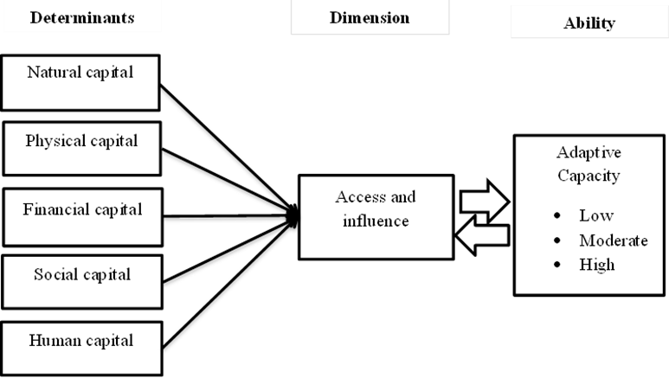
Recent Publications (minimum 5)
- Chepkoech, W., Mungai, W.N., Stöber, S. Bett, H.K., Lotze-Campen, H. (2018). Farmers’ perspectives: Impact of climate change on African indigenous vegetable production in Kenya, International Journal of Climate Change Strategies and Management, https://doi.org/10.1108/ IJCCSM-07-2017-0160
- Stöber, S., Chepkoech, W., Neubert S., Kurgat B., Bett H., Lotze-Campen, H. (2017). Adaptation Pathways for African Indigenous Vegetables’ Value Chains. In: Leal Filho et al. (ed) Climate Change Adaptation in Africa, Fostering Resilience and Capacity to Adapt, Climate Change Management, Springer International, Cham.
- Abdul-Razak, M., Kruse, S. (2017). The adaptive capacity of smallholder farmers to climate change in the Northern Region of Ghana. Climate Risk Management 17 (2017) 104–
- Asfaw, A., Simane, B., Hassen, A., Bantider, A. (2017). Determinants of non-farm livelihood diversification: evidence from rainfed-dependent smallholder farmers in north central Ethiopia (Woleka sub-basin). Development Studies Research 4(1):22-36.doi. 10.1080/21665095.2017.
- Kebede S.W, Bokelmann W. (2017). African Indigenous Vegetables and their Production Practices: Evidence from the HORTINLEA Survey in Kenya. Agrotechnology 6: 170. doi: 10.4172/2168-9881.1000170

 Biography (150 word limit)
Winifred is a final year PhD student at Humboldt Universität zu Berlin, Germany. She holds a Master of Science degree in Community studies and Extension from Egerton University, Kenya. Her passion for climate change research started in 2015 when she was awarded a doctoral degree scholarship by the Horticultural Innovations and Learning for improved nutrition and Livelihoods in East Africa (HORTINLEA) project. Her current research analysed the impacts of climate change on production of African Indigenous Vegetables and adaptation options. From her studies and field researches in Kenya she has gained experience in participatory research approaches which is pertinent in carrying out vulnerability studies. She has interests in carrying out further research on climate adaptation especially of vulnerable smallholder farmers in Africa.
Email: sangwinfred@gmail.com

Notes/Comments:

