Abstract (300 word limit)
The main problem faced by both modern and traditional data centres is carbon usage efficiency (CUE) and power usage efficiency. As per a report, over 10 year, data centres will waste over £0.5M in power charges and emit 80% of co2 but the chances of increasing the percentage in coming years are more. Thus creating Data centre a ‘Villain- Destroyer of Earth’. This paper illustrates and explains about the new Algae concept for carbon usage efficiency and power usage efficiency. Algae unicellular microorganism is a billionaire solution for all the current data centres. It can absorb tons of carbon dioxide in few minutes whereas a single tree can’t even do in its life time. Algae undergo photosynthetic reaction and gives biogas and biofuel as a by-product. Thus turning C02 into valuable products lead to significant changes in Data centers. This new Co2 controlling technique to save the environment with the help of algae panels can give us the most profitable business. By Moving to Algae Centered Power Plant(ACPP) Model, we can achieve the sustainability, energy efficiency and global conservation. Data Center Operators are no longer a pure Consumer, but also they are become a Producing Consumer- a “Prosumer”. The Opportunities to change a date center from the consumer to prosumer are more diverse here. This technology is a pioneer in green algae power and carbon neutrality. Using this algae technology, data centre can change its image from “CO2 villain to an Environment Saviour”.
Diagram:
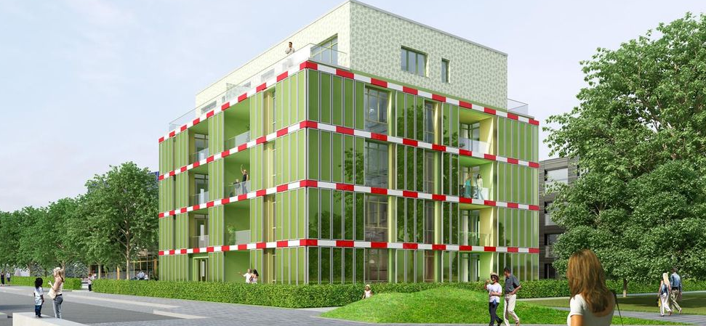
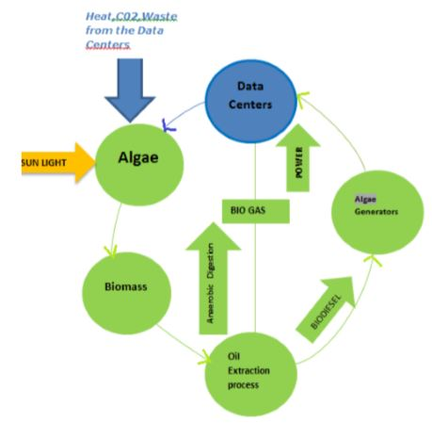
Recent Publications (minimum 5)
[1]Reducing all our emissions to fight climate change -
orange.com. 2017. Reducing all our emissions to fight
climate change - orange.com. [ONLINE] Available at:
https://www.orange.com/en/Commitments/Responsibilit
y/Environment/Folder/Climate-change/Folder/climate-
change-file. [Accessed 13 April 2017].
[2] &quot;Data Center CO2 Emissions&quot;. INFRARATI. N.p.,
2017. Web. 13 Apr. 2017.
https://infrarati.wordpress.com/2014/03/25/data-center-
co2-emissions/
[3] &quot;Study: Biofuels More Efficient As Electricity Source
| Worldwatch Institute&quot;. Worldwatch.org. N.p., 2017.
Web. 13 Apr. 2017.
http://www.worldwatch.org/node/6109
[4] &quot;The BIQ House: First Algae-Powered Building In
The World&quot;. Build Up. N.p., 2017. Web. 13 Apr.
2017.http://www.buildup.eu/en/practices/cases/biq-
house-first- algae-powered- building-world
[5] Chalcraft, Emilie. &quot;Arup Unveils World&#39;s First Algae-
Powered Building&quot;. Dezeen. N.p., 2017. Web. 13 Apr.
2017.https://www.dezeen.com/2013/04/15/arup-unveils-
worldsfirst-algae- powered-building/

Biography (150 word limit): Niveditha Kakinada, Ranjan Emani
Email Id: niveditha.kkd@gmail.com, ranjan.emani59@gmail.com
Phone no: o899889603,089962057
We are recently graduated from National Colllege of Ireland. Currently working on publishing few research papers related to my field of study.

