Germination of three Proteaceae species along a moisture gradient in a Mediterranean ecosystem under drought conditions
Judith L. Arnolds, PhD, PhD, South African National Biodiversity Institute, South Africa
Gert H. Krüger, PhD, North West University, Potchefstroom South Africa
Guy F. Midgley, PhD, University of Stellenbosch, Stellenbosch, South Africa
Abstract
The processes of recruitment such as seed germination and seedling emergence are crucial for plant species persistence and long-term survival. Climate controlled differences in seed production, seedling recruitment and persistence are considered the main reason that cause the distribution and size of plant communities as well as their internal structure and function. In Mediterranean ecosystems, like the Cape Floristic Region (CFR), temperature and the recording of rainfall is essential for effective establishment of seedlings and also the surviving of the first year’s summer drought is important for population continuity. Climate change is changing the environmental signals that seeds receive causing compromised seedling emergence. Here, we examine how temperature and moisture will affect germination in three Proteaceae species. An altitudinal gradient of temperature and moisture was used to simulate climate change effects. Climate change niches were constructed along the gradient and seeds of three Proteaceae species collected from the study site were planted in soil from the study site. Germination of the three species was also tested in a greenhouse. Under present climate change conditions germinations of the three species did not occur at the lowest altitude (545 m) because of higher temperature and low soil moisture. Germination of the three species occurred 227 days after sowing in the field and germination occurred after 74 days in the greenhouse. The highest germination percentages were found at the two closest stations (933m and 744 m) along the gradient. Protea repens had the highest germination percentage at both of the sites. Germination of the three species occurred at a temperature of between 6.7 ⁰C to 10.4 ⁰C. Temperature and moisture play an essential role in the germination process of Proteaceae. The results of this study suggest that under higher temperatures and low moisture Proteaceae in the Fynbos Biome maybe at risk.

Image
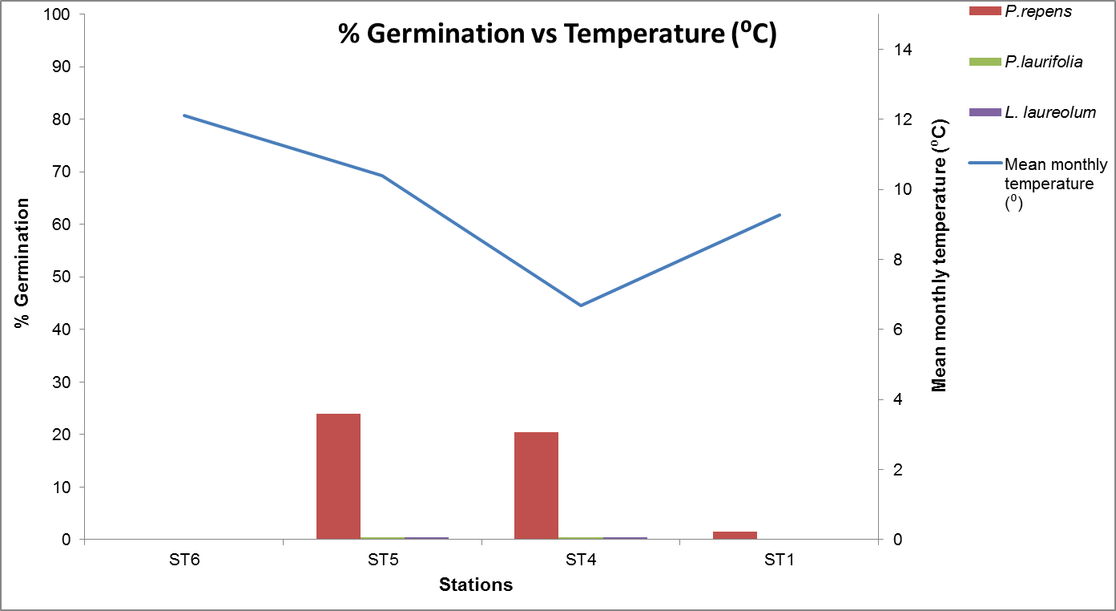
Figure 1: Percentage germination vs temperature(⁰C) at the different stations
Publications
- Graae BJ, Alsos IG, Ejrnaes R (2008) The impact of temperature regimes on development, dormancy and germination of dwarf shrub seeds from arctic, alpine and boreal sites. Plant Ecology, 198: 275–284.
- Holloway-Phillips MM, Huai H, Cochrane A, Nicotra, AB (2015) Differences in seedling water-stress response of two co-occurring Banksia species. Australian Journal of Botany, 63: 647-656. http://dx.doi.org/10.1071/BT15022.
- Luna B, Pérez B, Torres I, Moreno JM (2012) Effects of incubation temperature on seed germination of Mediterranean plants with different geographical distribution ranges. Folia Geobotanica, 47:17–27. DOI 10.1007/s12224-011-9110-0.
- Milbau A, Graae, BJ, Shevtsova A, Nijs I (2009) Effects of a warmer climate on seed germination in the subarctic. Annals of Botany (Oxford), 104: 287–296.
- Salvatore R, Moya D, Pulido L, Lovreglio L-S, De las Heras J, Leone, V (2010) Morphological and anatomical differences in Aleppo pine seeds from serontinous and non-serotinous cones. New Forests, 39: 329-341.

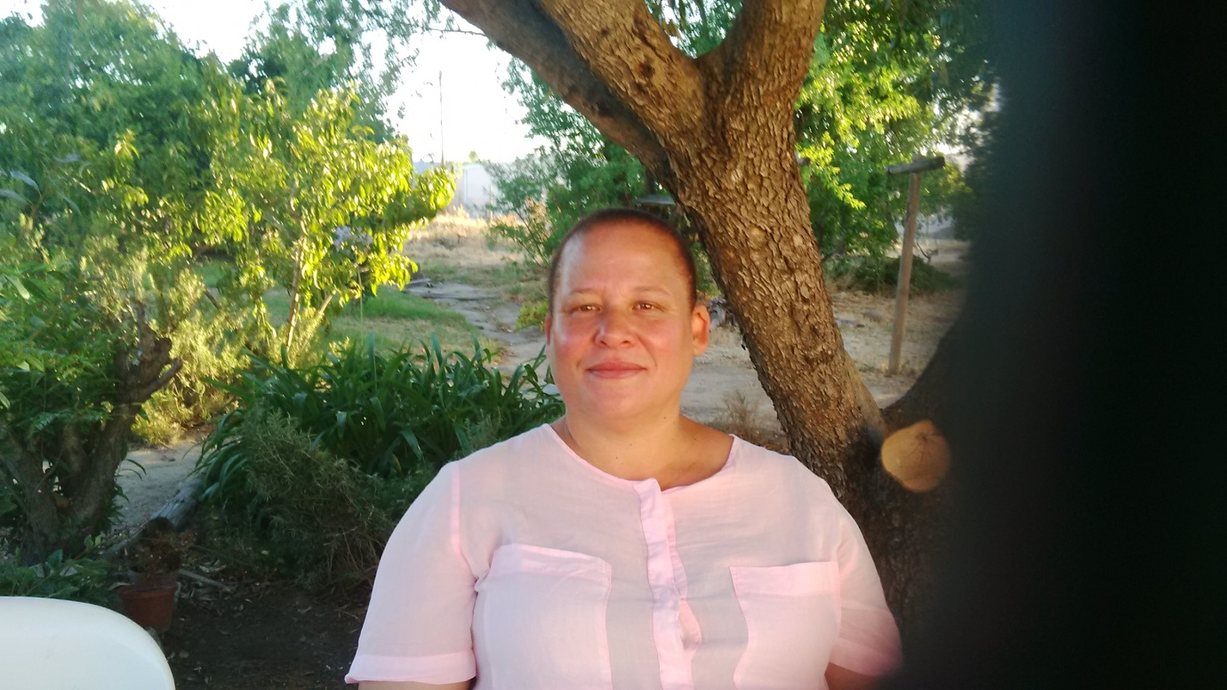
Biography
Judith Arnolds is a researcher at the South African National Biodiversity Institute (SANBI). My research focuses mainly on local and regional effects of temperature and drought stress on the ecology, physiology and reproduction of South African Mediterranean-climate plants. My current fields of interest include climate change effects (temperature stress) on plants and environmental health (ecotoxicology). I am also interested how aquatic plants can be used to remove metals from polluted waterbodies. I have a PhD in Botany and a PhD in Environmental Health. I am also a certified Environmental Impact Assessment Practitioner.

_____________________________________________________________

