Urban Mobility and Climate Change:
Spatial Assessment for NCT of Delhi, India

ABSTRACT
Cities are victims and catalysts to climate change accounting for over 70% of global greenhouse gas emissions (IPCC 2015). The paper highlights the interplay of urbanization and climate variability for NCT of Delhi, and their implication on city’s mobility. Empirical analysis carried out at macro-level by the authors reveals that for every 100 hectare increase in built up in Delhi it lost 94 hectares of its vegetative cover, 6 hectares of water bodies and 14.3 hectares of flood plains, during 1986-2016. Simultaneously, surface run-off increased three times leading to increased inundation, increased travel time and affected road infrastructure . At micro level the paper highlights climate change impacts on urban mobility for most vulnerable population taking case study of village habitations within flood plains of Yamuna river .The empirical analysis indicates that 141 villages are at risk of inundation in the city, home to over 2.8 lakh persons and the annual exercise of rehabilitation, recovery and preparation during monsoons burdens the state exchequer with over 201 lakhs INR, excluding the costs incurred by the vulnerable cohort. The paper highlights the interplay of urbanization and climate variability for NCT of Delhi, and their implication on city’s mobility. This interplay, and its multi-dimensional relationships with urban mobility, makes it imperative for the city to be envisaged in a holistic climate resilient framework for a livable urban future, guided by policies of land use- land cover and transport planning.
Keywords: Urban Development Pattern, Urban Flood, Travel Time, Inundation, Affected Population and Area

INTRODUCTION
Climate Change is a global phenomenon and variability of climate over decades is attributed, directly or indirectly to human activity which alters the composition of atmosphere, as observed over comparable time periods. The IPCC 2014 report highlights population growth from 4 billion to 7 billion, that is a 75 %increase post 1970, whereas greenhouse gas emissions increased by 82 per cent, with an annual increase of 2.2 %in past decade alone. The need for studying climate change and the impact of urban development on climate change becomes more important today with cities covering less than 3 %of the Earth’s surface but contributing over 70 %of emissions and accounting for 75 %of global energy consumption (UN-Habitat. 2011. Transportation systems of a city is associated as contributors of climate change and affected by climate change (UCCRN, 2014). Land use-transportation systems are determinant of greenhouse gas emissions in the urbanscapes. Mobility related emissions add to net emissions released by a city from its various activities and spaces, and lead to increasing air pollutants, which further enhance temperature. Apart from contribution in terms of emissions, urban transport also affects climate change by engulfing vegetative heat sinks and cutting across drainage channels to pave way for extensive networks, thereby aggravating climate variability and vulnerability. Further with rising temperatures and erratic climate changes, people’s mobility may be hindered or preferences for different modes change
In 2008, urban development became central to the international discourse on climate change, with global urban population reaching 50 %mark and accounting for 70 %of total emissions. Four cases for this situation were identified including land use land cover change, transportation, building construction and pollution problems related to industry which coincide with areas where the role of urban planner and urban planning fits in- in terms of planned development, adapting to climate impacts and mitigating future risks. In India while abundant research has been carried out which studies the impacts of climate change, the spatial distribution of greenhouse gas emissions, urban drainage in relation to changing intensities of precipitation and few other similar sub-theme but only a few try to assess climate change in terms of urban development pattern in general and urban mobility in particular.
This paper therefore, asserts the close knit relationship of climate change with urban development and urban mobility in case of Delhi. Empirical analysis conducted for the four time points- 1986, 1996, 2006 and 2016 is grounded in two prime secondary sources- meteorological data from Indian Meteorological Department and raw aerial LandSat imageries from the online portal of United States Geological Survey. GIS modelling and analysis of aerial imageries in relation to statistical data buttress the spatio-temporal analysis. . At micro level the paper highlights climate change impacts , with emphasis on urban floods, on urban mobility for most vulnerable population taking case study of village habitations within flood plains of Yamuna river .
.

2. PROFILE OF DELHI
  - Demographic Characteristics

As per 2011 Census, NCTD had a population of 16.78 million. Delhi is highly urbanized with 93.18% of its population living in urban areas as against the national average of 27.81%. The decadal growth of population for Delhi has declined from 51.45% in 1981-91 to 47.02% in 1991-2001 to 21.92 in 2001-2011. The average annual exponential growth rate of population of Delhi during 2001-2011 has been recorded as 1.92%. The overall population density of Delhi has increased from 9340 persons per sq.km. in 2001 to 11297 persons per sq.km. in 2011 which is highest as compare to All India and other States/UTs. The total literacy rate of Delhi is 86.34 % as per provisional data 2011 comprising 91.03 % of me and 80.93% of women literacy rate. There has been a substantial increase in the overall sex-ratio, from 821 in 2001 to 866 in 2011.

2.2 Transport System Profile
The existing transport network in Delhi is “Ring and radial’ in nature. The transportation network in Delhi is predominantly road based with 1284 km of road per 100Sq.km. The total road length (km. lane) which was 14,316 km in 1981 which increased to 28,508 km in 2001 and 31,373 km in 2009 respectively. The city had a registered vehicle population of 7.45 million in 2011 having increased from 5.21 million in 1981 at a CAGR of 1.20%. Two-wheelers (63%) followed by passenger cars (32%) have major share in the fleet. In terms of mass transport system the Delhi Transport Corporation (DTC) operates its bus services with 5,500 buses in use. Around 1300 buses are operating under the Cluster bus system. Delhi Metro today has a current operational network covering 192.81 kms approx. in Delhi and the National Capital Region (Gurgaon and Noida) with 146 operational stations. The daily ridership on metro increased from 82,000 in 2002 to 23.38 lakhs in 2015.

2.3 Urban Mobility Trends

The per capita trip rate (excluding walk trips) in the city has increased from 0.72 in 1981 to 0.87 in 2001. Per capita trip rate is increasing at the CAGR 1.8% per annum. It is estimated that per capita trip rate may reach to 1.2 by 2021 in Delhi. The observed average trip lengths of bus and car in the city are 10.7 km and 11.3 km respectively according to study by DIMTS (2007). The average trip lengths of motorised modes in Delhi has increased from 5.4 km in 1969 to 10.2 km in 2007 indicating the impacts of urban sprawl. An estimated 15.1 million motorised trips were performed in the city by 2007 of which the share of public transport was 54.7% while two wheelers and cars accounted for 25.5 % and 15.5 % share respectively. The intra-city motorized person trips are expected to increase from 15.1 million in 2007 to 17.4 million in 2021. In 2001 about 33% trips were estimated to be walk trips. Among the vehicular trips, the maximum (60%) trips were being performed by buses while the personalized modes of transport were carrying about 27% of vehicular trips in the city. The modal split in favor of public transport has increased from 41 % in 1969 to 52.5% in 2007

3. TRENDS OF URBAN DEVELOPMENT PATTERNS AND CLIMATE VARIABILITY
3.1 Urban Development Patterns
National Capital Territory of Delhi is testimony to numerous changes and challenges. This section underscores pattern and trend of urban development in the city. The trend is assessed using the LandSat imagery and digital elevation models. With raw imagery obtained from the online portal of the United States of Geological Survey, the land cover and land use pattern of Delhi has been classified with the help of GIS software, for 1986, 1996, 2006 and 2016.
Change in land cover of Delhi (Table 1) indicates that the city spread ouwards, post 1986 around its core with infill developments. Construction in 1986-1996 were 1.3 times the development of the preceding decade, which may be attributed to the real estate growth that emerged post-1980s Asiad Games and economic liberalization of the country’s economy in 1990. This resulted in conversion of agricultural fields into non-agricultural use like residential, commercial and such other non-permeable concrete jungles, associated with increased density. This change in development patterns during 1986-2016 is reflected in a population increase of 12.4 million , increase in urban density by 2.6 times, developed area density by 1.8 times and gross residential density by 2.14 times respectively.
Table 1: Change in Land Cover of Delhi: 1986-2016
Land Cover |  | 1986 | 1996 | 2006 | 2016 | Decadal Change
 |  | Area  (in sqkm) | Area  (in sqkm) | Area  (in sqkm) | Area  (in sqkm) | 1986-1996 | 1996-2006 | 2006-2016
 | Total Built Up | 581.45 | 710.4 | 783.6 | 863.5 | 22.5 | 11.0 | 10.8
 | Forests | 176.8 | 178.1 | 172.1 | 176.2 | 0.8 | -3.8 | 2.6
 | Other Greens | 48.6 | 66.8 | 70.2 | 75.8 | 36.0 | 5.5 | 8.6
 | Water Bodies | 41.9 | 34.4 | 29.6 | 25.4 | -21.7 | -16.6 | -16.9
 | Agriculture | 586.0 | 432.5 | 368.2 | 284.6 | -33.2 | -17.7 | -28.2
 | Wasteland | 48.3 | 60.8 | 59.3 | 57.6 | 25.9 | -2.8 | -3.2
TOTAL= |  | 1483 | 1483 | 1483 | 1483
Extracted by Author (2017) from USGS (1986, 1996, 2006 & 2016)

3.2. Climate Variability
The climate of NCT of Delhi is categorized into four seasons by the Indian Meteorological Department- winters, summers, monsoon and post monsoon. The analysis in this paper, assesses climate change through precipitation variables only, using meteorological data obtained from the Indian Meteorological Department, New Delhi and Irrigation and Flood Control Department, Government of NCT of Delhi. Temporal analysis of statistics reveal that post-1901 indicates increase in average rainfall by 210 millimeters and prolonged periods of drought, which are becoming longer than periods of heavy rain. Also, a trend of wetter summers and drier post monsoons is inferred with an indication of increasing average number of annual rainy days by 9. In past three decades, rainfall is becoming more intense with the intensity increasing from 13.2 mm/hour in 1986 to 22.9 mm/hour in 2016.
This drastic increase of rainfall along with depletion of soft paving and cut and fill of drainage networks, has been held responsible among the climatologists, for increased inundation as well as frequency and intensity of floods in the city. Over 50 %of city in 2016 was reported to be inundated under water within three hours of precipitation. Further the urban development patterns too have contributed towards deteriorated flood plains conditions of the city, thus disturbing the city’s microclimate and ecological balance. Empirical analysis indicates an annual rate of depletion of flood plains equivalent to 1.4 per cent per annum. Moreover, it is observed that flood plains are depleting at a much faster rate than the rate at which built up is increasing (equivalent to 1.3 per cent). This imbalanced and unsustainable development pattern of the city is adding to natural climate variability, accentuating vulnerability of the city and its citizens.

INTERPLAY OF CLIMATE CHANGE AND URBAN DEVELOPMENT WITH MOBILITY PATTERN

4.1 Contribution of Transportation sector in total GHG emissions
Increase in GHG emissions for Delhi have been assessed using Tier II methodology formulated by the Intergovernmental panel on Climate Change in 2007, utilizing emission factors for energy consumption in each sector. Here, the sectoral contribution of GHG emissions from the sectors of waste, transport, domestic and industries is estimated. Spatially, modeling of satellite imageries indicates an increase in the total area of greenhouse gas emitters. Statistically, the city had 42.5 %of its area under greenhouse gas emitters in 1986 which increased to 56.8 %in 2016, and is closely related to increasing densities.
As observed from Table 2 sectorally emissions have increased 4.5 times since 1986 while the increase has been over 12 times in case of transportation sector as against 3.5 times for domestic sector, 3 times for waste sector and 2.9 times for industrial sector. For every 100 hectare increase in built-up area between 1986-2016, vegetative heat sinks reduces by 94 hectares and water bodies by 6 hectare, leading to an increase of emissions by 0.078 million metric tonnes of CO₂ equivalent. Rising emissions, pollution and ambient air quality of the city has taken a toll in recent years. In 2014-15, the World Health Organization concluded that Delhi’s air was the worst of 1600 cities in 91 countries that it measured, on the basis of density of PM_{2.5}, or fine and extremely dangerous particles. In yet another report, documenting research findings of IIT-Kanpur, tit was reported that toxic exhaust fumes from vehicles constitute 25% of the city’s air pollution. The latest government data show 6,502 people died of respiratory diseases in 2015, making it one of the leading causes of death (HT Correspondent. 2016).

Table 2: Sectoral contribution of GHG emissions in Delhi : 1986-2016
Year | WASTE SECTOR |  | DOMESTIC SECTOR |  |  | INDUSTRIAL |  | TRANSPORTATION |  | Net GHG  Emissions  (In mmt)
Year | Waste  Generation  (in million kg) | GHG  Emissions  (In mmt)  (EF=0.13) | Area (in hectare) | Population  (in million) | GHG  Emissions  (In mmt)  (EF=0.06) | Energy  Consumption  (in million units) | GHG  Emissions  (In mmt)  (EF=0.15) | Fuel  Consumption (Petrol, Diesel,  CNG) (in '000 MT) | GHG  Emissions  (In mmt)  (EF=0.09) | Net GHG  Emissions  (In mmt)
1986 | 2.8 | 0.36 | 54600 | 5.8 | 3.51 | 1,085 | 0.16 | 948 | 0.57 | 4.60
1996 | 4.3 | 0.56 | 65640 | 8.6 | 5.20 | 1,537 | 0.23 | 1,718 | 1.03 | 7.02
2006 | 6.8 | 0.88 | 67780 | 11.9 | 10.74 | 2,518 | 0.38 | 2,028 | 1.83 | 13.82
2016 | 8.4 | 1.09 | 70520 | 13.6 | 12.25 | 3,135 | 0.47 | 7,693 | 6.92 | 20.73
Source : Estimated by authors (2017) from GNCTD (2016) and IPCC (2007)

Trends in Air Quality levels and GHG Emissions
Particulate matter (PM10 as well as PM2.5) is the pollutant of most concern for ambient air environment of Delhi . The trends of PM 2.5 during winter months in Delhi between 2010-13 at 6 locations in Delhi are shown in Fig. 1. It is observed that PM 2.5 levels is generally increasing over the years across various locations with few exceptions.

Figure 1: Air Pollution in Delhi – PM_{2.5} (During Winters)
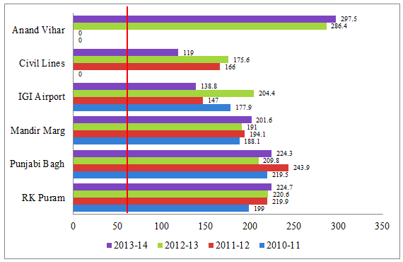
Source: Delhi Pollution Control Committee

The PM2.5 levels in Delhi in Jan. 2015 varied between 60 to 120 micrograms per cubic meter at various time the day which is much higher than the WHO norms of 25 micrograms per cubic meter.
Figure 2 : Average Concentration of Particulate and Gaseous Pollutants at Ten Sites - 2010
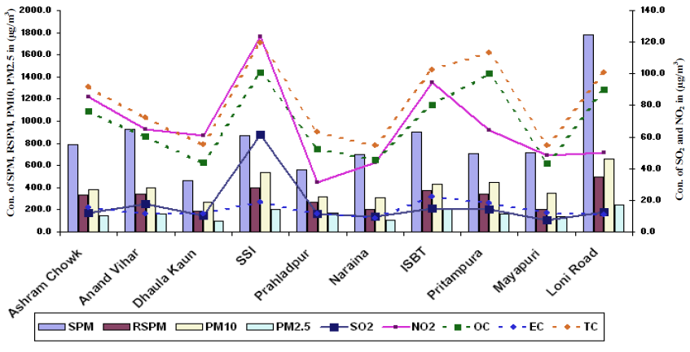
Source: Sitaramanjaneyulu (CRRI), New Delhi, 2010
It is observed that higher OC concentrations are observed at SSI followed by Pitrampura, ISBT, Loni road and Ashram Chowk, whereas lower at Dhaula Kuan, Naraina and Mayapuri. Higher EC concentration were observed at ISBT, SSI and lowest at Naraina. The OC/EC ratio is maximum at Loni followed by Naraina and Anand Vihar while it is lowest at ISBT and Mayapuri. The major sources of carbonaceous species are basically from refuse burning activities, vehicular movement resuspension of dust, high temperature fuel oil combustion.
It is estimated that if the city adheres to world health organization standards of 10 ug/m³ average life expectancy would increase by 9 years per person, while if it adheres to national standard of 40 ug/m³ average life expectancy would increase by 5.9 years per person (The Air Quality-Life Index, Energy Policy Institute at the University of Chicago. 2017).

4.3 Urban Floods and implications on urban mobility
The city comprises of 24,840 hectares of flood plains of which 68 %forms a part of the river Yamuna floodplains. The city has three drainage basins based on the watershed, including North Basin with area of 26,694 hectare; West basin of 75,633 hectares, and South and East Basin of 45,973 hectares. With increasing built up and population, the city lost over 41% of its flood plains and the loss has increased by 1.4 times since 1986 while surface run-off has increased 2.9 times in last 30 years. In other terms, for every hectare loss of green cover the surface run off increases by 0.0014 MLD. It is further aggravated by the fact that surface run-off is increasing (=3.7%) at a much faster rate than the loss of permeable surfaces in the city (=1.4%).
Increasing surface run-off and impermeable surface along with increasing intensity of rainfall has led to increase in area inundated by precipitation in Delhi (Figure 3). Road length affected by urban floods has increased in terms of area and localized nodes. It is related to the development pattern of the city- as the city expanded away from the center, so did its flood affected nodes. Majority of roads affected by urban floods are situated within the developed central areas of the city, with few spaced out in the peripheral areas, whereby drains have been covered to pave way for new developments.
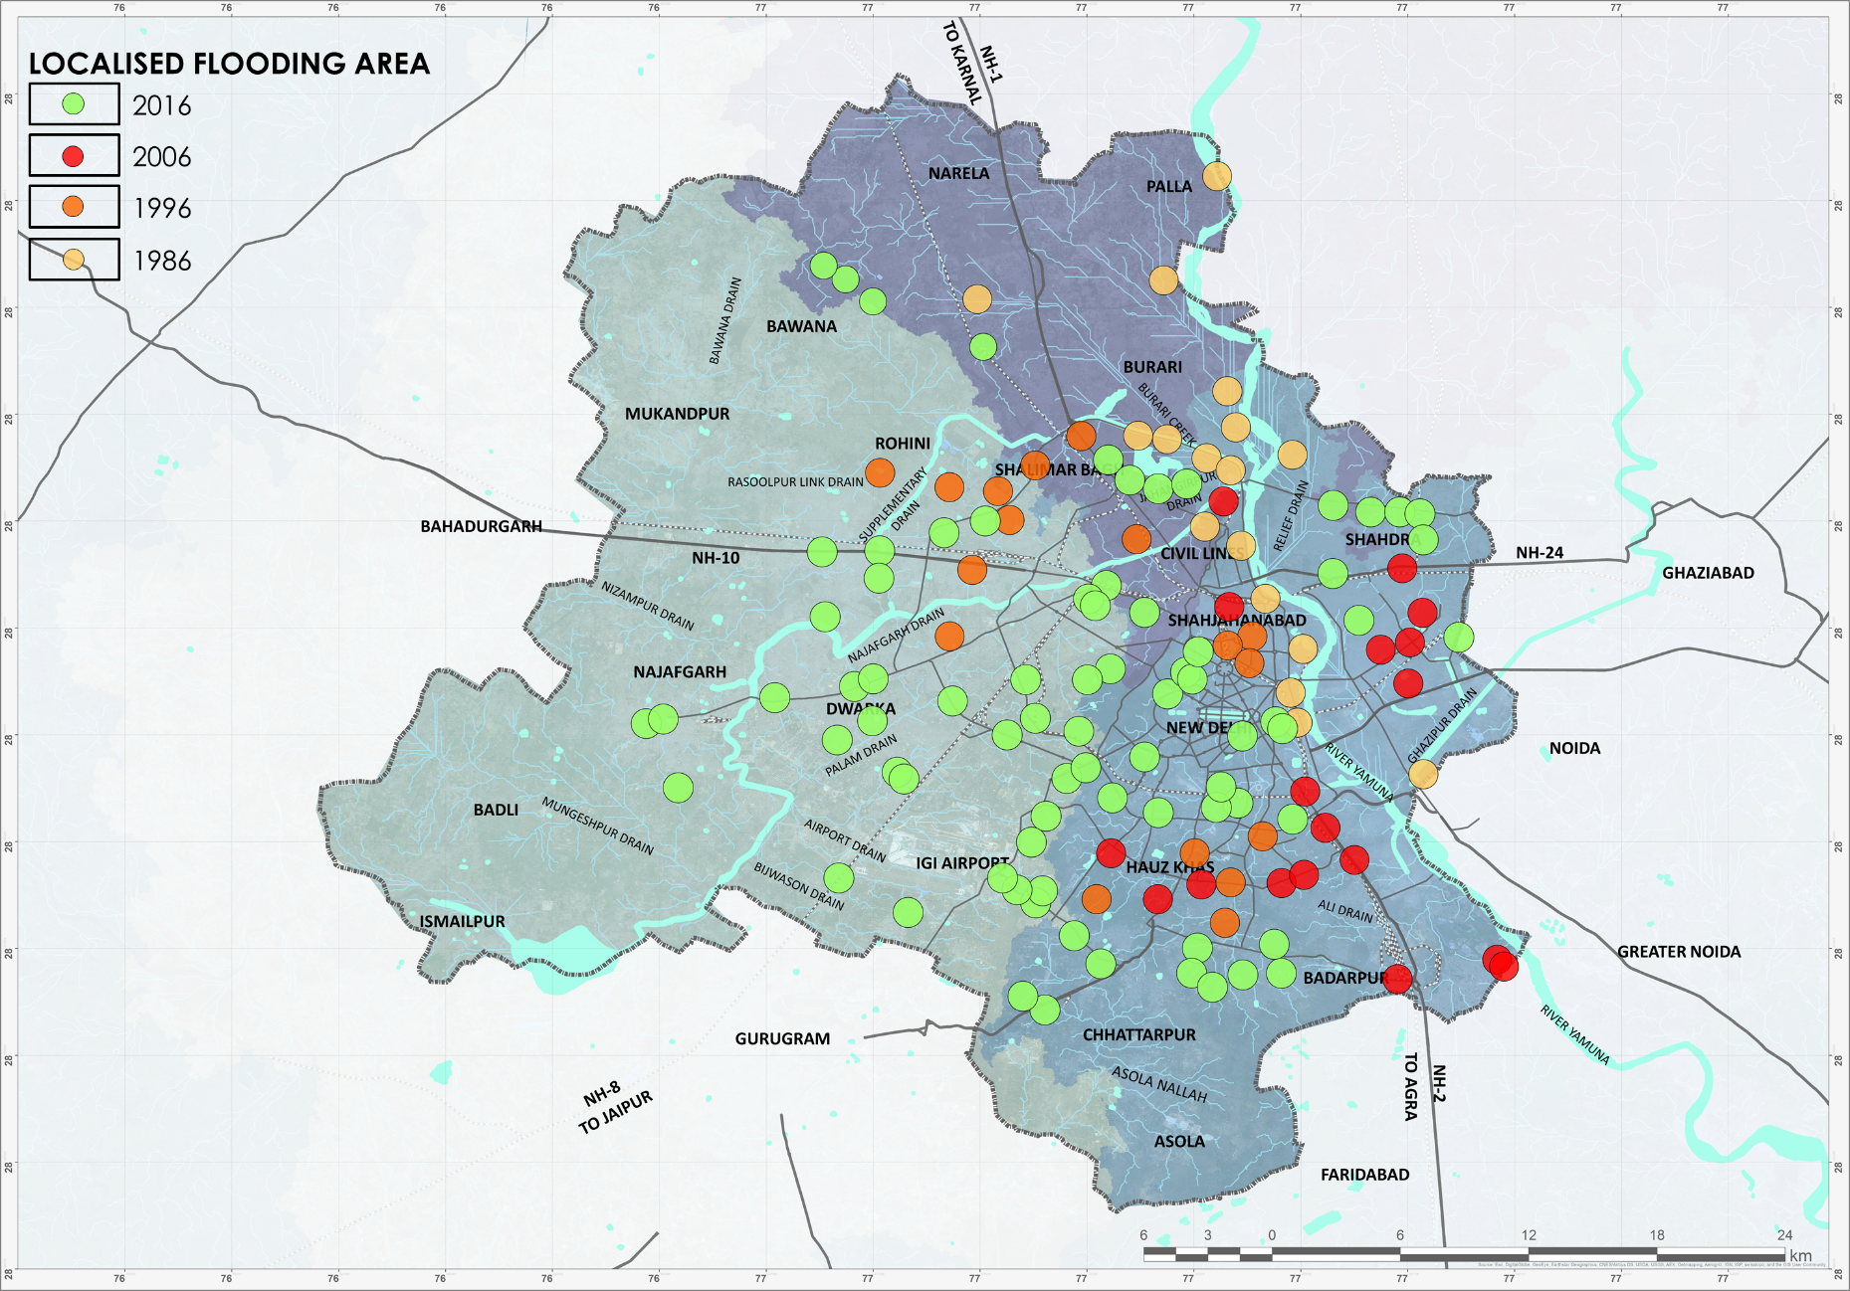
With an annual growth of surface run-off by 3.7 per cent, road length inundated by flood waters increased by 2.5% while the travel time increased by 5% owing to congestion and reduction of speeds. Moreover, with unit increase in surface run-off by 1 MLD, the inundation area increased by 85 hectares, while the road length affected increased by 68 meters and instances of vector borne diseases increased by 7.8%.
Figure 3: Change in waterlogged/inundated area in Delhi, 1986-2016
Extracted by Author (2017) from USGS (1986, 1996, 2006 & 2016)

Form the various secondary sources such as newspapers etc. water logging areas within the study area has been identified and it is observed that after 5 mm of rainfall with increase in every1 mm rainfall there is an estimated 2 minutes additional travel time per unit of travel in the network of Delhi and same is adopted for the study to understand the travel speeds during the flooding. Table 3 shows the few arterial corridors where rainfall and travel time data is available for assessing the impact of fllods on network speed and loss of consequent economic productivity

Table 3: Travel Times on Major arterial corridors during normal and rainy days
Identified Routes | Normal Day (TT in Mins) | Rainy Day (TT in Mins) | Rainfall (in mm)
Lajpat Nagar - Ashram | 30 | 90 | 26
Connaught Place - Faridabad | 42 | 90 | 22
South Extension- I P Estate | 40 | 90 | 26
Source : Collation from various articles by authors

5. IMPACT OF CLIMATE CHANGE AND URBAN DEVELOPMENT ON MOBILITY AND SOCIO ECONOMIC PATTERNS OF VULNERABLE POPULATION IN YAMUNA FLOODPLAINS
5.1 Yamuna Floodplain settlement profile
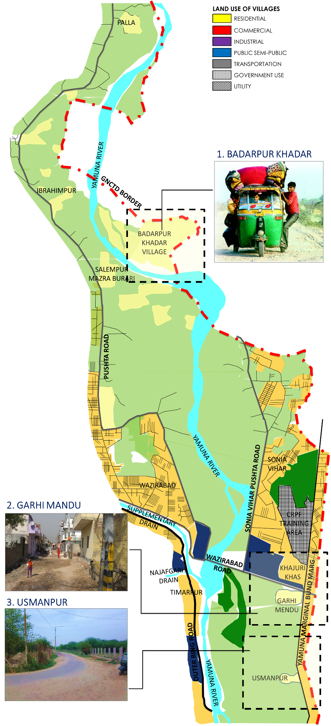
Flood plains of river Yamuna make up for over 68% of city’s total flood plains. Since 1986, studies have indicated that the flood plains have reduced in area and width of 800 metres on either sides of the river in 1986 to less than 300 meters on either side of river in 2016. With increasing developments on the flood plain of Yamuna, vulnerable population has increased by more than 2.4 times in the last 3 decades. Amongst the cohort, maximum increase has been in the number and area occupied by unauthorized colonies while villages have reduced in number due to conversion into census towns but increased in total population owing to natural increase. Planned colonies, like Commonwealth Games village, have also come up. In this study , flood plains of river Yamuna was identified and population at risk noted- unauthorized settlements, slums, planned colonies and villages were studied. Within the flood plains of Delhi exists 144 villages that are prone to flooding. These villages are categorized annually by the Irrigation and Flood Control Department of Delhi, Government of National Capital Territory of Delhi into two categories – most vulnerable/totally exposed area villages and moderate vulnerability/moderately exposed area village. Owing to constraints of time and human resource, only 3 villages (Figure 4) were identified for impact assessment, which includes Badarpur Khadar located near Delhi-Loni Border, Usmanpur and Garhi Mandu located east of Garhi Mandu city forest; were identified in the upstream of river Yamuna.
Figure 4: Case villages upstream of river Yamuna flood plains, 2017
Compiled by Author (2017)

5.2 Mobility pattern of Vulnerable Population
Across villages, one common theme that emerged regarding the mobility pattern was their strong inter-linkages with their immediate surroundings. Each village has well established work-home relationships with surrounding 5 kilometer range area. Over 70% of its working male work within 5 to 10 kilometer radius from their settlement, while over 85% working female are employed as domestic help within 500 meter radius. For accessing education and commercial facilities, villagers travel to as far as 2 kilometers, while for medical facilities, over 65% cases are dealt within 1 kilometer range at local nursing home and dispensary while less than 10% cases are sought care from major governmental hospitals including Maulana Azad hospital, Lok Nayak hospital and GB Pant hospital.

5.3 Implications of Immobility on Vulnerable Population
The impacts were assessed in terms of physical loss, social impact and economic impact, with a perspective towards their mobility pattern.
- Social impact - Owing to the loss of connectivity and inundation with flood waters, access to education facilities is also disrupted for an average of 10 to 12 days. Also, incidences of increasing vector borne diseases, like malaria, dengue, chikungunya and snake bites, have been recorded.
- Economic impact- The settlement and its inhabitants are closely associated with the community situated within 1-to-5 kilometer radius. They find their place of work, travel node, recreation, education, health, etc situated within 5 kilometer radius. But, due to loss of connectivity to outside world, a worker loses 7 to 12 working days and based on their per capita monthly income and occupation, tends to lose over 23 %to 50 %of monthly income. It varies from Rs 250 per day per capita to Rs 415 per day per capita.
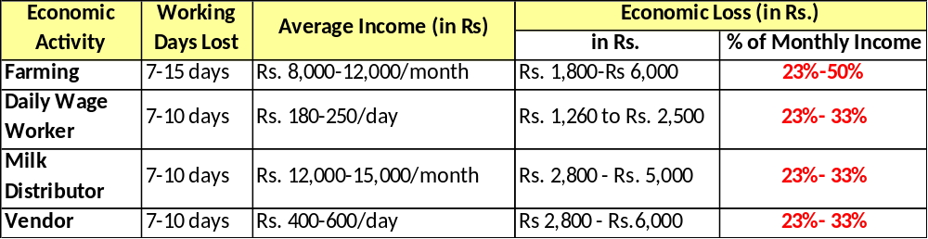
Table 4: Economic Impact of Floods in Case Villages
Compiled by Author (2017)
Articulation of survey results indicates that all the costs, be it physical, social or economic, are primarily an outcome of loss of road connectivity between home and work place owing to floods. Due to this hinderance, mobility of villagers is affected. Their access to work, home and place of education and relief is cut off. Overall, the monetary loss due to floods in the Yamuna river flood plain is valued at an estimated Rs 201 lakhs per annum which includes Rs 160 lakhs as the cost incurred by government. Thus, the need to enhance resilience of vulnerable population to counter the immobility environment owing to extreme climate change effects like floods becomes imperative.

SUMMING UP
This paper clearly establishes the fact that Delhi owing to its urbanization and associated urban development patterns has resulted in conversion of agricultural fields into non-agricultural use like residential, commercial and such other non-permeable concrete jungles, associated with increased density. Empirical analysis indicates an annual rate of depletion of flood plains equivalent to 1.4 per cent per annum which is much faster than than the rate at which built up is increasing (equivalent to 1.3 per cent). The city had 42.5 %of its area under greenhouse gas emitters in 1986 which increased to 56.8 %in 2016, and is closely related to increasing densities of development. At city level it is established that that there are critical linkages between urban development pattern, climate variability and urban mobility. Cumulative repercussions on urban mobility for the city and its vulnerable population, calls for climate resilient urban planning strategies for development of the capital, with a dire need to focus on climate carrying capacity based urban future.
______________________________________________________________________

References
Asian Development Bank, 2014. Urban Climate Change Resilience- A Synopsis, Philippines: Asian Development Bank.
Berggren, K., 2007. Urban Drainage and Climate Change- Impact Assessment , Lulea, Sweden: Lulea University of Technology.
Cartwright, A., Parnell, S., Oelofse, G. & Ward, S., 2012. Climate Change at the City Scale: Impacts, mitigation and adaptation in Cape Town. Abingdon: Earthscan .
GNCTD, 2009. Delhi Climate Change Action Plan, New Delhi: Government of National Capital Territory of Delhi .
HT Correspondent, 2016. At 10 million, Delhi hits record number of vehicles; air pollution up too. The Hindustan Times, 30 December
Rosenzweig, C., Solecki, W. D., Hammer, S. A. & Mehrotra, S. eds., 2011. Climate Change and Cities: First Assessment Report of the Urban Climate Change Research Network. Cambridge, United Kingdom: Cambridge University Press .
Satterthwaite, D., Bicknell, J. & Dodman, D., 2009. Adapting Cities to Climate Change: Understanding and Addressing the Development Challenges. London: Earthscan.

The World Bank, 2009. Climate Resilient Cities- A Primer on Reducing Vulnerabilities to Disasters, Washington DC: The World Bank.
TNN, 2015. City needs to grow with nature to survive climate change. The Times of India , 29 December.
UCCRN, 2014. ARC 3, Chapter 6: Climate change and urban transportation systems. Urban Climate Change Research Network, Cambridge University Press: Cambridge, UK
UN-Habitat, 2011. Global Report on Human Settlements 2011: Cities and Climate Change , London: United Nations Human Settlements Programme.

