Landsat-based vegetation abundance and surface temperature for surface urban heat island studies: the tale of Greater Amman Municipality in the Hashemite Kingdom of Jordan
Salahuddin M Jaber, PhD, Hashemite University, Jordan

Abstract (300 word limit)
This study aimed at evaluating the usability of Landsat for characterizing the spatial and temporal characteristics of vegetation abundance (represented by At-Sensor NDVI (ASNDVI) and Land Surface NDVI (LSNDVI)) and surface temperature (represented by At-Sensor Brightness Temperature (ASBT) and Land Surface Temperature (LST)), which are important for surface urban heat islands studies, and investigating the types of the relationships between these variables throughout different seasons in different years using TM and OLI/TIRS scenes. The study area is Greater Amman Municipality in Jordan, which represents an urban area with unplanned growth resulted partly from waves of refugee movements reflecting wider political circumstances. Change analysis from 1987 to 2016 showed that, despite the huge strides in population growth, the majority of the municipality showed either no change or small increase in vegetation abundance in summer and winter and either no change or small increase in surface temperature in summer and either no change or small decrease in surface temperature in winter. Correlation analysis showed the presence of negative relationship in summer and positive relationship in winter between vegetation abundance and surface temperature and showed that the differences between ASNDVI and LSNDVI maps and between ASBT and LST maps are not significant.

Image
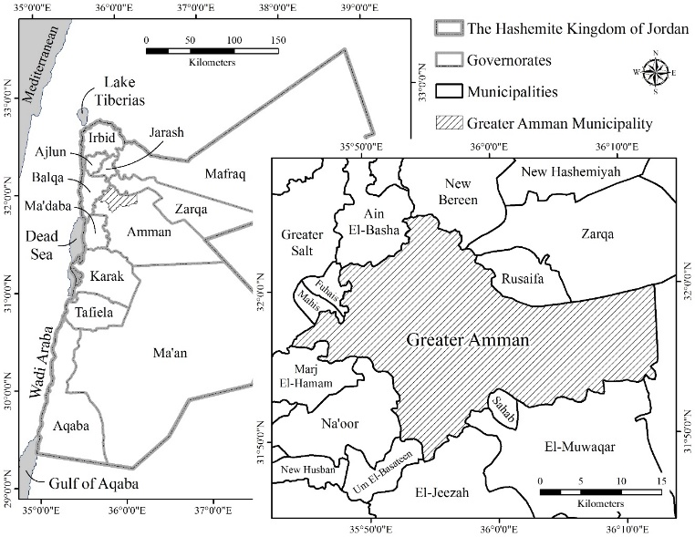
Figure 1. Location map of Greater Amman Municipality in Amman Governorate in the Hashemite Kingdom of Jordan.
Recent Publications (minimum 5)
- EPA (2017). Heat Island Compendium, Chapter 1: Urban Heat Island Basics. United States Environmental Protection Agency. URL: https://www.epa.gov/heat-islands/heat-island-compendium (accessed on 19 January 2017).
- Lin X., Zhang W., Huang Y., Sun W., Han P., Yu L., and Sun F. (2016). Empirical estimation of near-surface air temperature in China from MODIS LST data by considering physiographic features. Remote Sensing, 8, 629.
- UN-Habitat (2015). Integrating Climate Change into City Development Strategies (CDS), Climate Change and Strategic Planning. United Nations Human Settlements Programme (UN-Habitat), HS Number: HS/075/15E.
- Hewitt V., Mackres E., and Shickman K. (2014). Cool Policies for Cool Cities: Best Practices for Mitigating Urban Heat Islands in North American Cities. American Council for an Energy-Efficient Economy and Global Cool Cities Alliance, Report Number U1405.
- Zhou W., Qian Y., Li X., Li W., and Han L. (2014). Relationships between land cover and the surface urban heat island: seasonal variability and effects of spatial and thematic resolution of land cover data on predicting land surface temperatures. Landscape Ecology, 29: 153-167.

Biography (150 word limit)
In 2006 I graduated from Southern Illinois University in Carbondale, Illinois, USA, with a PhD degree in Environmental Resources and Policy with a concentration in GIS, Remote Sensing, and Environmental Modelling. Since my graduation I joined the Department of Water Management and Environment at the Hashemite University in Jordan as an Assistant Professor. In 2015 I have been promoted to an Associate Professor. During the last ten years (after PhD) I acquired multiple experiences as a teacher, researcher, administrator, trainer, consultant, and supervisor for graduate students.
Email: sjaber@hu.edu.jo

Notes/Comments:

