Properties of black carbon and other insoluble light-absorbing particles in seasonal snow of northwest China
Wei Pu, PhD candidate in climatology, Lanzhou University, China

Abstract (300 word limit)
Insoluble light-absorbing particles (ILAPs), primarily black carbon (BC), organic carbon (OC), and dust, deposited on snow can reduce snow albedo, which can significantly affect regional and global climate. Hence, understanding ILAPs content in snow is very important for climate prediction. We conducted a large field campaign and collected 284 snow samples at 38 sites in Xinjiang Province and 6 sites in Qinghai Province across northwestern China from January to February 2012. A spectrophotometer combined with chemical analysis was used to measure ILAPs and chemical components in seasonal snow. The results indicate that the cleanest snow was found in northeastern Xinjiang along the border of China, and it presented an estimated black carbon (${\text{C}}_{\text{BC}}^{\text{est}}$) of approximately 5 ng g⁻¹. The dirtiest snow presented a ${\text{C}}_{\text{BC}}^{\text{est}}$ of approximately 450 ng g⁻¹ near industrial cities in Xinjiang. Overall, the ${\text{C}}_{\text{BC}}^{\text{est}}$ of most of the snow samples collected in this campaign was in the range of 10-150 ng g⁻¹. Vertical variations in the snowpack ILAPs indicated a probable shift in emission sources with the progression of winter. An analysis of the fractional contributions to absorption implied that organic carbon (OC) dominated the 450-nm absorption in Qinghai, while the contributions from BC and OC were comparable in Xinjiang. Finally, a Positive Matrix Factorization (PMF) model was run to explore the sources of particulate light absorption, and the results indicated an optimal three-factor/source solution that included industrial pollution, biomass burning, and soil dust.
Image
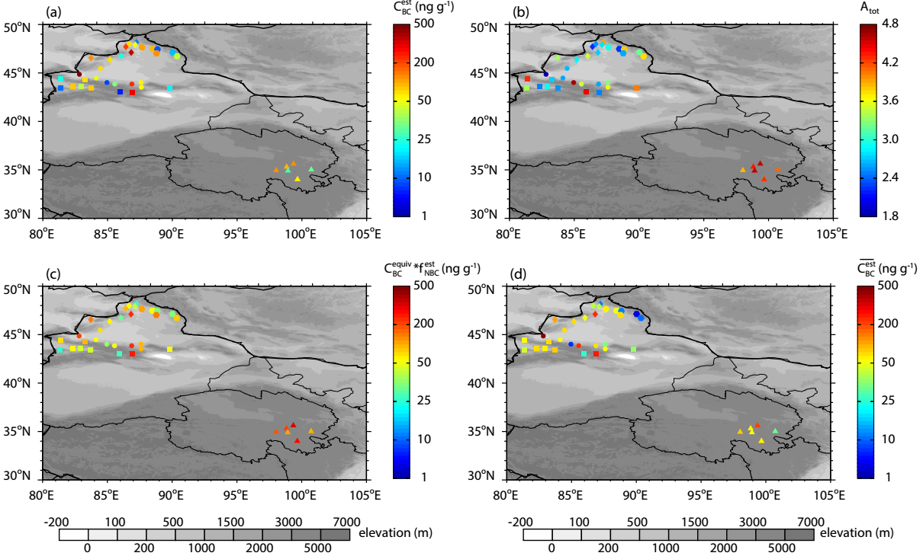
Figure: (a) ${\text{C}}_{\text{BC}}^{\text{est}}$ and (b) ${\text{Å}}_{\text{tot}}$ for the surface layer at each site. (c) Estimated BC-equivalent mixing ratio (ng g⁻¹) required to explain the spectrally integrated (300–750 nm) absorption of sunlight by non-BC components in snow. (d) Estimated average snow BC mixing ratio, $\overline{{\text{C}}_{\text{BC}}^{\text{est}}}$ , which was calculated by integrating the snow water content and BC mass over the entire snowpack.
Recent Publications (minimum 5)
- Wei Pu, Xin Wang, and Hailun Wei, et al., Properties of black carbon and other insoluble light-absorbing particles in seasonal snow of northwest China (in TCD).
- Wei Pu, Xin Wang, Xueying Zhang, et al., Size distribution and optical properties of particulate matter (PM10) and black carbon (BC) during dust storms and local air pollution events across a Loess Plateau Site, Aerosol Air Quality Research, 2015, 15: 2212-2224.
- Xin Wang, Wei Pu, Yong Ren, et al., Observations and model simulations of snow albedo reduction in seasonal snow due to insoluble light-absorbing particles during 2014 Chinese survey, Atmospheric Chemistry and Physics, 2017, 17(3): 2279-2296.
- Xin Wang, Wei Pu, Xueying Zhang, et al., Water-soluble ions and trace elements in surface snow and their potential source regions across northeastern China, Atmospheric Environment, 2015, 114: 57-65.
- Xin Wang, Wei Pu, Jinsen Shi, et al., A comparison of the physical and optical properties of anthropogenic air pollutants and mineral dust over northwest china, Journal of Meteorological Research, 2015, 29(2): 180-200.

Biography (150 word limit)
Wei Pu is a PhD candidate in climatology. He focused on studying insoluble light-absorbing particles (ILAPs) in snow and its effect on snow albedo and subsequent climate change. He has participated in several field campaigns to collect snow in China and has rich experiences in processing snow samples and analyzing ILAPs content. He also has involved in the development of a snow albedo model.
Email: puw09@lzu.edu.cn

Notes/Comments:

