Analysis on Seasonal and Interannual Variability Characteristics of the Mesoscale Eddy in the South China Sea

Wang Wenjie, Liu Yudi, Zhao shimei

Institute of Meteorology, People's Liberation Army of China University of Science and Technology, Nanjing, 211101, China

Abstract

There are numerous mesoscale eddies exist every year in the South China Sea (SCS), under the influence of the special geography environment and the reverse monsoon forcing in winter and summer, Kuroshio and asymmetric heating and buoyancy forcing factors. It’s of great significance in studying mesoscale eddies in the South China Sea in the development of marine resources and battlefield construction.
An automatic vector Geometry-based eddy detection&tracking algorith，the empirical orthogonal function (EOF), power spectrum and Morlet wavelet analysis and other methods are applied to analyze the characteristics of eddy activity in SCS during 1958-2007 years based on SODA-2.1.6 datasets, and the statistics shows as follows:
(1) 1420 eddies are detected during 50 years in SCS, distributing in the northeast-southwest horizontally and in the 2000 meters in depth, among which about 56% are Cyclonic eddies. They mainly active in the three regions, west of the Luzon strait, east of Vietnam and south of SCS, most frequently in east of Vietnam. The average radius is about 55 km.
(2) The SCS mesoscale eddies are stronger in autumn and winter, mostly Cyclonic, than in spring and summer, anticyclone mostly. The variation reflects the response of upper circulation over the monsoon forcing , but the flow field lags behind wind stress curl in time.
(3) The interannual variability of the number and distribution of mesoscale eddies in SCS, 6 years and 2.5 or 3.5 years periodically, embodies the ENSO signal obviously, but not exactly the same as ENSO period, which reflects that the upper wind is not the only factor in the process of SCS eddy activities in the interannual scale.

Keywords: the South China Sea; mesoscale eddy; seasonal and interannual variability; RMS of Sea Surface Height anomaly; eddy kinetic energy

Image

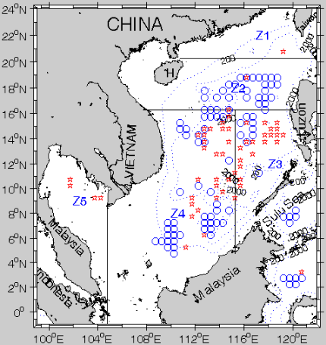
All mesoscale eddies detected during 1958 and 2007，(☆：anticyclone,○：cyclone)

Recent Publications

1.QI Chen，LIU Yu-di，LIU Jian-qiang，et al., Seasonal variabilities of the sound velocity spring layer in the South China Sea, MARINE FORECASTS,2011,28(3):46-54.
2.ZHAO Bao-hong, LIU Yu-di,FU Bang-yu, Inter-annual variability of salinity front in the South China Sea,MARINE FORECASTS,2012，12（6）：74-83.
3.WANG Wen-jie, LIU Yu-di, QI Chen, et al., Classification and seasonal variability of the sound velocity spring layer in the South China Sea,Marine Sciences,2014，38（8）：82—93.
4.ZHAO Bao-hong,LIU Yu-di,ZHAO Jia-hua,et al.,A Preliminary Study in the Seasonal Distribution Characteristics of Ocean Fronts in the South China Sea,Proceedings of the 28th annual meeting at the Chinese academy of meteorological,Nov.2011,Xia men,713-713.
5.WANG Wen-Jie, LIU Yu-di, ZHU Jin-shuang,et al., Seasonal and interannual variability of mesoscale eddy intensity in the South China Sea, Marine Sciences,2016，40（12）：1-14.

Biography

Yudi Liu has his expertise in study of numerical modeling and microwave data retrieval. He has built a numerical atmospherical model based on the Spherical Yin-Yang grids to improve the computational efficiency and accuracy of the latitude-longitude mesh prototype. The study of seasonal and interannual variability of ocean fronts, mesoscale eddy and sound velocity spring layer in the South China Sea is based on microwave data .

E-mail: udy.liu@pku.edu.cn

