Current progress and future challenges of climate technology research for the climate change
Joon Ha Kim, School of Environmental Science and Engineering, Gwangju Institute of Science and Technology (GIST), Gwangju 61005, Republic of Korea

Abstract
The world has been making substantial efforts that reducing vulnerabilities and building resilience to the impacts of climate changes since the Paris Convention. From the Paris Convention, it has become clear that carbon reduction and response to climate change are a key to deal with globally confronted humanity with problems caused by extreme weather events. To solve issues caused by climate change, climate technology is indispensable.
Heretofore, climate technology has focused on reducing carbon emissions, such as carbon capture and sequestration (CCS) technologies, such as direct reduction of carbon dioxide emissions as major greenhouse gases, or mineralization of emitted carbon dioxide.
Technologies for adaptation are technologies that adjusting to climate change to mitigate potential damage by application of existing technologies. Among various technologies monitoring and data processing technology can cope with local climate change by effectively analyzing incoming massive amounts of data generated by combination of Internet of Things (IoT), advanced sensor, and artificial intelligence (AI).
Thus, climate technology should improve existing carbon reduction efficiency and focus more on adaptation to climate change by modifying or extending scale of existing technologies (e.g., Internet of Things, artificial intelligence).

Image
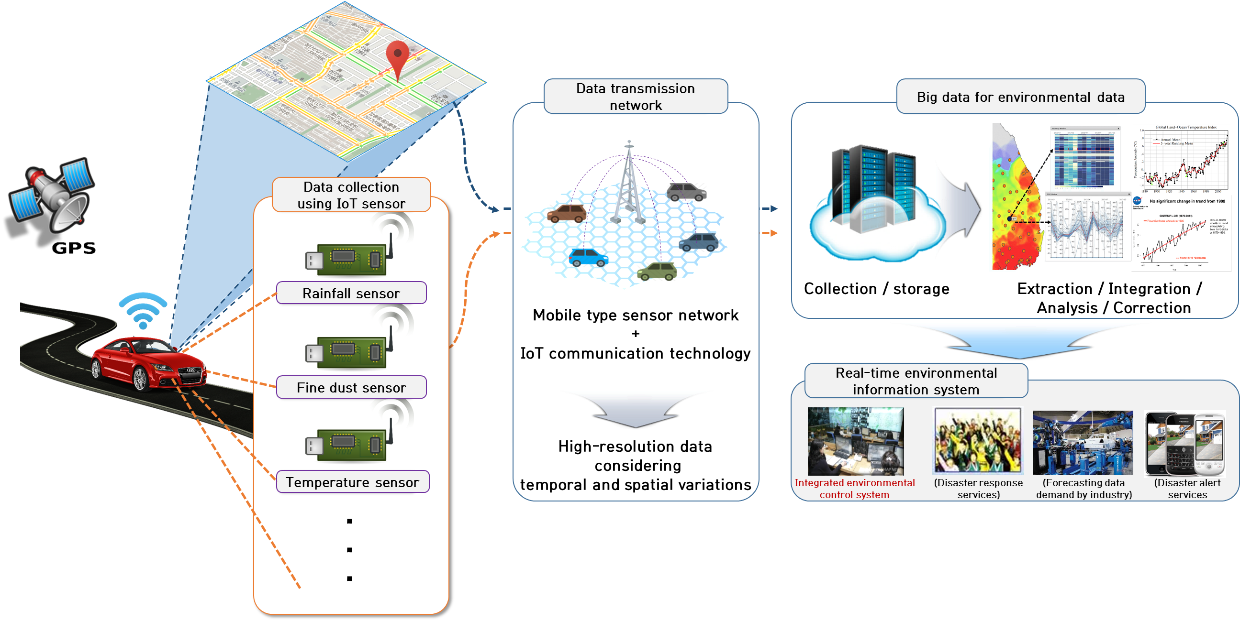

Recent Publications
- Kyung Hwa Cho, Yakov A, Pachepsky, Minjeong Kim, JongCheol Pyo, Mi-Hyun Park, Jung-Woo Kim, Young Mo Kim and Joon Ha Kim*, "Modeling Seasonal Variability Fecal Coliform in Natural Surface Waters using the Modified SWAT". Journal of Hydrology, (2016), 535, 377-385.
- Yongeun park, Yakov A. pachepsky, Kyung Hwa Cho, Dong Jin Jeon, Joon Ha Kim*, "Stressor-response modeling using the 2D water quality model and regression trees to predict chlorophyll-a in a reservoir system", Journal of hydrology, (2015), 529, 805-815
- Yongeun Park; Kyung Hwa Cho; Joo-Hyon Kang; Seung Won Lee; Joon Ha Kim*, "Developing a flow control strategy to reduce nutrient load in a reclaimed multi-reservoir system using a 2D hydrodynamic and water quality model", Science of the Total Environment (2014), 466-467, 871-880.
- Seo Jin Ki, Joo-Hyon Kang, Seung Won Lee, Yun Seok Lee, Kyung Hwa Cho; Kwang-Guk An; Joon Ha Kim, "Advancing assessment and design of stormwater monitoring programs using a self-organizing map: Characterization of trace metal concentration profiles in stormwater runoff", Water Research (2011), 45(14), 4183-4197.
- Kyung Hwa Cho; Sung Min Cha; Joo-Hyon Kang; Seung Won Lee; Yongeun Park; Jung-Woo Kim; Joon Ha Kim, "Meteorological Effects on the Levels of Fecal Indicator Bacteria in an Urban Stream: A Modeling Approach", Water Research (2010), 44, 2189-2202.

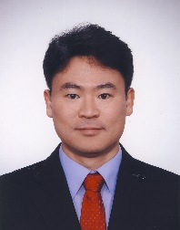 Biography
Joon Ha Kim has completed his PhD from University of California, Irvin, USA. He is a professor of School of Environmental Science and Engineering Gwangju Institute of Science and Technology (GIST), Korea since 2004. And he is the director of the International Environmental Research Center (IERC) which is one of the UNU-GIST Joint Program. He has published more than 110 papers in reputed journals and has been serving as an editorial board member of repute.
Email: joonkim@gist.ac.kr

Notes/Comment

