DISCOVERY OF THE HELIUM IN SAUGOR DIVISION, SOUTHERN GANGA BASIN, BUNDELKHAND REGION, M.P. INDIA..

Arun K. Shandilya, Anurag Shandilya,& Anupam Shandilya
Department of Applied Geology
Dr.Hari Singh Gour University
Sagar M.P.INDIA.
email - akshandilya_u@rediffmail.com
ABSTRACT
The discovery of the helium in the petroliferous tube wells in Saugor Division, southern Ganga Basin region has been carried out in great detail in 50 Tube wells, along with the stable isotopic analysis were carried out for the gas sample were collected from the 50 tube wells in Sagar and Damoh District of M.P. The discovery of the rare gas helium in hydrocarbon rich zone in the tube wells in agricultural field at Garhakota, Rahatgarh, Bina, Banda & Sagar Tahsils, of District and Batiyagarh, Patharia, Jabera, tahsils in Damoh District of M.P. is a unique finding in rocks of the Vindhyan Super Group, in the history of Earth Science in India. The depth of tube wells are varying in 300 feet to 750 feet.
On the basis of geochemical analysis, it is remarkable to note that average values of helium contents varies from 0.34 % to 0.732 % along with the 72% to 99 % of methane and ethane, and minor amount of oxygen, nitrogen and CO2 gases in the hydrocarbon rich zone are recorded during the geochemical and stable isotope analysis. It has been found in the stable isotope δ C¹³ value the values for the methane is - 43.6 per mil w. r. t. to - 54.9 per mil w.r.t. PDB and for the Ethane gas is --24.9 to --26.4 per mil w. r. t. PDB in the gas samples. The occurrence of rare helium gas in the Hydrocarbon rich zone is reported first time in the tube wells of Sagar Distt, which were geochemically and stable isotopically analyzed in the labs of KDMIPE,ONGC, Dehradun & NGRI Hyderabad. The gaseous hydrocarbon analysis show the presence of moderate to low concentration of methane ( C1) 1 to 104 ppb, Ethane( C2)-1 to 14 ppb, Propane( C3) 1 to 10 ppb, i- Butane ( i C4) 1 to 9 ppb and n Butane ( n C4) 1 to 8 ppb in the soil samples collected from different locations.
The Result of the stable isotopic analysis of Ethane gas in these samples δ C¹³ value are ranging from -24.9 per mill w.r.t. PDB and -26.9 per mill w.r.t. PDB are indicative that this gas is of thermogenic origin, which must have been formed at very high temperature & pressure condition in the deeper horizon of the Great Vindhyan sedimentary basin of an early Proterozoic ( > 600 m.y.) period.
Keywords- Petroliferous, tube wells, hydrocarbon gas, helium gas, proterozoic, isotopic, thermogenic.
INTRODUCTION:
The present studies on the hydrocarbon gas anomalies in the seepages and leakages of natural petroleum rare gas Helium gases in the agricultural field of Sagar and Damoh district has been done in the hydrocarbon rich zone. These hydrocarbon gases and helium gas were escape from the reservoir and migrated to the surface, the secondary porosity in the rocks, sediment and soil or diffuse into the atmosphere or added in the ground water. These leakage of natural gas is an indication of petroleum gas in the form of oil and gas seeps from precursor underground.
The attempt has been made through the cheaper and faster method of geochemical prospecting,which provides the direct evidence for the presence of petroleum accumulation under ground. The samples of soil, water and gas were collected from the tube wells of agricultural field are located in the agricultural field of various villages in the Meerkheri, Rahatgarh (tahsil) Pipariya –Bhutoli villages in Garhakota tahsils of Sagar and Mahalwara village in Sukha block of patharia tahsil of Damoh distt. in the southern fringes of Bundelkhand region in M.P. The first time leakage of petroleum gas was reported in 1980 from the Meerkheri village located on the Sagar to Vidisha road, at about 15 km from the Rahatgarh town. In 1993, in another tube well at Rahatgarh the leakage was reported by the author.

The carbon isotope studies of methane and other gases were done to know whether these petroleum gases are of biogenic of thermogenic origin. Coleman et al (1977) in a study on the leakage of gas from the underground storage reservoir, showed that isotopic analysis is a reliable technique for differentiating between methane from thermogenic and biogenic source. A useful geochemical method to correlate gases with their source rocks is δ C¹³ determination. The isotopic composition of methane was found to be a more reliable indicator of hydrocarbon reservoir. Shandilya(2007) has reported the occurrence of the petroleum gas in the Sagar District and suggested that theses petroleum gas is of thermogenic in origin. Shandilya, (2008) made Discovery of Natural Gas leakages from Bore wells in the rocks of the Vindhyan Super group in Sagar and Damoh Distts. M.P. and forecasted the reserves of natural gas in Sagar District. Shandilya(2009) published a article on “Gas in the backyard” in the Business India Magazine suggesting that this gas is of thermogenic origin. Shandilya (2009) has suggested the possibility of Petroleum Gas reserve in Southern Bundelkhand Region. M.P. Shandilya, & Gajbhiye. (2010) made the Discovery of Rare Helium Gas in Sagar Distrcit, M.P.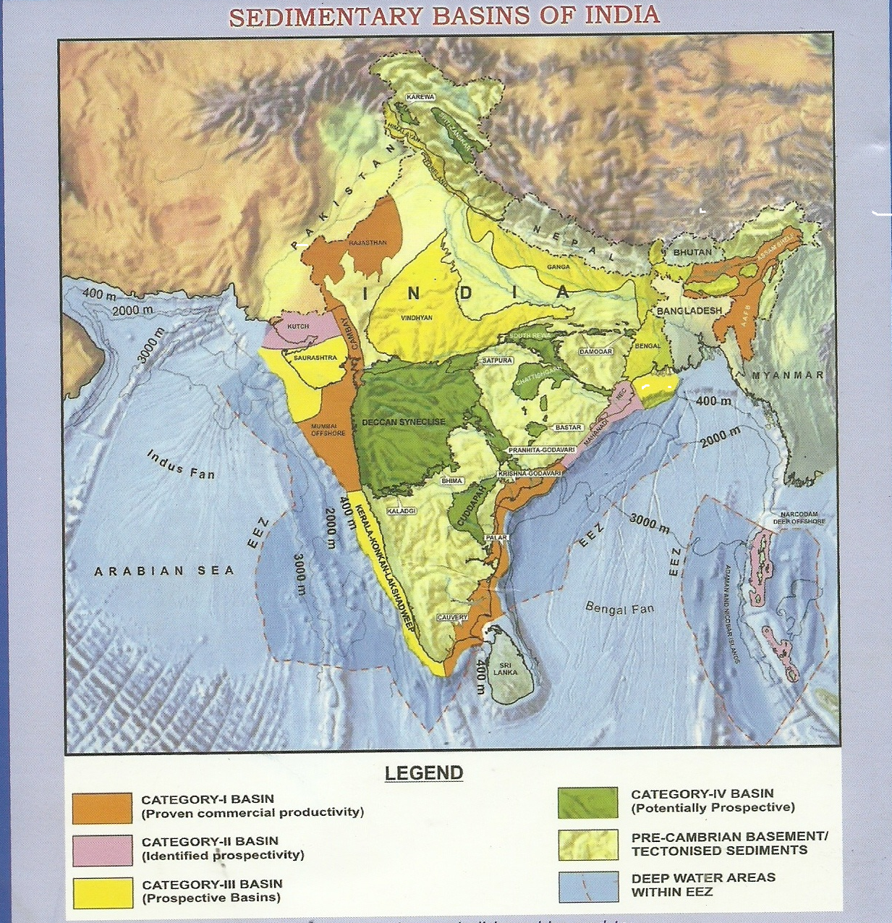
Prasanna et al (2010)did the detail investigation of light gaseous hydrocarbon anomolies in the surface soil around Sagar using the geochemical exploration methods. The study of hydrocarbon leakages has been focused on the detection of absorbed petroleum gases by gas chromatographic method in Vindhyan basin using composition and ratio of the light hydrocarbons- methane, ethane, propane, butane.

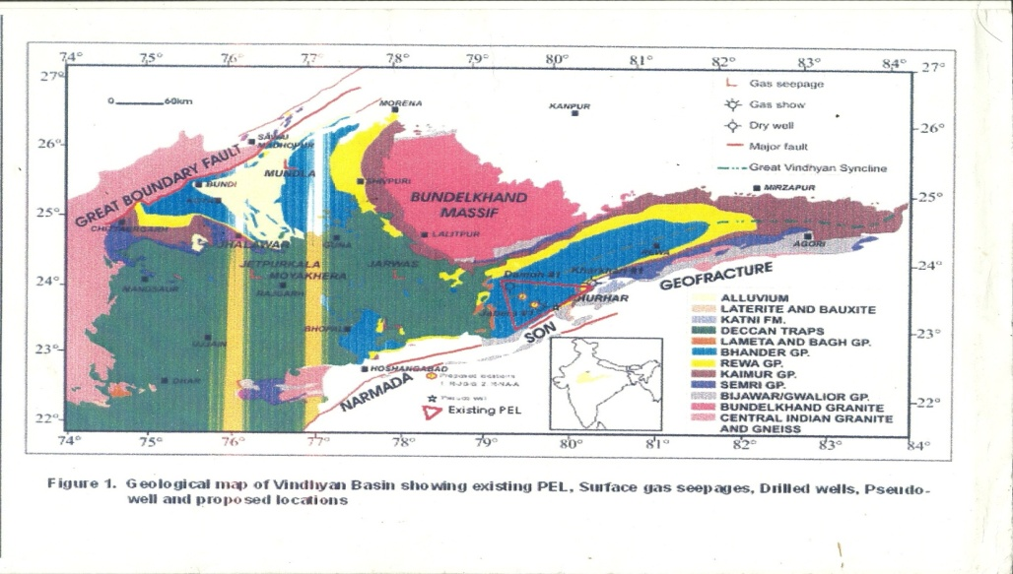

GEOLOGY:

The present natural gas leakages has been discovered in the dried tube wells, located on the rocks of Sandstone, shale and limestone of the Rewa and Bhander Group of the Vindhyan Super Group as the basement rocks. These petroliferous rocks are overlain by the Lameta bed (late Cretaceous) in the western part of the Pipariya and Bhutoli area in Garhakota tahsil. On the western part of present area is overlain by the rocks of Upper Cretaceous Deccan Trap Basaltic flows, which are intercalated with intertrappean limestone. The areas where the leakage of petroleum gas has been discovered are located on the alluvial soil cover. The Deccan Trap Basaltic rocks are exposed west of the Chinnoua village in Garhakota Tahsil .The dips of the sandstone and shales rocks are 10 - 15 degree toward SE direction. The topography is more or less flat with some low lying areas near the stream. The geological formation of Sagar area consists of 09 flows of Deccan Trapwith several intertrappean limestone beds, whole area being underlain to the east and south by the Lameta limestone which forms the plains and some hills to the south.
Western fringe of The Rahatgarh and Meerkheri areas are covered mostly by the Basaltic flows of Deccan Traps except few inliers of the shale and sandstone rocks of Rewa Group and Bhander Group of the Vindhyan Super Group. The Deccan Trap basalt rocks are mostly covered by the black soil. The Deccan volcanism during late Cretaceous must have generated the proper thermal conditions and acted as a catalyst in triggering Mesozoic hydrocarbon generation processes in the Vindhyan sedimentary basin in Central India.

Table 1- The Stratigraphic Succession In Sagar District, M. P.

AGE | FORMATION
Recent Sub Recent/Quaternaries. | Alluvium soil  Black soil
Upper Cretaceous | Deccan Trap Basalt  ( with Intertrapean limestone )
Lower Cretaceous | Lameta Formation
Late Proterozoic  Vindhyan Super Group  _____________________  Middle Proterozoic  Bijawar Super Group  ______________________  Early Proterozoic Bundelkhand Granite Complex  __________________________  Archean  Mehroni Super Group | Bhander (Containing the Petroleum gas & Helium gas)  Rewa  Kaimur  Semri  _____________________________________________  Phosphastic Dolomite  Dolomite.  Ferrugenous Shale  Ferrugenous Sandstone  Iron Formation / BHQ  Quartzite  Conglomerate bed.  ____________________________________________________  Quartz reef intrussion  Pegmatitic intrussion  Ultramafic intrusive  Granite Intrussive rocks.  Granite Gneiss  Biotite Schist.  _________________________________________________  Intrussive body  Dolomitic Marble  Slate  Ferrugenous Formation  Quartzite  Schist
(Modified after Rang Rajan 1978)

OBSERVATION:

On the request of authors, the Director Exploration, KDM IPE, ONGC Dehradun and Director, NGRI Hyderabad has sent a team of scientists for the detailed investigation of the Piparia-Bhutoli, Rahatgarh and Meerkheri area and collected the samples of soil, water and gas. The samples were collected from the following localities-

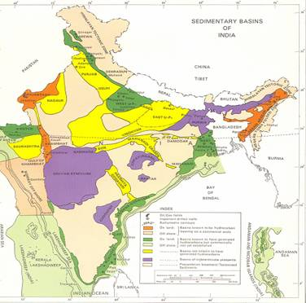

(1) Bhu-1: These tube wells fall under the panchayat and P.O. chanauaa tahsil Garhakota dist. Sagar, M.P.(part of survey of India toposheet no. 55M/1). These tube wells are accessible by a 3 km Village road from town Garhakota around 45 km East of Sagar on way to Damoh. The leakage of petroleum gas is reported from 08 tube wells in the month of March 2007.These bore/tube wells vary in the depth from 260 to 400 ft, with top 60 ft is of 8" diam. with plastic casing, and rest of well is of 6" diam. belongs to Shri Bhagwan singh Yadav (lat: 23º47'59.2"N, long 79º05'29.6" E, Elevation 448m).

(2)Pip-1: The tube wells (depth 400 feet) of Sri Asharam Patel (lat: 23⁰48'20" N, long: 79º50'20.7" E, elevation 450m).

(3) Rah-1: This village is located 40km west of Sagar on way to Bhopal Road. In the bore well of Shri Leeladhar Tiwari (Tiwari Dhawa: lat: 23º57'15.7" N, Long: 79º25'03"E, Elevation 484m), the tube well is situated on the deccan trap - Vindhyan contact. The leakage of petroleum gas is reported since 1993.

(4) Mee-1: This tube well (lat: 23º45'56"N, Long:78º18'9.6"E, Elevation 440m) from where gas seepage was occurring belongs to Shri Dhan Singh. The area falls in the toposheet of India No. 55 I/5. This tube well is the eastern extremity of village meerkhedi, 13 km of Rahatgarh on way to Vidisha. This tube well pouring the petroleum gas since 1984 having enormous bubbling in the water. The tube well is located on the contact of Deccan trap basalt and Vindhyan sand stone (Inlier).The quantity of petroleum gas bubbling is increasing day by day.

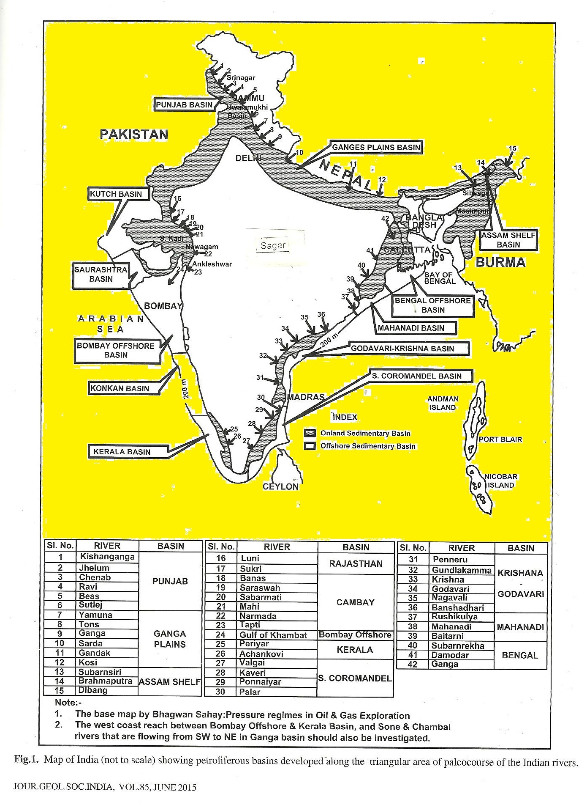
(5) Mah-1: The leakages of the petroleum gas has been reported in 2009 from this village in Patharia Tahsil of Damoh district. The 378 feet deep tube well is pouring the water along with the natural petroleum gas and the water which is coming out of the tube well is burning up to 2-3 feet long flame. The tube well belongs to Sri Halle Singh Lodhi at Mahalwara about 11 km north of Patharia railway Station in Damoh Distt.

(6) Bat-1: It is located about 25 Km from Damoh. In the tube wells the water is giving the smell of kerosene/diesel since the month of Nov-Dec 2008. The tube wells are varying in depth from 350 to 400 feet in the Vindhyan Limestone rocks.

(7) Pat-1: In this village the tube well is situated in the inliers of the Vindhyan
Rocks among the Deccan Trap cover. The tube well was dug in 2000, and depth is about 380 feet. It is also pouring the natural petroleum gas as it was reported in Nov. 2011.

(8) SUK-1: In the agricultural field near the Limestone quarry of Narsingh garh Cement (Heidel berg Cement Plant) there is a leakage of petroleum gas along with water. Reported in Dec.2009

(9) Man1: A tube well situated in the Deccan trap rocks in Mandi Bamora, depth is 390 feet, dug in May 2012 also pouring the natural gas along with water. The flame of 8-10 feet was observed at the well site in the Public Health Centre at Mandi Bamora. The thickness of the Deccan trap in very low at the site, resting over the rocks of Vindhyan Super Group, in the northern most extend of the Deccan cover.

(10) Jhi-1: The tube well is situated on the Vindhyan rocks. The tube well was dug in Deccan trap rocks, which has overlying rocks of Vindhyan Super Group. The depth of tube wells are varying from 300-400 feet.
(11) Ban-1: In this village the leakage of the natural petroleum gas has been reported in March 2012, from a tube well which is about 360 feet deep.
(12) Gho-1: The Gho-1 falls in the Banda Tahsil of Sagar Districtabout 25 Km from Banda, on way to Patharia. In this village there are six (06) tube wells pouring natural gas along with the water. Two hand pumps are also leaking this petroleum gas and burning day and night. With the help of the local administration the fire has been controlled on 7th May 2012. The continuous gas leakage has been reported from this village. In the agriculture fields, the tube wells were dug in different time, but all of them are pouring the natural gas, which is burning 6-8 feet high flame.
The experiment of the gas leakage were done in some of the old tube wells, in which the natural gas in coming along with water which is burning, one can say that water in burning (Paani me Aag).

GEOCHEMICAL ANALYSIS:
(1) At ONGC, Dehradun
The samples were analyzed in the geochemical laboratory of KDM IPE, Kaulagarh Road, ONGC, Dahradun. The finding of the geochemical analysis of the natural gas, water, and soil are as follows-

Table-2 – Geochemical Composition Of Natural Gas And Stable Isotope Values
s.n. | Bore Well | Chemical Composition % (v/v) |  |  |  |  |  | Isotopic Values  (δ C¹³)
s.n. | Bore Well | He | O₂ |  | CO₂ | C₁ | C₂₊ | δ C¹³
1 | Pipariya Bhatoli | 0.34 | 1.6 | 24.87 | 0.93 | 72.14 | 0.01 | -61.5
2 | Rahatgarh | 0.72 | 0.65 | 14.37 | 0.28 | 84.00 | 0.02 | -54.0
(After Shandilya2007)

The Oil and Natural Gas Commission Dehradun has concluded with- the seepage gases of Pipariya, Bhatoli and Rahatgarh are predominantly methane (72.14%-84% in Pipariya Bhutoli and 99% in Tiwari Dhaba, Rahatgarh Bore well) and are devoid of higher hydrocarbons. The hydrocarbon gases seem to have predominance of bacterial methane. The pressure of both the seepages is extremely low. As per the owners, the quantity of gas is diminishing day-by-day. Genetically the seepage gases from Pipariya, Bhatoli and Rahatgarh seem to be different from thermogenic gases encountered in exploratory well jabera-1, drilled by ONGC in Distt. Damoh(M.P.).
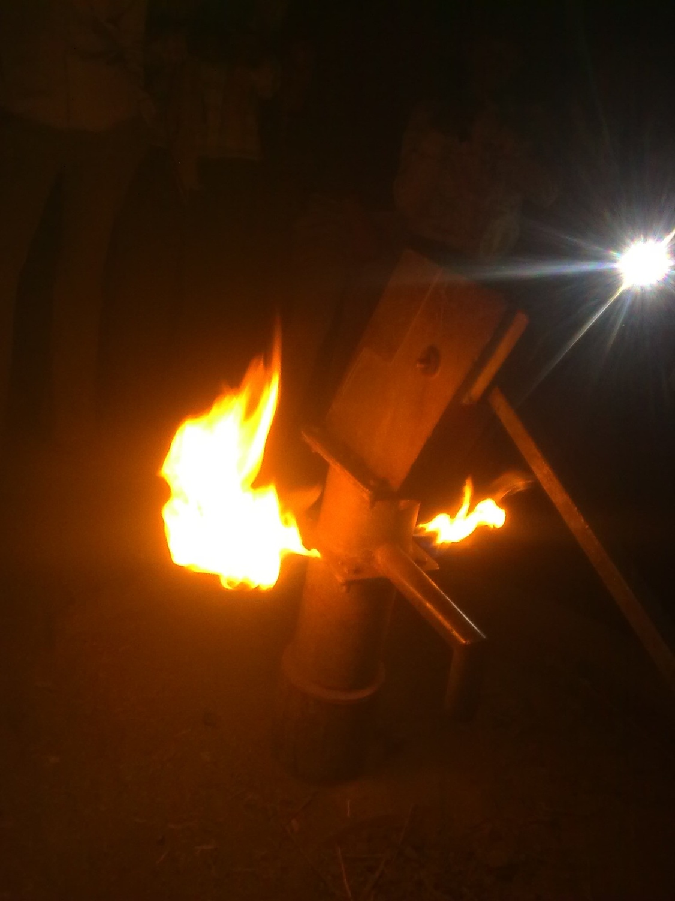
In January 2008 in Bhutoli village further land owner bore the well up to 400 ft. deep there is huge quantity of natural gas has been reported to governmental agencies. In the Feb.2008 two villagers at Pipariya-Bhutoli have drilled two more tube wells upto the depth of 300- 350 feet about 600-700 m away from the earlier wells in the shales and sandstone rocks of Lower Bhander they could not find the ground water, but there is leakage of natural gas, which is giving blue flame.

(2) At NGRI, HYDERABAD:

The samples of petroleum gas, soil, water were also collected by the of NGRI Hyderabad along with the author on 4-5 May 2008.The detail geochemical and stable Isotopic studies of the natural petroleum gas, soil and water sample has been done in the Laboratories of NGRI.

Table 3- Stable Isotopic Value Of Hydrocarbon Gas In Sagar District M.P.

LOCATION | NAME OF PETROLEUM GAS | STABLE ISOTOPIC VALUE  δ C¹³
Piparia Bhutoli | Methane  Ethane | -43.6 per mil w.r.t. PDB  -24.6 per mil w.r.t. PDB
Rahatgarh Mirkheri | Methane  Ethane | - 54.9 per mil w.r.t. PDB  - 26.4 per mil w.r.t. PDB
(After Shandilya 2008)

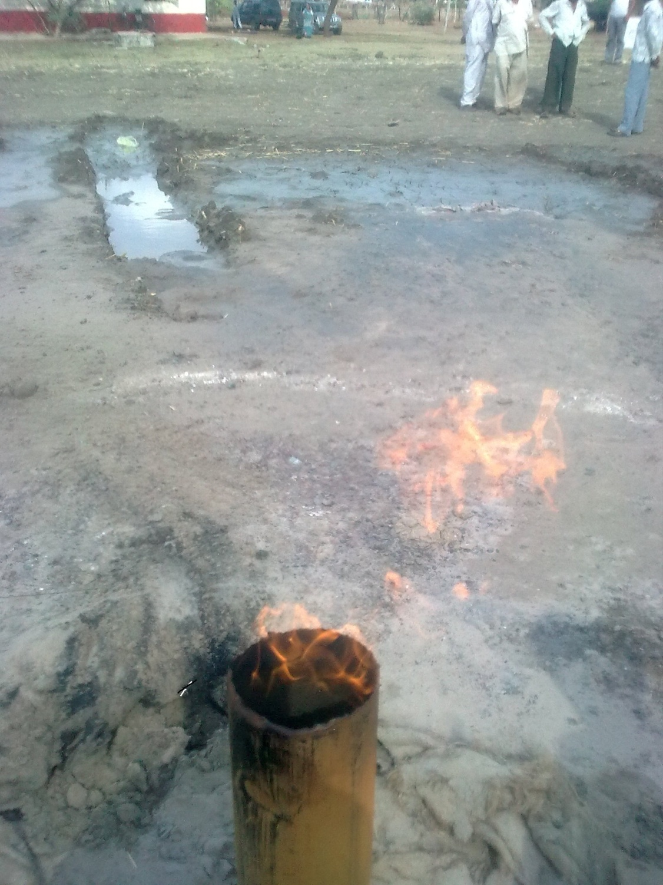

The presence of the Ethane gas in both the localities, and δ C¹³ value in the range of -.24.6 per mil. w.r.t .P.D.B. and - 26.4 per mil. w.r.t. P.D.B. indicate the thermogenic source of these gases. On the basis of the geochemical and stable isotopic studies of the natural petroleum gas, soil and water suggest that the samples of the Piparia-Bhutoli-Rahatgarh-Meerkheri of Sagar District containing 72% to 99% of methane, 0.34% - 0.742% of Helium, along with the oxygen, Carbon Dioxide and Nirogen gases. The stable isotopic δ C¹³ values in the range varying from -43.6 per mil. w.r.t PDB for Methane -24.66 per mil. w.r.t PDB for Ethane at Piparia –Bhutoli to -54.9 per mil. w.r.t PDB for Methane and -26.4 per mil. w.r.t PDB for Ethane at Rahatgarh are indicative of the thermogenic origin and also that methane is associated with oil. Bernard (1978) suggested a genetic diagram by correlating C1/ C2+C3) ratio with δ C¹³ concentration of methane to classify natural gas types. Molecular ratio C1/C2+C3 less than 50 are typical for the thermogenic hydrocarbon gases with δ C¹³ values between -30% and -55% (PDB). This suggests that most of the samples fall in the thermogenic range.
The results indicate the presence of methane, ethane, and very poor propane and butane in Sagar District M.P. The carbon isotope studies suggest that these seeped hydrocarbons are of thermogenic origin and petroliferous in nature.

CONCLUSION:

In my opinion the natural petroleum and helium gas are containing the higher amount of Methane(72-99 %), and remarkable content 0.34% to 0.742% of Helium, and minor amount of oxygen, nitrogen, and carbon dioxide. It suggests that it must have been formed at higher temperature condition at deeper horizon in the Pre-Cambrian Vindhyan sedimentary basin (Proterozoic in age). The reservoir must be lying below the ground at mote then 1000m or deeper level. The present leakage of natural gas releasing through many hairline cracks/fractures and feather joints in the sandstone, shales and limestone rocks of the Rewa and Bhander group rocks of the Vindhyan Super Group.

As per the geochemical and stable isotopic studies of gas samples analyzed at NGRI found the methane and ethane gas. The presence of ethane gas collected from the above mentioned localities and the δ C¹³ stable isotopic value in the range of -24.9 per mil. w.r.t. PDB to - 26.9 per mil w.r.t. PDB indicative of the thermogenic sources.

ACKNOWLEDGEMENT:

The authors are thankful to the Director, NGRI and Dr. A. M. Dayal Asstt. Director of NGRI Hyderabad, and the Director, KDMIPE, ONGC, Dehradun for the Geochemical and Stable isotopic analysis of the various samples. The author is highly thankful for the critical comments and valuable suggestions on this manuscript by Prof. R..P Tiwari, Vice chancellor, Dr. H.S.G..University, Sagar Prof. L.P. Chouraisa, Head Deptt. of Applied Geology,D.HSG VV,Sagar .& Prof. P.S.Saklani, Ex, Vice Chancellor, ,HNB Garhwal University,Srinagar Garhwal and Prof. S.P. Banarjee (Rtd) and Prof. K.S Pitre,(Rtd) ,Deptt. of Chemistry, Dr. Hari Singh Gour University, Sagar.and Prof. D.M Banerjee, (Rtd) Delhi University Delhi M. P for their valuable comments on manuscript and suggections.

REFERENCES

Bernard,B.B.(1978) Light Hydrocarbon in Sediments. Ph.D dissertation. Texas A&M University, USA p.144.
Coleman, D. D., Meents, W.F, Liu, C.L and Keogh, R.AS (1977) Isotopic identification of leakage gas from underground storage reservoir- a progress report III,Petrology, 1977,111, 1-10.

Fuex, A.N(1977) The use of stable carbon isotopes in Hydrocarbon exploration. Jour.Geochem.Explor.,1977,7,155-188.Lones,V.T and Drozd,R.J (1983)- Prediction of oil and gas potential by near surface geochemistry. Ameri.Asso.Petr.Geol.Bull.,983, 67,932-952.

Horvitz, L(1979) Near surface evidence of hydrocarbon movement from depth problems of petroleum migration. Am. Asso. Pet. Geol.1979,10,241-269.Prasanna M.V, Rasheed, M.A, Madhavi. T, Kalpana. G,

Patil D.J. and Dayal A.M.(2010)- Light gaseous hydrocarbon anomalies in the near surface soils of Sagar District, Vindhyan Basin, India. Published in Current Science, Vol.99(11) Dec.10, 2010 p.1586-1590.

Rajrajan, K (1978)- Geology of Sagar district and western part of Damoh distt. Memoirs, GSI, Vol.109,).

Raina et. al. & Tiwari et. al. (2007). Unpublished report of ONGC 2007.

Shandilya, Arun K. (2007)Natural Petroleum Gas found in Piparia-Bhutoli- Rahatgarh in Sagar District, Bundelkhand Region M.P. University Journal- MadhyaBharati, Vol.53, p.122-124.
Shandilya Arun K. (2008a) Discovery of Natural Petroleum gas in the rocks of the Vindhyan Super Group in Sagar Distt.Bundelkhand Region,M.P. Qtrly Jour. of GARC,Vol.16(I) p.24-27.
Shandilya, Arun K. (2008b) FUEL HO - Leakages of Gas in Tube wells spew natural gas. The NEWS MAGZINE mach 2008, p.31-32
Shandilya, Arun K. (2008c) Natural Gas leakages from Bore wells in the rocks of the Vidhyan Super group in Sagar and Damoh Distts.M.P. Jour. Himalayan Geology, Vol.29(2)2008,p.174 175.
Shandilya, Arun K. (2008d) Natural Gas Reserves in Sagar District. "SRUJUN" UNIVERSITY NEWS LETTER.Vol.9,Jan-March 2008, p.19.
Shandilya, Arun K. (2009a) GAS IN THE BACKYARD. in the BUSINESS INDIA MAGZINE Feb.22. 2009, Page 144.
Shandilya, Arun K. (2009b) Thermogenic Petroleum Gas found in tube wells of Sagar District. M.P. Madhya Bharati, Diamond Jubilee Volume, P.314-319
Shandilya, Arun K. (2009c) The possibility of Petroleum Gas reserve in Southern Bundelkhand Region. M.P. UNIVERSITY NEWS LETTER, Vishwavidyalaya Samvad. Vol. 2 Page3,Jan.2009.
Shandilya, Arun K. (2010) Discovery of Rare Helium Gas in Sagar District, M.P. INDIA.
Proc. V th Inter.Conference, South Valley University QENA, EGYPT. Jan2-7,2010 .p.26-30
Shandilya, Arun K. ( 2011) The Discovery of natural petroleum and Helium gas in Tube wells of Sagar- Damoh Distt. in Vindhyan Rocks , M.P. Proc. Sedimentary Basins of India, Gondwana Geological Society, NAGPUR 2011. p. 125-130.
The News of Discovery of Petroleum gas was published in News papers - : Dainik jagran, Dainik Bhaskar, Raj express, Nav Bharat, Nai dunia, Hindustan times, Acharan etc.
Shandilya, Arun K, Shandilya Anurag,& Shandilya Anupam- (2012) Hydrocarbon gaseous anomalies found in Agriculture Field around Sagar and Damoh Distt. Southern fringes of Bundelkhand region, M.P. Int. Jour. of Chemical and lifescince Vol.1(3) Dec 2012.p-1039-1044.
Shandilya, Arun K (2013)-Studies on Helium & Natural gas anomalies in tube wells around southern Ganga Basin,Bundelkhand region,M.P. India. In Book-Management of Water ,Energy & Bioresources in the Era of Climate Change.Ed.-N.Janardhan Raju, Wolgane,Ramanatha & M.Sudhakar.Capital Publ.House,New delhi.p/154-160
Shandilya,Arun K.(2013) Discovery of Rare Gas Helium in Sagar Distt.M.P. India.
Proc. Int. Conf.Geothermal Energy, Pd. DD Uni. Gandhi nagar Gujrat, July26,2013 p.8-15.
Shandilya, Arun k.,Shandilya Anurag(2014) Helium and petroleum gas found in rocks of Vindhayn Super Group , south Ganga basin, Bundelkhand region, M.P. India.
Proc.III Inter. Conf. on Petroleum Science and Technology (ICPST2014) IIT Madras Nov.3-5,2014.p.26.
Shandilya, Arun K. ( 2016) The studies on the Helium gas in tube wells in Sagar Division, south Ganga Basin, M.P. India. Int. Jour. of BioScience. May 2016 vol.5(2)
The News of Discovery of Petroleum Gas was broad casted in T.V. Channels : - Door Dhashan(DD) state and National both, Sahara National, India T.V., ETV, Times, and AajTak, Khabar Bharti, & P-7 TV channel,
___________________________________________________________
Phone- 07582 236597 (R) 09977576665 (M) 07582265818(o)
email – akshandilya_u@rediffmail.com
Prof. Arun K.Shandilya,
Deptt. of Applied Geology
Dr. H.S.G Univers

Table 1- The Stratigraphic Succession In Sagar District, M. P.

AGE | FORMATION
Recent Sub Recent/Quaternaries. | Alluvium soil  Black soil
Upper Cretaceous | Deccan Trap Basalt  ( with Intertrapean limestone )
Lower Cretaceous | Lameta Formation
Late Proterozoic  Vindhyan Super Group  _____________________  Middle Proterozoic  Bijawar Super Group  ______________________  Early Proterozoic Bundelkhand Granite Complex  __________________________  Archean  Mehroni Super Group | Bhander (Containing the Petroleum gas & Helium gas)  Rewa  Kaimur  Semri  _____________________________________________  Phosphastic Dolomite  Dolomite.  Ferrugenous Shale  Ferrugenous Sandstone  Iron Formation / BHQ  Quartzite  Conglomerate bed.  ____________________________________________________  Quartz reef intrussion  Pegmatitic intrussion  Ultramafic intrusive  Granite Intrussive rocks.  Granite Gneiss  Biotite Schist.  _________________________________________________  Intrussive body  Dolomitic Marble  Slate  Ferrugenous Formation  Quartzite  Schist
(Modified after Rang Rajan 1978)
ity, SAGAR ( pin-470003) M.P. INDIA.

