Climate Change and Energy in Egypt
S.A. Al-Gamal

Department of Siting and Environmental Impacts,Egyptian Atomic Energy,Egypt

Abstract

The main problem pertaining to climatic change and climatic variability in Egypt and even in some parts of the Mediterranean Basin is that systematic climate observation programs are, at present, inadequate to permit reliable assessment, quantification and prediction of climatic conditions and their impacts. A more accurate assessments of regional climate variability and change and their related environmental and socio-economic impacts is highly needed.The total energy demand of Egypt is marked by an exponential growth of demand on electricity, at a pace much faster than that of GDP, of primary energy consumption and of population, particularly in Egypt and the Southern and Eastern Mediterranean Countries as well. For this set of countries, the demand is likely to increase by 2.6 between 2006 and2025, mainly due to a doubling up of the consumptions of Egypt. The expected development of the industrial sector, the accelerated access to electricity, and the improvement of standards of living (directly connected with the consumption of the residential sector) are the reason for these consumption upsurges.
Keywords:GDP,per capita ,climate change, energy , Greenhouse ,Gasses(GHG),fossil fuel, rise in sea level.

1.Introduction

The overall objective of this paper is, to bring together main components of climatic data and energy data to remedy deficiencies in systematic climate observation programs in Egypt in order to ensure that the information produced by them meets the needs of decision makers and other users, as well as defining the optimum strategies to mitigate and/or adapt to the negative effects of global climate on the exponential demand of energy in Egypt. Energy lies at the heart of the climate change issue.
Knowledge of the long-term behavior of climate over past decades and centuries is essential to understanding climatic variability, planning for adaptation to future climatic variations and for the calibration of global and regional climate models. Egypt as a part of the Mediterranean Basin possesses a rich heritage of observational records of climate. However, many of these records are not readily accessible or are stored in perishable paper formats in publications and archives.

1.1.The Problem and current status of Energy in Egypt

In 2006, the electricity consumption of the Egypt and south Mediterranean countries accounted for 26% of the total electricity consumption of the Mediterranean basin Anthoff ]1[. This figure is likely to reach 40% by 2025. Turkey and Egypt account for about 60% of the total electricity production of the south Mediterranean countries Amelung et al]2[. The average annual electricity consumption per capita is 3.8 times lower in Egypt than in the Northern Mediterranean Countries (NMCs); this ratio is likely to shrink to 2.3 by 2025. In Egypt, the fossil energies used to produce electricity accounted for over a third of primary energy (34%) in 2006. The choice of sectors depends on the natural resources available in the countries (gas in Algeria and in Egypt; coal in Israel, in Turkey and in Morocco). Over the past 35 years, a salient fact has been the penetration of natural gas which accounted, in 2006, for 50% of the sources of energy used to produce electricity, as against 3% in 1971. The oil share in electricity production has reported a reverse trend: passing from 56% in 1971 to 17% in 2006. Coal, which accounted for 10% in 1971, rose to 20% in 2006. For the time frame 2025, coal is likely to account for 31% of fossil fuels for electricity (as against 23% in 2006) and gas for 64% (as against 55% in 2006). The nuclear option is under consideration in Egypt; it is likely to emerge in the energy mix within the time frame 2025.It ensues from these evolutions that CO2 emissions due to the electricity sector have grown tenfold (x 10) between 1971 and 2006. By 2025, these emissions are likely to grow more than twofold with respect to their level of 2006 in Egypt.
The strong penetration of natural gas at the expense of oil since 1970 (whose combustion emits 1.2 times less of CO2 than that of oil) has contributed in curbing emissions rises. However, the increase in demand and the growth in the share of coal for electricity production (whose combustion emits 1.7 times less than that of gas and 1.4 times more than that of oil) have tended to dent the advantages provided by the penetration of natural gas. In this regard, three options are examined to estimate the reduction potential possible in the future:
Accelerated shift from one type of fuel to another (natural gas): according to the trend scenario in Egypt, the share of natural gas in primary energy consumption (of which about a half is used for power production in Egypt) will pass from 34% in 2006 to 38%. This evolution would help bring the level of CO2 emissions within the range of 7 to 10%1 by comparison with a scenario in which the share of natural gas would remain at its level of 2006;• Use of more efficient and less fuel consuming, technologies: the previous trend-based evolution may be inverted via a large-scale program of rehabilitation of the old plants over a ten-year time period. This is the equivalent of an additional reduction of CO2 emissions in the range of 3.7% to 5.2% for the time frame 20252;. Finally, the capture and storage of the CO2 emitted by power plants could mitigate the high emissions of coal-fired plants. However, this option is as yet costly (cost twice higher than for a non equipped plant); it is also energy consuming, without a mature market, and is beset with several uncertainties—especially of an environmental character—, which hardly entertains the likelihood that the Egypt would be using it on a large scale within the time frame 2025.

1.2. Material and Methods
Data and results on climate change include analyses from paleoclimatology studies and proxies. Latest statements from the IPCC report (AR4) are also included. Climate projections for the 21st century are from global and regional climate models including those from ARPEGE-IFS. Selected results are from the main IPCC scenario: A1B, B1, and A2. Impact analyses and results are based upon multidisciplinary and sectoral applied research. Finally, results concerning post-Kyoto and from the Bali Conference are also presented
2. Results and discussion
2.1. Climate change-based issues
The impacts of the rise in temperatures, the decrease in rainfall, the multiplication of the number and intensity of extreme events and the possible rise in Mediterranean sea level overlap and amplify the already existing pressures of anthropogenic origin on the natural environment. Through the crucial issue of scarcity of water resources in Egypt, their impacts are fraught with consequences in the 21st century for human activities, in particular agriculture, fishery, tourism, infrastructures, urbanized coastal areas and hydropower production. In order to minimize as much as possible the economic losses and damages, several adaptation options must be thought out and implemented. Energy lies at the heart of the climate change issue. On the one hand, it is the main GHG emitting sector, and CO2 emissions in the future are likely to increase much more rapidly than the global average. On the other hand, hydropower production in Egypt (14% of power production)—is affected by the climate as well as by the plant cooling constraints. In the following paragraphs the key climatic issues such as GHG as well as the negative impacts of climate-change expressed in terms of rise in sea level, temperature rise, and change in rainfall patterns will be discussed with much more details.

2.1.1. Egypt's Sources of GHG emissions
The GHG inventory estimated that the total GHG emissions of Egypt in 1990 were equal to 116.608 mtCO2 equivalent using the 1995 Global Warming Potential (GWP) of the IPCC, while the net emissions were equal to 106.708 mtCO2 eq. as GHG sinks represented 9.9 mtCO₂ eq. (Plan leu,2008)(Organization for Energy Planning (OEP),1998)

2.1.2.Air Temperature Scenario
An increase in air temperature in the range of 2.2 C° to 5.1 C° for Egypt as well as the countries of Southern Europe and the Mediterranean region over the period 2080 – 2099 with respect to the period 1980 – 1999 (IPCC scenario AIB ]3([, is considered in the present work. However, Fig.1 presents the mean annual increase in air temperature in summer time according to the scenario developed by Somot and al]4[ for Egypt and Mediterranean Basin.
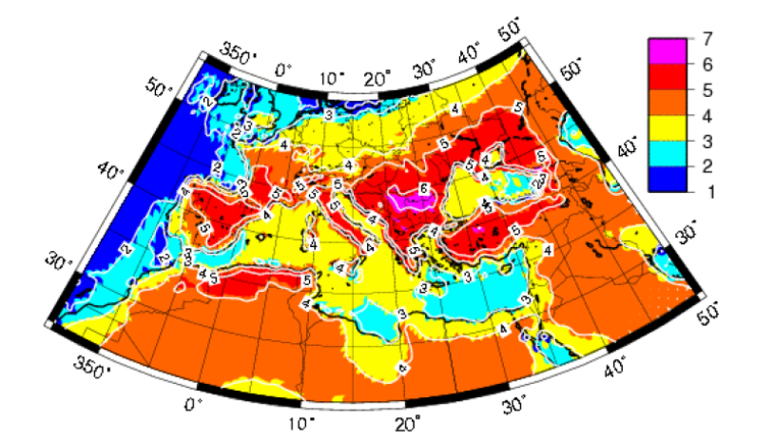
Figure 1: Annual mean variation of air temperatures in summer (°C) – 2070-2099 vs 1961-1990.Source : Somot et al]4[
2.1.3. Rainfall Scenario
A significant decrease in rainfall, ranging between -4 and -27 % for the countries of Southern Europe and the Mediterranean region according to Goodess and Jones ]5[ and IPCC]3[ scenario A1B).A subsequent Increase in drought periods manifested by a high frequency of days during which the temperature would exceed 30 °C (Giannakopoulos et al]6[). Extreme events, such as heat waves, droughts or floods, are likely to be more frequent and violent.Consequently,this situation will be impacted on crop production. An estimated loss of grains in millions of tons is shown as Fig.2.

Figure 2: Estimated production loss due to climate change related threat at 2030
2.1.4.Sea level Scenario
Rising sea level of Mediterranean Basin during the 21st century is expected to destroy areas where sand belts are essential for the protection of lagoons and low-lying reclaimed lands (Figs 3 and 4).
An increase of the sea level which, according to some specific studies, could be around 35 cm up to the end of the century. Cities located in very low-lying coastal areas and in delta zones will have to contend with the rise in sea level (Figure 3). A rise in sea level by 1 metre1 would affect 6% and 10% of the total population in Tunisia and in Egypt, respectively (Fig.3 ). More significant exposures of the infrastructures to the action of the waves (erosion) and coastal storms are among the most serious impacts The same problems will be faced by port installations (Alexandria), lagoon areas, and Nile delta as presented in Fig. 4. The costliest effects for infrastructure will be the ones related to extreme, intense but short-lived events.
The impacts can be very serious in Egypt where 1/3 of fish catches are from lagoons. Sea level rise would thus change the water quality and affect most fresh water fish. Valuable agricultural land would be flooded as well, threatening Alexandria and Port Said. Recreational tourism beach facilities are to be endangered with salination of groundwaters and increasing wave actions.
The cost of sea level rise in Egypt and on the surrounding countries in % of GDP is presented in Fig.4 according to Shérif]7[ .The financial impact could claim as much as 7% of GDP—loss of 13% of farmland, loss of habitat, biodiversity and water resources, as well as adverse impacts on health (Figure 4). The city of Alexandria, but also the cities of Rosetta and Port Saïd, are particularly vulnerable: a rise in sea level by 50 cm is likely to entail the loss of 200000 jobs (Figs.5 and 6) and incur the loss of 30 billion dollars in farmland and housing infrastructures (Shérif ]7[).
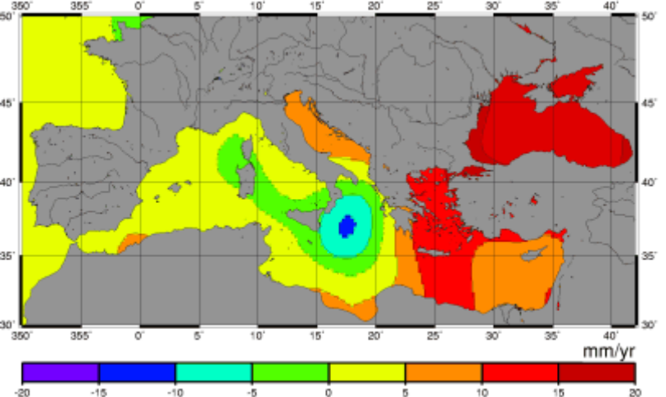
Figure 3: Mediterranean sea level changes as observed during the first seven years of the TOPEX/Poseidon project
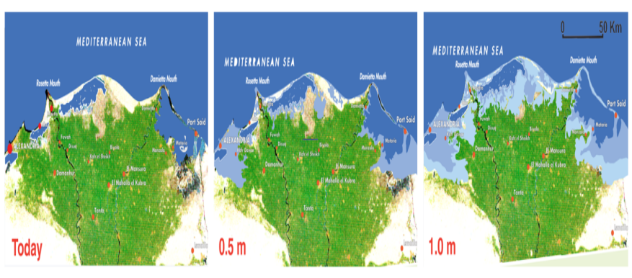
Figure 4: Nile Delta, potential impact of sea level rise(Source: UNEP/GRID – Arendal Maps and Graphics Library ]8[).

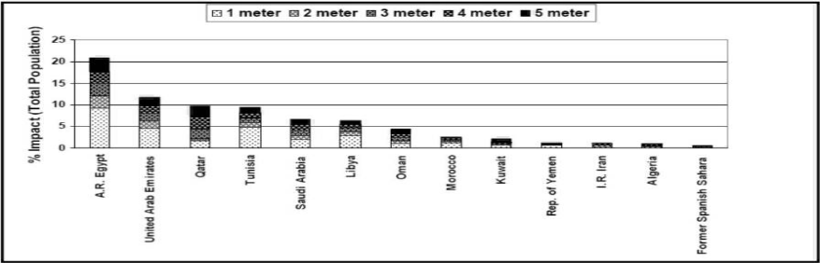
Figure 5:Impact of sea level rise on the population of Egypt and on the surrounding countries (Shérif]7[).
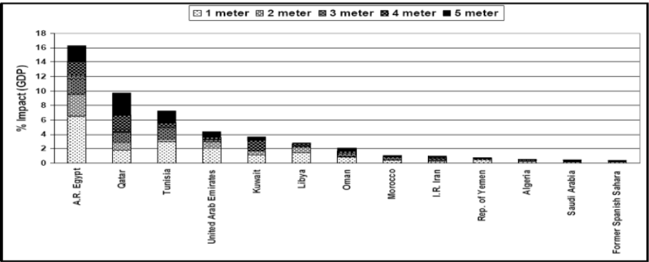
Figure 6: Cost of sea level rise in Egypt and on the surrounding countries (in % of GDP) (El Raey]7[)
2.1.5.Water Resources Scenario
In Egypt, hydroelectric production is entirely based on the exploitation of the Nile waters. The large uncertainties about the impacts of climate change on the development of water resources (though some studies estimate an increase of 30% in water resources in the catchment area of the Nile, others forecast a decrease of 20 to 70% of these resources by the year 2100) and on that of the Nile flow make it very difficult to estimate expected hydroelectric power. In 2005/2006, hydropower plants generating capacity was 2783 MW representing less than 14% of total installed capacity. It is expected to be 4.1% by 2030 (Plan Bleu]9[). Today, the sharing of water resources has become more complex (Fig.7). To meet the increase in demand for water for all sectors of activity and the need for better water quality in rivers and on the seafront, the regulatory and legislative environment has evolved. Meanwhile, severe hydro climatic Water withdrawals in Egypt already near or even exceed the limit threshold of renewable resources. By 2025, the significant increase in pressures on water resources, gauged by the exploitation index of renewable natural water resources, highlights strong and sometimes alarming contrasts as regards the “future of water” (Fig.8). New mitigation and adaptation policies are necessary and clearly demanded by Europe (Green Paper on climate change) and by the government of Egypt.

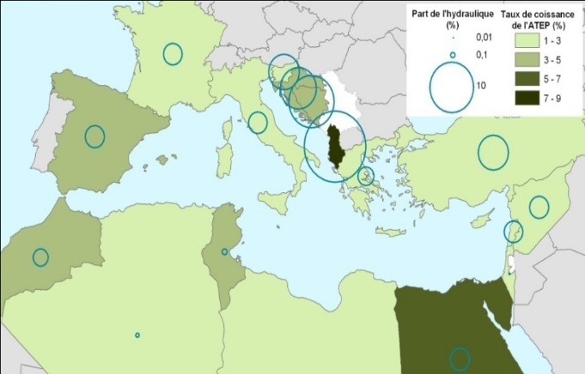
Figure 7: Share of hydropower in energy balance for Egypt and Mediterranean Basin (1990-2004)(PlanBleu]9[
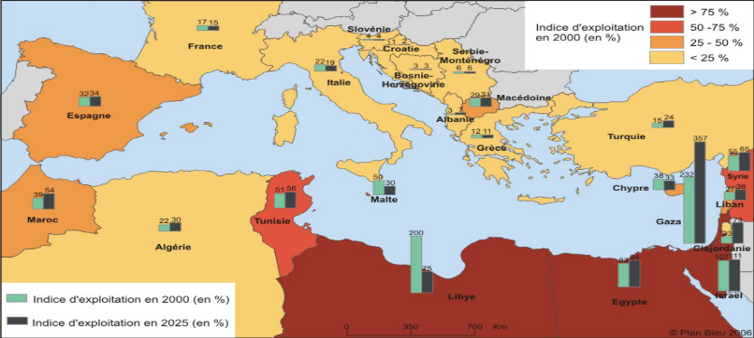

Figure 8: Exploitation indices of renewable natural water resources in Egypt and South Mediterranean (Plan Bleu]9[)
The further inspection to Fig.8 reveals that Indices nearing or exceeding 75% reveal very strong pressures exerted on water resources; ratios between 50 and 75% point significant medium-term risks of structural stress; indices between 25 and 50% indicate that countries may endure local or fluctuating stress.
2.2.Energy Based Issues
The expected growth of energy consumption in Egypt is considerable for the time frame 2025, which is connected,above all, with the development of electricity production.This growth could, nevertheless, be slowed down by difficulties related to the financing of infrastructures. One of the major constraints, for Egypt and for Turkey, is connected with the investments necessary for the new plants (+120 GW by 2020) which have been estimated by OME]11[, based on the costs of January 2008, as about 110 billion Euros. To this, there must also be added the investments related to coal ports and natural gas production and transport infrastructures, which are equally considerable; this explains, among other reasons, the predilection for projects of gas combine cycle plants (+60 GW), which are less costly and easier to construct than coal-fired plants, for instance. This represents a reduction by 50 to 71 Mt of CO2 for the time frame 2025 thanks to the gas penetration projected in the various countries. These reduction rates are calculated with respect to the current level of total emissions in Egypt .
2 This represents (Egypt plus countries in the southern Mediterranean Sea Basin) 26 to 37 Mt of CO2 for the time frame 2025. These reduction rates are calculated with respect to the total emissions of 709 Mt of CO2.
2.2.1.Analysis of energy consumption pattern in Egypt
The per capita electricity consumption for Egypt grew on average by 5% per year since 1980/81, as it increased from 380 KWh/capita in 1980/81 to 1225 KWh/capita in 2004/05 (Ministry of Electricity,2). Although the per capita electricity consumption in 2004/05 is still below world average (2330 KWh/capita), the annual growth rate is more than 3 times the world annual average growth rate (1.6%).The future annual growth rate is expected to have an average value of 5.7% based on energy demand. The growth rate is assumed to follow the following changes:
• For the period 2005/06 to 2010/11: 6.6% per year.
• For the period 2010/11 to 2020/21: 5.8% per year.However,due to the present political instability,this foregoing planned growth was not maintained.
• For the period 2020/21 to 2029/30: 5.2% per year.
It should be important to mention that during the last 25 years the electricity consumption has increased by an annual average growth rate of about 6.7% while the Gross Domestic Product (GDP) has increased by a lower annual average value of 4.5%. This would be attributed to current electricity consumption behavioral practices which are characterized by relatively low efficiency of electric energy usage (high electric energy intensity). It is expected that the situation will be improved through anticipated electricity tariff reform and market liberalization.

2.2.2.Electricity consumption

The residential and the industrial sectors are major end users of electricity in Egypt. In 2005/06, out of a total demand of 93 TWh these two sectors accounted for 36% and 35% of Egypt's total electricity demand, respectively. These two sectors have also been major drivers for electricity demand fast growth, accounting for 67% of the total growth in electricity demand over the last 5 years.
Annual growth rate per sector over last five years are as follows:
• Industry 5.9%
• Residential 7.5%
• Commercial 10.2%
• Public utilities 9.4%
• Government 8.3%
• Agriculture 7.9%

2.2.3.Oil products and natural gas consumption

During the period 1980 – 2006 the total oil and gas consumption has increased annually by about 4.8% from 15.6 million ton oil equivalent (mtoe) to 52 mtoe. The oil and gas consumed for electricity generation has increased from 4 mtoe to 21 mtoe with a growth rate of 6.6% annually, while the oil and gas consumption for other sectors increased from 11.6 mtoe to 31 mtoe with an annual average increase of 4%. Domestic gas consumption is dominated by the power sector at 60% for the year 2005/06, followed by the fertilizer industry, petrochemicals and other industrial sectors. Natural gas for power generation is expected to decline to about 50% of local gas demand by 2029/30.Gas exports were equivalent to 25% of Egypt local gas demand in 2005/06, but are expected to peak at about 60% in 2012/13, and eventually reducing to about 35% by 2029/30.
As natural gas is becoming increasingly important to the economy of Egypt, particularly with the growing potential for exports, moving towards cost-based pricing of gas is becoming increasingly important. As a result, the government of Egypt (GOE) is planning to undertake an assessment to determine the cost of gas and has requested the World Bank assistance to do so. The objective of the study will be to calculate the economic cost of natural gas for domestic customers at certain off take points from the network, including at power stations. The study objective has been modified later to include a strategy for energy pricing and should be completed by the end of 2008 and will provide important input to the GOE’s long-term energy pricing policy and strategy including sensitivity analysis of gas price changes impact on the long run marginal cost of electricity

2.2.4.Renewable Energy in Egypt(RE)

Egypt has a significant wind resource on the western bank of the Suez Canal and benefits from an excellent sunshine over the whole country. This potential attracts foreign investors (German,Spanish, apanese…). In 2000, the government announced that, by 2010, 3% of electricity would be produced based on wind energy. Subject to an adequate policy, these objectives can be hold. For the time frame 2021, the objectives are quite ambitious, with 7% wind power and 7% hydropower.However the present situation shows that RE share only 6.1% in the total primary energy supply in 1995 and went as low as 5.5% in 2000 then it continued to decrease by the year2006 to be 4.2% (OME]11[ ).The share of
hydropower in the renewable energy of Egypt by the year 2006 amounts to 2783 MW while other sources of RE combined together as solar,wind and thermal account only for 253 MW. However , International cooperation can also operate through the form of investments in projects implementation. Thus, the various stages of the wind energy farm of Zafarana in Egypt, for example, benefited from a variety of funds (loans and/or grants) by the German development bank Agency (DANIDA) and the Spanish cooperation. In this country, several donors envision to invest in wind energy (Fig. 9). In Egypt, the development of solar water heaters allowed the creation of 9 industrial enterprises.The 230 MW of wind mills installed are maintained by Egyptian teams. Besides, approximately 25% of the wind energy equipment is manufactured in Egypt and it is envisioned that this rate would reach 50% in 2007(Plan Bleu]10[)
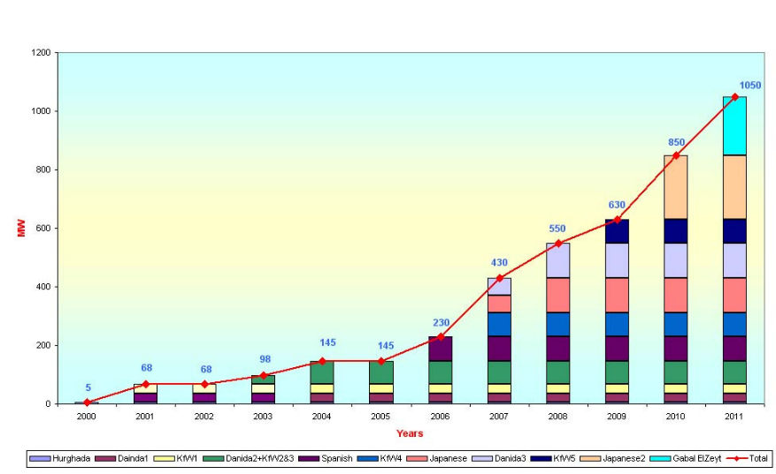
Figure 9: Installed wind power plants capacity present and planned until 2010 distributed according to cooperating countries in Egypt.

Source : R.Y Georgy, A. Soliman, national study carried out for Plan Bleu]11[.

3.Conclusions and Recommendations
Long-term, high-quality, reliable instrumental climate records are indispensable for undertaking robust and consistent studies to better understand, detect, predict, and respond to global climate variability and change. Although Egypt has a very long and rich monitoring history in the atmospheric and surface domains, the climate data heritage is largely under-exploited. This reality is preventing the region from undertaking more accurate assessments of regional climate variability and change and their related environmental and socio-economic impacts, as well as defining the optimum strategies to mitigate and/or adapt to the negative effects of global climate change over the Egypt and surroundings.

References
]1[ Anthoff, D., Hepburn, C., Tol, R.S.J.Equity weighting and the marginal damage costs of climate change”, The Fondazione Eni Enrico Mattei Note di Lavoro, 43.2007.

]2[ Amelung, B., Viner, D. ,The vulnerability to climate change of the Mediterranean as a tourist destination, in Climate Change and Tourism: Assessment and Coping Strategies, Amelung, B., Blazejczyk, K., Matzarakis, A.,Viner, D. (eds.), Kluwer Academic Publishers, Dordrecht, the Netherlands,2004.

]3[ Intergovernmental Panel on Climate Change , Climate Change,The Scientific Basis. Contribution of Working Group I to the Third Assessment Report of the Intergovernmental Panel on Climate Change. Houghton,2001.JT, Ding Y, Griggs DJ, et al. (Eds.), Cambridge: Cambridge University Press. Intergovernmental Panel on Climate Change. Cambridge: Cambridge University Press, 183-224,2001.

] 4[ Somot, S., Modélisation climatique du bassin Méditerranéen : Variabilité et scénarios de changement climatique.Thése de Doctorat, Université Toulouse III-Paul Sabatier. UFR Sciences de la Vie et de la Terre. pp 347,2005.

] 5[ Goodess, C. M., and P. D. Jones, Links between circulation and changes in the characteristics of Iberian rainfall.Int. J. of Climatology, 22, 13, 1593 – 1615,2002.

]6[ Giannakopoulos Ch., Psiloglou B.E. Trends in energy Load Demand for Athens, Greece: Weather and nonweather Related Factors”, Climate Research, 31, 97-106,2006.

]7[ Shérif, A. , The Cost of Inaction in the Middle East and North Africa Countries”, Presented at the 2nd International Expert Meeting on Sustainable Consumption and Production Costa Rica, San Jose 5 September,2005

]8[ UNEP, Changement Climatique en Méditerranée, Energie et Changement Climatique, Tourisme et Changement Climatique, Douzième réunion de la Commission Méditerranéenne du développement durable, Istanbul, 30-31mai,2007b.
]9[ Plan Bleu, F a c i l i t y f o r E u r o - M e d i t e r r a n e a n I n v e s t m e n t a n d P a r t n e r s h i p (FEMIP) and

]9[ Plan Bleu, Energy prospects in the Mediterranean region up to 2020. Etude réalisée par l’OME dans le cadre du suivi de la SMDD. Disponible sur le web : http://www.planbleu.org/themes/atelier_energie_monaco.html,2006

]10 [Plan Bleu, MEDITERRANEE – Les perspectives du Plan Bleu sur l’environnement et le développement, Benoit, G, Comeau,A., éditions de l’Aube,2005.

]11[ OME/Plan Bleu,Energy prospects in the mediterranean region up to 2020 », Etude dans le cadre du suivi de la SMDD. Disponible à l’adresse : http://www.planbleu.org/themes/atelier_energie_monaco.html,2006.

