Climate change in Afghanistan
Abdul Rasheed Rasoul, B.Sc. in forestry and NR

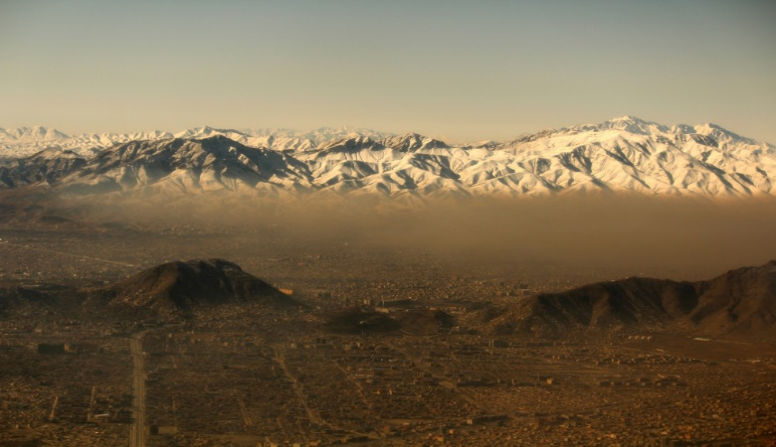
Abstract
Afghanistan is a landlocked, mountainous and very dry country in south and Central Asia with an area of 647500 square kilometers and population of about 26 million. It is bordered by Pakistan in the south and east, Turkmenistan, Uzbekistan and Tajikistan in the north, and Iran in the west.
Climate change projections for Afghanistan show regional differences however overall indicate a strong increase in mean annual temperature (higher than mean global temperature projections), with more rapid warming in the spring/summer seasons in Afghanistan. Precipitation is expected to decrease in the spring/summer and increase in the autumn/ winter with overall long-term declines in average mean rainfall. Projections also indicate an increase in the intensity and frequency of flooding due to heavy precipitation events and increased thawing of snow/ice pack. The effects of flooding are further exacerbated by poor land use practices including overgrazing and deforestation. Further, drought is expected to increase in frequency from the historical trend of droughts occurring in approximately 15-year cycles lasting for 2-3 years. In short, drought is expected to become more of a norm as opposed to a cyclical event. The impact on agriculture is expected to increase agricultural water demand due to lower soil moisture levels and increased evapotranspiration.
Afghanistan has already been, and will continue to be, heavily affected by the negative impacts of climate change. And it is the most vulnerable people particularly subsistence farmers and pastoralists who depend on natural resources for their survival –who are suffering most.
My recommendations include:
- Climate change should be integrated into school and higher curriculum to promote further mainstreaming across relevant disciplines as well as build national capacity to understand and apply key climate change adaptation and mitigation approaches.
- Civil Society and Non-governmental Organizations (NGOs), particularly involving women and youth, should be involved in awareness-raising events and capacity building activities to generate greater public awareness of climate change in the community.
- In rural areas without access to electrical grids, decentralized, low emission, and climate-friendly energy projects should be prioritized in order to provide accessible energy to rural populations and stimulate rural economic growth.
- A comprehensive survey of forest and rangeland species (flora and fauna) should be conducted in order to identify which species are most threatened by and resilient to climate change.

Image
Air pollution in Kabul city, Afghanistan

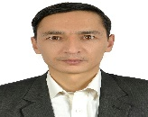

Biography
Abdul Rasheed Rasoul, is an Afghan born and based Environmental Compliance Specialist. Over the past six years, I have worked in wide variety of professional capacities in both the national and international organizations; National Environmental Protection Agency (NEPA) of Afghanistan, Development Alternative Incorporations (DAI), Shekib Naweed Construction Co (SNCC), International Relief and Development, Inc. (IRD), Danish Refugee Council (DRC)–Danish Demining Group (DDG), and AECOM International Development, Inc. I earned my B.Sc. in Forestry & Natural Resources, Faculty of Agriculture in 2009 through the Kabul University.

Date of Birth: November/19/1986
Email: ab.rasheed86@yahoo.com
Telephone number: +93 (0) 784 808 087
Linked in account:
Facebook account: Abdul Rasheed Rasoul
Category: Oral (or) Poste

Notes/Comments:

