Phosphorus Transfer from Land to Oceans Accelerating Under Climate Change
Philip M. Haygarth, Lancaster Environment Centre, Lancaster University, LA1 4YQ, UK

Abstract (300 word limit)

The devastating hurricanes that have occurred recently in an around the Caribbean and Gulf of Mexico remind us of the great dynamics and power in our weather and climate. As well as the immediate flood and human hazards, such events can have implications for the earth’s biogeochemical cycles too. My team has been studying the extent to which phosphorus losses from land to water will be impacted by climate change and land management, with detrimental impacts on aquatic ecosystems and food production. There is a great challenge in determining this, with all the complexities, controversies and uncertainties that surround it. I will describe work from my team that uses a combination of methods to evaluate the impact of projected climate change on future phosphorus transfers, and to assess what scale of agricultural change might be needed to mitigate these transfers in the UK. We combined novel high-frequency phosphorus flux data from three representative catchments across the UK, a new high-spatial resolution climate model, uncertainty estimates from an ensemble of future climate simulations, two phosphorus transfer models of contrasting complexity and a simplified representation of the potential intensification of agriculture based on expert elicitation from land managers. We show that the effect of climate change on average winter phosphorus loads (predicted increase up to 30% by 2050s) will be limited only by large-scale agricultural changes (e.g., 20–80% reduction in phosphorus inputs). Perhaps the global phosphorus cycle is now starting to accelerate with climate change, with implications for long term biogeochemical transfers to oceans? This work was published in Nature Communications August 2017 and is available here doi:10.1038/s41467-017-00232-0

Image
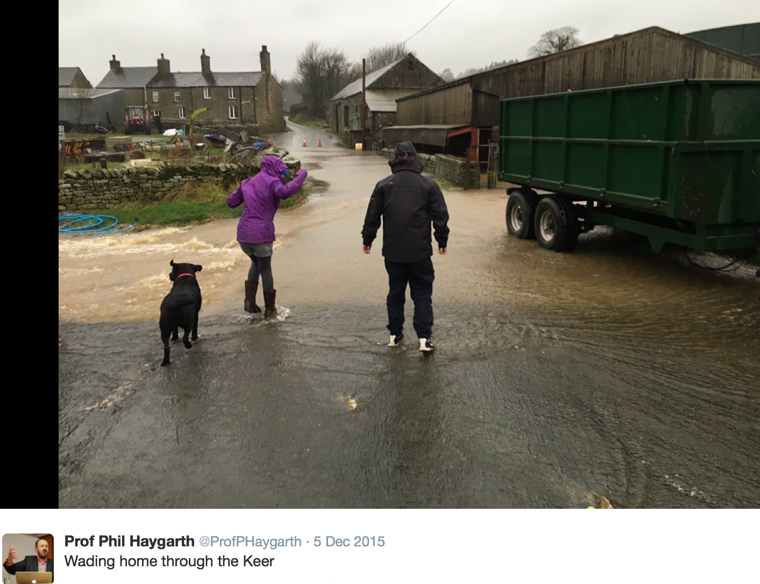
Recent Publications (minimum 5)
- Forber, K.J., Ockenden, M.C., Wearing, C., Hollaway, M.J., Falloon, P.D., Kahana, R., Villamizar, M.L., Zhou, J.G., Withers, P.J.A., Beven, K.J., Collins, A.L., Evans, R., Hiscock, K.M., Macleod, C.J.A. & Haygarth, P.M. 2017. Determining the Effect of Drying Time on Phosphorus Solubilization from Three Agricultural Soils under Climate Change Scenarios. Journal of Environmental Quality, 46, 1131-1136.
- Holden, J., Haygarth, P.M., Dunn, N., Harris, J., Harris, R.C., Humble, A., Jenkins, A., MacDonald, J., McGonigle, D.F. & Meacham, T. 2017. Water quality and UK agriculture: challenges and opportunities. Wiley Interdisciplinary Reviews: Water, 4.
- Ockenden, M.C., Deasy, C.E., Benskin, C.M.H., Beven, K.J., Burke, S., Collins, A.L., Evans, R., Falloon, P.D., Forber, K.J., Hiscock, K.M., Hollaway, M.J., Kahana, R., Macleod, C.J.A., Reaney, S.M., Snell, M.A., Villamizar, M.L., Wearing, C., Withers, P.J.A., Zhou, J.G. & Haygarth, P.M. 2016. Changing climate and nutrient transfers: Evidence from high temporal resolution concentration-flow dynamics in headwater catchments. Science of The Total Environment, 548–549, 325-339.
- Ockenden, M.C., Hollaway, M.J., Beven, K.J., Collins, A., Evans, R., Falloon, P., Forber, K.J., Hiscock, K., Kahana, R. & Macleod, C. 2017. Major agricultural changes required to mitigate phosphorus losses under climate change. Nature Communications, 8.
- Powers, S.M., Bruulsema, T.W., Burt, T.P., Chan, N.I., Elser, J.J., Haygarth, P.M., Howden, N.J., Jarvie, H.P., Lyu, Y. & Peterson, H.M. 2016. Long-term accumulation and transport of anthropogenic phosphorus in three river basins. Nature Geoscience, 9, 353-356.

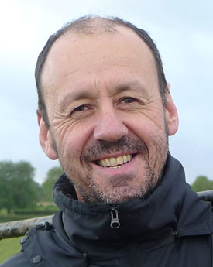
Biography (150 word limit)

Professor Phil Haygarth leads the Sustainable Catchments Research Challenge Area for Lancaster University, and conducts personal research on the interface between soils and freshwaters, with a focus on diffuse (particularly phosphorus) pollution and runoff control. Phil’s research studies the way in which soils can be encouraged to hold phosphorus at an optimal level to supply plants for food production, whist defining conditions that prevent the unwanted leakage to fresh-waterways. The practical impact of his research has been to help the UK government, and others around the world, develop policies that help farmers and catchment managers optimize plant uptake of nutrients but minimize losses to water. Often this involves efforts to reduce runoff energy, which can have dual benefits for both diffuse pollution and flood contro under climate change scenarios.

Date of Birth: 07/22/1966
Email: p.haygarth@lancaster.ac.uk
Telephone number: +44 7791512177
Twitter: @ProfPHaygarth
Category: Oral (or) Poste Oral

Notes/Comments:

